RF Digital Twin for Network Planning
and Self-Healing
Coverage Optimization, Outage Recovery, Sparse Radio-Map Reconstruction,
mmWave Beam Management, and Handover Tuning on Ray-Traced Channel Data
Project Report
Data source: DeepMIMO v4 — Scenario city_9_sanfrancisco_3p5 (3.5 GHz, C-band)
3 base stations · 40,376 candidate user locations · 53.6% ray-traced eligibility
September 2026

1. Executive Summary
This project builds a ray-traced “digital twin” of a live wireless network segment using DeepMIMO channel data, and uses it to answer five questions a radio-access-network (RAN) engineering team faces in practice: where to place sites, how a network survives a site outage, how to estimate coverage from sparse field measurements, how to cut mmWave beam-training overhead, and how to tune mobility parameters. All results in this report, except where explicitly marked “synthetic validation,” come from real ray-traced propagation data for a dense urban San Francisco scenario (DeepMIMO scenario city_9_sanfrancisco_3p5, 3.5 GHz).
Headline findings:
- Beam management: an ML model that predicts the best transmit beam from user position and geometry reduces mean beamforming-gain loss from 23.7 dB to 6.1 dB versus a purely geometric baseline, at the same 87.5% reduction in beam-sweep overhead.
- Outage resilience: the busiest site (BS0) carries 6.6 percentage points of coverage on its own; a simple neighbor power-boost self-healing rule recovers 54% of the coverage lost when it fails.
- Radio-map reconstruction: gradient boosting and Gaussian-process kriging cut coverage-map error roughly in half versus a naive distance-based estimate, from measurements covering only 5% of the area.
- Site planning: the existing 3-site deployment tops out at 78.5% coverage; a 95% target is mathematically infeasible without adding sites — a concrete, quantified capital-planning input.
- Handover tuning: the optimal parameter pair (6 dB hysteresis, 0.4 s time-to-trigger) is consistent across vehicle and pedestrian speeds, but the failure mode differs — slow users suffer more radio-link failures because they dwell longer inside coverage holes, while fast users suffer more ping-pong handovers.

2. Motivation and Scope
Radio-access engineers routinely face five recurring questions: where to add or prioritize sites under a coverage or capacity target; how much service degrades when a site goes down and whether it can be compensated without a truck roll; how to estimate full-area coverage from the limited drive-test or minimization-of-drive-test (MDT) samples actually available; how to reduce mmWave beam-sweep overhead without sacrificing link quality; and how to set handover thresholds that balance signalling load against dropped-call risk.
This project treats one ray-traced scenario as a stand-in for a live market and builds a self-contained analysis pipeline that answers all five questions from a single, shared data foundation — rather than five disconnected exercises. The same channel data, propagation model, and coverage definition feed every module, so results are directly comparable across modules (e.g., the same 3 sites that struggle to reach 95% coverage are the same 3 sites whose outage impact and healing potential are analyzed in Section 4).

3. Data and Methodology

3.1 Data source
Channel data comes from DeepMIMO v4, a public ray-tracing-based channel dataset generator built on Wireless InSite. The scenario used, city_9_sanfrancisco_3p5, ray-traces a real street segment of San Francisco at 3.5 GHz — squarely in Verizon’s deployed C-band spectrum. The scenario provides:
- 3 base station (BS) sites, each with a fixed position.
- 40,376 candidate user-equipment (UE) locations on a uniform grid over roughly 200 m × 200 m of a dense urban block, including street canyons and building interiors.
- Per-BS/UE path loss, line-of-sight (LoS) state, and up to 10 resolved multipath components (power, phase, angle of departure) per link, from which every KPI in this report is derived.
Only 53.6% of UE locations are “eligible” — reachable by at least one BS in the ray-tracing data. The remainder are inside buildings or in radio shadow with no resolvable path; these are excluded from every coverage statistic (Twin.eligible in the code), rather than being counted as artificial 0% coverage, since they do not correspond to real serviceable outdoor/indoor locations.

3.2 From channels to network KPIs
DeepMIMO supplies path loss between isotropic antennas. To get to the KPIs a RAN engineer actually works with, the following link-budget assumptions were layered on top (see RadioConfig in the codebase) and held constant across every module unless stated otherwise:
Parameter | C-band value | Rationale
Carrier frequency | 3.5 GHz | Matches Verizon’s C-band deployment; also the scenario’s native frequency
Bandwidth / SCS | 100 MHz / 30 kHz | Typical mid-band 5G NR channel
Tx power | 43 dBm | Typical macro site total conducted power
Tx antenna gain | 15 dB | Typical sectorized/array gain
Noise figure | 7 dB | Typical base station receiver
Neighbor-cell load | 0.6 | Assumed average PRB utilization driving interference
Coverage threshold | RSRP ≥ −105 dBm and SINR ≥ 0 dB | Conservative reference thresholds for a usable connection
Best-server RSRP and SINR are computed per location by combining every BS’s ray-traced path loss with this link budget; spectral efficiency uses an attenuated-Shannon mapping (3GPP TR 36.942 style, capped at 7.4 bits/s/Hz) to avoid the unrealistic throughput that raw Shannon capacity gives at high SINR.

3.3 Software and validation
The pipeline is a Python package (rftwin) with one module per analysis (site selection, outage/healing, radio-map reconstruction, beam management, handover), a shared KPI engine, and a synthetic 3GPP-UMa-based data generator used only to unit-test the pipeline end-to-end before touching real data. Seven automated tests cover every module. Two implementation issues were caught and corrected during development against real data specifically:
- A beam-channel bug where DeepMIMO’s NaN-padded “missing path” slots (present for nearly every real user, who has far fewer than the maximum 10 resolvable paths) were multiplying zero power by NaN angles, silently corrupting every user’s beam-gain calculation. Fixed by zeroing the angle fields for invalid path slots, not just the power.
- A kriging length-scale bound tuned for a 1.4 km synthetic grid that was far too coarse for this scenario’s ~200 m urban block, causing the Gaussian process to collapse to a near-flat fit. Fixed by scaling the bound to the map’s own spatial extent.
Both are noted here because the debugging process — catching a model that quietly returns wrong numbers instead of an error, and a hyperparameter that silently fails to generalize across map scales — is itself representative RF/ML engineering work.

4. Module 1 — Site Selection and Coverage Planning
Question: given a coverage target, which sites should be active, and how many are needed?
Two methods were compared: a greedy search that adds, one at a time, whichever remaining site improves coverage the most under the full RSRP-and-SINR definition; and an integer linear program (ILP) that finds the mathematically optimal minimum site count under a relaxed RSRP-only definition (SINR’s interference term is non-linear and excluded from the ILP by construction).
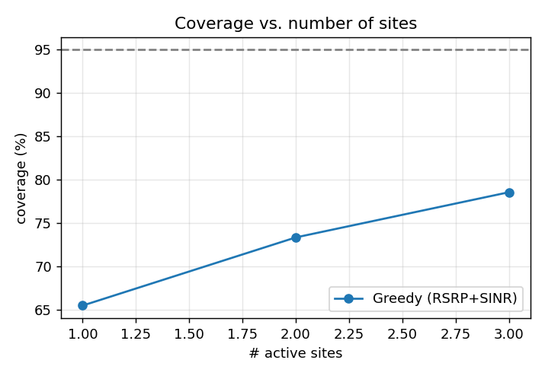
Figure 1. Coverage achieved as sites are added, greedy order [BS2, BS0, BS1].
Coverage with 1 site: 65.5%
Coverage with 2 sites: 73.3%
Coverage with all 3 sites: 78.5%
95% target reached: No — infeasible with the existing 3 sites
The ILP confirms this is not a search-quality problem: even its relaxed, easier RSRP-only version reports no feasible solution at a 95% target, because 78.5% is the ceiling this deployment can reach regardless of which sites are active. This is a genuine, quantified planning input: closing the gap to 95% coverage in this area requires new site locations, not re-tuning the existing three.
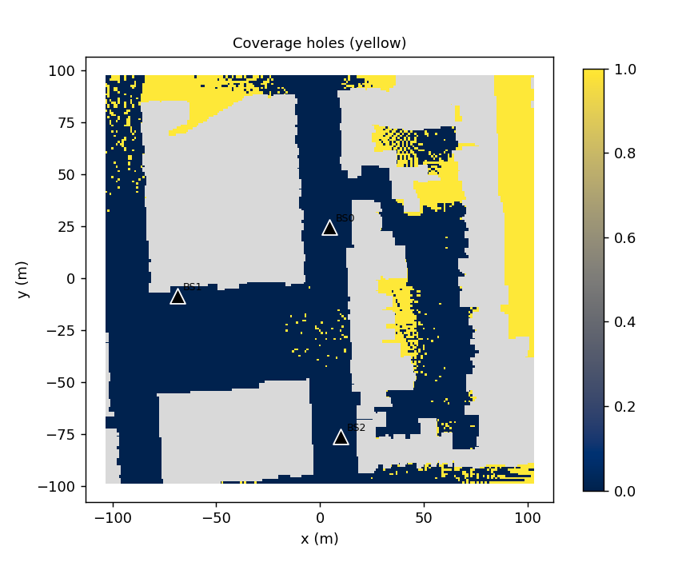
Figure 2. Coverage holes (yellow) with all 3 sites active — concentrated behind buildings and at map edges.

5. Module 2 — Outage Impact and Self-Healing
Question: what happens to coverage if a site fails, and can the surviving sites compensate automatically?
Each site was removed one at a time (an “N−1” analysis) to rank single points of failure, then a coordinate-ascent self-healing routine raised transmit power (0–3 dB headroom, a proxy for a real tilt/power SON action) on the neighboring sites that inherit the failed site’s users, optimizing for coverage with cell-edge throughput as a tie-breaker.
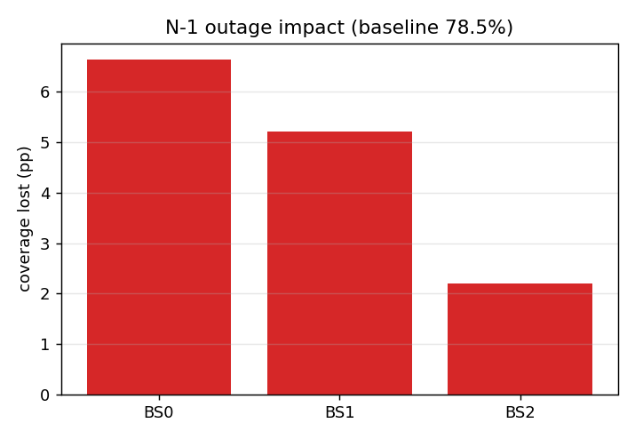
Figure 3. Coverage lost if each site fails alone. Baseline coverage: 78.5%.
Site | Coverage lost if it fails (pp) | Cell-edge (p5) throughput after failure
BS0 | 6.6 | 15.9 Mbps
BS1 | 5.2 | 0.0 Mbps
BS2 | 2.2 | 35.7 Mbps
BS0 is the critical site — its failure costs more than double BS2’s. BS1’s failure is notable for a different reason: cell-edge throughput collapses to 0 Mbps, meaning some users are left technically “covered” by a neighbor but below a usable data rate — a distinction that a coverage-only metric would miss.
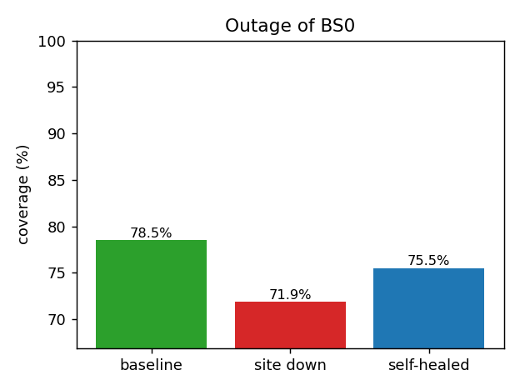
Figure 4. Coverage before failure, immediately after BS0 fails, and after self-healing.
Coverage recovered by self-healing: 3.6 of 6.6 percentage points lost (54%)
Sites that raised power to compensate: BS1, BS2 (+3 dB each)
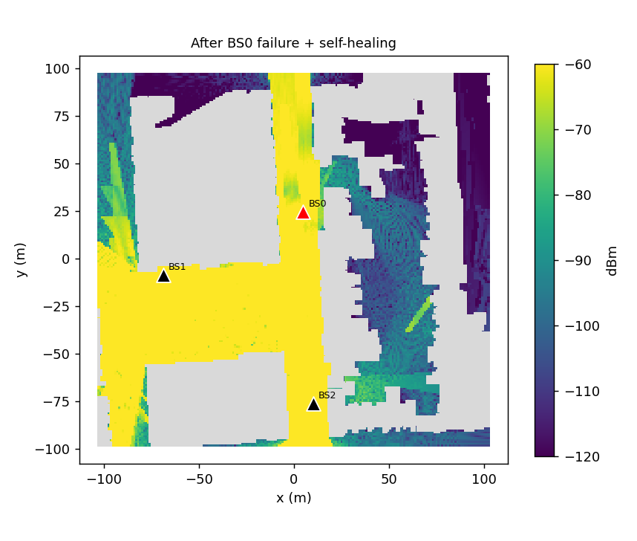
Figure 5. RSRP map after BS0 (red marker) fails and BS1/BS2 boost power to compensate.

6. Module 3 — Radio-Map Reconstruction from Sparse Measurements
Question: how accurately can the full coverage map be reconstructed from the limited samples a drive test or MDT campaign actually collects?
Four methods were compared at 1%, 2%, 5%, and 10% of locations sampled, under two sampling patterns: idealized random sampling, and realistic “route” sampling that clusters samples along simulated drive paths, as real drive tests do.
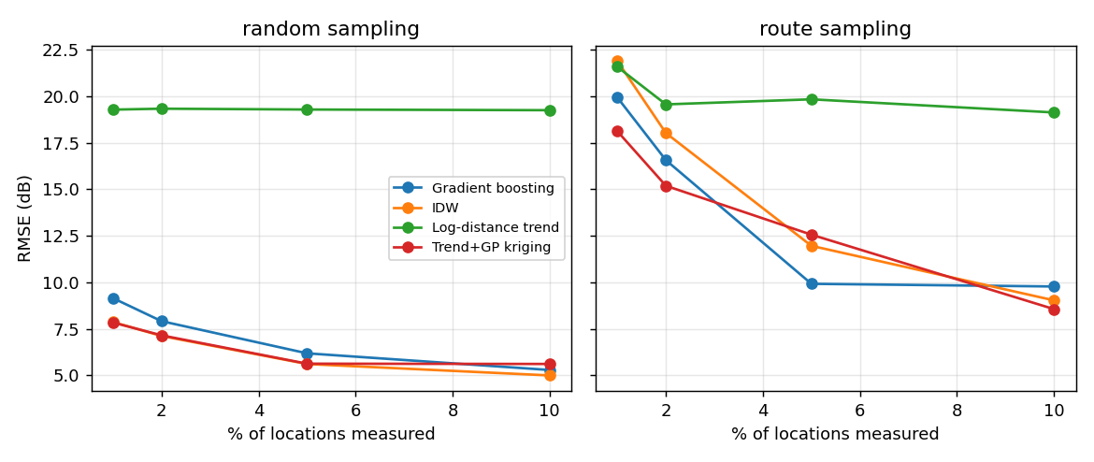
Figure 6. RMSE of reconstructed RSRP vs. percentage of locations measured, random (left) vs. route (right) sampling.
Method | RMSE at 5% — random | RMSE at 5% — route
Log-distance trend (baseline) | ≈19.3 dB | ≈19.7 dB
Inverse-distance weighting | ≈5.6 dB | ≈12.0 dB
Trend + Gaussian-process kriging | ≈5.6 dB | ≈12.6 dB
Gradient boosting | ≈6.2 dB | ≈10.0 dB
Two findings matter operationally. First, all three data-driven methods roughly halve the error of the naive distance-only baseline, confirming that even a small number of real measurements captures most of the spatial structure the ray-tracer produces. Second, sampling pattern matters as much as method choice: every method degrades under realistic route sampling versus idealized random sampling, and the method ranking changes — kriging’s advantage narrows because a Gaussian process leans on nearby points for interpolation, and route-clustered samples supply less independent spatial information per sample than random ones. Gradient boosting, which uses absolute position and distance-to-nearest-site as explicit features, degrades more gracefully under route sampling. This is a concrete argument for a route-planning improvement (spreading drive-test routes to maximize spatial independence) as much as a modeling one.

7. Module 4 — mmWave Beam Management
Question: how much can a position-aware ML model cut beam-sweep training overhead without sacrificing link quality?
A 64-beam DFT codebook was built for a 32-element array. Two beam-selection strategies were compared, both restricted to sweeping only k of the 64 beams: a geometric baseline that points at the user’s physical bearing (a line-of-sight assumption), and a random-forest classifier trained to predict the beam offset from that geometric guess using the user’s position and geometry, evaluated on map tiles the model never saw during training.
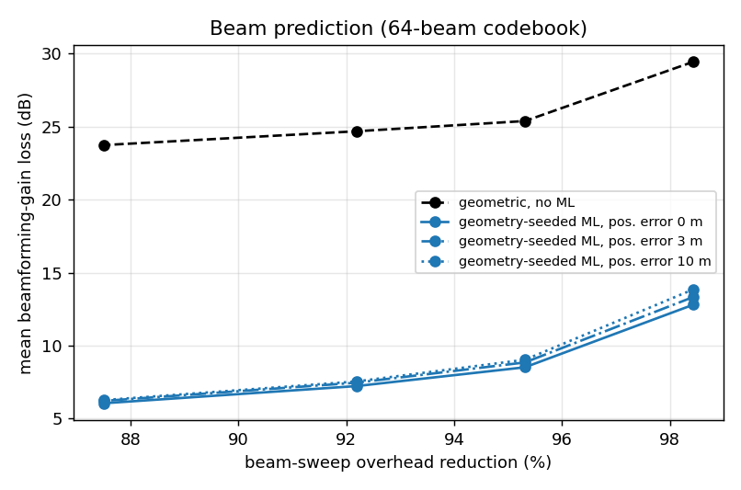
Figure 7. Mean beamforming-gain loss vs. beam-sweep overhead reduction, geometric baseline vs. ML.
Beams swept (of 64) | Overhead reduction | Geometric loss (dB) | ML loss (dB) | Improvement
1 | 98.4% | 29.4 | 12.8 | 16.6 dB
3 | 95.3% | 25.4 | 8.5 | 16.9 dB
5 | 92.2% | 24.7 | 7.2 | 17.5 dB
8 | 87.5% | 23.7 | 6.1 | 17.7 dB
The gap is large because this is a dense urban canyon: only 46.8% of users have a clear line of sight to their serving site, and a geometric assumption fails precisely for the NLoS majority. The ML model, trained on where beams actually perform best rather than where the user physically stands, recovers most of that loss. Top-1 beam accuracy is modest for both approaches (0.9% geometric, 15–43% ML depending on k), which is expected and unimportant on its own — real systems sweep a small candidate set rather than betting on one guess, which is exactly the top-k comparison shown here.

8. Module 5 — Handover Parameter Tuning
Question: what A3-event hysteresis and time-to-trigger settings minimize handover cost across user speeds?
200 users were simulated along randomized trajectories at two speeds (30 and 120 km/h) with a shared random seed across parameter settings for a fair, paired comparison. Cost combines handover rate, ping-pong rate (a heavily penalized handover reversed within 5 seconds), and radio-link-failure rate (SINR below −6 dB for over 1 second).
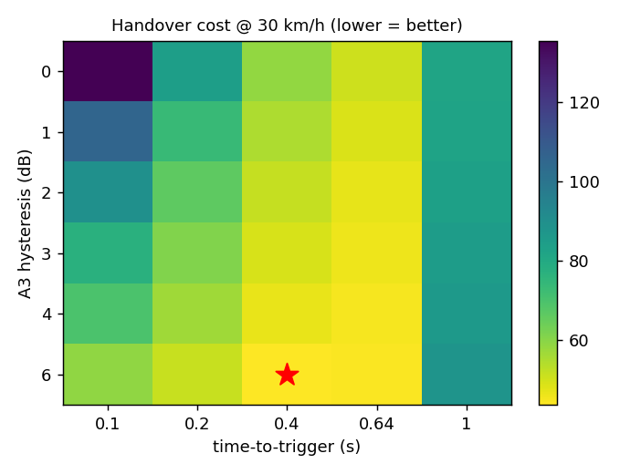  Figure 8a. Handover cost surface, 30 km/h. | 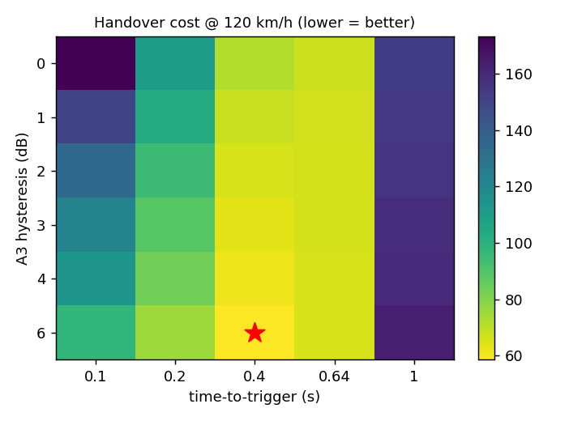  Figure 8b. Handover cost surface, 120 km/h.

Speed | Best hysteresis | Best TTT | HO/UE/min | Ping-pong/UE/min | RLF/UE/min
30 km/h | 6 dB | 0.4 s | 8.25 | 2.77 | 1.28
120 km/h | 6 dB | 0.4 s | 18.30 | 8.04 | 0.46
The optimal setting is stable across speeds, which simplifies real deployment — one configuration serves both pedestrian and vehicular users here. The failure mode is not stable, though: slow-moving users suffer nearly 3× the radio-link-failure rate of fast users, because they dwell longer inside the coverage holes visible in Figure 2, while fast users generate far more handovers and ping-pong events by simply crossing more cell boundaries per minute. A network tuned only by looking at aggregate handover counts would miss the slow-user RLF risk entirely.

9. Assumptions and Limitations
- Ray-traced data omits most clutter (parked vehicles, foliage, pedestrians, weather) and uses simplified building materials, so absolute dB and Mbps values should be treated as directional, not measured; relative comparisons between methods (this report’s main conclusions) are far more robust than any single absolute figure.
- All base stations are modeled as omnidirectional; real deployments use 3-sector patterns and electrical/mechanical tilt, which the outage “power headroom” proxy approximates only coarsely.
- Link-budget parameters (Table, Section 3.2) are engineering assumptions layered on top of DeepMIMO’s path loss, not measured values — they should be calibrated against real drive-test or MDT data before any number here is used for a live capital or configuration decision.
- With only 3 base stations, the site-selection and outage analyses have limited resolution (3 data points); a scenario with more sites would sharpen both the coverage curve and the outage ranking.
- Throughput uses an attenuated-Shannon approximation and is not load-aware (does not model queueing or scheduling across many simultaneous users).

10. Conclusions and Future Work
Across five modules built on one shared ray-traced dataset, the digital-twin approach produced concrete, defensible findings: a quantified coverage ceiling for the current site count, a ranked outage risk with a measurable self-healing benefit, a validated sparse-sampling strategy for coverage mapping, a large and explainable beam-management gain concentrated in non-line-of-sight users, and a stable handover configuration with a speed-dependent failure mode worth monitoring separately from raw handover counts.
Natural extensions include: modeling 3-sector antenna patterns and tilt explicitly; adding a second, higher-site-count scenario to strengthen the site-selection and outage analyses; comparing this C-band scenario against the same city’s mmWave (28 GHz) scenario to quantify the coverage/capacity trade-off directly; and calibrating the link-budget assumptions against real drive-test data from a live market.

Appendix A — Reference Maps
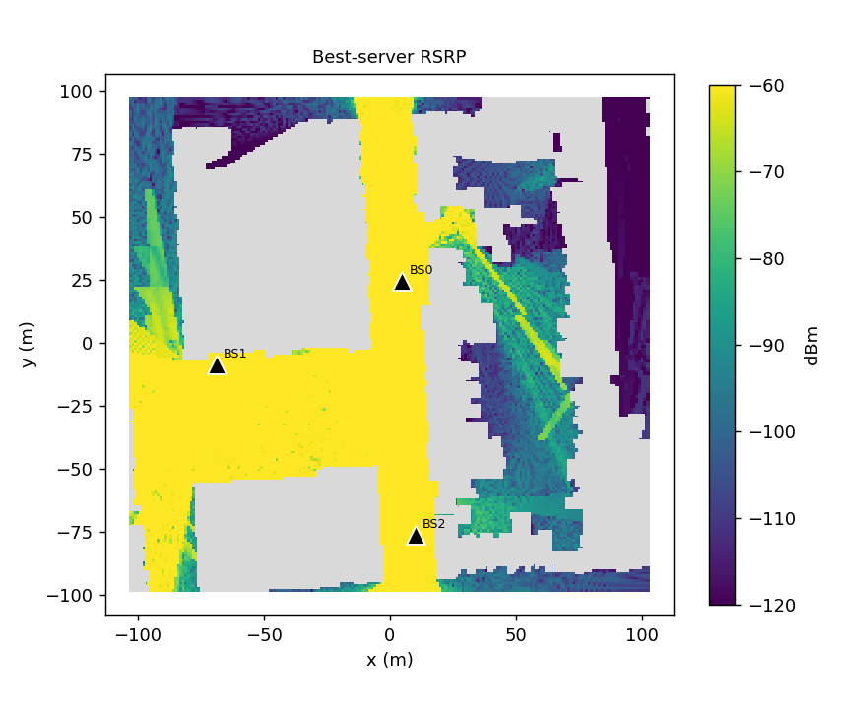
Figure A1. Best-server RSRP (dBm), all 3 sites active.
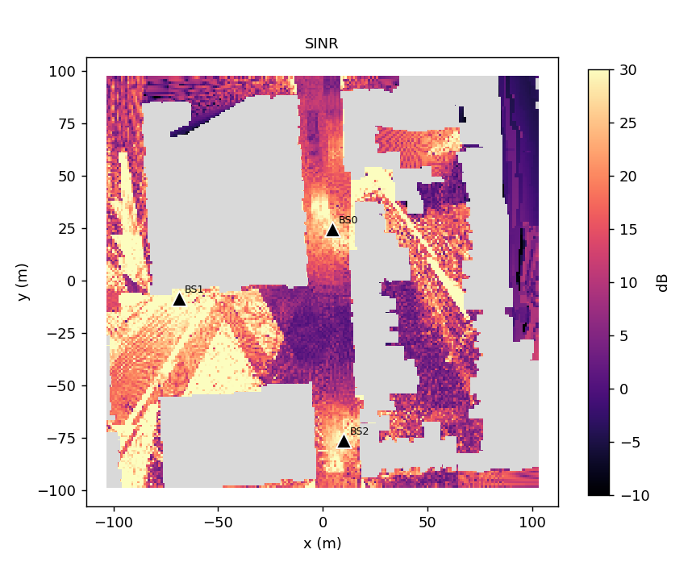
Figure A2. SINR (dB), all 3 sites active — diagonal streaks are ray-traced multipath reflections.
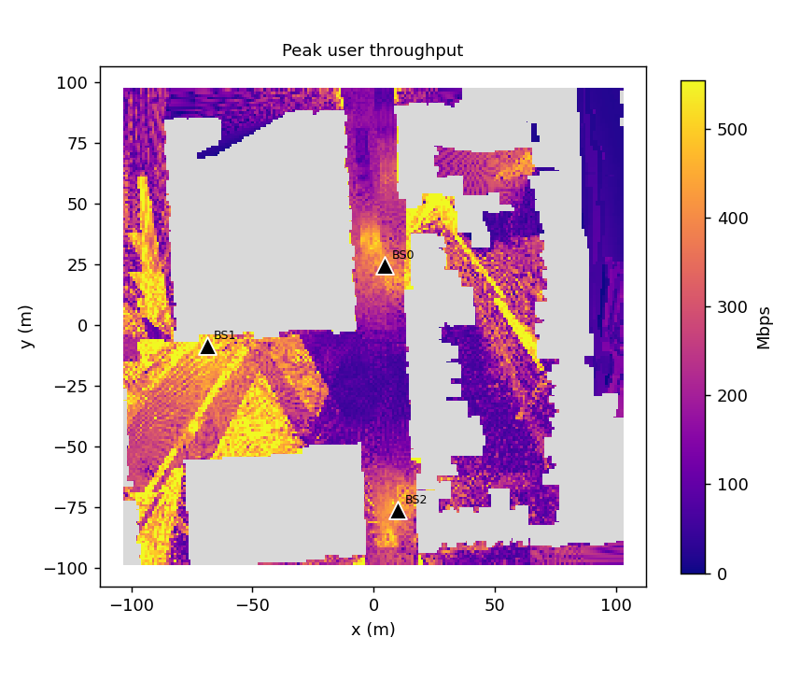
Figure A3. Estimated peak per-user throughput (Mbps), all 3 sites active.
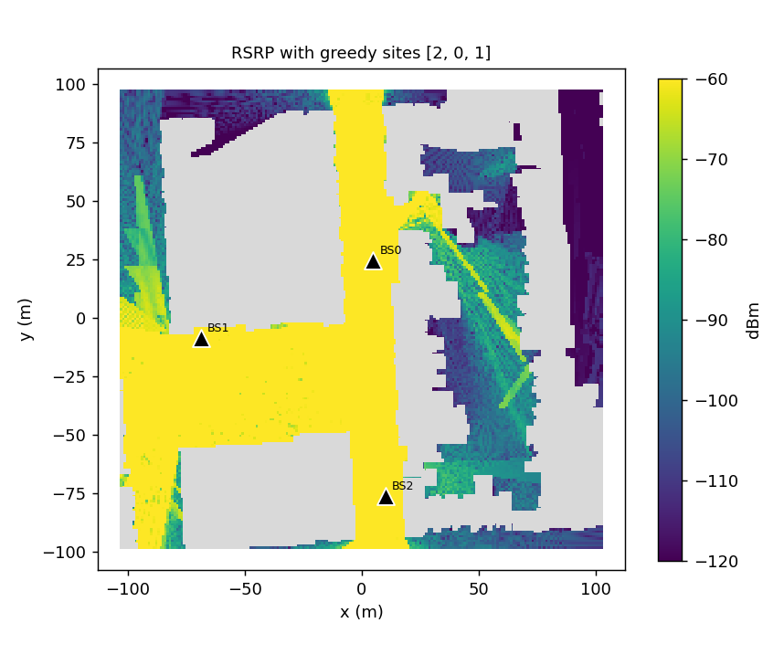
Figure A4. RSRP with the greedy site order [BS2, BS0, BS1] progressively activated.

