Week-1-2

# Program 1:

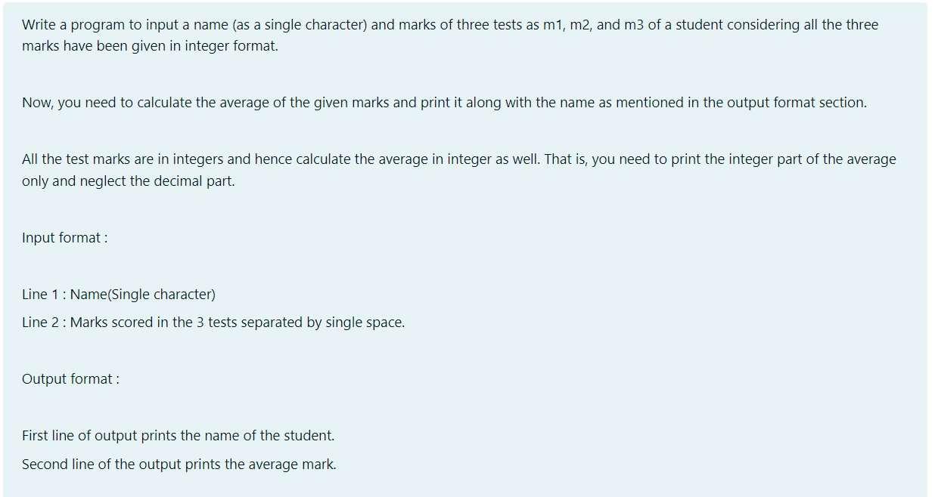

# Code:

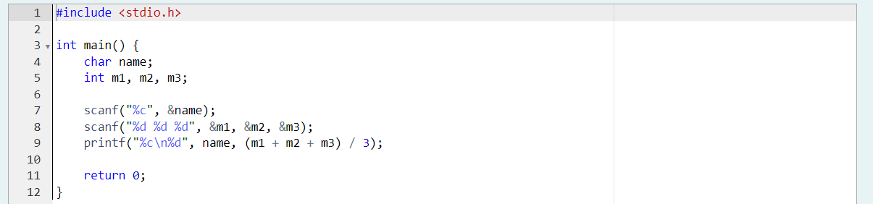

# Output:

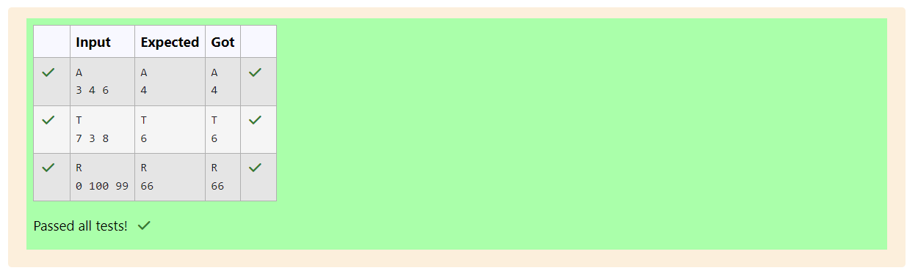

# Program 2:

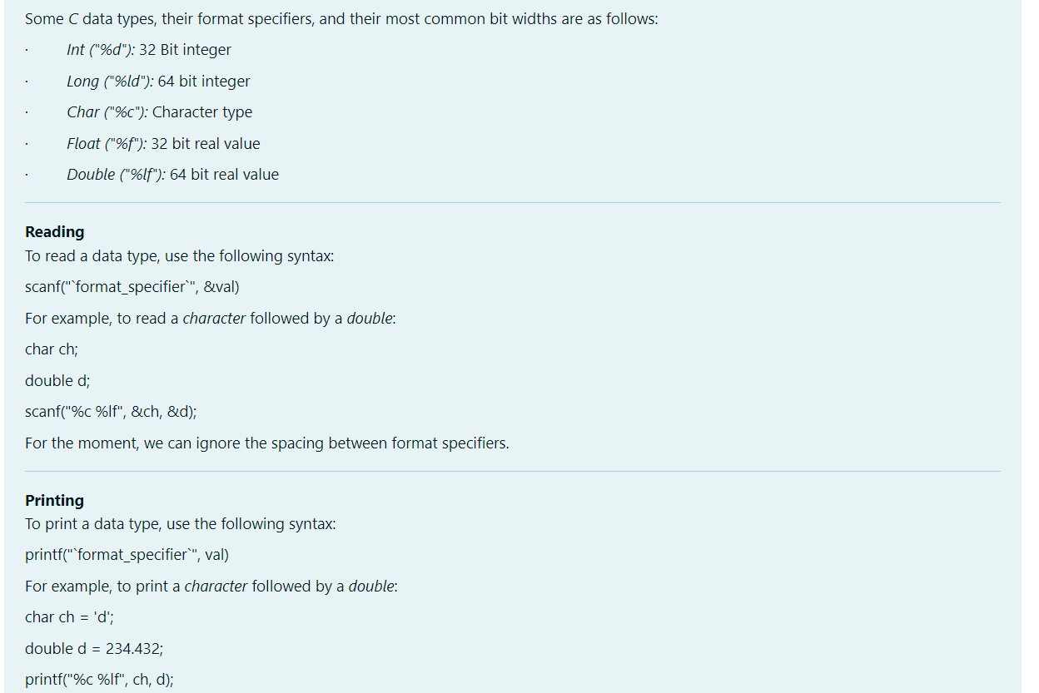 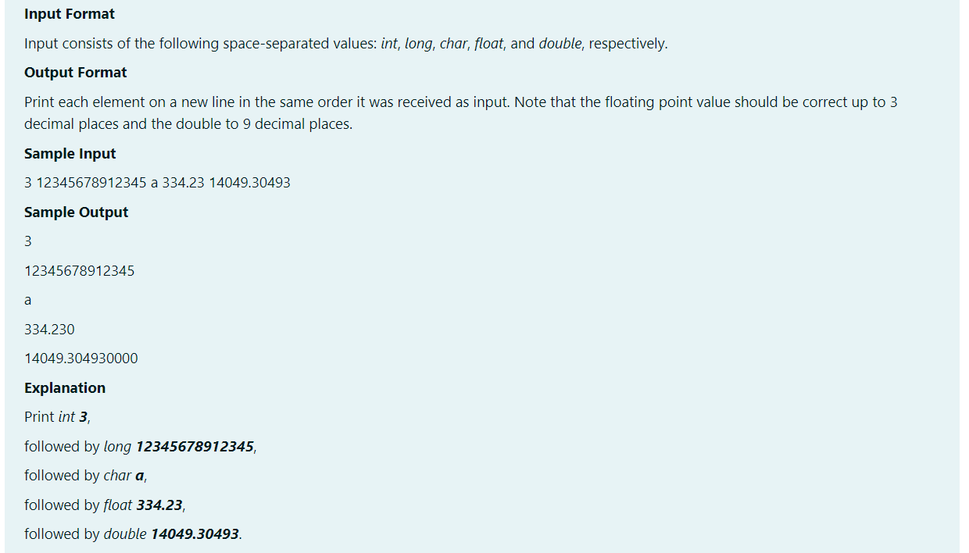

# Code:

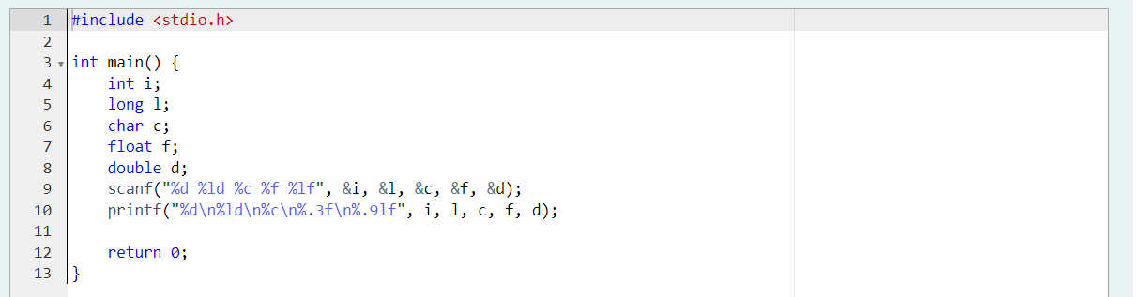

# Output:

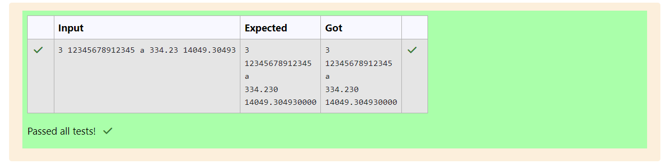

# Program 3:

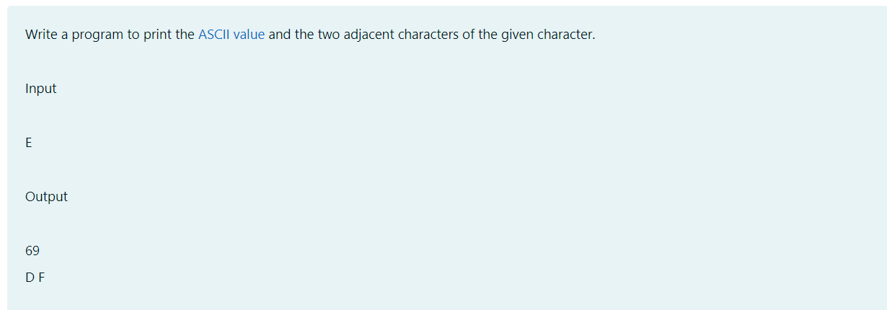

# Code:

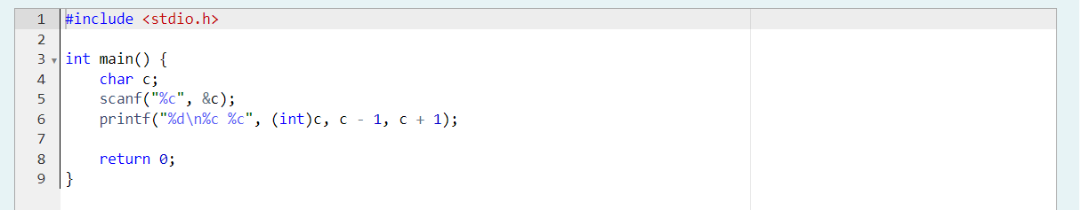

# Output:

