Tree Practice

Practice problems to build comfort with traversals

# THEORY

[*Striver Trees*](https://youtube.com/playlist?list=PLkjdNRgDmcc0Pom5erUBU4ZayeU9AyRRu&si=fHl6q3XciVZc3_9R)*.*

# TRAVERSALS

1. In-order (Left Root Right)

*void inorder(node) {*

*if (node == null) {*

*return*

*}*

*inorder(node->left)*

*print(node->data)*

*inorder(node->right)*

*}*

1. Pre-order (Root Left Right)

*void preorder(node) {*

*if (node == null) {*

*return*

*}*

*print(node->data)*

*preorder(node->left)*

*preorder(node->right)*

*}*

1. Post-order (Left Right Root)

*void postorder(node) {*

*if (node == null) {*

*return*

*}*

*postorder(node->left)*

*postorder(node->right)*

*print(node->data)*

*}*

# SEARCHES

1. Breadth first search (BFS) / Level Order

*q.append(root)*

*ans=[]*

*while q:*

*level = []*

*for i in range(len(q)):*

*node = q.popleft().val*

*if node is not None:*

*level.append(node.val)*

*q.append(node.left)*

*q.append(node.right)*

*if level != []:*

*ans.append(level)*

*return ans*

1. Depth first search (DFS)

# Q1. Perform traversals & searches [*https://youtu.be/jmy0LaGET1I?si=0fjBxLxEO0EDsD4Q*](https://youtu.be/jmy0LaGET1I?si=0fjBxLxEO0EDsD4Q)

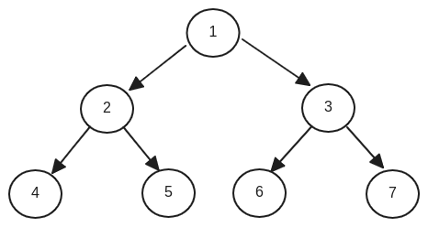

* In-Order: 4, 2, 5, 1, 6, 3, 7
* Pre-order: 1, 2, 4, 5, 3, 6, 7
* Post-order: 4, 5, 2, 6, 7, 3, 1
* BFS: 1, 2, 3, 4, 5, 6, 7
* DFS:

# Q2. Perform traversals & searches

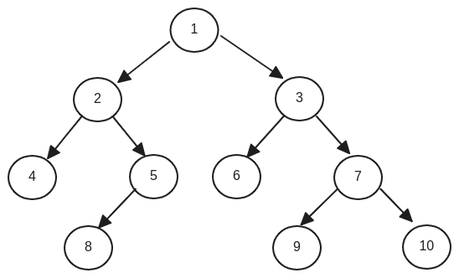

* In-Order: 4, 2, 8, 5, 1, 6, 3, 9, 7, 10
* Pre-order: 1, 2, 4, 5, 8, 3, 6, 7, 9, 10
* Post-order: 4, 8, 5, 2, 6, 9, 10, 7, 3, 1
* BFS: 1, 2, 3, 4, 5, 6, 7, 8, 9, 10
* DFS:

# Q3. Perform traversals & searches

[*https://youtu.be/RlUu72JrOCQ?si=j7aTtUhpCG9s-5Q0*](https://youtu.be/RlUu72JrOCQ?si=j7aTtUhpCG9s-5Q0)

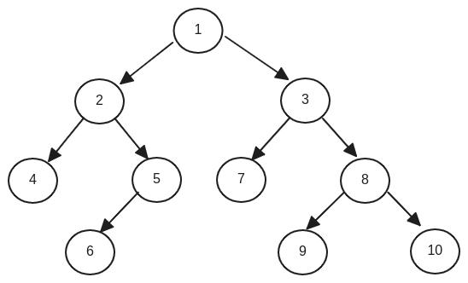

* In-Order: 4, 2, 6, 5, 1, 7, 3, 9, 8, 10
* Pre-order: 1, 2, 4, 5, 6, 3, 7, 8, 9, 10
* Post-order: 4, 6, 5, 2, 7, 9, 10, 8, 3, 1
* BFS: 1, 2, 3, 4, 5, 7, 8, 6, 9, 10
* DFS:

# 

# Q4. Perform traversals & searches

[*https://shraddhagupta60542.medium.com/tree-traversal-1cb49ff5b5ca*](https://shraddhagupta60542.medium.com/tree-traversal-1cb49ff5b5ca)

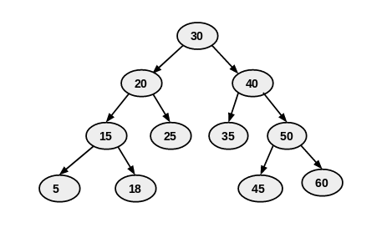

* In-Order: 5, 15, 18, 20, 25, 30, 35, 40, 45, 50, 60
* Pre-order: 30, 20, 15, 5, 18, 25, 40, 35, 50, 45, 60
* Post-order: 5, 18, 15, 25, 20, 35, 45, 60, 50, 40, 30
* BFS: 30, 20, 40, 15, 25, 35, 50, 5, 18, 45, 60
* DFS:

# Q5. Perform traversals & searches

[*https://en.wikipedia.org/wiki/Tree_traversal*](https://en.wikipedia.org/wiki/Tree_traversal)

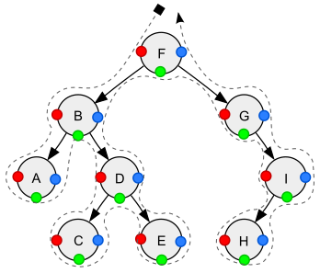

* In-Order: A, B, C, D, E, F, G, H, I
* Pre-order: F, B, A, D, C, E, G, I, H
* Post-order: A, C, E, D, B, H, I, G, F
* BFS: F, B, G, A, D, I, C, E, H
* DFS: