SIMATS ENGINEERING
ASSIGNMENT 1 REPORT
Design, Implement and Validate the Fare Logic of a City Metro Smart-Card System
Student Name | MITHRAN VISHAL M
Register Number | 192565051
Course | C++ Programming / OOP
Compiler | g++ (Debian 14.2.0-19), C++17
Build Flags | g++ -std=c++17 -Wall -Wextra -pedantic
Working report draft — personalize and verify before submission.

Verification and Submission Note
The assignment brief was read from the provided 13-page document. All 16 C++ source files in the accompanying repository compiled using g++ 14.2.0 with C++17. The Task 4 and Task 5 output predictions are recorded before the actual output in their task notes, and the executed output matched those predictions. Task 4 intentionally produces a signed/unsigned comparison warning to illustrate the conversion under discussion. Task 9 includes 13 executed test cases. Output preview PNGs are generated from captured standard output, not photographs of a student's own IDE. Replace/add genuine IDE screenshots if the instructor requires personal screenshots. This chat did not create a remote GitHub repository or submit anything to Google Classroom.

Compiler and execution commands
g++ -std=c++17 -Wall -Wextra -pedantic path/to/source.cpp -o program
./program
Compile each .cpp file independently. The repository README lists task folders, run steps, and progressive commit commands.

Task 1 — Problem and Object Analysis

Assumptions and rules
- Zone base fares are Inner = ₹10, Middle = ₹20, Outer = ₹30.
- Peak hours are [08:00, 10:00) and [17:00, 20:00): start is included, end is excluded. Thus 08:00 and 17:00 are peak; 10:00 and 20:00 are off-peak.
- A peak surcharge is 20% of the base fare. The current base fares produce whole-paise results.
- Money is stored as integer paise. A journey is permitted only when the remaining balance is at least 5,000 paise (₹50).
- Student/senior concessions are mentioned in the scenario but their rates are not specified; they must not be guessed. They are represented as a future policy requirement.

Objects, data and behaviour
Object | Data | Behaviour / justification
SmartCard | card ID, balance in paise | checks eligibility, deducts fare, rejects an invalid deduction; owns the balance invariant
Passenger | passenger ID, category (regular/student/senior) | supplies eligibility for a concession; category belongs to the person, not the journey
Journey | origin/destination or zone, hour, weekend flag | records what is being charged and when; supports audit and test reproduction
Zone | strongly typed zone value | identifies the fare band without magic numbers
FareTable / FarePolicy | base fares and surcharge/discount rules | centralizes pricing so one rule change does not require editing many functions

Procedural versus object-oriented style
A procedural design would use a balance variable and free functions such as calculateFare(zone, hour) and canTravel(balance, fare). An OOP design keeps state and operations together: SmartCard::canTravel checks the invariant and SmartCard::deduct changes the private balance only after validation. Both designs can run in O(1) time per journey and use O(1) state per card. The OOP design usually limits a fare-rule change to the policy/fare class; procedural code can also be clean, but shared globals and scattered rules increase the number of edit locations and the risk of inconsistent updates.

OOP principles in this system
- Encapsulation: SmartCard keeps balancePaise private and validates every deduction.
- Abstraction: callers ask fareFor(...) or canTravel(...) without needing the arithmetic details.
- Inheritance: Passenger could be a base type with StudentPassenger and SeniorPassenger variants if their policies differ; composition may be simpler if only a category flag is needed.
- Polymorphism: a ConcessionPolicy interface could let student and senior policies implement their own discount calculation.

Correctness rules
- A base fare is selected from one authoritative fare table.
- Peak time uses inclusive starts and exclusive ends: ((hour >= 8 && hour < 10) || (hour >= 17 && hour < 20)).
- Money arithmetic is in paise; do not use floating-point money for settlement.
- A journey is accepted only if balance - fare >= 5000.
- Invalid zones, hours outside 0–23 and negative recharges are rejected.
- A rejected journey must not change the balance.
- Each accepted fare and balance change is auditable.

Complexity
For a fixed three-zone table, fare calculation and balance validation are O(1) time. Stored card state is O(1) space per card. If journeys are processed as a batch of J journeys, total processing is O(J) time. Adding a new zone should change one central policy definition, not multiple duplicated fare literals.
classDiagram
class SmartCard {
-long long balancePaise
+canTravel(farePaise) bool
+deduct(farePaise) bool
+balance() long long
}
class Journey {
+Zone zone
+int hour
+bool weekend
}
class FarePolicy {
+fareFor(zone, hour, weekend) long long
+isPeakHour(hour) bool
}
class Passenger {
+string passengerId
+PassengerCategory category
}
class MonthlyPass {
-Zone firstZone
-Zone secondZone
+covers(zone) bool
}
SmartCard --> FarePolicy : requests fare validation
Journey --> FarePolicy : priced by
Passenger --> Journey : takes
MonthlyPass --> Passenger : assigned to
This is a design sketch rather than a generated UML-tool export. The SmartCard owns and protects balance state; FarePolicy owns fare rules; Journey records the trip facts; Passenger identifies concession eligibility; MonthlyPass is added in Task 12.

Task 2 — Tokens and Constants
- Keywords: int, return, enum, class, if.
- Identifiers: BASE_PAISE, PEAK_SURCHARGE_PERCENT, MIN_BALANCE_PAISE, Zone.
- Constants/literals: 1000, 2000, 3000, 20, 5000.
- Operators: =, ==, <<, ?:, +.
- Punctuators: {}, (), ;, ,, [].
#define is a preprocessor text substitution: it has no type or normal scope and can cause surprising substitutions. const prevents modification after initialization. constexpr requires a compile-time constant when possible and is suitable for fixed fare values. enum class Zone is scoped and does not implicitly convert to int, reducing accidental mixing of zone values and unrelated integers.
Identifier conventions: descriptive names, PascalCase for types (SmartCard, FarePolicy), camelCase for functions (calculateFare) and uppercase snake case for constants (MIN_BALANCE_PAISE). Avoid spaces, leading digits and C++ keywords.
Alternative using macros: #define INNER_FARE 1000 etc. It can compile to the same machine operations and does not inherently change runtime complexity, but macros lack type checking and scope. constexpr and enum class are safer and normally require no extra runtime storage for compile-time constants. Looking up a fixed-size fare is O(1) time either way.

Source files
- constants.cpp

Generated output preview
Rendered from captured standard output; replace with a genuine IDE screenshot if required.
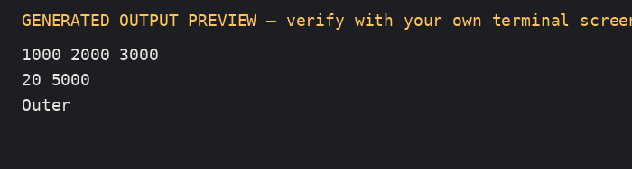

Task 3 — Data Types and Compatibility
Value | Recommended type | Reason
Fare/balance | `long long` paise | exact integer arithmetic and large totals
Hour | `int` | values 0–23
Zone | `enum class Zone` | readable, type-safe values
Journey count | `long long` | network-scale counts and totals
Valid/peak status | `bool` | true/false state
Single character | `char` | character data
Approximate measurement only | `double` | not for settlement money
Inferred local type | `auto` | only when the inferred type is clear

On the supplied g++/Linux environment, the program prints sizeof values at runtime; typical sizes are bool=1, char=1, int=4, long long=8, float=4, double=8 bytes, but sizeof output is the evidence for the actual compiler. INT_MAX is normally 2,147,483,647 and LLONG_MAX is much larger. Three million maximum peak fares total 3,000,000 × 3,600 = 10,800,000,000 paise, which exceeds a 32-bit signed int; use long long.
Money in integer paise avoids binary floating-point rounding. In mixed expressions, integer operands may be promoted or converted to a common type. For example, 7 / 2 is integer division and equals 3; assigning it to double afterward gives 3.0, not 3.5. 7.0 / 2 or static_cast<double>(7) / 2 gives 3.5. A bool used as an integer converts to 0 or 1.
The rounding demo intentionally adds 0.1 repeatedly to demonstrate floating-point representation error; the current metro fares (whole rupees and 20% surcharge) happen to be exactly representable, but future fractional fares may not be. Each addition is O(1) time and each accumulator is O(1) space.
On the verified run, 100,000 additions of 0.1 produced 10000.0000000188 instead of exactly 10000.0000000000: a difference of about 0.0000000188 rupees (about 0.00000188 paise). The integer-paise total was exactly 1,000,000 paise (₹10,000).

Source files
- rounding_demo.cpp
- types.cpp

Generated output preview
Rendered from captured standard output; replace with a genuine IDE screenshot if required.
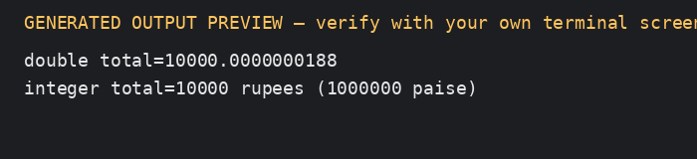

Task 4 — Implicit Conversions and Prediction

Prediction written before execution
3 3.5
C 68
1 true
s >= u

Actual output after compilation and execution
The actual output is the same as the prediction above.

Explanation
- a / b uses two int operands, so integer division yields 3 before conversion to double. The explicit cast makes the second division floating-point and yields 3.5.
- 'A' + 2 promotes the character to int, adds 2, then converts the result to char (C on the usual ASCII-compatible execution character set). In ch + 1, ch is promoted to int, producing 68.
- bool flag = 5 converts nonzero integer 5 to true. bool prints as 1 by default; after std::boolalpha, it prints true.
- In s < u, the signed int s is converted to unsigned because of the usual arithmetic conversions. -1 becomes a large unsigned value, so the comparison is false and the conditional expression prints s >= u.
Alternative: use explicit static_cast<double> for intentional floating-point division and brace initialization for values where narrowing must be rejected. Explicit casts do not materially change runtime complexity or storage, but they make conversion intent visible. Brace initialization such as int x{3.7}; is ill-formed and catches narrowing at compile time. Avoid comparing signed and unsigned values without validating their ranges.
The companion explicit_conversions.cpp demonstrates explicit casts. static_cast<double>(a) / b makes the numerator floating-point before division; static_cast<double>(a / b) intentionally preserves integer division first, so it prints 3.0 rather than 3.5. Brace initialization (int x{3.7};) is rejected at compile time because it narrows a double to int.

Source files
- explicit_conversions.cpp
- predict.cpp

Generated output preview
Rendered from captured standard output; replace with a genuine IDE screenshot if required.
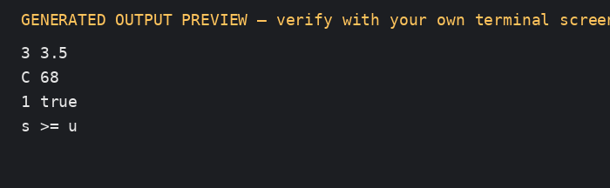

Task 5 — Operators and Prediction

Prediction written before execution
11 16
9 6 4
6 4
3 1 -3 -1
18

Actual output
The actual output matches the prediction.

Operator-by-operator explanation
- y * 2 is evaluated before addition, so 5 + 3 * 2 = 11. Parentheses force (5 + 3) * 2 = 16.
- x++ contributes the old value 5 and then increments x to 6. ++y increments y from 3 to 4 and contributes 4. Thus z = 5 + 4 = 9; x=6 and y=4.
- x > y is true, so the conditional operator chooses x=6. % and * have equal precedence and associate left-to-right: (6 % 4) * 2 = 4.
- Integer division truncates toward zero: 10/3=3 and -10/3=-3. The remainder keeps the dividend's sign: 10%3=1 and -10%3=-1.
- The loop adds i values 0, 3, 6, 9, giving k=18.
Peak-hour expression: (hour >= 8 && hour < 10) || (hour >= 17 && hour < 20). Parentheses improve readability; && binds more tightly than ||, so the unparenthesized form is equivalent. x++ uses the old value; ++x uses the incremented value. Avoid i = i++ because it is confusing and redundant; it was undefined before C++17, while C++17 sequencing rules define it. Prefer a separate i++ statement when incrementing is intended. For negative operands, / truncates toward zero and % is consistent with a == (a/b)*b + a%b.
Alternative: bool peak[24] gives O(1) lookup time and uses 24 bool elements (typically 24 bytes). The combined expression is also O(1) and uses no table storage; it may be preferable for only two intervals. A table is easier to maintain for many irregular schedules.
peak_table.cpp demonstrates the alternative lookup-table implementation. It initializes a 24-element boolean table and marks hours 8–9 and 17–19 as peak. The check is a single O(1) array lookup, at the cost of 24 bool elements (typically 24 bytes).

Source files
- peak_table.cpp
- predict.cpp

Generated output preview
Rendered from captured standard output; replace with a genuine IDE screenshot if required.
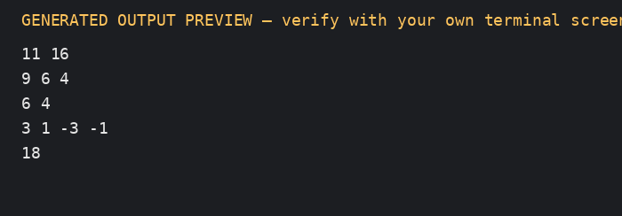

Task 6 — Control Structures and Fare Code
ALGORITHM CalculateFare(zone, peak)
CASE zone OF
Inner: baseFare <- 1000
Middle: baseFare <- 2000
Outer: baseFare <- 3000
OTHERWISE: reject invalid zone
END CASE
IF peak THEN
baseFare <- baseFare + (baseFare * 20 DIV 100)
END IF
RETURN baseFare
END ALGORITHM
ALGORITHM CanTravel(balance, fare)
RETURN (balance - fare >= 5000)
END ALGORITHM
The switch is readable for a small closed set of zones. if is suitable for surcharge and balance checks; ?: is suitable only for a short expression. A counted for loop fits a known list/array of trips; range-based for is clean when iterating over a container; while is appropriate when input continues until a sentinel or until valid input is received. break exits a switch case or stops a search; continue skips an invalid journey when processing a batch. A switch without a matching case and without default does not execute a case; for safety, validate enum values or add a default rejection.
Boundary rule: hour 8 and 17 are peak; hour 10 and 20 are off-peak. The included program prints these boundary results after the required sample journeys.
The switch statement selects the zone's base fare, an if applies the peak surcharge, and another if checks the minimum remaining balance. A for loop is appropriate for the known trip array; a range-based for makes iteration concise. A while loop is more suitable for retrying input until valid. break ends a switch case; continue can skip an invalid trip in a batch. If a switch receives a value with no matching case and no default, no case body runs, so production code should validate the zone or reject the default case.
Peak rule: ((hour >= 8 && hour < 10) || (hour >= 17 && hour < 20)). The start times 8 and 17 are peak, while 10 and 20 are off-peak. The program tests exactly these four values.
Alternative: a constexpr long long FARE[] = {1000, 2000, 3000} indexed by a validated zone value replaces the switch. Both switch and array lookup are O(1) time. The table uses three fare values of storage (typically 24 bytes for three long long values), while a compiler may implement a dense switch as a jump table. Adding a fourth zone requires one more enum value and fare entry; a switch requires another case. The table reduces duplicated mapping code but relies on enum ordering matching table indices, so tests should cover every zone.
fare_array.cpp is the compact array-lookup alternative. The index must be validated before lookup in production code; the sample only uses valid enum values.

Source files
- fare_array.cpp
- fare_todo.cpp

Generated output preview
Rendered from captured standard output; replace with a genuine IDE screenshot if required.
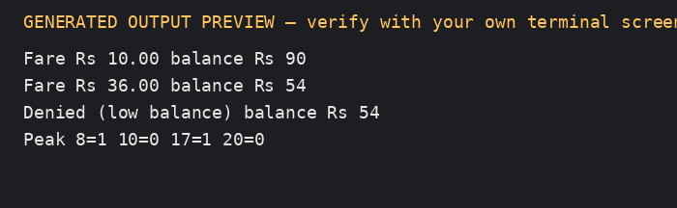

Task 7 — Procedural and OOP Versions
Both examples calculate and validate a fare. The procedural version passes balance and fare into free functions; the OOP version encapsulates the balance and exposes canTravel, deduct, and a read-only balance accessor. The class prevents negative/too-low balances because the only state-changing operation checks the rule before subtracting. A public balance member would let unrelated code assign a negative value or bypass the ₹50 minimum. Time and space remain O(1) per journey in either version. A minimum-balance change should be made once in MIN_BALANCE/MIN_BALANCE_PAISE; encapsulation helps ensure all deductions use the same validation.

Source files
- oop.cpp
- procedural.cpp

Generated output preview
Rendered from captured standard output; replace with a genuine IDE screenshot if required.
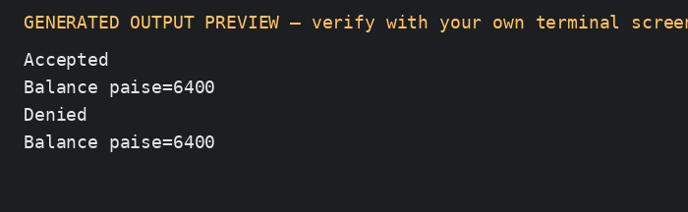

Task 8 — Safe Input and Output
The program checks each extraction using if (cin >> value). On failure it prints an error, calls cin.clear() to reset the stream's fail state, and cin.ignore(max, '\n') to discard the invalid line before retrying. It validates zone and hour ranges before calculating a fare. Fare is stored in paise; output formats the whole-rupee and two-digit paise parts with setw(2) and setfill('0').
Alternative: getline reads a full line, then stoi inside try/catch converts it. Parsing a line of length L is O(L) time and O(L) buffer space. Stream extraction is also linear in consumed input and generally uses a small stream buffer; getline/stoi makes whole-line validation easier, while cin >> is convenient for token-based input. Invalid input must always be consumed to avoid repeatedly failing on the same characters.
getline_parse.cpp demonstrates the alternative whole-line parser. stoi throws on malformed input; the code also checks that the entire line was consumed and validates the 0–23 range.

Source files
- getline_parse.cpp
- safe_io.cpp

Generated output preview
Rendered from captured standard output; replace with a genuine IDE screenshot if required.
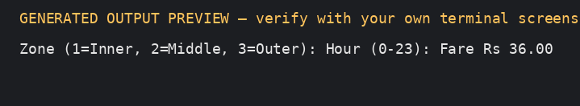

Task 9 — Implementation and Test Evidence
The executable input format is: initial_balance_paise recharge_paise zone_number hour. Zone 1=Inner, 2=Middle, 3=Outer. Use recharge 0 for ordinary fare tests.
Test | Input | Expected result | Purpose
Inner off-peak | `10000 0 1 12` | fare 1000; balance 9000 | normal zone
Inner peak | `10000 0 1 8` | fare 1200; balance 8800 | Inner surcharge
Middle off-peak | `10000 0 2 12` | fare 2000; balance 8000 | normal zone
Middle peak | `10000 0 2 8` | fare 2400; balance 7600 | peak start included
Outer off-peak | `10000 0 3 12` | fare 3000; balance 7000 | normal zone
Outer peak | `10000 0 3 17` | fare 3600; balance 6400 | peak start included
10 AM off-peak | `10000 0 1 10` | fare 1000; balance 9000 | end of morning peak excluded
8 PM off-peak | `10000 0 3 20` | fare 3000; balance 7000 | end of evening peak excluded
Leaves exactly ₹50 | `6000 0 1 12` | fare 1000; balance 5000 | allowed boundary
Below minimum after fare | `5999 0 1 12` | denied | does not deduct
Unknown zone | `10000 0 4 12` | invalid zone or hour | reject invalid zone
Negative recharge | `10000 -100 1 12` | invalid recharge | reject negative recharge
Letters for hour | `10000 0 1 x` | invalid input | stream failure is detected

For a five-journey hand calculation with initial balance ₹200, assume zones/hours: Inner 12 (₹10), Middle 8 (₹24), Outer 20 (₹30), Inner 17 (₹12), Middle 12 (₹20). Total fare = ₹10+₹24+₹30+₹12+₹20 = ₹96; remaining balance = ₹104. This five-journey sum is a hand calculation; the single-journey executable is used to test each rule independently.
A table-driven test loop can store each input and expected result and iterate through t cases: O(t) time and O(t) space for the test table. Adding a boundary case is then a new row rather than a new hand-written conditional.

Verified actual outputs
Inner off-peak
Input: 10000 0 1 12
Output: Fare paise=1000
Balance paise=9000
Exit code: 0
Inner peak
Input: 10000 0 1 8
Output: Fare paise=1200
Balance paise=8800
Exit code: 0
Middle off-peak
Input: 10000 0 2 12
Output: Fare paise=2000
Balance paise=8000
Exit code: 0
Middle peak
Input: 10000 0 2 8
Output: Fare paise=2400
Balance paise=7600
Exit code: 0
Outer off-peak
Input: 10000 0 3 12
Output: Fare paise=3000
Balance paise=7000
Exit code: 0
Outer peak
Input: 10000 0 3 17
Output: Fare paise=3600
Balance paise=6400
Exit code: 0
10 AM off-peak
Input: 10000 0 1 10
Output: Fare paise=1000
Balance paise=9000
Exit code: 0
8 PM off-peak
Input: 10000 0 3 20
Output: Fare paise=3000
Balance paise=7000
Exit code: 0
exactly Rs 50 remains
Input: 6000 0 1 12
Output: Fare paise=1000
Balance paise=5000
Exit code: 0
below Rs 50 denied
Input: 5999 0 1 12
Output: Denied (low balance)
Exit code: 0
unknown zone
Input: 10000 0 4 12
Output: Invalid zone or hour
Exit code: 0
negative recharge
Input: 10000 -100 1 12
Output: Invalid recharge
Exit code: 0
nonnumeric hour
Input: 10000 0 1 x
Output: Invalid input
Exit code: 0

Source files
- fare_system.cpp

Generated output preview
Rendered from captured standard output; replace with a genuine IDE screenshot if required.
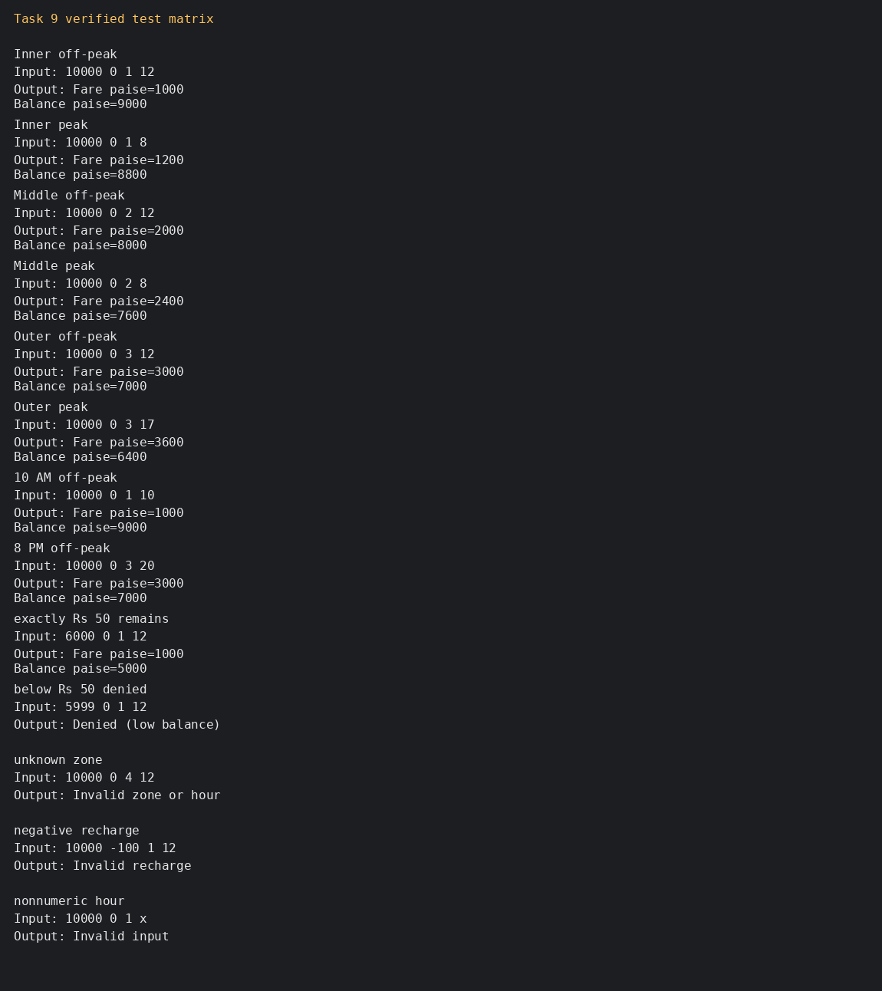

Task 10 — Expectations versus Execution
For a controlled comparison, the code uses the maximum current fare of 3,600 paise (₹36) for every journey. Because 36.0 and the resulting integer rupee totals are exactly representable at these magnitudes, the double rupee total and integer-paise total agree for these specific inputs:
Journeys | Exact total paise | Exact total rupees | Fits signed 32-bit `int` in paise?
20,000 | 72,000,000 | ₹720,000 | Yes
500,000 | 1,800,000,000 | ₹18,000,000 | Yes (below INT_MAX, narrowly)
3,000,000 | 10,800,000,000 | ₹108,000,000 | No

A signed 32-bit int accumulator would overflow for the third case; signed overflow is undefined behaviour, so do not rely on a particular wrapped result. long long safely stores the exact paise total. double is wide enough for these totals and the chosen whole-rupee fares, but other fractional fare values can accumulate rounding error. A separate repeated-addition experiment in Task 3 demonstrates that risk. Each addition is O(1) time; each accumulator is O(1) space (typically 4 bytes for int, 8 for long long/double on this compiler). Compile with -Wall -Wextra; warnings should be reviewed rather than ignored.

Source files
- totals.cpp

Generated output preview
Rendered from captured standard output; replace with a genuine IDE screenshot if required.
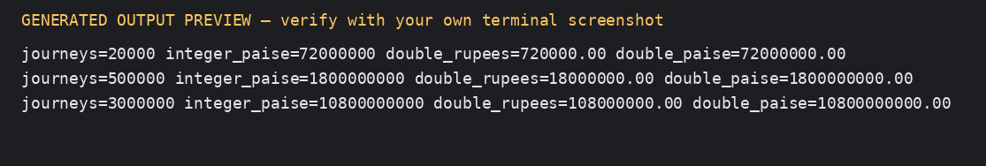

Task 11 — Final Design Recommendation
Recommend a hybrid object-oriented design: enum class Zone, one centralized compile-time fare table, integer paise stored in long long, an explicit isPeakHour function, a FarePolicy/fareFor function, and a SmartCard class with a private balance and validated canTravel/deduct methods. This gives exact settlement arithmetic and keeps the ₹50 minimum-balance invariant in one place.
A fare revision changes one fare table entry or policy constant, followed by regression tests. The current design is O(1) time per journey and O(1) per-card state; processing J journeys is O(J). Limitations: the initial three-zone design does not include concession rates because the assignment does not specify them; it also assumes hourly granularity rather than minute-level timestamps, and compile-time fares require rebuilding/redeploying after a fare revision.
For a larger network or frequent policy updates, reading a validated configuration file at startup is a reasonable next step. Reading z fare values takes O(z) startup time and O(z) memory, and avoids recompiling for each fare update. The program must reject missing, negative or malformed values and should version/audit the configuration. For only three fixed fares, constexpr values are simpler and safer.
Evidence basis: Task 6's sample execution demonstrates exact ₹10.00 and ₹36.00 fares and refusal when a fare would leave less than ₹50. Task 9's test matrix checks time boundaries and the exact minimum-balance boundary. Task 10's calculation shows why long long is needed for network-scale paise totals.

Task 12 — Revised Design Challenge

A. Impact analysis
- Add Airport to enum class Zone and add ₹60 = 6,000 paise to the fare table.
- Update every switch/table that maps a zone to a fare; a table reduces the number of separate case edits.
- Add a weekend input/flag and a separate discount rule.
- Add MonthlyPass to record two covered zones and answer whether a journey is covered.
- Keep SmartCard balance private and keep the minimum-balance check centralized.

B. Evaluate the original design
The original three-case switch can be extended with an Airport case, but every switch must be updated and an omitted case can silently fall through if no default is present. A four-entry table makes the fare data easier to review and is O(1) lookup. The original SmartCard balance/deduction invariant still works, but the fare policy needs a weekend flag and a pass decision before charging.

C. Revised design and explicit assumption
The program uses a four-entry array and a MonthlyPass class that covers two chosen zones. Assumption: when a journey is covered by the monthly pass, its fare is zero; the balance remains unchanged. For a weekend journey, the 10% discount takes precedence and the 20% peak surcharge is not applied. Therefore Airport weekday peak = 6,000 + 20% = 7,200 paise (₹72.00), while Airport weekend = 6,000 × 90% = 5,400 paise (₹54.00), even if the hour is peak. This precedence is explicit to avoid combining discounts.

D. Evidence-based defence
The revised implementation centralizes fares in one table, makes the new zone a single enum value, and separates pass coverage from fare calculation. Table lookup and pass coverage are O(1); per-card state remains O(1). The trade-off is that table ordering must match enum values, so the mapping needs tests. A configuration file would be more flexible for frequent fare changes but adds parsing, validation and startup complexity.

Source files
- revised_design.cpp

Generated output preview
Rendered from captured standard output; replace with a genuine IDE screenshot if required.
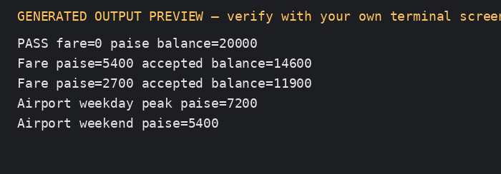

Final Submission Checklist
- Replace student name, register number, and GitHub URL placeholders.
- Read and understand the code; be ready to explain or modify it in the viva.
- Compile and execute all C++ files on your own system.
- Add genuine IDE/terminal screenshots if required by the faculty.
- Create the repository named DSA01-<RegisterNumber>-Assignment1.
- Commit progressively, with at least one commit per task.
- Push the repository, verify the link, and add faculty as collaborator if private.
- Submit the repository URL and final report through Google Classroom.

