Sine; Cosine; Tangent

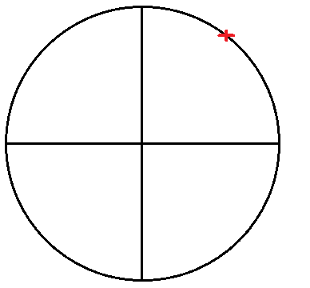
Suppose you want to know to label the red spot.

#1: Traversing the circle.
How much do you need to traverse the circle to reach that spot? This approach only requires 1 value t. Starting from the horizontal axis, measure how far, t, along the circle you have to travel.

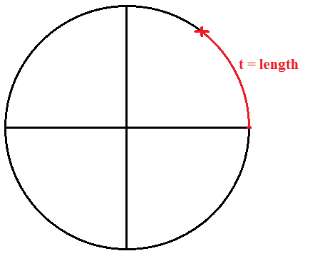

#2: cos(t) and sin(t)
Starting from the center, measure how far to the right (cos) and then up (sin) you have to go.
This approach requires 2 value.
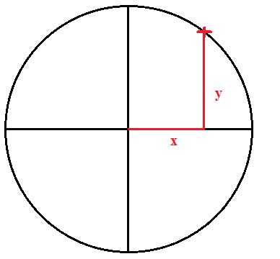

Since both methods #1 and #2 contain measures on how to label the same spot, both measures contain basically the same information. There is some relationship between the value from method #1 and the values from method #2.

Suppose you have labeled this red spot using method #1. Since there is a relationship between the values of both approaches, you can obtain the values from method #2 using the value you got via method #1.

How? Well, the aforementioned relationship is caught in the functions cos(t) and sin(t).
t = distance

sin(t):
Sine
How much you would need to go to the top from the center to reach a spot.

cos(t):
How much you would need to go to the right from the center to reach a spot.
Fun fact: The “co” in cosine comes from the word “complementary”

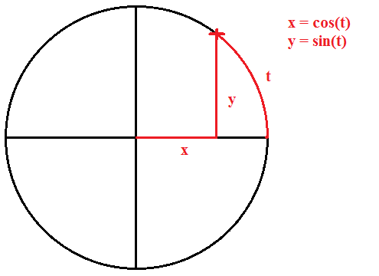

If you have sin(t) and cos(t), you can calculate the following values:

tan(t) = sin(t)/cos(t)
sec(t) = 1/cos(t)
csc(t) = 1/sin(t)
cot(t) = cos(t)/sin(t)
Extra #1
Suppose you have a circle with a radius (i.e. line from center to circle line) of 1. And also suppose that you want to use the sin(t) and cos(t) method. Then you actually draw a triangle with the following shape:
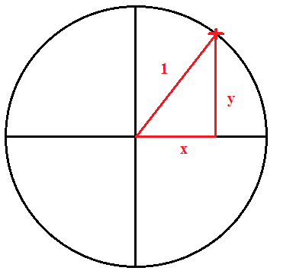

Here, the diagonal line is called the “hypotenuse” (i.e. longest side of a right triangle). Suppose you did not know the radius of the circle (i.e. the hypotenuse in this example; diagonal line), but you did have the lengths of both sides x and y, then you could have used Pythagorean theorem to find out the circle’s radius:

cos² (t) + sin² (t) = hypotenuse²

Suppose you have nothing, except the knowledge that the circle radius is 1. Then you can derive the cos(t) and sin(t) by using the Pythagorean theorem as well.

cos² (t) + sin² (t) = 1

Extra #2
pi (3.14..) is the number you get when you divide the distance AROUND the circle (i.e. circumference) by the distance ACROSS the circle (i.e. diameter; 2 * radius).
pi = circumference / diameter

This also means that:

pi = circumference / diameter
circumference = pi * diameter
diameter = circumference / pi

The entire circumference of our circle is thus pi * 2. In other words, if you want to know only the circumference of half the circle, you do pi * 1 = pi. If you want to know it for only a quarter of the circle, you do pi * 0.5 = pi / 2.

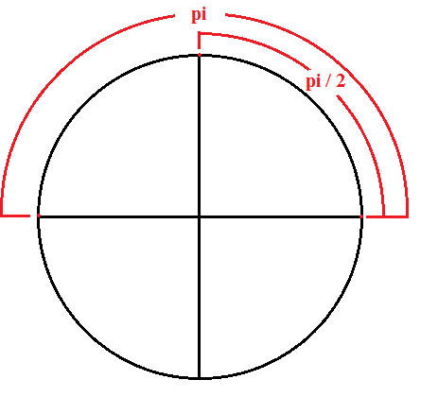

Extra #3
Tangent is the ratio between sin(t) and cosin(t)

