**Map Function:-**

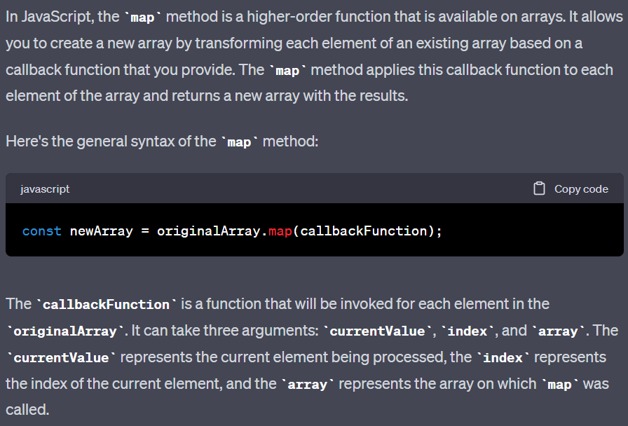

**Filter Function:-**

**Reduce Function:-**

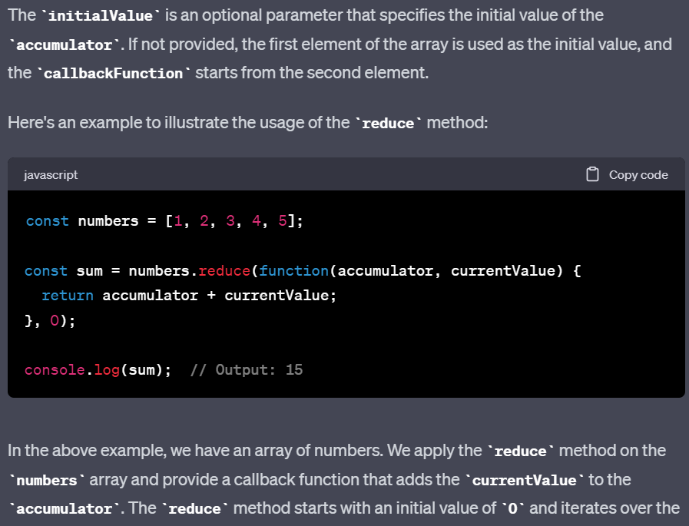

**States**

