CREATION OF VARIOUS CORRELATION COEFFICIENT FUNCTIONS IN PYTHON

SOURCE CODE
- ​Plot the correlation plot on dataset and visualize an overview of relationships among data (Iris)
Property | Program | Output
Read the data | import pandas as pd  df = pd.read_csv("Iris.csv") | Id SepalLengthCm SepalWidthCm \  0 1 5.1 3.5
Read the data | print(df.head()) | 1 2 4.9 3.0
Read the data | print(df.shape) | 2 3 4.7 3.2
Read the data | print(df.isnull().sum()) | 3 4 4.6 3.1
Read the data |  | 4 5 5.0 3.6
Read the data |  | PetalLengthCm PetalWidthCm Species
Read the data |  | 0 1.4 0.2 Iris-setosa
Read the data |  | 1 1.4 0.2 Iris-setosa
Read the data |  | 2 1.3 0.2 Iris-setosa
Read the data |  | 3 1.5 0.2 Iris-setosa
Read the data |  | 4 1.4 0.2 Iris-setosa
Read the data |  | (150, 6)
Read the data |  | Id 0
Read the data |  | SepalLengthCm 0
Read the data |  | SepalWidthCm 0
Read the data |  | PetalLengthCm 0
Read the data |  | PetalWidthCm 0
Read the data |  | Species 0
Read the data |  | dtype: int64
Unique species and | data = df.drop_duplicates(subset="Species") | Id SepalLengthCm SepalWidthCm \
counts | print(data)  print(df.value_counts("Species")) | 0 1 5.1 3.5  50 51 7.0 3.2
 |  | 100 101 6.3 3.3
 |  | PetalLengthCm PetalWidthCm \
 |  | 0 1.4 0.2
 |  | 50 4.7 1.4
 |  | 100 6.0 2.5
 |  | Species
 |  | 0 Iris-setosa
 |  | 50 Iris-versicolor
 |  | 100 Iris-virginica
 |  | Species
 |  | Iris-setosa 50
 |  | Iris-versicolor 50
 |  | Iris-virginica 50
 |  | Name: count, dtype: int64
Count plot of | import seaborn as sns
Species | import matplotlib.pyplot as plt  sns.countplot(x='Species', data=df)
 | plt.show()
 | 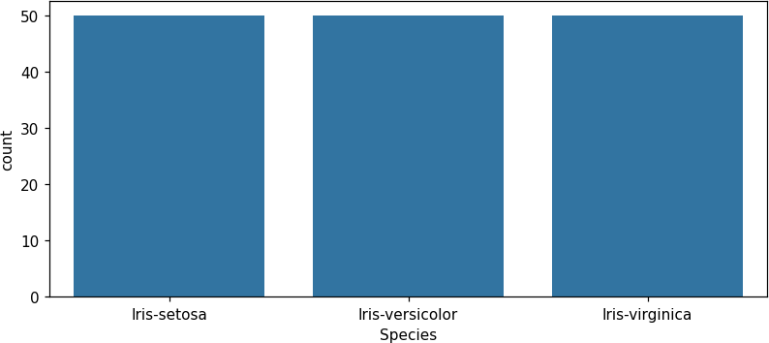

Property | Program | Output
Pair plot to show relationships between the variables | sns.pairplot(df.drop(columns='Id'), hue='Species', height=2.2)  plt.show() | 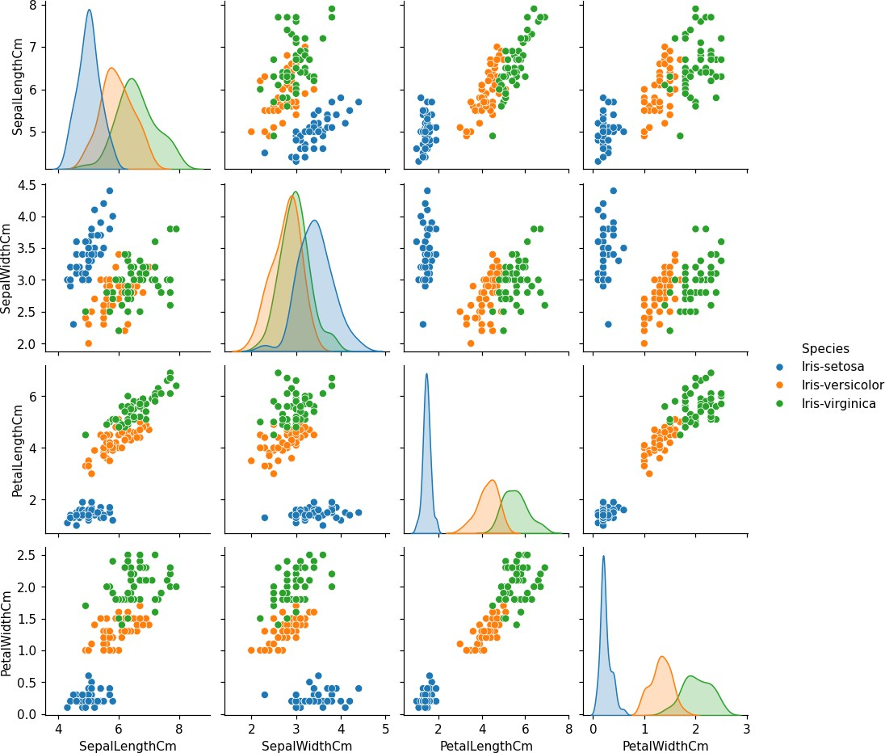
- ​Find the correlation matrix

Property | Program | Output
Pearson correlation matrix with dataframe.corr() | num = df.select_dtypes('number') print(num.corr(method='pearson')) | Id SepalLengthCm \  Id 1.000000 0.716676  SepalLengthCm 0.716676 1.000000  SepalWidthCm -0.402301 -0.117570  PetalLengthCm 0.882637 0.871754  PetalWidthCm 0.900027 0.817941
Pearson correlation matrix with dataframe.corr() |  | SepalWidthCm PetalLengthCm \  Id -0.402301 0.882637  SepalLengthCm -0.117570 0.871754  SepalWidthCm 1.000000 -0.428440  PetalLengthCm -0.428440 1.000000  PetalWidthCm -0.366126 0.962865
Pearson correlation matrix with dataframe.corr() |  | PetalWidthCm  Id 0.900027  SepalLengthCm 0.817941  SepalWidthCm -0.366126  PetalLengthCm 0.962865  PetalWidthCm 1.000000
Heatmap of the correlation matrix | corr = num.corr() plt.figure(figsize=(6, 4.5))  sns.heatmap(corr, annot=True, cmap='coolwarm', xticklabels=corr.columns.values, yticklabels=corr.columns.values)  plt.title("Correlation matrix (Pearson)") plt.show() | 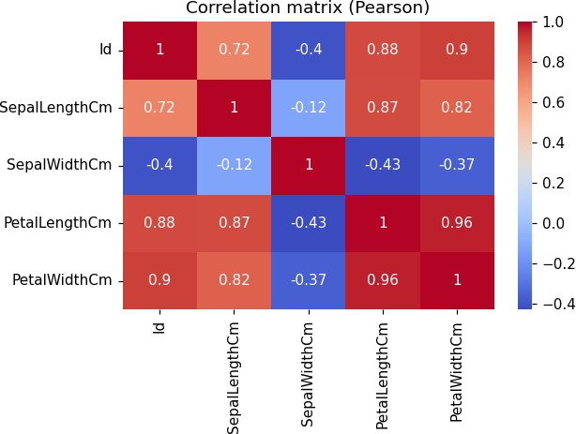
Property | Program | Output
Other correlation coefficient functions: Spearman and Kendall | print("Spearman:") print(num.drop(columns='Id').corr(method='spearma  n').round(3)) print("Kendall:")  print(num.drop(columns='Id').corr(method='kendall ').round(3))  from scipy.stats import pearsonr  r, p = pearsonr(df['PetalLengthCm'], df['PetalWidthCm'])  print("pearsonr(PetalLengthCm, PetalWidthCm) =  %.4f, p-value = %.3g" % (r, p)) | Spearman:  SepalLengthCm SepalWidthCm \  SepalLengthCm 1.000 -0.167  SepalWidthCm -0.167 1.000  PetalLengthCm 0.882 -0.310  PetalWidthCm 0.834 -0.289
PetalLengthCm PetalWidthCm
SepalLengthCm 0.882 0.834
SepalWidthCm -0.310 -0.289
PetalLengthCm 1.000 0.938
PetalWidthCm 0.938 1.000
Kendall:
SepalLengthCm SepalWidthCm \
SepalLengthCm 1.000 -0.077
SepalWidthCm -0.077 1.000
PetalLengthCm 0.719 -0.186

Property | Program | Output
PetalWidthCm 0.655 -0.157

PetalLengthCm PetalWidthCm
SepalLengthCm 0.719 0.655
SepalWidthCm -0.186 -0.157
PetalLengthCm 1.000 0.807
PetalWidthCm 0.807 1.000
pearsonr(PetalLengthCm, PetalWidthCm) = 0.9629, p-value = 4.68e-86
- ​Analysis of variance (ANOVA), when data have categorical variables - Iris

Property | Program | Output
Mean sepal width per species and one-way ANOVA | from scipy.stats import f_oneway print(df['SepalWidthCm'].groupby(df['Species']).m  ean())  groups = [g['SepalWidthCm'].values for _, g in df.groupby('Species')]  f, p = f_oneway(*groups)  print("F-statistic = %.3f, p-value = %.3g" % (f, p))  print(df.drop(columns='Species').mean()) | Species  Iris-setosa 3.428  Iris-versicolor 2.770  Iris-virginica 2.974  Name: SepalWidthCm, dtype: float64  F-statistic = 49.160, p-value = 4.49e-17 Id 75.500000  SepalLengthCm 5.843333  SepalWidthCm 3.057333  PetalLengthCm 3.758000  PetalWidthCm 1.199333 dtype: float64
Box plot of sepal width by species | sns.boxplot(x='Species', y='SepalWidthCm', data=df)  plt.title("Sepal width by species") plt.show()
 | 