DATA VISUALIZATION USING MATPLOTLIB

SOURCE CODE
Line Plot

Property | Program | Output
Line plot of Age and Marks per student | import pandas as pd  import matplotlib.pyplot as plt plt.rcParams["figure.figsize"] = [7.50, 3.50] plt.rcParams["figure.autolayout"] = True headers = ['Name', 'Age', 'Marks']  df = pd.read_csv('student.csv', names=headers) df.set_index('Name').plot()  plt.show()
 | 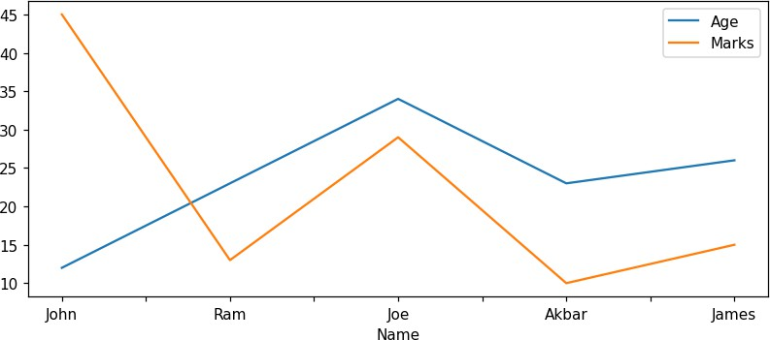
Bar Plots

Property | Program | Output
Bar plot of students | import matplotlib.pyplot as plt
over the years | import pandas as pd  data = pd.read_csv('data.csv')
 | df = pd.DataFrame(data)
 | X = list(df.iloc[:, 0])
 | Y = list(df.iloc[:, 1])
 | plt.bar(X, Y, color='g')
 | plt.title("Students over 11 Years")
 | plt.xlabel("Years")
 | plt.ylabel("Number of Students")
 | plt.show()
 | 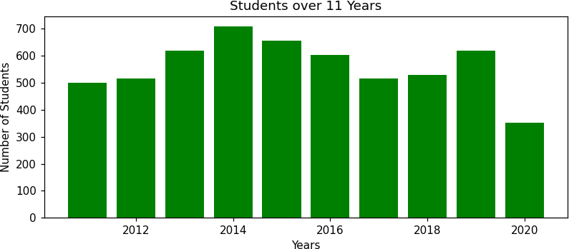
Histograms

Property | Program | Output
Histograms of every | import pandas as pd |  | Pregnancies Glucose BloodPressure \
column of the diabetes data | data = pd.read_csv("diabetes.csv")  print(data.head()) data.hist(figsize=(10, 10), bins=10) | 0  1  2 | 6 148.0 72.0  1 85.0 66.0  6 117.0 86.0
 | plt.show() | 3 | 1 120.0 0.0
 |  | 4 | 1 177.0 63.0
 |  |  | SkinThickness Insulin BMI \
 |  | 0 | 35.0 0.0 33.6
 |  | 1 | 29.0 0.0 26.6
 |  | 2 | 32.0 0.0 29.0
 |  | 3 | 0.0 0.0 32.6
 |  | 4 | 0.0 0.0 36.6
 |  |  | DiabetesPedigreeFunction Age Outcome
 |  | 0 | 0.627 50 1
 |  | 1 | 0.351 31 0
 |  | 2 | 0.173 38 0
 |  | 3 | 0.612 64 0
 |  | 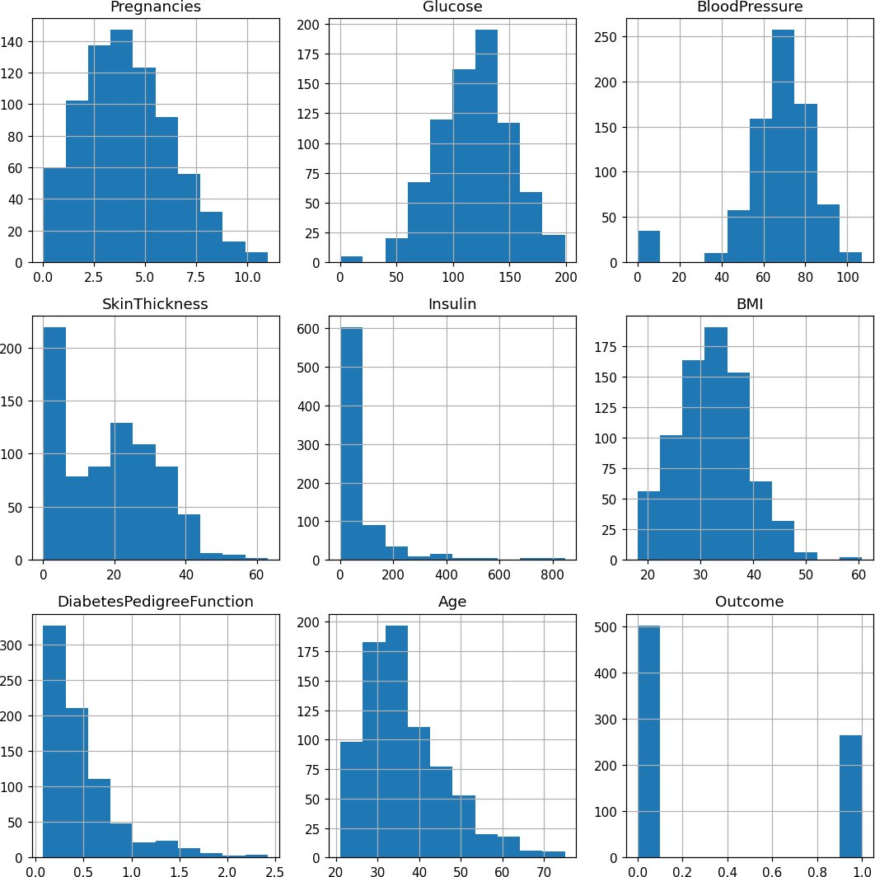  4 | 0.618 39 1
Density Plots

Property | Program | Output
Density plot of the Age attribute | import pandas as pd  import matplotlib.pyplot as plt  dataFrame = pd.read_csv("Cricketers2.csv") dataFrame.Age.plot.density(color='green') plt.title('Density plot = Age')  plt.show()
 | 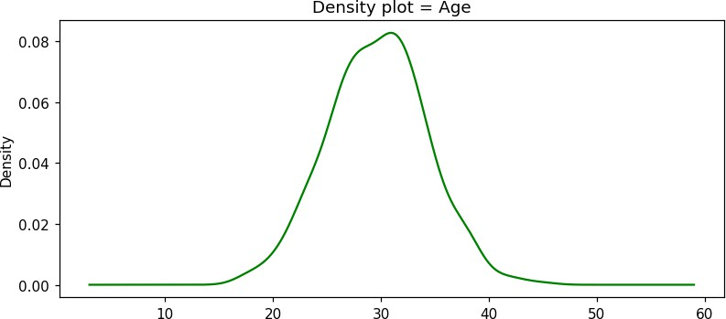
Scatter Plots

Property | Program | Output
Scatter plot of tree locations (Latitude vs Longitude) | import pandas as pd  df = pd.read_csv('Street_Tree_List.csv', parse_dates=['PlantDate'])  df['PlantYears'] = (pd.to_datetime('today') - df['PlantDate']) / pd.Timedelta(days=365)  df['qSpecies'] = df['qSpecies'].apply(lambda x: x.split(" ")[0])  df = df[['Latitude', 'Longitude', 'PlantYears', 'qSpecies']]  df.dropna(subset=['PlantYears', 'Latitude'], inplace=True)  print(df.head()) df.plot.scatter(x='Longitude', y='Latitude',  ylim=(37.69, 37.82))  plt.show() | 0  4  5 | Latitude 37.736095  37.809313  37.757899 | Longitude  -122.407330  -122.480785  -122.432066 | PlantYears 18.260656  30.252437  11.764766 | \
Scatter plot of tree locations (Latitude vs Longitude) |  | 6 | 37.788809 | -122.431533 | 26.296272 | \
Scatter plot of tree locations (Latitude vs Longitude) |  | 7 | 37.754161 | -122.373572 | 38.241478 | \
Scatter plot of tree locations (Latitude vs Longitude) |  |  | qSpecies |  |  | \
Scatter plot of tree locations (Latitude vs Longitude) |  | 0 | Platanus |  |  | \
Scatter plot of tree locations (Latitude vs Longitude) |  | 4 | Eriobotrya |  |  | \
Scatter plot of tree locations (Latitude vs Longitude) |  | 5 | Platanus |  |  | \
Scatter plot of tree locations (Latitude vs Longitude) |  | 6 | Prunus |  |  | \
Scatter plot of tree locations (Latitude vs Longitude) |  | 7 | Platanus |  |  | \
 | 