IMPLEMENTATION OF LOGISTIC REGRESSION MODEL FOR GIVEN DATA

SOURCE CODE
Load and explore the data

Property | Program | Output
Read the dataset | import pandas as pd import numpy as np | <class 'pandas.DataFrame'> admit gre gpa rank
Read the dataset | import matplotlib.pyplot as plt | 0 0 600 3.33 3
Read the dataset | dataset = pd.read_csv("binary.csv") | 1 0 400 2.95 2
Read the dataset | print(type(dataset)) | 2 0 500 3.82 2
Read the dataset | print(dataset.head()) | 3 0 720 3.29 4
Read the dataset | print(dataset.shape) | 4 0 440 3.26 3
Read the dataset | print(dataset.info()) | (400, 4)
Read the dataset | print(dataset.count()) | <class 'pandas.DataFrame'>
Read the dataset | print(dataset.columns) | RangeIndex: 400 entries, 0 to 399
Read the dataset |  | Data columns (total 4 columns):
Read the dataset |  | # Column Non-Null Count Dtype
Read the dataset |  | 0 admit 400 non-null int64
Read the dataset |  | 1 gre 400 non-null int64
Read the dataset |  | 2 gpa 400 non-null float64
Read the dataset |  | 3 rank 400 non-null int64
Read the dataset |  | dtypes: float64(1), int64(3)
Read the dataset |  | memory usage: 12.6 KB
Read the dataset |  | None
Read the dataset |  | admit 400
Read the dataset |  | gre 400
Read the dataset |  | gpa 400
Read the dataset |  | rank 400
Read the dataset |  | dtype: int64
Read the dataset |  | Index(['admit', 'gre', 'gpa', 'rank'],
Read the dataset |  | dtype='str')
Distribution of GRE scores and GPA grades | import seaborn as sns sns.set(style="white", context="talk")  f, (ax1, ax2) = plt.subplots(1, 2, figsize=(10, 6))  sns.histplot(dataset.iloc[:, 1], kde=True, stat="density", ax=ax1, color="r") sns.histplot(dataset.iloc[:, 2], kde=True, stat="density", ax=ax2, color="g")  plt.tight_layout() plt.show()
 | 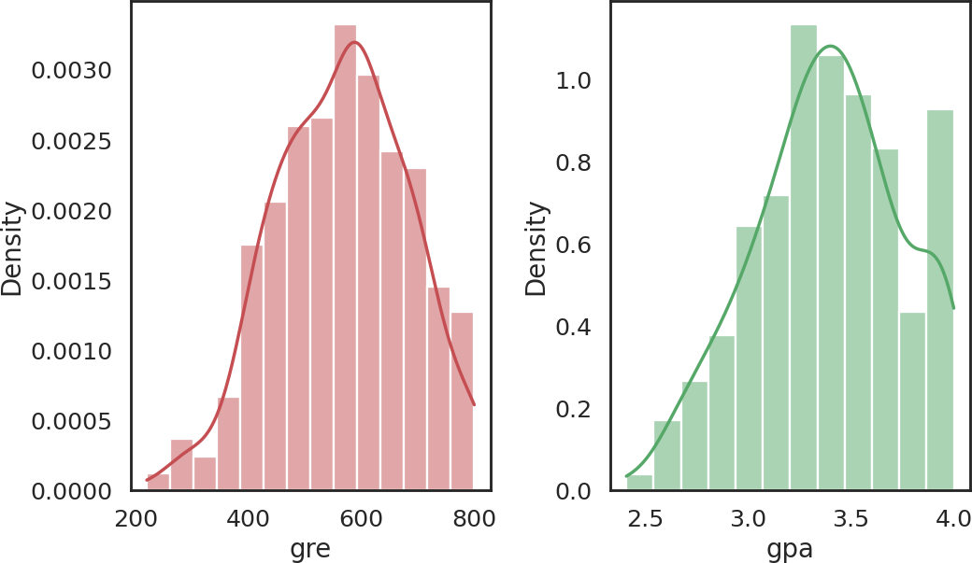
Property | Program | Output
Multivariate analysis | sns.pairplot(dataset, hue='admit', palette="husl", x_vars=["gre", "gpa", "rank"], y_vars=["gre", "gpa", "rank"], height=2.5)  plt.show()

Property | Program | Output
 |  | 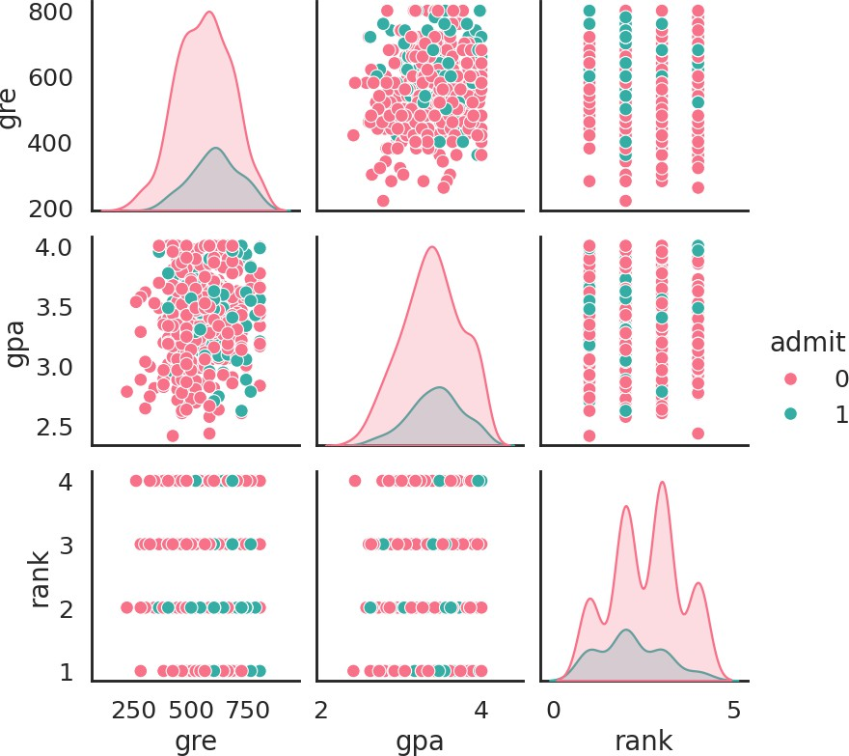
Split the data and compare models

Property | Program | Output
Training / testing split | from sklearn.model_selection import train_test_split  dataArray = dataset.values  X = dataArray[:, 1:4] y = dataArray[:, 0] validation_size = 0.10  seed = 9  X_train, X_test, Y_train, Y_test = train_test_split(X, y, test_size=validation_size, random_state=seed)  print(X_train.shape) print(X_test.shape) print(Y_train.shape) print(Y_test.shape) | (360, 3)  (40, 3)  (360,)  (40,)
Prepare the models | from sklearn.model_selection import KFold, | LR: 0.800000 (0.080316)
and evaluate each with 10-fold cross validation | cross_val_score  from sklearn.linear_model import LogisticRegression  from sklearn.discriminant_analysis import | LDA: 0.800000 (0.080316)  KNN: 0.769444 (0.079592)  CART: 0.702778 (0.072489)  RF: 0.736111 (0.062423)
 | LinearDiscriminantAnalysis | NB: 0.788889 (0.075768)
 | from sklearn.neighbors import | SVM: 0.791667 (0.079786)
 | KNeighborsClassifier
 | from sklearn.tree import DecisionTreeClassifier
 | from sklearn.ensemble import
 | RandomForestClassifier
 | from sklearn.naive_bayes import GaussianNB
 | from sklearn.svm import SVC
 | num_trees = 200
 | max_features = 3
 | models = []
 | models.append(('LR', LogisticRegression()))
 | models.append(('LDA',
 | LinearDiscriminantAnalysis()))
 | models.append(('KNN', KNeighborsClassifier()))
 | models.append(('CART', DecisionTreeClassifier()))
 | models.append(('RF',
 | RandomForestClassifier(n_estimators=num_trees
 | , max_features=max_features)))
 | models.append(('NB', GaussianNB()))
 | models.append(('SVM', SVC()))
 | results = []
 | names = []
 | scoring = 'accuracy'
 | for name, model in models:
 | kfold = KFold(n_splits=10, shuffle=True,
 | random_state=7)
 | cv_results = cross_val_score(model, X_train,
 | Y_train, cv=kfold, scoring=scoring)
 | results.append(cv_results)
 | names.append(name)
 | print("%s: %f (%f)" % (name,
 | cv_results.mean(), cv_results.std()))

Property | Program | Output
Box plots for machine learning algorithm comparison | fig = plt.figure()  fig.suptitle('Machine Learning algorithms comparison')  ax = fig.add_subplot(111) plt.boxplot(results) ax.set_xticklabels(names) plt.show()
 | 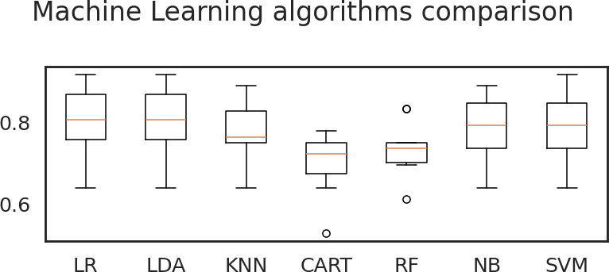
Logistic Regression model

Property | Program | Output
Create, fit and | from sklearn.metrics import accuracy_score, classification_report, confusion_matrix  model = LogisticRegression() model.fit(X_train, Y_train) predictions = model.predict(X_test) print("Model --> Logistic Regression") print("Overall Accuracy:  {}".format(accuracy_score(Y_test, predictions) * 100))  print(classification_report(Y_test, predictions)) | Model --> Logistic Regression
evaluate the model |  | Overall Accuracy: 80.0  precision recall f1-score
 |  | support
 |  | 0.0 0.80 1.00 0.89
 |  | 32
 |  | 1.0 0.00 0.00 0.00
 |  | 8
 |  | accuracy 0.80
 |  | 40
 |  | macro avg 0.40 0.50 0.44
 |  | 40
 |  | weighted avg 0.64 0.80 0.71
 |  | 40
Confusion matrix heatmap | cm = confusion_matrix(Y_test, predictions) plt.figure(figsize=(4, 3.5)) sns.heatmap(cm, annot=True, fmt='d',  xticklabels=['reject', 'admit'], yticklabels=['reject', 'admit'])  plt.xlabel("Predicted"); plt.ylabel("Actual") plt.show() | 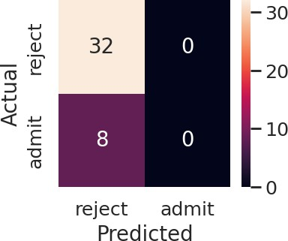
Property | Program | Output
Make predictions on new data - (gre_score, gpa_grade, rank) | new_data = [(720, 4, 1), (300, 2, 1), (400, 4,  4)]  new_array = np.asarray(new_data) labels = ["reject", "admit"] prediction = model.predict(new_array)  no_of_test_cases, cols = new_array.shape for i in range(no_of_test_cases):  print("Status of STUDENT with GRE score= {}, | Status of STUDENT with GRE score= 720, GPA grade= 4, Rank= 1 will be --> reject  Status of STUDENT with GRE score= 300, GPA grade= 2, Rank= 1 will be --> reject  Status of STUDENT with GRE score= 400, GPA grade= 4, Rank= 4 will be --> reject

Property | Program | Output
GPA grade= {}, Rank= {} will be -->
{}".format(
new_data[i][0], new_data[i][1], new_data[i][2], labels[int(prediction[i])]))

