IMPLEMENTATION OF NORMAL DISTRIBUTION FUNCTION

SOURCE CODE
Normal distribution function (probability density)

Property | Program | Output
Define the normal PDF and plot it for different mean / standard deviation | import numpy as np  import matplotlib.pyplot as plt from scipy import stats  def normal_pdf(x, mu=0.0, sigma=1.0):  return (1.0 / (sigma * np.sqrt(2 * np.pi))) * np.exp(-0.5 * ((x - mu) / sigma) ** 2)
x = np.linspace(-6, 6, 400)
for mu, sigma in [(0, 1), (0, 2), (2, 0.7)]: plt.plot(x, normal_pdf(x, mu, sigma),
label=f"mu={mu}, sigma={sigma}") plt.plot(x, stats.norm.pdf(x, 0, 1), 'k:',
label="scipy norm.pdf(0,1)") plt.title("Normal distribution");
plt.xlabel("x"); plt.ylabel("density"); plt.legend(); plt.grid(True)
plt.show()
 | 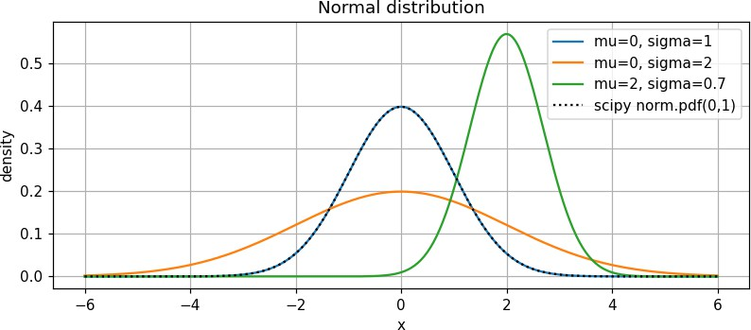
Univariate analysis of numeric variables (Marks.csv)

Property | Program | Output
Descriptive statistics plotted over the distribution of each variable | import pandas as pd import seaborn as sns  df = pd.read_csv('Marks.csv')  def UVA_numeric(data): var_group = data.columns size = len(var_group)  plt.figure(figsize=(6 * size, 4)) for j, i in enumerate(var_group):  mini = data[i].min() maxi = data[i].max() ran = maxi - mini mean = data[i].mean()  median = data[i].median() st_dev = data[i].std() skew = data[i].skew() kurt = data[i].kurtosis()  points = mean - st_dev, mean + st_dev plt.subplot(1, size, j + 1) sns.histplot(data[i], kde=True,  stat="density") sns.lineplot(x=list(points), y=[0, 0],  color='black', label="std_dev") sns.scatterplot(x=[mini, maxi], y=[0, 0],  color='orange', label="min/max") sns.scatterplot(x=[mean], y=[0],  color='red', label="mean")  sns.scatterplot(x=[median], y=[0],

Property | Program | Output
color='blue', label="median") plt.xlabel(i, fontsize=14) plt.ylabel('density')
plt.title('std_dev = ({}, {}); kurtosis =
{};\nskew = {}; range = ({}, {},
{})\nmean = {}; median = {}'.format( round(points[0], 2), round(points[1],
2), round(kurt, 2), round(skew,
2),
round(mini, 2), round(maxi, 2),
round(ran, 2), round(mean, 2),
round(median, 2)), fontsize=8) plt.tight_layout()

UVA_numeric(df) plt.show()
 | 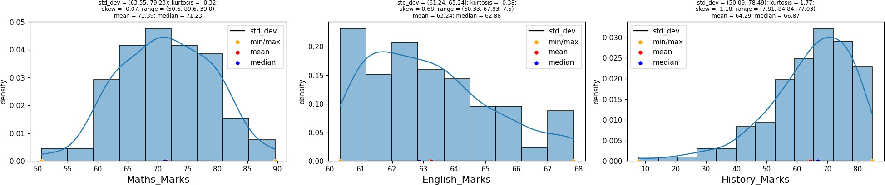
QQ plot

Property | Program | Output
QQ plot of random data against the normal distribution | import numpy as np  from scipy import stats  import matplotlib.pyplot as plt data_points = np.random.normal(0, 1, 100) fig, ax = plt.subplots(figsize=(5, 4))  stats.probplot(data_points, dist="norm", plot=ax) ax.set_title("QQ plot")  plt.show() | 