PERFORMING FREQUENCY DISTRIBUTIONS OVER MULTIPLE DATA

SOURCE CODE
(i) Ungrouped frequency distributions

Property | Program | Output
Create the DataFrame and build the frequency table | import pandas as pd df = pd.DataFrame({  'ID': ['1', '2', '3', '4', '5', '6'],  'Product_name': ['alex', 'bob', 'cathy',  'doge', 'eric', 'fred'],  'State': ['Taminadu', 'Tamilnadu', 'Taminadu', 'Andra', 'Madhyapradesh', 'Orissa'],  'Salescount': ['1000', '2000', '3500', '450',  '560', '250']})  print(df) print(df['State'].value_counts()) | ID Product_name State Salescount  - 1 alex Taminadu 1000  - 2 bob Tamilnadu 2000  - 3 cathy Taminadu 3500  - 4 doge Andra 450  - 5 eric Madhyapradesh 560  - 6 fred Orissa 250  State  Taminadu 2  Tamilnadu 1  Andra 1  Madhyapradesh 1  Orissa 1  Name: count, dtype: int64
Histogram of the State column | import matplotlib.pyplot as plt plt.hist(df['State']) plt.ylabel('Frequency count') plt.xlabel('Data') plt.title('My histogram') plt.show()
 | 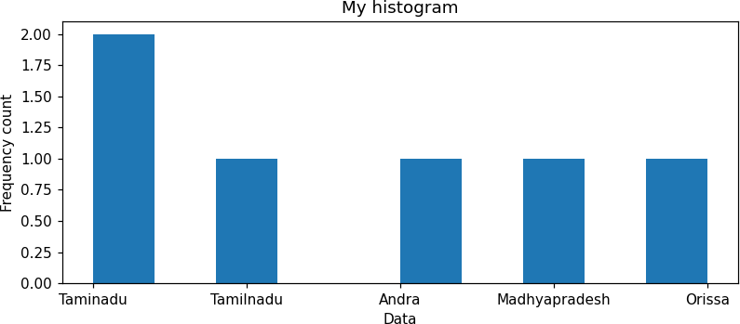
- ​Grouped frequency distribution

Property | Program | Output
Group by ID and | import pandas as pd  import matplotlib.pyplot as plt df = pd.DataFrame({  'ID': ['1', '1', '2', '3', '4'],  'Product_Name': ['CS', 'SE', 'SE', 'SE', 'CS'],  'State': [60, 70, 59, 51, 80],  'Salescount': [20, 21, 20, 22, 23]})  print(df) df.groupby('ID')['Salescount'].max().plot(kind='b  ar', legend=True) plt.show() |  | ID | Product_Name | State | Salescount
plot the maximum Salescount |  | 0  1  2 | 1  1  2 | CS  SE SE | 60  70  59 | 20  21  20
 |  | 3 | 3 | SE | 51 | 22
 |  | 4 | 4 | CS | 80 | 23

Property | Program | Output
 | 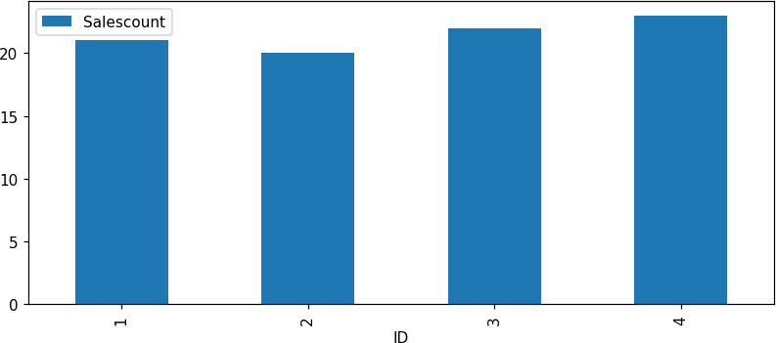
- ​Cumulative frequency distributions

Property | Program | Output
Cumulative frequency using scipy.stats.cumfreq | from scipy import stats import numpy as np  Salescount = [20, 21, 20, 22, 23] print("Array element : ", Salescount, "\n")  a, b, c, d = stats.cumfreq(Salescount, numbins=4) print("cumulative frequency : ", a)  print("Lower Limit : ", b) print("bin size : ", c) print("extra-points : ", d) | Array element : [20, 21, 20, 22, 23]  cumulative frequency : [2. 3. 4. 5.]  Lower Limit : 19.5 bin size : 1.0 extra-points : 0
Cumulative frequency plot | x = b + np.arange(len(a)) * c plt.plot(x, a, marker='o') plt.title("Cumulative frequency");  plt.xlabel("Salescount"); plt.ylabel("Cumulative count"); plt.grid(True)  plt.show()
 | 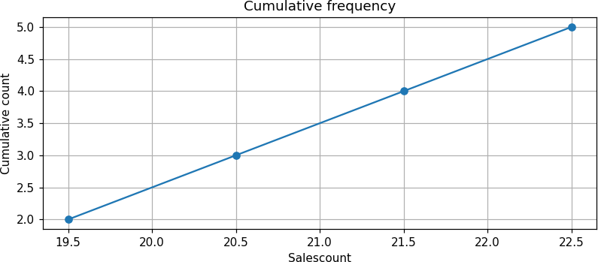
- ​Relative frequency distributions

Property | Program | Output
Relative frequency histogram | from scipy import stats import numpy as np  import matplotlib.pyplot as plt Salescount = [20, 21, 20, 22, 23]  a, b, c, d = stats.cumfreq(Salescount, numbins=4) print("cumulative frequency : ", a) print("relative cumulative frequency : ", a /  len(Salescount)) fig = plt.figure()  ax = fig.add_subplot(111) | cumulative frequency : [2. 3. 4. 5.]  relative cumulative frequency : [0.4 0.6 0.8  1. ]

Property | Program | Output
ax.hist(Salescount, edgecolor='black', weights=np.ones_like(Salescount) / len(Salescount))
ax.set_xlabel("Salescount"); ax.set_ylabel("Relative frequency"); ax.set_title("Relative frequency histogram")
plt.show()
 | 