**Assignment :02**

**Name: Mithun Patil**

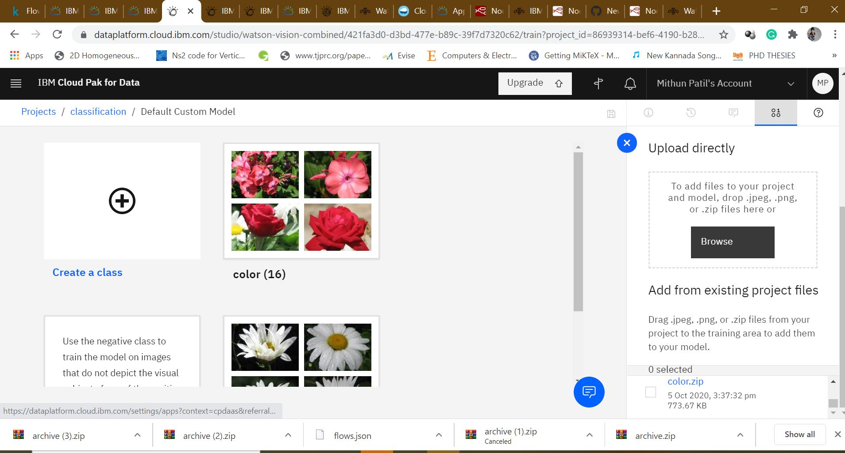**Fig 1: Dataset used**

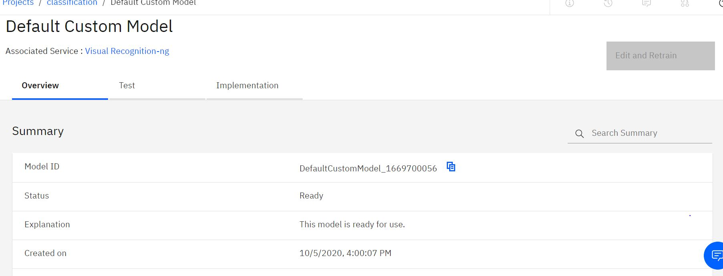

**Fig 2: trained Model**

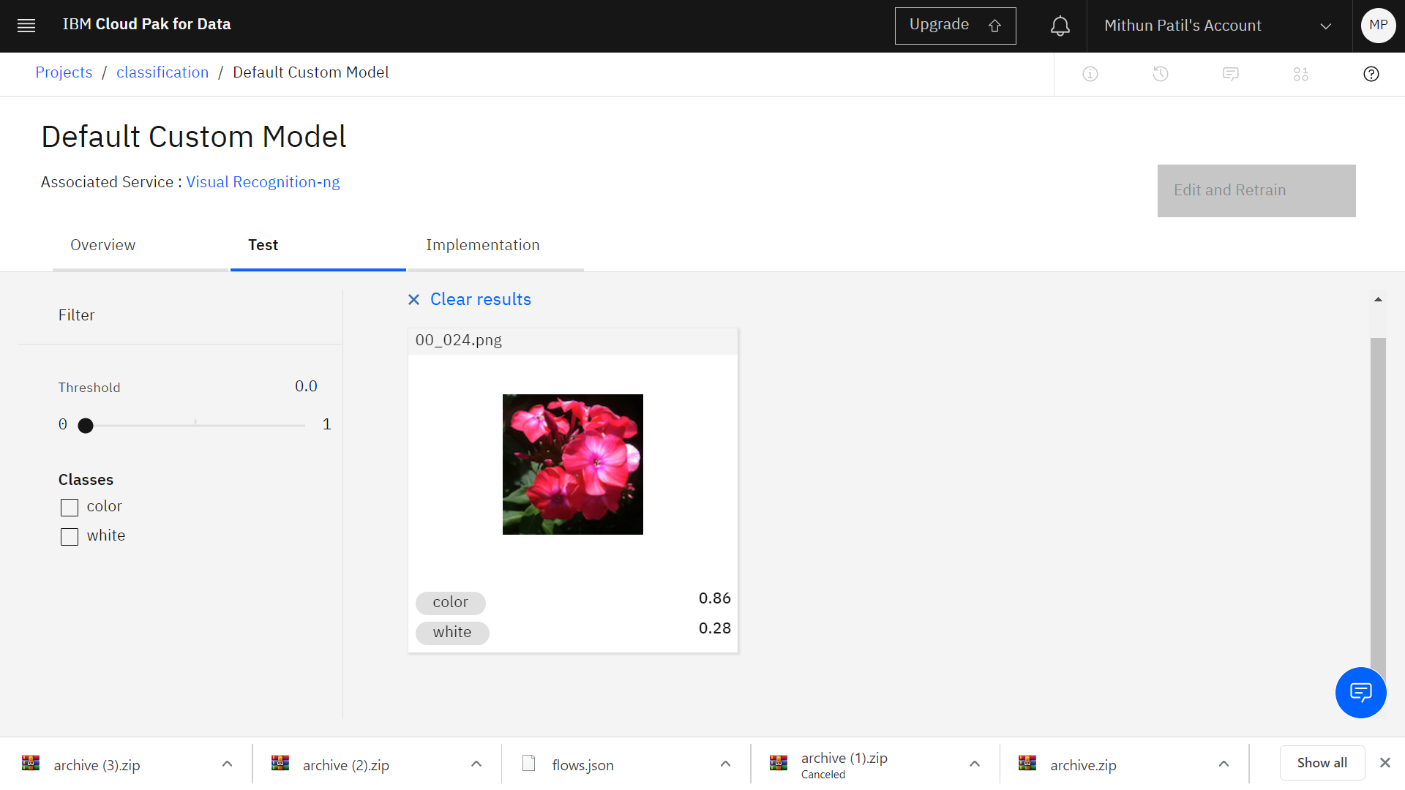

Fig 3 :result of classification