**Introduction to Pointers**

A Pointer in C language is a variable which **holds the address of another variable** of same data type.

Pointers are used to access memory and manipulate the address.

Pointers are one of the most distinct and exciting features of C language. It provides power and flexibility to the language.

Ex :

searching book in a rack by name will take to time to search.

Searching book by its position takes less time.(we should know position before searching(=>this is where pointers fits))

**Address in C**

Whenever a variable is defined in C language, a memory location is assigned for it, in which it's value will be stored. We can easily check this memory address, using the **&** symbol.

If var is the name of the variable, then **&var** will give it's address.

**Let's write a small program to see memory address of any variable that we define in our program.**

#include<stdio.h>  
void main()  
{  
 int var = 7;  
 printf("Value of the variable var is: %d\n", var);  
 printf("Memory address of the variable var is: %x\n", &var);  
}

Value of the variable var is: 7  
Memory address of the variable var is: bcc7a00

You must have also seen in the function scanf(), we mention &var to take user input for any variable var.

scanf("%d", &var);

This is used to store the user inputted value to the address of the variable var.

**Concept of Pointers**

Whenever a **variable** is declared in a program, system allocates a location i.e an address to that variable in the memory, to hold the assigned value. This location has its own address number, which we just saw above.

Let us assume that system has allocated memory location 80F for a variable a.

int a = 10;

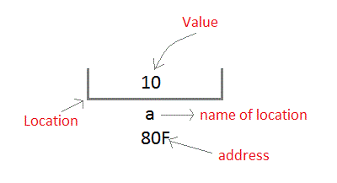

We can access the value 10 either by using the variable name a or by using its address 80F.

The question is how we can access a variable using it's address? Since the memory addresses are also just numbers, they can also be assigned to some other variable. The variables which are used to hold memory addresses are called **Pointer variables**.

A **pointer** variable is therefore nothing but a variable which holds an address of some other variable. And the value of a **pointer variable** gets stored in another memory location.

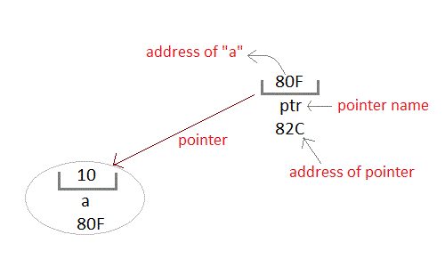

**Benefits of using pointers**

1. Pointers are more efficient in handling Arrays and Structures.
2. Pointers allow references to function and thereby helps in passing of function as arguments to other functions.
3. It reduces execution time of program.
4. It allows C language to support Dynamic Memory management.

**Ex program**

#include<stdio.h>

void main()

{

int var = 7;

int *ptr = &var;

printf("%d\n",*ptr); //prints value present at location

printf("%x\n",&ptr); //prints address stored in pointer

}

Note : format specifier %x prints address location in lower-case hexadecimal.

* printf("%x\n",p); will print address location

Output:

* 7 - value stored at the address stored by pointer
* f467f90 - hexadecimal address