**Automation build tools**

Ant, gradle and Maven

**Maven**

**Maven** is a [build automation](https://en.wikipedia.org/wiki/Build_automation) tool used primarily for [Java](https://en.wikipedia.org/wiki/Java_(programming_language)) projects.

Uses xml file (pom.xml : project object model)

Automatically downloads dependency jar files from online maven repository and keeps it in local repository(in your system).

Maven addresses two aspects of building software: first, it describes how software is built, and second, it describes its dependencies. An [XML](https://en.wikipedia.org/wiki/XML) file describes the software project being built, its dependencies on other external modules and components, the build order, directories, and required [plug-ins](https://en.wikipedia.org/wiki/Plug-in_(computing)). It comes with pre-defined targets for performing certain well-defined tasks such as compilation of code and its packaging.

Maven dynamically downloads [Java](https://en.wikipedia.org/wiki/Java_(programming_language)) libraries and Maven plug-ins from one or more repositories such as the Maven 2 Central Repository, and stores them in a local cache.[[4]](https://en.wikipedia.org/wiki/Apache_Maven#cite_note-maven2repo-4) This local cache of downloaded [artifacts](https://en.wikipedia.org/wiki/Artifact_(software_development)) can also be updated with artifacts created by local projects.

**<project>**  
 *<!-- model version is always 4.0.0 for Maven 2.x POMs -->*  
 **<modelVersion>**4.0.0**</modelVersion>**  
   
 *<!-- project coordinates, i.e. a group of values which*  
 *uniquely identify this project -->*  
   
 **<groupId>**com.mycompany.app**</groupId>**  
 **<artifactId>**my-app**</artifactId>**  
 **<version>**1.0**</version>**  
  
 *<!-- library dependencies -->*  
   
 **<dependencies>**  
 **<dependency>**  
   
 *<!-- coordinates of the required library -->*  
   
 **<groupId>**junit**</groupId>**  
 **<artifactId>**junit**</artifactId>**  
 **<version>**3.8.1**</version>**  
   
 *<!-- this dependency is only used for running and compiling tests -->*  
   
 **<scope>**test**</scope>**  
   
 **</dependency>**  
 **</dependencies>**  
**</project>**

**Project folders**

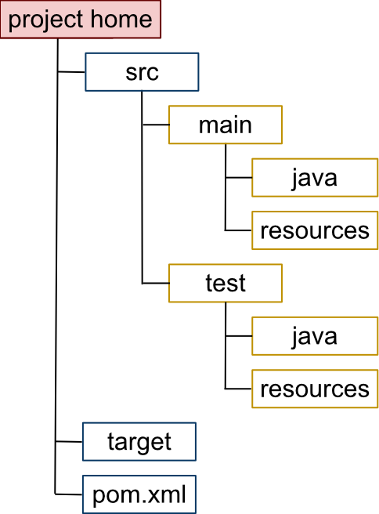

|  |  |
| --- | --- |
| project home | Contains the pom.xml and all subdirectories. |
| src/main/java | Contains the deliverable Java source code for the project. |
| src/main/resources | Contains the deliverable resources for the project, such as property files. |
| src/test/java | Contains the testing Java sourcecode (JUnit or TestNG test cases, for example) for the project. |
| src/test/resources | Contains resources necessary for testing. |