**Hibernate - Framework - ORM Object relational mapping tool**

**Hibernate is not a replcement of JDBC**

**Why Hibernate when compared to JDBC?**

1.Query embedded in code : Tomorrow if database is changes , we have to change the query which is embedded in the code because queries are database specific.

2.Mapping(impedance mismatch) : Java Bean/DTO/POJO object contains data which has to be mapped manually in the query using prepared statements.(ORM is difficult in JDBC)

3.Our code is not tested/efficient code till it goes through testing process, hibernate is a tested framework.

4.In jdbc Manual transaction management done manually including rollback.

(Ex : Data to be saved into four tables, but failed to save at fourth table so rollback has to be done. Ex : ATM deducts account balance but failed to dispense money)

5.Hibernate provides generic query hql(hibernate query language) supports all databases(no need to learn all database queries) (internally it translates to db specific query)

6.Supports association(one to one/ one to many / many to one), In jdbc it is done manually.

**Hibernate** is an object-relational mapping**(ORM)** tool for the Java programming language.

It provides a framework for mapping an object-oriented domain model to a relational database.

Hibernate's primary feature is mapping from Java classes to database tables, and mapping from Java data types to SQL data types.

Hibernate also provides data query and retrieval facilities. It generates SQL calls and relieves the developer from the manual handling and object conversion of the result set.

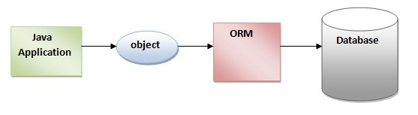

Advantages of Hibernate Framework over JDBC

There are many advantages of Hibernate Framework. They are as follows:

**1) Opensource and Lightweight:** Hibernate framework is open source under the GNU LGPL license and lightweight.

**2) Fast performance:** The performance of hibernate framework is fast because cache is internally used in hibernate framework. There are two types of cache in hibernate framework first level cache and second level cache. First level cache is enabled by default.

**3) Database Independent query:** HQL (Hibernate Query Language) is the object-oriented version of SQL. It generates the database independent queries. So you don't need to write database specific queries. Before Hibernate, If database is changed for the project, we need to change the SQL query as well that leads to the maintenance problem.