MySQL **JOINS** are used to retrieve data from multiple tables. A MySQL JOIN is performed whenever two or more tables are joined in a SQL statement.

There are different types of MySQL joins:

* MySQL INNER JOIN (or sometimes called simple join)
* MySQL LEFT OUTER JOIN (or sometimes called LEFT JOIN)
* MySQL RIGHT OUTER JOIN (or sometimes called RIGHT JOIN)

## **INNER JOIN (simple join)**

Chances are, you've already written a statement that uses a MySQL INNER JOIN. It is the most common type of join. MySQL INNER JOINS return all rows from multiple tables where the join condition is met.

### **Syntax**

The syntax for the INNER JOIN in MySQL is:

SELECT columns  
FROM table1   
INNER JOIN table2  
ON table1.column = table2.column;

In this visual diagram, the MySQL INNER JOIN returns the shaded area:

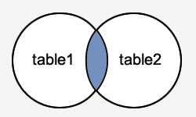

Suppliers table

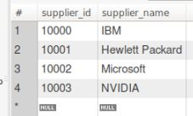

Orders table

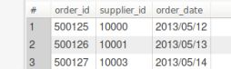

**Example query for self join**

select suppliers.supplier_id, suppliers.supplier_name, orders.order_date

from suppliers

inner join orders

on **suppliers.supplier_id = orders.supplier_id**;

Output :

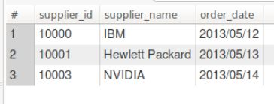

## **LEFT OUTER JOIN**

Another type of join is called a MySQL LEFT OUTER JOIN. This type of join returns all rows from the LEFT-hand table specified in the ON condition and **only** those rows from the other table where the joined fields are equal (join condition is met).

### **Syntax**

The syntax for the LEFT OUTER JOIN in MySQL is:

SELECT columns  
FROM table1  
LEFT [OUTER] JOIN table2  
ON table1.column = table2.column;

In some databases, the LEFT OUTER JOIN keywords are replaced with LEFT JOIN.

### **Visual Illustration**

In this visual diagram, the MySQL LEFT OUTER JOIN returns the shaded area:

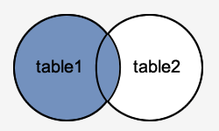

Query example :

SELECT suppliers.supplier_id, suppliers.supplier_name, orders.order_date

FROM suppliers

LEFT JOIN orders

ON suppliers.supplier_id = orders.supplier_id;

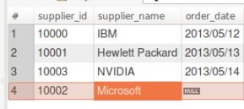

## **RIGHT OUTER JOIN**

Another type of join is called a MySQL RIGHT OUTER JOIN. This type of join returns all rows from the RIGHT-hand table specified in the ON condition and **only** those rows from the other table where the joined fields are equal (join condition is met).

### **Syntax**

The syntax for the RIGHT OUTER JOIN in MySQL is:

SELECT columns  
FROM table1  
RIGHT [OUTER] JOIN table2  
ON table1.column = table2.column;

In some databases, the RIGHT OUTER JOIN keywords are replaced with RIGHT JOIN.

### **Visual Illustration**

In this visual diagram, the MySQL RIGHT OUTER JOIN returns the shaded area:

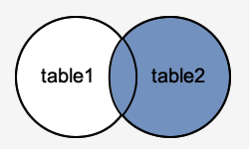

Example query

SELECT orders.order_id, orders.order_date, suppliers.supplier_name

FROM suppliers

RIGHT JOIN orders

ON suppliers.supplier_id = orders.supplier_id;

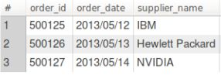

## **SQL FULL OUTER JOIN Keyword**

The FULL OUTER JOIN keyword return all records when there is a match in either left (table1) or right (table2) table records.

**Note:** FULL OUTER JOIN can potentially return very large result-sets!

Query:

SELECT * FROM suppliers

LEFT JOIN orders ON suppliers.supplier_id = orders.supplier_id

UNION

SELECT * FROM suppliers

RIGHT JOIN orders ON suppliers.supplier_id = orders.supplier_id

