**Foreign key constraint**

A FOREIGN KEY is a key used to link two tables together.

A FOREIGN KEY is a field (or collection of fields) in one table that refers to the PRIMARY KEY in another table.

The table containing the foreign key is called the child table, and the table containing the candidate key is called the referenced or parent table.

Look at the following two tables:

Person table and Orders table

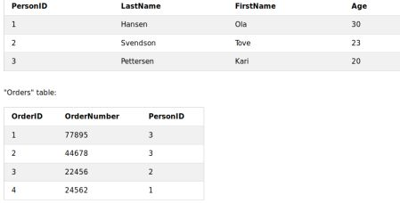

The "PersonID" column in the "Persons" table is the PRIMARY KEY in the "Persons" table.

The "PersonID" column in the "Orders" table is a FOREIGN KEY in the "Orders" table.

The FOREIGN KEY constraint is used to prevent actions that would destroy links between tables.

The FOREIGN KEY constraint also prevents invalid data from being inserted into the foreign key column, because it has to be one of the values contained in the table it points to.

**Example :**

create table Persons (

PersonId int primary key auto_increment,

LastName text,

FirstName text,

age int

);

CREATE TABLE Orders (

OrderID int NOT NULL,

OrderNumber int NOT NULL,

PersonID int,

PRIMARY KEY (OrderID),

**FOREIGN KEY (PersonID) REFERENCES Persons(PersonId)**

);

Or

CREATE TABLE Orders (

OrderID int NOT NULL,

OrderNumber int NOT NULL,

PersonID int,

PRIMARY KEY (OrderID),

CONSTRAINT fk_person_order FOREIGN KEY (PersonID)

REFERENCES Persons(PersonId)

);

insert into Persons (LastName, FirstName , age) values ("Hensen","Ola",30);

insert into Persons (LastName, FirstName , age) values ("Svendson","Tove",23);

insert into Persons (LastName, FirstName , age) values ("Petterson","gump",20);

insert into Orders (OrderID, OrderNumber,PersonID) values (1,77895,3);

insert into Orders (OrderID, OrderNumber,PersonID) values (2,44678,3);

insert into Orders (OrderID, OrderNumber,PersonID) values (3,22456,2);

insert into Orders (OrderID, OrderNumber,PersonID) values (4,24562,1);

**Add a foreign key constraint**

To allow naming of a FOREIGN KEY constraint, and for defining a FOREIGN KEY constraint on multiple columns, use the following SQL syntax:

*alter table Orders*

*add constraint fk_person_order*

*foreign key (PersonID) references Persons(PersonId);*

**DROP a FOREIGN KEY Constraint**

To drop a FOREIGN KEY constraint, use the following SQL:

**Query :**

ALTER TABLE Orders

DROP FOREIGN KEY fk_person_order;