**HttpSession** object is used to store entire session with a specific client. We can store, retrieve and remove attribute from **HttpSession** object. Any servlet can have access to **HttpSession** object throughout the getSession() method of the **HttpServletRequest** object.

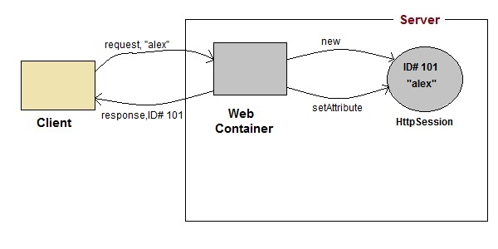

1. On client's first request, the **Web Container** generates a unique session ID and gives it back to the client with response. This is a temporary session created by web container.
2. The client sends back the session ID with each request. Making it easier for the web container to identify where the request is coming from.
3. The **Web Container** uses this ID, finds the matching session with the ID and associates the session with the request.

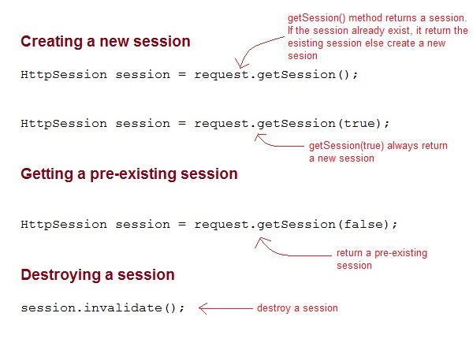

Sample to create http session

**Web.xml**

<web-app>

<servlet>

<servlet-name>Validate</servlet-name>

<servlet-class>Validate</servlet-class>

</servlet>

<servlet>

<servlet-name>Welcome</servlet-name>

<servlet-class>Welcome</servlet-class>

</servlet>

<servlet-mapping>

<servlet-name>Validate</servlet-name>

<url-pattern>/Validate</url-pattern>

</servlet-mapping>

<servlet-mapping>

<servlet-name>Welcome</servlet-name>

<url-pattern>/Welcome</url-pattern>

</servlet-mapping>

<welcome-file-list>

<welcome-file>index.html</welcome-file>

</welcome-file-list>

</web-app>

**Index.html takes username and password input**

<!DOCTYPE html>

<html>

<head>

<meta charset="UTF-8">

<title>Insert title here</title>

</head>

<body>

<form method="post" action="Validate">

User: <input type="text" name="user" /><br/>

Password: <input type="text" name="pass" ><br/>

<input type="submit" value="submit">

</form>

</body>

</html>

**Create two servlets ,one for validate and and one to welcome**

**Validate servlet**

import java.io.*;

import javax.servlet.*;

import javax.servlet.http.*;

public class Validate extends HttpServlet {

protected void doPost(HttpServletRequest request, HttpServletResponse response)

throws ServletException, IOException {

response.setContentType("text/html;charset=UTF-8");

String name = request.getParameter("user");

String pass = request.getParameter("pass");

if(pass.equals("1234"))

{

//creating a session

HttpSession session = request.getSession();

session.setAttribute("user", name);

response.sendRedirect("Welcome");

}

}

}

**Welcome servlet**

import java.io.*;

import javax.servlet.*;

import javax.servlet.http.*;

public class Welcome extends HttpServlet {

protected void doGet(HttpServletRequest request, HttpServletResponse response)

throws ServletException, IOException {

response.setContentType("text/html;charset=UTF-8");

PrintWriter out = response.getWriter();

**HttpSession session = request.getSession();**

String user = (String)session.getAttribute("user");

out.println("Hello "+user);

}

}

**Closing session or Session Invalidate**

public class Validate extends HttpServlet {

protected void doPost(HttpServletRequest request, HttpServletResponse response)

throws ServletException, IOException {

HttpSession session;

response.setContentType("text/html;charset=UTF-8");

String name = request.getParameter("user");

String pass = request.getParameter("pass");

if(pass.equals("1234"))

{

//creating a session

session = request.getSession();

if(session.isNew()){

session.setAttribute("user", name);

response.sendRedirect("Welcome");

}else{

System.out.println("hello boss i remember you Mr."+session.getAttribute("user"));

//session.invalidate();

//System.out.println("now you have logged out sign in again");

}

}

}

}