In this sample a student information is being stored to database. Servlet , jsp and jdbc is used to achieve this sample.

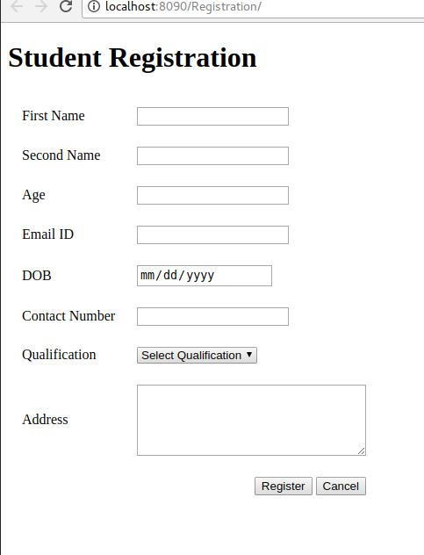

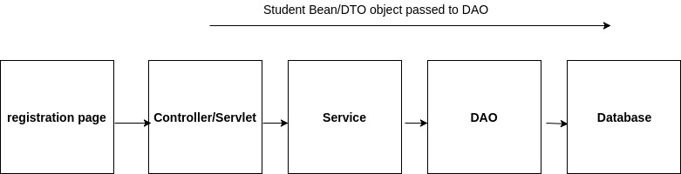

**1.Create index.jsp to for input fields to register student details**

<body>  
  
 <h1>Student Registration</h1>  
 <form action="doRegister" method="post">  
 <table cellpadding="8" cellspacing="8">  
 <tr>  
 <td><label>First Name</label></td>  
 <td><input type="text" name="firstName"></td>  
 </tr>  
 <tr>  
 <td><label>Second Name</label></td>  
 <td><input type="text" name="secondName"></td>  
 </tr>  
 <tr>  
 <td><label>Age</label></td>  
 <td><input type="number" name="age"></td>  
 </tr>  
 <tr>  
 <td><label>Email ID</label></td>  
 <td><input type="text" name="emailId"></td>  
 </tr>  
 <tr>  
 <td><label>DOB</label></td>  
 <td><input type="date" name="dob"></td>  
 </tr>  
 <tr>  
 <td><label>Contact Number</label></td>  
 <td><input type="text" name="contactNumber"></td>  
 </tr>  
 <tr>  
 <td><label>Qualification</label></td>  
 <td>  
 <select name="qualification">  
 <option value="">Select Qualification</option>  
 <option value="Primary">Primary</option>  
 <option value="Secondary”>Secondary</option>  
 </select>  
 </td>  
 </tr>  
   
 <tr>  
 <td><label>Address</label></td>  
 <td>  
 <textarea cols="30" rows="5" name="address">   
 </textarea>  
 </td>  
 </tr>  
   
 <tr>  
 <td></td>  
 <td align="right">  
 <input type="submit" value="Register">  
 <input type="Reset" value="Cancel">  
 </td>  
 </tr>  
   
 </table>  
 </form>  
   
</body>

**2.create success.jsp** to display after successful insertion of student information into database.

<body>

<h1>Hi, You have Registered Successfully....</h1>

</body>

**3.web.xml**

<?xml version="1.0" encoding="UTF-8"?>

<web-app xmlns:xsi="http://www.w3.org/2001/XMLSchema-instance" xmlns="http://xmlns.jcp.org/xml/ns/javaee" xsi:schemaLocation="http://xmlns.jcp.org/xml/ns/javaee http://xmlns.jcp.org/xml/ns/javaee/web-app_3_1.xsd" id="WebApp_ID" version="3.1">

<display-name>SimpleRegistration</display-name>

<welcome-file-list>

<welcome-file>index.jsp</welcome-file>

</welcome-file-list>

<servlet>

<servlet-name>Registration</servlet-name>

<servlet-class>com.dineshkrish.controller.RegistrationController</servlet-class>

</servlet>

<servlet-mapping>

<servlet-name>Registration</servlet-name>

<url-pattern>/doRegister</url-pattern>

</servlet-mapping>

<welcome-file-list>

<welcome-file>index.jsp</welcome-file>

</welcome-file-list>

</web-app>

4.Create **Student** class inside package **com.dineshkrish.dto**

import java.sql.Date;

public class Student {

private String firstName;

private String secondName;

private int age;

private String emailId;

private Date dob;

private String contactNumber;

private String qualification;

private String address;

public String getFirstName() {

return firstName;

}

public void setFirstName(String firstName) {

this.firstName = firstName;

}

public String getSecondName() {

return secondName;

}

public void setSecondName(String secondName) {

this.secondName = secondName;

}

public int getAge() {

return age;

}

public void setAge(int age) {

this.age = age;

}

public String getEmailId() {

return emailId;

}

public void setEmailId(String emailId) {

this.emailId = emailId;

}

public Date getDob() {

return dob;

}

public void setDob(Date dob) {

this.dob = dob;

}

public String getContactNumber() {

return contactNumber;

}

public void setContactNumber(String contactNumber) {

this.contactNumber = contactNumber;

}

public String getQualification() {

return qualification;

}

public void setQualification(String qualification) {

this.qualification = qualification;

}

public String getAddress() {

return address;

}

public void setAddress(String address) {

this.address = address;

}

}

**5.create table in database**

CREATE TABLE student_details(firstName varchar(30), secondName varchar(30), age int, emailId varchar(50), dob date, contactNumber varchar(12), qualification varchar(30), address varchar(100));

**6.Create RegistrationController inside package com.dineshkrish.controller**

package com.dineshkrish.controller;

import java.io.IOException;

import java.sql.Date;

import java.text.DateFormat;

import java.text.ParseException;

import java.text.SimpleDateFormat;

import javax.servlet.RequestDispatcher;

import javax.servlet.ServletException;

import javax.servlet.http.HttpServlet;

import javax.servlet.http.HttpServletRequest;

import javax.servlet.http.HttpServletResponse;

import com.dineshkrish.bo.StudentService;

import com.dineshkrish.dto.Student;

public class RegistrationController extends HttpServlet {

private String firstName;

private String secondName;

private int age;

private String emailId;

private Date dob;

private String contactNumber;

private String qualification;

private String address;

@Override

public void doPost(HttpServletRequest req, HttpServletResponse resp) throws ServletException, IOException {

// Defining Student Service Object

**StudentService service = new StudentService();**

// Getting all Parameter value from HTML form

firstName = req.getParameter("firstName");

secondName = req.getParameter("secondName");

age = Integer.parseInt(req.getParameter("age"));

emailId = req.getParameter("emailId");

dob = convertStringToDate(req.getParameter("dob"));

contactNumber = req.getParameter("contactNumber");

qualification = req.getParameter("qualification");

address = req.getParameter("address");

// Defining Student Object

Student student = new Student();

student.setFirstName(firstName);

student.setSecondName(secondName);

student.setAge(age);

student.setEmailId(emailId);

student.setDob(dob);

student.setContactNumber(contactNumber);

student.setQualification(qualification);

student.setAddress(address);

**boolean flag = service.addStudent(student);**

if(flag) {

// Dispatching Success Page

RequestDispatcher dispatcher = req.getRequestDispatcher("success.jsp");

dispatcher.forward(req, resp);

} else {

// Dispatching Error Page

RequestDispatcher dispatcher = req.getRequestDispatcher("error.jsp");

dispatcher.forward(req, resp);

}

}

// Method to Convert String java.sql.Date Object

private Date convertStringToDate(String strDate) {

DateFormat format = new SimpleDateFormat("yyyy-MM-dd");

java.util.Date d = null;

try {

d = format.parse(strDate);

} catch (ParseException e) {

e.printStackTrace();

}

return new Date(d.getTime());

}

}

**7.create service class inside package com.dineshkrish.bo**

package com.dineshkrish.bo;

import com.dineshkrish.dao.StudentDAO;

import com.dineshkrish.dto.Student;

//validation,conversion and mathematical operation can be done here

public class StudentService {

public boolean addStudent(Student student) {

**StudentDAO dao = new StudentDAO();**

**boolean result = dao.add(student);**

return result;

}

}

**8.create StudentDAO class inside package com.dineshkrish.dao**

package com.dineshkrish.dao;

import java.sql.Connection;

import java.sql.PreparedStatement;

import java.sql.SQLException;

import com.dineshkrish.db.ConnectionProvider;

import com.dineshkrish.dto.Student;

public class StudentDAO {

public boolean add(Student student) {

// Getting Connection Object

Connection connection = ConnectionProvider.getConnection();

try {

PreparedStatement ps = connection.prepareStatement("INSERT INTO student_details(firstName, secondName, "

+ "age, emailId, dob, contactNumber, qualification, address) VALUES (?,?,?,?,?,?,?,?)");

ps.setString(1, student.getFirstName());

ps.setString(2, student.getSecondName());

ps.setInt(3, student.getAge());

ps.setString(4, student.getEmailId());

ps.setDate(5, student.getDob());

ps.setString(6, student.getContactNumber());

ps.setString(7, student.getQualification());

ps.setString(8, student.getAddress());

// It will return 1 if its Inserted successfully..

if(ps.executeUpdate() > 0) {

return true;

}

} catch (SQLException e) {

System.out.println(e.getMessage());

e.printStackTrace();

}

return false;

}

}

**9.create ConnectionProvider inside package com.dineshkrish.db**

package com.dineshkrish.db;

import java.sql.Connection;

import java.sql.DriverManager;

import java.sql.SQLException;

public class ConnectionProvider {

private static Connection connection;

public static Connection getConnection() {

try {

// Loading Driver Class

Class.forName("com.mysql.jdbc.Driver");

// Getting the Connection

connection = DriverManager.getConnection("jdbc:mysql://localhost:3306/Test", "root", "root");

} catch (ClassNotFoundException e) {

System.out.println(e.getMessage());

e.printStackTrace();

} catch (SQLException e) {

System.out.println(e.getMessage());

e.printStackTrace();

}

return connection;

}

}

/*table create statement*/

/*CREATE TABLE student_details(firstName varchar(30), secondName varchar(30), age int, emailId varchar(50), dob date, contactNumber varchar(12), qualification varchar(30), address varchar(100));*/