Input:

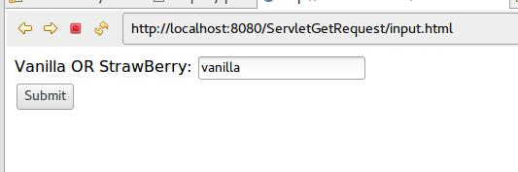

Output

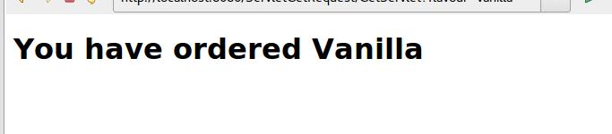

**Step 1 : Create input.html**

<!DOCTYPE html>

<html>

<body>

<form action = "GetServlet" method = "GET">

Vanilla OR StrawBerry: <input type = "text" name = "flavour">

<br />

<input type = "submit" value = "Submit" />

</form>

</body>

</html>

**Step 2 : under WEB-INF folder, create web.xml**

<?xml version="1.0" encoding="ISO-8859-1"?>

<web-app>

<servlet>

<servlet-name>GetServlet</servlet-name>

<servlet-class>GetServlet</servlet-class>

</servlet>

<servlet-mapping>

<servlet-name>GetServlet</servlet-name>

<url-pattern>/GetServlet</url-pattern>

</servlet-mapping>

</web-app>

//make sure you have servlet api jar in either tomcat libraries(java resources>libraries>tomcat) or in project

**Step 3 : Create servlet. File Name GetServlet.java**

import javax.servlet.ServletException;

import javax.servlet.http.HttpServlet;

import javax.servlet.http.HttpServletRequest;

import javax.servlet.http.HttpServletResponse;

public class GetServlet extends HttpServlet {

@Override

protected void doGet(HttpServletRequest req, HttpServletResponse resp) throws ServletException, IOException {

// TODO Auto-generated method stub

//super.doGet(req, resp);

String flavour = req.getParameter("flavour").toLowerCase();

System.out.println("flavour="+flavour);

switch(flavour){

case "vanilla" : req.setAttribute("message", "You have ordered Vanilla"); req.getRequestDispatcher("output.jsp").forward(req, resp);

break;

case "strawberry" : req.setAttribute("message", "You have ordered StrawBerry");

req.getRequestDispatcher("output.jsp").forward(req, resp);

break;

default : req.setAttribute("message", "Sorry, "+flavour+" not available");

req.getRequestDispatcher("output.jsp").forward(req, resp);

break;

}

}

}

**Step 4 : output.jsp**

<%@ page language="java" contentType="text/html; charset=UTF-8"

pageEncoding="UTF-8"%>

<!DOCTYPE html PUBLIC "-//W3C//DTD HTML 4.01 Transitional//EN" "http://www.w3.org/TR/html4/loose.dtd">

<html>

<head>

<meta http-equiv="Content-Type" content="text/html; charset=UTF-8">

<title>output</title>

</head>

<body>

<h1>${message}</h1>

</body>

</html>