**1.Create Dynamic web project**

**2.Create web.xml file in web-inf folder**

<?xml version="1.0" encoding="ISO-8859-1"?>

<web-app>

<servlet>

<servlet-name>HelloForm</servlet-name>

<servlet-class>HelloForm</servlet-class>

</servlet>

<servlet-mapping>

<servlet-name>HelloForm</servlet-name>

<url-pattern>/HelloForm</url-pattern>

</servlet-mapping>

</web-app>

**3.Create Html file in web inf folder. FileName HelloForm.html**

**File > Create File > HTML**

<!DOCTYPE html>

<html>

<body>

<form action = "HelloForm" method = "POST">

First Name: <input type = "text" name = "first_name">

<br />

Last Name: <input type = "text" name = "last_name" />

<input type = "submit" value = "Submit" />

</form>

</body>

</html>

**4.Create Servlet Class. FileName : HelloForm.java**

**File > class**

import javax.servlet.ServletConfig;

import javax.servlet.ServletException;

import javax.servlet.http.HttpServlet;

import javax.servlet.http.HttpServletRequest;

import javax.servlet.http.HttpServletResponse;

public class HelloForm extends HttpServlet {

@Override

protected void doPost(HttpServletRequest req, HttpServletResponse resp) throws ServletException, IOException {

// TODO Auto-generated method stub

super.doPost(req, resp);

System.out.println("first name="+req.getParameter("first_name"));

System.out.println("last name="+req.getParameter("last_name"));

}

}

**5.Project structure**

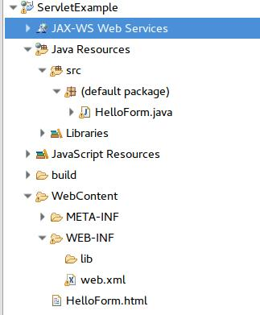

**6.To run the project , click on run on server > select downloaded version of Tomcat > run**

**7.To display the input data in the jsp file**

Create a display.jsp file

File > New file > jsp file

<%@ page language="java" contentType="text/html; charset=UTF-8"

pageEncoding="UTF-8"%>

<!DOCTYPE html PUBLIC "-//W3C//DTD HTML 4.01 Transitional//EN" "http://www.w3.org/TR/html4/loose.dtd">

<html>

<head>

<meta http-equiv="Content-Type" content="text/html; charset=UTF-8">

<title>Insert title here</title>

</head>

<body>

<h2>hi, welcome</h2>

<h1>**${first_name} ${last_name}**</h1>

</body>

</html>

**8.HelloForm.java**

**Forward request to jsp file**

import javax.servlet.ServletConfig;

import javax.servlet.ServletException;

import javax.servlet.http.HttpServlet;

import javax.servlet.http.HttpServletRequest;

import javax.servlet.http.HttpServletResponse;

public class HelloForm extends HttpServlet {

@Override

protected void doPost(HttpServletRequest req, HttpServletResponse resp) throws ServletException, IOException {

// TODO Auto-generated method stub

//super.doPost(req, resp);

String firstName = req.getParameter("first_name");

String lastName = req.getParameter("last_name");

System.out.println("first name="+firstName);

System.out.println("last name="+lastName);

req.setAttribute("first_name", firstName);

req.setAttribute("last_name", lastName);

**req.getRequestDispatcher("display.jsp").forward(req, resp);**

}

}

**Get vs Post**

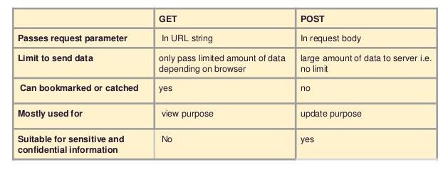

**Get : for reading data/accessing data**

**Post : create data,update data(not a best practice for updating data?(chances of creating new instead of update))**

**Put : update data**

**Del : delete data**