WEBTESTING SE1LENIUM

CC1

MITHUN

727721EUIT090

Q1]

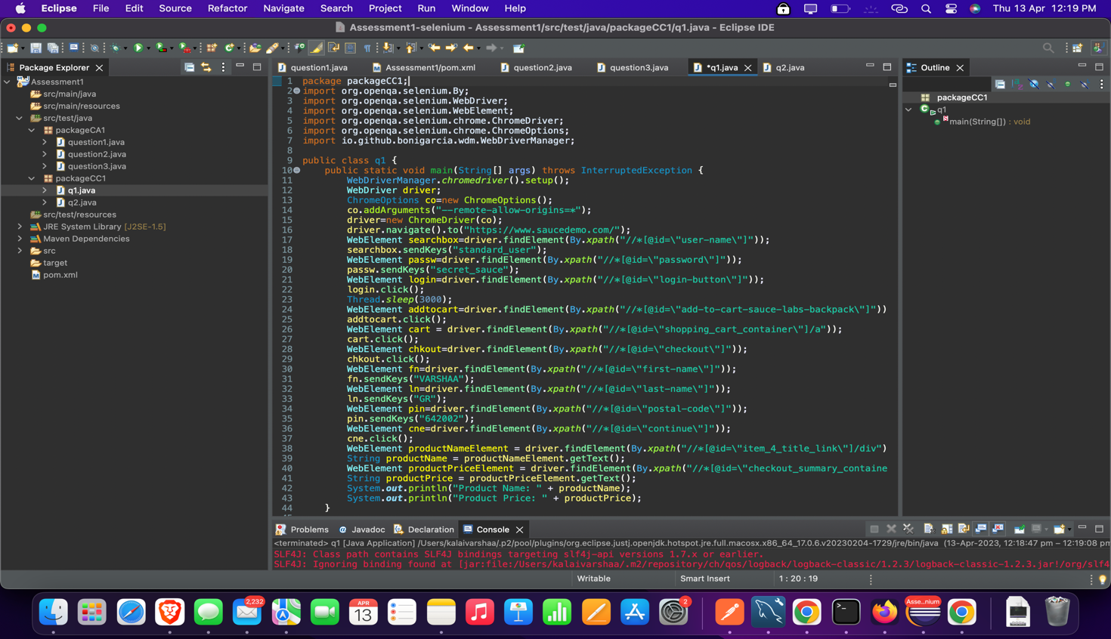

OUTPUT:

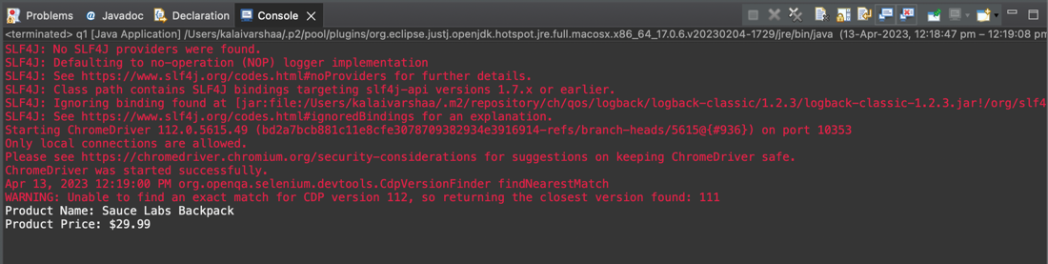

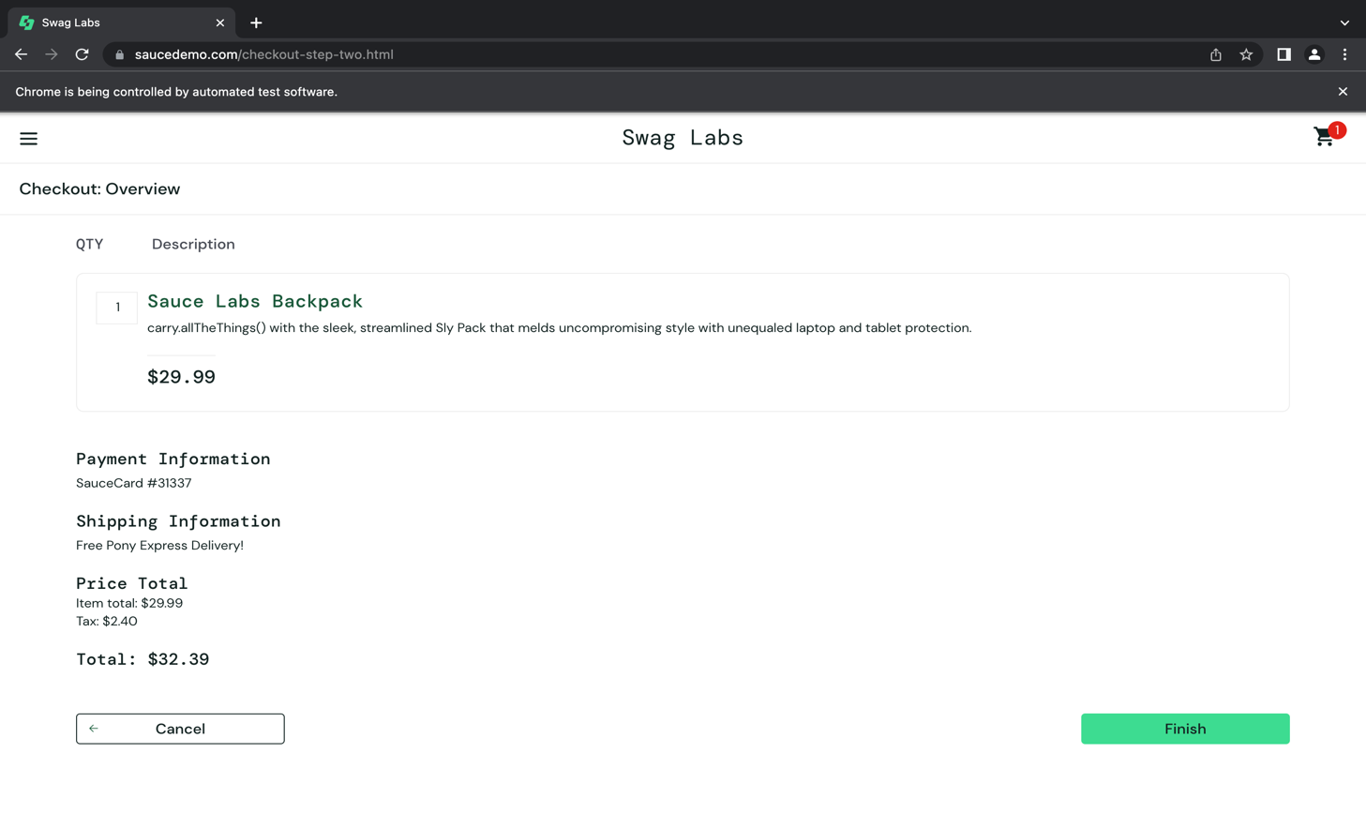

Q2]

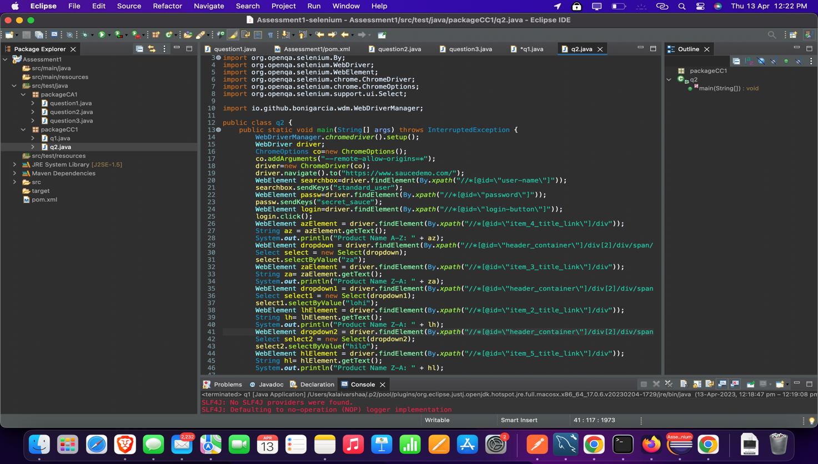

OUTPUT:

