Web Development

**Multi Responsive Web Page**

**A Vacation Mini Project**

**Report Submitted by**

**R.Mithun Nitheesh Rogan-200701077**

**Department of Electronics and Communication Engineering**

**Sri Venkateshwara College of Engineering (svce)**

**(An Autonomous Institution)**

**Sri Venkateshwara College of Engineering (svce), Post Bag no.1 Pennalur Village, Chennai-Bengaluru Highways, Sripermbadur (off Chennai) Tk.**

**Chennai-602117, Tamil Nadu, India**

**ABSTRACT**

The introduction of numerous new, web-enabled devices is leading to a change in the mindset in the design of web systems. Increasingly often, they are designed to take into account the special characteristics of different devices. In terms of implementation, designing these responsive web services requires frameworks and guidelines for user interface design for both desktop and mobile devices. The aim of the FOOD-PARK website is to provide current and correct information in a clear and accessible format at the same time providing the best possible user experience.  We provide some insights to tools and libraries used in building the responsive user interfaces and share some of the findings that work well in customizing existing software.

|  |  |  |
| --- | --- | --- |
| **chapter**  **Table of Contents** | **Title** | **page** |
| 1 | Acknowlegement | 2 |
| 2 | Introduction | 4 |
| 3 | What is Responsive Web Design? | 5 |
| 4 | Benefits of Responsive Web Design | 6 |
| 5 | Why is Responsive Web Design Important? | 7 |
| 6 | Proposed method with Architecture | 13 |
| 7 | **Overview** | 14 |
| 8 | Project Implementation | 15 |
| 9 | **Conclusion** | 16 |

**INTRODUCTION**

The number of handheld devices operating worldwide is growing exponentially. According to stats, more than 90% of adults own a cell phone, whereas almost 50% of smartphone users admit that they could not live without their devices. What can we say; the mobile web is a huge thing these days.

On the one hand, it is a good thing since we have an opportunity to address issues quickly and efficiently, locating information on the spot. On the other hand, this reality has created a challenge for all those who provide users with information.

Creating styles for each screen size is time-consuming, resource-consuming, and expensive. Even if you manage to cover all the breakpoints in the World, this will seriously overload the website and ipso facto decrease performance that drastically worsens conversions and user’s engagement with the brand, to say nothing about investing lots of money without decent ROI. So, how can entrepreneurs avoid this fate and successfully meet the fast-changing realms of digital expanses? The answer is simple – adopt responsive design.

Investing in a website whose pages are responsive and accessible, regardless of the browser, platform, or screen that your reader must use to access, is the only way to stay afloat these days. Responsive web design is no longer a tendency; it is a standard that we need to enforce to make the web a better place.

**What is Responsive Web Design?**

So, what is a responsive website? What does it look and feel like?

According to Wikipedia, responsive web design is an approach that ensures all the pages of the website look, work and feel perfectly on any device. Whether it is a tiny old cell phone with a screen width of 320px, a modern Tablet with 7 inches screen, a big iPad, or a TV with a massive diagonal line, all the main aspects such as content, design, and especially functionality should perform consistently to provide users with an excellent user experience.

In technical terms, responsive web design implies a set of instructions that help web pages change their layout and appearance to meet different screen widths and resolutions.

The concept of a responsive website appeared due to non-effective and ill-suited ways of handling screen sizes. Originally, pages were built to target a particular device. This approach implied creating a range of designs for each responsive tier resulting in different versions of the same page. However, with the mobile web becoming a reality and more and more devices with non-standard resolutions appeared, this approach has quickly become irrelevant since it could not handle this variety efficiently.

**Benefits of Responsive Web Design**

The main benefits of using a responsive website are

* Consistent visual Experience
* better user experience;
* no need for redirects;
* lower bounce rates;
* lower maintenance needs;
* high web page loading speed;
* no extra fees for creating and maintaining different versions;
* easy analytics

Even though responsive design is not flawless, it has its cons, for example,

* It is not fully optimized;
* It can slow performance;
* It may suffer from web browser incompatibility;
* It makes it challenging to run advertising campaigns;
* It makes it challenging to offer different things to different users depending on the device used;

Nevertheless, it had and has significant advantages over other solutions. Therefore, nowadays, responsive web design is a standard for websites.

**Why is Responsive Web Design Important?**

The rise of responsive design has to do much with the rise of mobile devices, tablets, and smart devices like Kindle, game consoles, etc. The modern-day user expects to be able to access any website with a vast range of devices. Your website should be ready to handle any scenario. You cannot ignore these demands because numbers do not lie: according to recent studies,

* more than 80% of users surf through the internet using mobile devices in 2019;
* more than 60% of Google’s visits are done via a mobile device;
* mobile devices accounted for more than 50% of website traffic worldwide.

Your brand cannot neglect this tendency. If you cannot meet these expectations and growing demands by quickly adapting to the new reality, then you are doomed to failure, and your brand is doomed to extinction.

Let us consider some good reasons why responsive web design is important:

* Google gives priority to websites that display well on smart phones and other mobile devices. Since 2015, a responsive design with mobile-friendly behavior is a must-have for those who care about ranks in search engines.
* Consistent user experience across all devices reinforces engagement, amplifies lead generation, and boosts sales and conversions. According to studies, one in two people has gone to a competitor’s website after a poor mobile experience.
* Without a good responsive website, you may lose out on new leads and sales from the mobile web.
* It lets you reach customers and deliver messages on all types of devices (tablets, tablets, smart phones), thereby widening your target audience.
* It builds positive brand recognition and trust with consumers. According to stats, people are more likely to recommend a business with a well-designed mobile website.
* It keeps prospects on your website longer by providing a consistent experience and bringing them value on the spot.
* It is cost-effective. Responsive design offers a lower cost than creating various versions of the same website to meet multiple screen sizes. In addition, it is easier to maintain. You do not need to hire a whole agency to handle your multi-version platform.
* Last but not least, you can get a chance to stay ahead of your competition since almost 50% of companies all around the World still ignore mobile behavior and responsive layout.

Although initially responsive web design was chosen as a recommended solution due to lack of proper alternative, it has proved to everyone that it is a reliable approach with lots of benefits for the brand over the past years. It can cope with various situations and scenarios, providing a solid foundation for developers to build on and entrepreneurs to run their marketing campaigns to generate revenue and help businesses stay afloat.

### How Does Responsive Web Design Work?

The idea behind responsive web design lies in building a flexible website whose content and design behave like water that fills the container, aka a device that customers use to visit the website. All elements of the website undergo changes to feel comfortable inside the screen. If it is necessary, they shrink to perfectly fit into smaller spaces or, on the contrary, stretch to occupy every inch of space. Everything scales up or down automatically to match the device.

A responsive website’s key point is to understand that its primary task is to provide a comfortable user experience for anyone. This requires ensuring good readability, proper visual experience, a certain level of accessibility, as well as maintaining consistent functionality from device to device.

**Difference between Responsive Design and Mobile-friendly Design**

There are two basic options when deciding how you want your website to look on small devices (cell phones and phablets): responsive web design or mobile-friendly design. While some people believe that these two are the same thing, in fact, they are not. So, who is who?

Responsive website changes depending on the screen size. It uses a dynamic grid, responsive images, and typography to adapt perfectly to whatever resolution is coming its way. It gracefully refits the content to each change in screen size.

Mobile-friendly design functions the same way regardless of the device: it just does not change. Simply put, it is a mobile version of the website. Although it stays relatively neutral to screen size changes, it still has some significant benefits over responsive design. First and foremost, a mobile-friendly website is made with mobile users in mind. It means it provides the best user experience, taking into account even the tiniest details. For example, it has a navigation that is “thumb-friendly,” buttons and links that are easily tappable, graphics that is large, uncluttered design with fewer features, etc.

So, which one to choose? Well, everything depends on your brand, target market, and most importantly, marketing goals. Answer these three essential questions to get some hints on direction:

* What is the purpose of your website? This helps define what information is essential and what information can be eliminated to provide quick access to crucial details.
* What will visitors do on your website? This helps define what functionality is vital and how to make it easily accessible on each screen size.
* What devices does your target market use most of the time? This helps to focus on the most viewed version and provides the best user experience for customers.

Finally, bear in mind that your website should take your visitors on a smooth, frictionless, valuable, and enjoyable journey. If this journey targets mostly audiences on the mobile web, then the mobile-friendly design is your option. However, if you are up to a broad audience from various devices, then responsive design is the only way out.

**Best Practices for Responsive Designs**

* As we have already said, a responsive website is not a separate technology with a one-size-fits-all solution. To nail it, you need to use techniques that bring about the best result for your brand, audience, and marketing goals. This implies capitalizing on the key features such as flexible layout, flexible images, media queries, and responsive typography, as well as introducing some time-proven tips and solutions. Let us walk through some good practices that may help you create a fully responsive website that meets all your users’ expectations.
* Design the mobile website first and work your way up to the desktop version. According to stats, the mobile web is prevailing over the desktop one. Therefore, chances are your users will visit your website using handheld devices. Prioritize the mobile version and use it as a foundation to build on. More so, it is easier to scale up design rather than scale it down.
* Know popular screen resolutions. According to Global Stats, almost **25% of visitors use small cell phones with 360px wide screens**, and only **12% use laptops with standard 1366px widescreens**. In addition, there is no one preferable size in each niche. This means you need to find the perfect responsive tier in each category. Use Stat counter to define what devices your target market use to determine the best responsive tiers.
* Cater to resolutions that are gaining popularity to create a future-proof user experience that will work even when the market share changes.
* Know web browser market share. Responsive design is also about adapting to the capabilities of the device hardware and web browser. Seamless experience requires your website to work flawlessly across all platforms. The harsh truth is, the World of web browsers is not perfect. There are still browser versions that do not support even the popular CSS features, to say nothing about such modern and pioneering methods like calc() or Flex box. In this case, you cannot rely blindly on your solution. You need to adjust it according to the browsers that your audience uses. In addition, it is highly recommended to provide a fallback if you want to widen your target market and serve content to every customer regardless of the web browser he or she might use.
* Take into account physical differences in using the website on a small screen and a large one. Mobile World is all about designing for thumbs. At a minimum, it means that
  + the links should be easily trappable;
  + sliders should be swipe able;
  + interactive elements, key details, and navigation should be within easy reaching distance of thumbs;
  + navigation should be at the bottom;
  + fingers should not block the view of the content when trying to reach navigation;
  + Target area should be enlarged to accommodate touching ideally.
* Do not be obsessed with the F-shape pattern. While on desktop versions, it rules the roost, when it comes to small screens like cell-phones, it is useless. People prefer exploring interfaces in other ways. As a rule, mobile users look at the center of the screen first. It is also the easiest place for them to reach. Therefore, the most critical information, including CTAs and navigation, should be there. However, when it comes to tablets and mid-sized devices, the screen’s central part is not easy to reach. Here you need to place navigation and crucial details on sides.
* Make sure you are not embarrassed with what happens in between breakpoints. Remember, not all people are going to maximize their windows to surf through your website. Your interface should be ready for such a scenario. The layout should naturally adapt as the browser resizes.
* Do not ignore landscape orientation since it is the main hindrance to achieving optimal usability and accessibility.
* Avoid bombarding the user at the small screen with all the content. Eliminate friction and focus on vital information. Do not scale down the whole design since you will end up with a long-long page that is difficult to read on small screens. Also, according to stats, mobile users are usually after quick answers. They should locate information in no time. Otherwise, they will leave. Therefore, display only what matters most to users and give them the controls to find the rest.
* Do not cling to the past. Follow the trends. Sometimes modern approaches may meet current demands more efficiently than old and time-proven ones. As proof, it is highly recommended these days to use scalable vector graphics, aka SVG. While there are various ways to ensure your images are responsive and adapt gracefully to new sizes, but why not benefit from the format that already knows how to behave in such a situation. Furthermore, SVGs often have a small file size so that they do not overload the website nor compromise the website’s speed, and most importantly, they save the quality of the visuals.

### TOUCHSCREENS VS CURSORS

Touch screens are becoming increasingly popular. Assuming that smaller devices are more likely to be given touch screen functionality is easy, but don’t be so quick. Right now touch screens are mainly on smaller devices, but many laptops and desktops on the market also have touch screen capability

Touch screens obviously come with different design guidelines than purely cursor-based interaction, and the two have different capabilities as well. Fortunately, making a design work for both doesn’t take a lot of effort. Touch screens have no capability to display CSS hovers because there is no cursor; once the user touches the screen, they click. So, don’t rely on CSS hovers for link definition; they should be considered an additional feature only for cursor-based devices.

**Proposed method with Architecture**

1. Defining the information architecture (commonly known as IA) and structure of the page,
2. Adding design elements to make it responsive and look good across all devices.

## Create your content and structure

Content is the most important aspect of any site. So let’s design for the content and not let the design dictate the content. In this guide, we identify the content we need first, create a page structure based on this content, and then present the page in a simple linear layout that works well on narrow and wide viewports.

### Create the page structure

We have identified us need:

1. A form to collect information from users who are interested in our product
2. An in depth description and video
3. Images of the product in action
4. A data table with information to back the claims up

**What are HTML, CSS, and JavaScript?**

* HTML is also known as Hypertext Markup Language which is used to create the core of web pages.
* CSS also known as Cascading Styling sheets is used to make the webpage more attractive.
* JavaScript is rather used to make the web pages more dynamic by providing fluidity through linking, buttons, etc.
* These languages together form the basic part of web development. Web development is becoming a trending topic in the coming years with new versions of programming languages.
* Creating a customized website will not be that hard and anybody who possesses the basic knowledge will surely be able to do it.

**Overview**

* Creating a website is one of the prior tasks to endorse one’s business.
* If you are about to open some business, then it is better to create a website and advertise on the internet.
* Advertising and reaching people with the help of the website is quite common and effective.
* Building a website is also very important when it comes to web page layout and their interconnections between them.
* Although there are many readymade templates where you can get various designs, creating your own will help in connecting with the audience.
* In this project, we will see how to create a multi-page responsive website that gives true results when interacted with.
* To create the website we need to have some skills. These skills include HTML, CSS, etc.
* These programming languages will help you create a good web page.
* By creating web pages separately, we will need to connect every page through linking.
* The linking tag which is used is in HTML i.e. <herf>

**Project Implementation**

* First, we need to create a framework on how the webpage will look. The first page which is also known as the home page is quite important and the other subsequent pages are connected to its different links.
* Then we will create the different web pages that will connect to the home page. We can also create many other pages that will connect to that subsequent webpage.
* To make the website more responsive, we can do the linking through different images, buttons, etc. These can increase the approachability of the website.
* The website should look attractive to get a click from the users, once you will learn all the necessary parts of web development in this course. You will be able to make good websites.
* The languages HTML, CSS, and JavaScript are used to create, decorate, and make it more dynamic respectively. Using all these three basics parts we can create good web pages.

**Demo:**

**Web Page:**

[demo\webpage Demo.mp4](demo/webpage%20Demo.mp4)

**Code:** [https://drive.google.com/file/d/1v3JLNLWZud-dJcz7GR55RmyWos9fhDSI/view?usp=sharing](demo/Code%20Demo.mp4)

**Screenshots:**

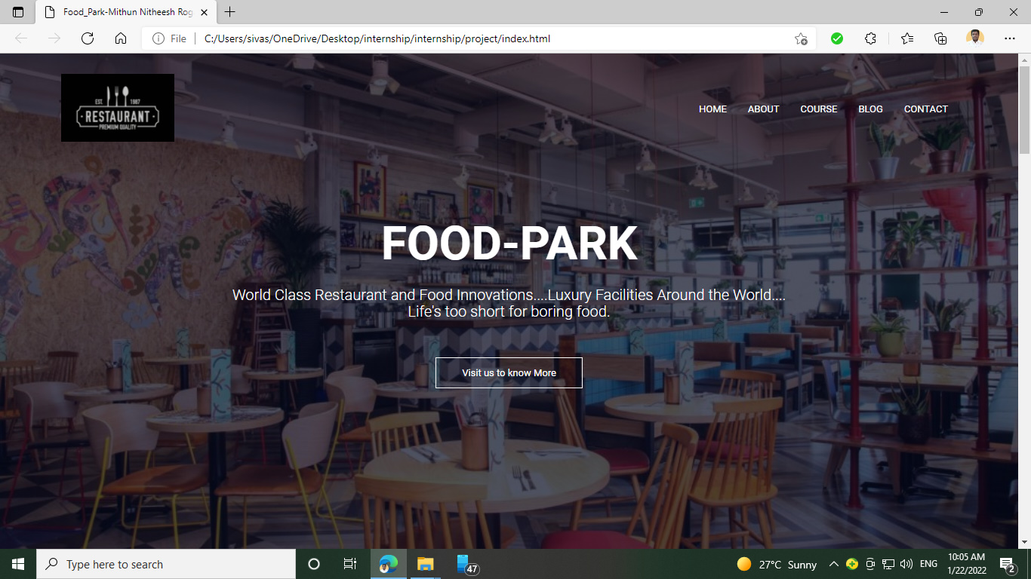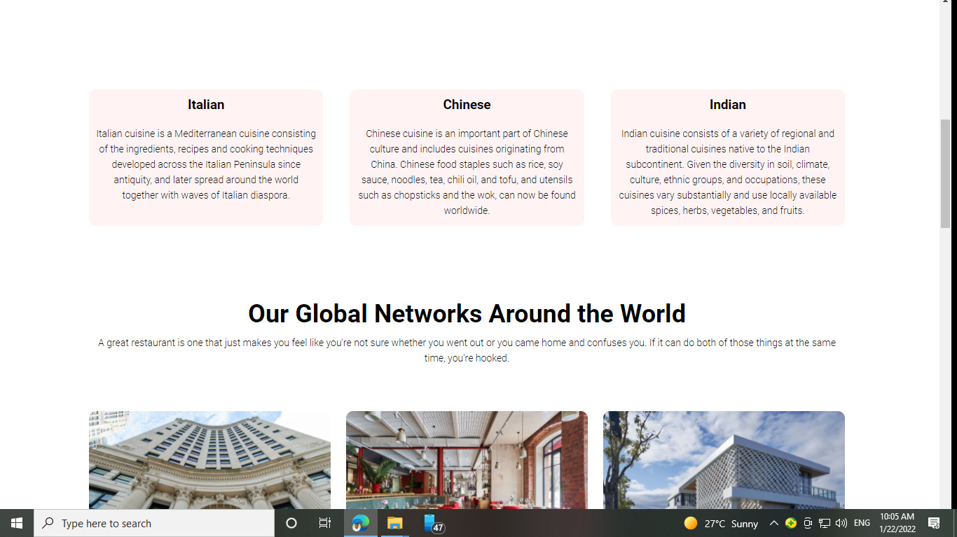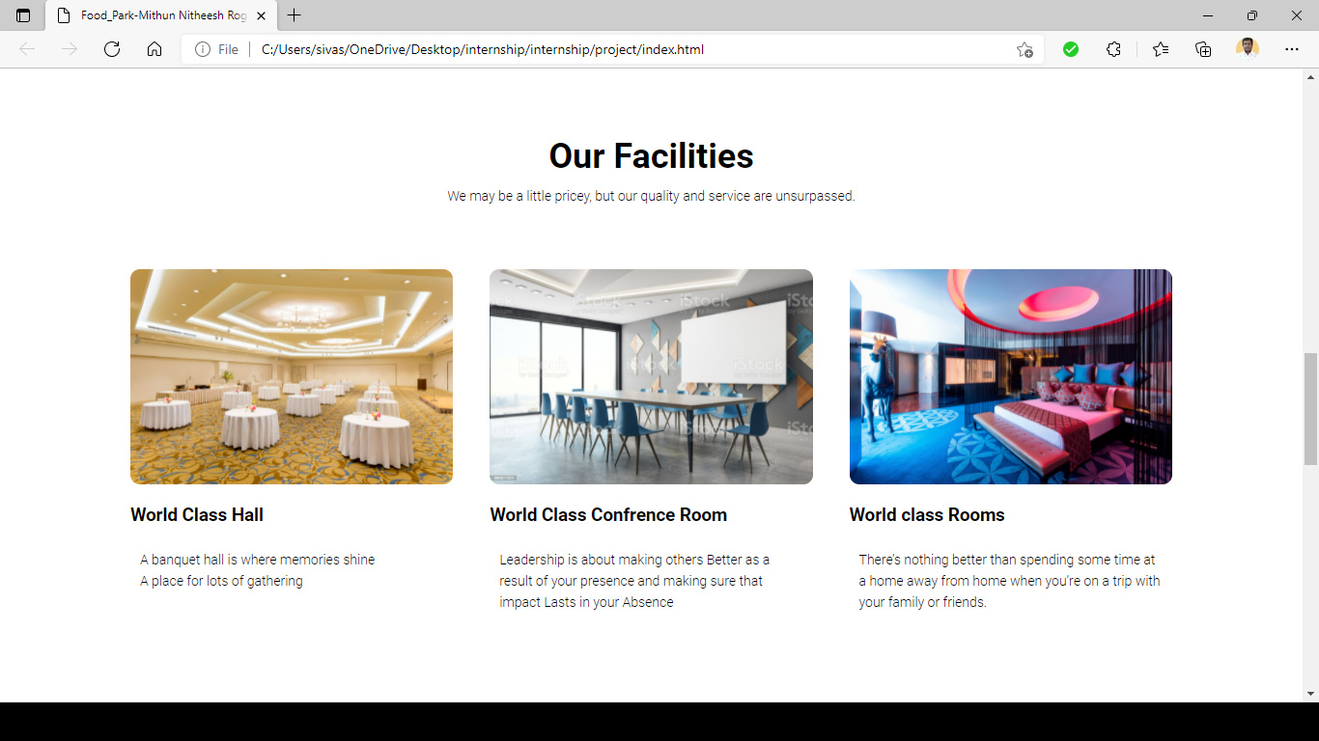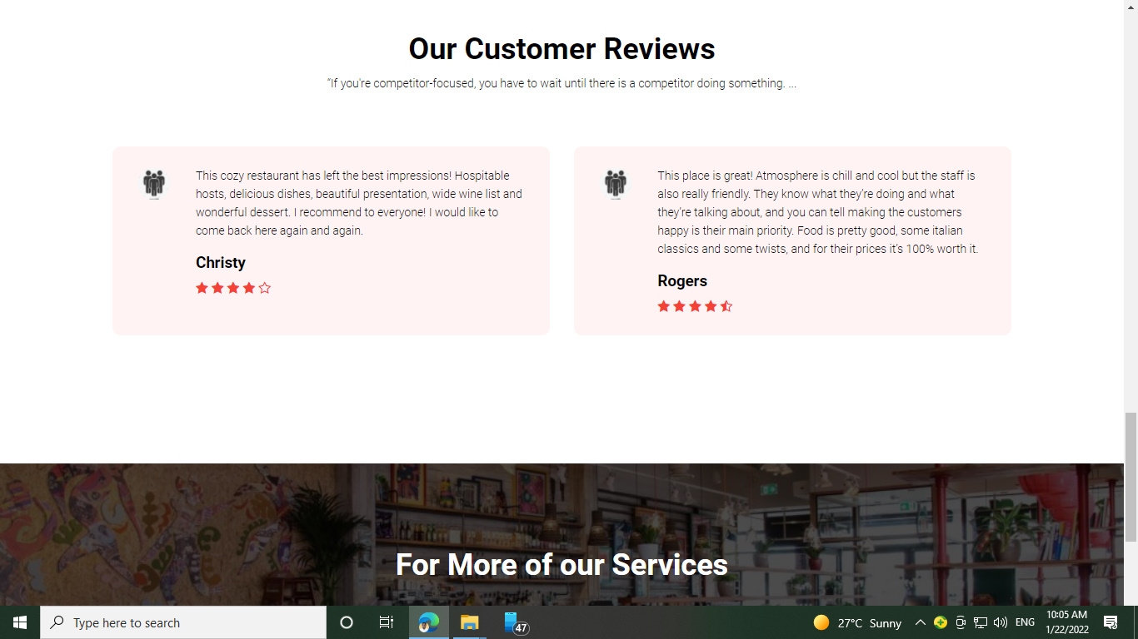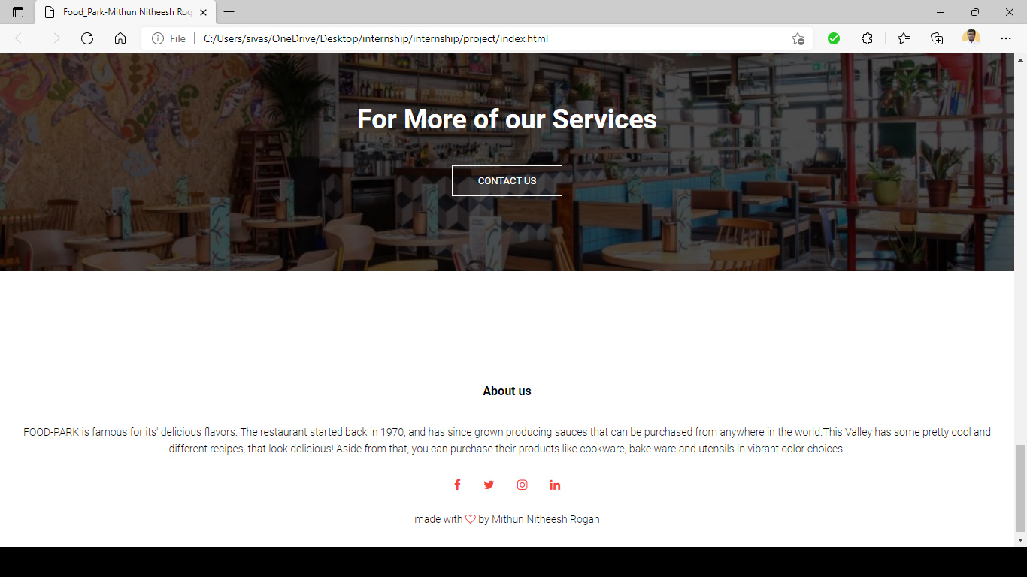

**Conclusion**

In this project, you will learn the aspects of creating a multi-page responsive website for the user interface.

We are indeed entering a new age of Web design and development. Far too many options are available now, and there will be far too many in the future to continue adjusting and creating custom solutions for each screen size, device and advancement in technology. We should rather start a new era today: creating websites that are future-ready right now. Understanding how to make a design responsive to the user doesn’t require too much learning, and it can definitely be a lot less stressful and more productive than learning how to design and code properly for every single device available.

Responsive Web design is a mere concept that when implemented correctly can improve the user experience, but not completely solve it for every user, device and platform. We will need to constantly work with new devices, resolutions and technologies to continually improve the user experience as technology evolves in the coming years.

Besides saving us from frustration, responsive Web design is also best for the user. Every custom solution makes for a better user experience. With responsive Web design, we can create custom solutions for a wider range of users, on a wider range of devices. A website can be tailored as well for someone on an old laptop or device as it can for the vast majority of people on the trendiest gadgets around, and likewise as much for the few users who own the most advanced gadgets now and in the years to come. Responsive Web design creates a great custom experience for everyone.