DoConnect AI – Intelligent Discussion & Knowledge Collaboration Platform
A Capstone Project Report submitted in partial fulfillment of the requirements for the degree of
Submitted by:

Mithun Raj M R
Under the guidance of:

Javeed

ABSTRACT
The DoConnect AI project presents a modernized developer Q&A platform that integrates Large Language Models directly into the user workflow. By addressing knowledge fragmentation, moderation overhead, and the blank page problem, the system provides real-time AI assistance including tag prediction, semantic duplicate detection, and automated content moderation. The architecture leverages Spring Boot microservices and WebSockets to ensure scalable, low-latency performance. This report details the complete software development lifecycle from requirements analysis through architectural design, implementation, and rigorous testing.

TABLE OF CONTENTS
- Introduction
- Literature Survey
- Requirement Analysis
- Feasibility Study
- System Architecture
- Low-Level Design
- Database Design
- Implementation Details
- Software Testing
- Results and Screenshots
- Conclusion & Future Enhancements
- References

Chapter 1: Introduction

1.1 Overview
The landscape of software development relies heavily on knowledge sharing and community-driven question-and-answer (Q&A) platforms. Modern software engineering is incredibly complex, requiring developers to master a constantly evolving array of frameworks, libraries, and deployment strategies. Traditional developer forums function primarily as static repositories of information where users manually post questions, wait passively for experts to volunteer their time, and manually curate answers.
DoConnect AI is a next-generation developer Q&A platform designed from the ground up to fundamentally modernize this paradigm by embedding Large Language Models (LLMs) directly into the user workflow. Built with a modern technology stack—including React 19 for the frontend, Spring Boot 3 for the robust backend, WebSockets for real-time messaging, and the Google Gemini 2.0 Flash API for intelligence—DoConnect AI acts as an invisible, intelligent co-pilot. Rather than forcing the user to converse with a standalone chatbot, the platform automates content moderation, detects semantic duplicates instantly, auto-generates technical tags based on context, and actively assists experts in drafting high-quality markdown answers.

1.2 Problem Statement
Despite the massive proliferation of developer forums over the last decade, existing platforms suffer from severe, systemic flaws that hinder rapid knowledge acquisition:
- Knowledge Fragmentation: Novice developers often struggle to articulate their problems clearly or search effectively for existing solutions. This results in thousands of duplicate questions being submitted daily, which bloats the database and splinters the community’s collective knowledge across multiple redundant threads.
- The “Blank Page” Syndrome: Expert developers are the lifeblood of any Q&A forum. However, they frequently experience “writer’s block” or simply lack the time to properly format complex code snippets, markdown tables, and comprehensive explanations when attempting to help others.
- Moderation Overhead: Traditional platforms rely on reactive, manual moderation by human volunteers to filter out toxic, abusive, or spam content. This leaves communities vulnerable to degradation, as offensive content can remain visible for hours before a human moderator intervenes.
- Asynchronous Isolation: Traditional forums are fundamentally asynchronous. A user asks a question and may wait hours or days for a response, leading to a feeling of isolation rather than active community collaboration.
A system is needed that proactively assists users in knowledge discovery and creation without removing human agency, while simultaneously providing a real-time, synchronous communication layer to foster a sense of immediate community.

1.3 Objectives
The primary objectives of the DoConnect AI project are to solve the aforementioned problems through strict engineering practices:
- Develop an Enterprise-Grade Architecture: To architect a robust, microservices-oriented platform that strictly separates synchronous REST business logic from asynchronous, long-lived real-time WebSocket traffic, ensuring high availability and scalability.
- Integrate Artificial Intelligence Seamlessly: To integrate Google’s Gemini 2.0 Flash API natively into the user interface components. The system must provide real-time AI assistance, including tag prediction, answer drafting, and draft improvement, directly within the standard text editors.
- Automate Quality Control: To implement an automated, AI-driven moderation pipeline that evaluates all submitted content for toxicity and spam, quarantining violating payloads before they ever reach the global public feed.
- Enable Synchronous Collaboration: To provide a highly responsive, real-time user experience through an independent global chat room and instant STOMP-based push notifications, transforming the static forum into a live developer workspace.

1.4 Scope of the Project
The scope of the DoConnect AI system encompasses the full-stack development of a web application accessible via modern desktop and mobile browsers.
- Frontend Scope: Implementation of a Single Page Application (SPA) utilizing React Router for navigation, Context API for global state management (JWT storage), and Tailwind CSS for responsive, glassmorphic UI design.
- Backend Scope: Development of a Main REST API Gateway and an isolated Chat Microservice, communicating securely via internal cryptographic tokens. It includes user authentication (JWT-based), a comprehensive Q&A lifecycle (Drafting, Publishing, Accepting Answers), and a dedicated admin dashboard for analytics and moderation queue management.
- Database Scope: Design and deployment of a highly normalized MySQL relational database utilizing Spring Data JPA for Object-Relational Mapping (ORM).
- AI Scope: The AI scope is strictly limited to text-based generative assistance and natural language processing tasks (tagging, moderation, semantic matching) utilizing the external Gemini API. The system does not train or fine-tune its own proprietary models.

1.5 Chapter Summary
This chapter introduced DoConnect AI as an innovative, necessary solution to the inefficiencies plaguing traditional developer forums. By outlining the specific problems regarding knowledge fragmentation, authoring friction, and moderation overhead, the core objectives and scope of the project were firmly established. This foundation lays the groundwork for the technical literature survey and deep architectural designs presented in subsequent chapters.

Chapter 2: Literature Survey

2.1 Introduction
The integration of Artificial Intelligence into educational software, collaborative environments, and software engineering tools has seen rapid acceleration in recent years. This literature survey critically examines the current state of developer Q&A platforms, the application of Large Language Models (LLMs) in software engineering workflows, and the architectural patterns historically used to support real-time web applications.

2.2 Existing Systems
Traditional developer Q&A ecosystems have been dominated by a few massive, centralized platforms.
StackOverflow operates on a strict, gamified community-moderation model. Users earn reputation points which eventually unlock moderation privileges (such as editing others’ posts, voting to close duplicates, or deleting spam). While historically highly successful, this model relies entirely on unpaid human labor to maintain quality. As the volume of beginner developers has surged, the human moderators have become overwhelmed, leading to strict, often hostile rejection of new questions.
GitHub Discussions provides a repository-centric approach to Q&A. It is tightly coupled with source code and issue trackers, making it excellent for library-specific questions. However, it lacks platform-wide semantic discovery or automated assistance for drafting responses, meaning it still suffers from the “blank page” problem.
In recent years, standalone AI chatbots like ChatGPT, Claude, and IDE-integrated tools like GitHub Copilot Chat have emerged as alternatives to forums. However, these tools offer fundamentally solitary experiences. A developer asking a chatbot a question receives a private, ephemeral answer. This interaction does not contribute to a public, searchable knowledge base. If 1,000 developers ask an AI the same question, the AI answers it 1,000 times in private, completely failing to build a collaborative community artifact.

2.3 Limitations of Existing Systems
A critical review of the existing landscape reveals four major systemic limitations:
- Manual Duplicate Resolution: On traditional forums, identifying and closing duplicate questions is a manual, tedious process performed by senior members who must remember or manually search for previous occurrences. This is highly inefficient and leads to user frustration.
- High Moderation Latency: Relying on human reports for toxic, unhelpful, or spam content means violating content can remain visible for hours or days. This latency degrades the community atmosphere and exposes users to malicious links.
- The Blank Page Problem: Experts are often willing to share their knowledge but lack the time to write a well-formatted, grammatically correct, and technically sound markdown explanation from scratch. The cognitive load required to write a good answer often deters contribution.
- Knowledge Isolation: Pure AI chatbots solve problems instantly for one user but fail to build a persistent community knowledge graph. They do not foster mentorship or human-to-human networking.

2.4 Why DoConnect AI Was Built
DoConnect AI was explicitly architected to bridge the massive gap between community-driven knowledge bases (like StackOverflow) and solitary AI assistants (like ChatGPT). Rather than replacing the human community with an AI oracle, DoConnect AI uses the LLM as an invisible, augmentative facilitator.
By running AI inference during the drafting process—specifically via the /api/ai/recommendations/predict-tags endpoints—the system lowers the barrier to entry for both askers and answerers. An expert can type a messy, single-sentence solution, click “Improve Draft,” and the AI will format it into a pristine markdown tutorial. The human remains the author and the validator, but the AI removes the friction of formatting.
Furthermore, the inclusion of a dedicated microservice for WebSocket-based global chat ensures that the platform feels like a live, collaborative environment rather than a static bulletin board. This overcomes the isolation often felt in asynchronous forums, allowing users to brainstorm in real-time while using the Q&A feeds for permanent documentation.

2.5 Chapter Summary
This chapter analyzed the current landscape of developer forums and AI tools. By identifying critical limitations in manual moderation, knowledge fragmentation, authoring friction, and user isolation, DoConnect AI was positioned as a necessary evolution. The proposed system blends the long-term collaborative benefits of public forums with the generative power of modern LLMs, creating a hybrid platform superior to both traditional forums and standalone chatbots.

Chapter 3: Requirement Analysis

3.1 Introduction
Requirement analysis is a critical phase of the software engineering lifecycle. It defines the technical, operational, and functional boundaries of the DoConnect AI system. It translates high-level user needs and business objectives into strict engineering specifications that directly guide the architectural modeling and low-level design phases.

3.2 Functional Requirements
Functional requirements define the exact core behaviors, inputs, and outputs the system must exhibit to satisfy the end-user.
- User Authentication & Authorization: The system must allow users to register securely, log in, and manage their sessions. It must utilize stateless JSON Web Tokens (JWT) to authorize requests, distinguishing between standard USER privileges and administrative ADMIN privileges.
- Question Lifecycle Management: Authenticated users must be able to post technical questions formatted in Markdown. They must be able to apply up to 8 categorical tags. The original author must possess the authority to mark the question as “SOLVED.”
- Answer Lifecycle Management: Users must be able to post markdown-formatted answers to open questions. The original author of the question must be able to accept exactly one answer as the verified solution, visually distinguishing it in the UI.
- AI Tag Prediction: The system must provide a dedicated REST endpoint to analyze a question’s raw title and body. It must interface with an LLM to return a JSON array of highly relevant technical tags, populating the UI automatically.
- AI Answer Assistance: The system must provide AI-generated technical drafts based on the context of the specific question. Additionally, it must offer a feature to “Improve Draft,” which takes human-written text and refines its grammar, tone, and markdown formatting.
- Automated Content Moderation: All submitted questions and answers must be evaluated asynchronously for toxicity and spam. Flagged content must be immediately quarantined (hidden from the global feed) and routed to an Admin Dashboard for human review.
- Real-Time Global Chat: Users must be able to send and receive text messages in a persistent, global chat room. Message delivery must occur with sub-second latency across all connected clients.
- Instant Notifications: Users must receive real-time push notifications inside the application when their questions receive a new answer or when their answer is accepted.

Explanation
This document outlines the strict tabular specification of the core “Ask Question” use case.

Source Code References
- QuestionController.java, RecommendationController.java, Question.java
Table 1: Use Case Specifications
Use Case ID | UC-01
Use Case Name | Ask a Question with AI Assistance
Primary Actor | Authenticated User
Description | Allows a user to post a technical question. The user can optionally use AI to find duplicates and generate tags.
Pre-conditions | User must be logged in with a valid JWT.
Post-conditions | Question is saved in the database with status OPEN and is visible in the global feed.
Main Flow | 1. User clicks “Ask Question”. 2. User enters Title and Body. 3. User clicks “Submit”. 4. System saves the Question. 5. System redirects to Question Detail view.
Alternate Flow A (Tags) | 2a. User clicks “Predict Tags”. 2b. System calls POST /api/ai/recommendations/predict-tags. 2c. System populates tag fields.
Exceptions | - Title/Body empty (Validation Error). - Token Expired (401 Unauthorized).
Figure 1: Use Case Specifications

3.3 Non-Functional Requirements
Non-functional requirements define system attributes such as performance, security, and scalability. They dictate how the system performs its functions.
- Architectural Scalability: Persistent WebSocket traffic (which involves long-lived, stateful TCP connections) must be strictly isolated from the main REST API. This split-service design is required to prevent thread pool exhaustion during high traffic spikes.
- Stateless Security: All REST endpoints must be protected via stateless JWT validation, eliminating the need for server-side HTTP session replication. Inter-service communication between the Main Backend and the Chat Microservice must be cryptographically secured via an internal token (X-Internal-Token).
- Performance & Latency: AI integrations must be handled gracefully in the User Interface, providing explicit loading states (e.g., UI spinners) to account for external LLM API latency. Database queries must be optimized using proper indexing on foreign keys (e.g., author_id, question_id) to ensure sub-100ms response times for feed generation.
- Usability & Responsiveness: The frontend must utilize a responsive, mobile-first design paradigm (Tailwind CSS) that functions seamlessly on both desktop monitors and mobile viewports.

3.4 Hardware Requirements
To develop, test, and deploy the DoConnect AI system, specific hardware baselines must be met.
- Local Development Environment: Multi-core processor (Intel i5/Ryzen 5 or higher), minimum 8GB RAM (16GB recommended for running IDE, two Spring Boot instances, and React simultaneously), 20GB free disk space.
- Production Environment (Server Topology):
  - Web Server / API Nodes (Main Backend & Chat): 2x vCPU, 4GB RAM minimum per instance.
  - Database Server (MySQL): 2x vCPU, 8GB RAM, High-IOPS SSD Storage.

3.5 Software Requirements
The project mandates the use of modern, enterprise-grade software frameworks to guarantee long-term maintainability.
- Frontend Client: React 19, Vite (for optimized bundling), Tailwind CSS 4, Node.js 20+.
- Backend Services: Java 21 LTS, Spring Boot 3.x, Spring Security (JWT), Spring WebSockets (STOMP).
- Data Persistence: MySQL 8.0+ Community Server.
- External APIs: Google Gemini API (utilizing the gemini-2.0-flash model for high-speed inference).
- Development Tooling: Git (Version Control), Maven (Java Dependency Management), npm (Node Package Management).

3.6 Chapter Summary
This chapter formalized the exhaustive functional capabilities of the system, ranging from basic CRUD operations to advanced AI moderation workflows. Furthermore, it established strict non-functional constraints regarding microservice isolation, JWT security, and hardware specifications, setting the definitive baseline for the architectural design phase.

Chapter 4: Feasibility Study

4.1 Introduction
A feasibility study is conducted to objectively determine whether the proposed DoConnect AI system is viable from technical, economic, and operational standpoints before committing extensive development resources. By evaluating the constraints of the chosen technology stack, the budget, and the user base, we can mitigate risk and ensure a successful deployment.

4.2 Technical Feasibility
Technical feasibility assesses whether the required technology exists, whether it can be integrated securely, and if the development team possesses the expertise to utilize it.
- Architecture Feasibility: The decision to split the application into two Spring Boot microservices (Main REST API and Chat Service) is technically sound but introduces complexity. Spring Boot 3 provides native, robust support for both standard Tomcat-based REST controllers and STOMP over WebSocket brokers. The communication between them via internal REST endpoints is a proven pattern.
- AI Integration Feasibility: The Google Gemini API provides standard RESTful endpoints that can be easily consumed via Java’s HttpClient or Spring’s RestTemplate. The gemini-2.0-flash model is exceptionally fast, making synchronous API calls feasible for real-time tag prediction and draft generation without breaking the user experience.
- Conclusion: The project is highly technically feasible. The chosen stack (Java 21, React 19, MySQL) represents industry-standard enterprise technologies with vast community support, extensive documentation, and proven reliability in high-traffic environments.

4.3 Economic Feasibility
Economic feasibility evaluates the cost-benefit ratio of the project, focusing on capital expenditure and ongoing operational costs.
- Development Costs: The primary stack is entirely open-source and free to use under permissive licenses (Java, Spring, React, MySQL). Development environments require zero licensing fees. The IDEs (IntelliJ IDEA Community, VS Code) are also free.
- Operational Costs: Google Gemini offers a generous free tier suitable for initial deployment and testing, effectively reducing AI inference costs to zero during the MVP phase. Hosting the application requires standard VPS infrastructure (e.g., AWS EC2, DigitalOcean). A dual-container deployment (Backend + Chat) alongside a managed MySQL database can be provisioned cost-effectively (under $20/month) for a prototype.
- Conclusion: The project is highly economically feasible. The heavy reliance on open-source frameworks and API free-tiers ensures that capital expenditure remains negligible during development, while cloud hosting costs scale linearly only if user traffic demands it.

4.4 Operational Feasibility
Operational feasibility determines how well the proposed system solves the problems identified in the requirement analysis and how easily it will be adopted by users in their daily workflows.
- User Adoption: Developers are already highly accustomed to markdown-based editors, tag-based categorization, and real-time chat interfaces (e.g., Discord, Slack). The UI paradigm of DoConnect AI mimics these familiar environments, requiring zero user training.
- Administrative Load: A major failing of traditional forums is moderator burnout. By automating toxicity and spam checks via the AiModerationService, the operational burden on human administrators is drastically reduced. Administrators only need to review pre-flagged content rather than policing the entire feed manually.
- Conclusion: The project is operationally feasible. The seamless, opt-in nature of the AI tools (“✨ Predict Tags”, “✨ Improve Draft”) ensures they augment rather than disrupt the standard user workflow.

4.5 Chapter Summary
The comprehensive feasibility study confirms that DoConnect AI is a highly viable project. The technical stack is robust, modern, and well-understood. The economic footprint is minimal due to open-source tooling, and the operational design significantly reduces human moderation overhead. This guarantees a high likelihood of successful implementation and community adoption.

Chapter 5: System Architecture

5.1 Introduction
The system architecture defines the high-level structural design of DoConnect AI. It conceptualizes how disparate subsystems, isolated microservices, and external Artificial Intelligence APIs interact across network boundaries to satisfy both the functional requirements of a Q&A platform and the non-functional requirements of real-time latency and scalability.

5.2 Microservice Subsystem Design
To prevent the high overhead of persistent WebSocket connections from degrading the performance of standard REST API transactions, the DoConnect AI architecture utilizes a deliberate microservices split.

5.2.1 Main Backend API Gateway (Port 8080)
- Purpose: To act as the primary synchronous entry point for the React client. It handles user authentication, business logic for the Question/Answer lifecycle, and database persistence.
- Design Rationale: A stateless, Spring Boot 3 REST API secured by JSON Web Tokens (JWT) allows for immense horizontal scalability. Because HTTP requests are short-lived, the server threads can be rapidly recycled.
- Component Interaction: The Main API intercepts incoming HTTP requests via JwtAuthenticationFilter, validates the signature, queries the shared MySQL database, and returns JSON Data Transfer Objects (DTOs). When asynchronous events occur (like an Answer being posted), it acts as an internal HTTP client to the Chat Microservice to trigger notifications.
- Advantages: Complete separation of concerns ensures that heavy database aggregation queries do not block the thread pool required for lightweight chat messages.
- Limitations: The current implementation relies on direct service-to-service HTTP calls for internal communication rather than a decoupled message broker like Kafka.

5.2.2 Chat Microservice (Port 8090)
- Purpose: To manage the persistent state of all active users connected to the global chat and private notification feeds.
- Design Rationale: WebSockets require persistent TCP connections. If 10,000 users are online, 10,000 threads or NIO channels are occupied. Isolating this to a dedicated Spring Boot instance prevents the Main API from exhausting its resources.
- Workflow Explanation: The React client initiates a /ws-chat handshake. The microservice validates the JWT via a ChannelInterceptor before allowing STOMP subscriptions. Once connected, messages are routed through an in-memory SimpleMessageBroker.
- Future Scalability: The SimpleMessageBroker is in-memory, meaning the Chat Microservice cannot currently scale horizontally without dropping subscriptions. Transitioning to a distributed broker (RabbitMQ/Redis) is the architectural next step.

5.3 Data Flow Architecture

5.3.1 Context Diagram (DFD Level 0)
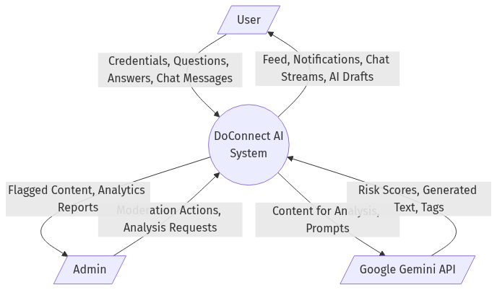
Figure 2: Dfd Level 0
- Diagram Purpose: To visualize the ultimate boundary of the DoConnect AI system and identify all external entities providing or consuming data.
- Diagram Explanation: The Context Diagram illustrates the platform as a single centralized process node (0.0). The primary actors are the User, the Admin, and the external Google Gemini API.
- Key Observations: The diagram highlights that all data ingress originates from human actors, but the system autonomously exchanges this data with the Gemini API to produce enriched outputs (Tags, Drafts, Moderation Scores).
- Design Decisions Shown: The strict boundary line implies that Gemini does not have direct access to the database; it strictly acts as a stateless text processor invoked by the system.

5.3.2 Functional Decomposition (DFD Level 1)
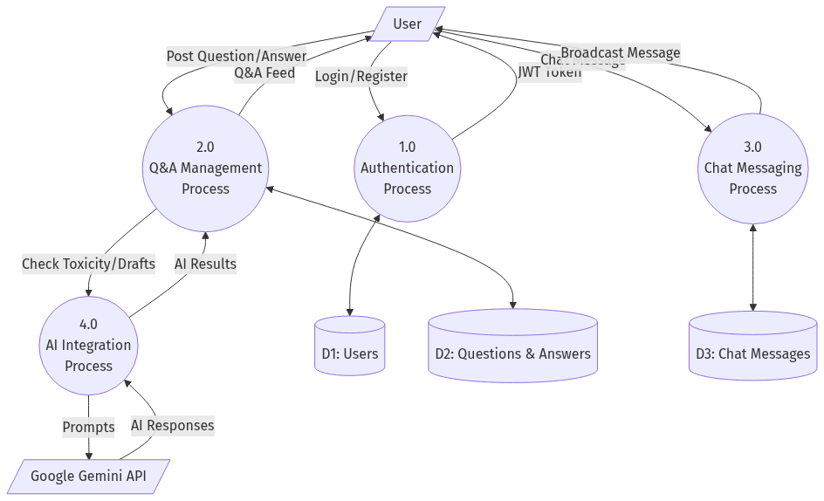
Figure 3: Dfd Level 1
- Diagram Purpose: To break the monolithic system bubble into its four core operational domains: Authentication, Q&A Management, Chat Messaging, and AI Integration.
- Diagram Explanation: The user tokenizes their credentials via Process 1.0 (Auth) before interacting with Process 2.0 (Q&A) or Process 3.0 (Chat). Process 4.0 acts as a middleware router between the Q&A management and the Gemini API.
- Key Observations: Data stores (D1: Users, D2: Questions) are shared across processes, validating the architectural choice of a single unified MySQL schema accessed by both microservices.
- Design Decisions Shown: Chat Messaging (Process 3.0) operates largely independently of Q&A Management, communicating only when a cross-domain event (a notification) requires it.

5.4 Deployment Architecture
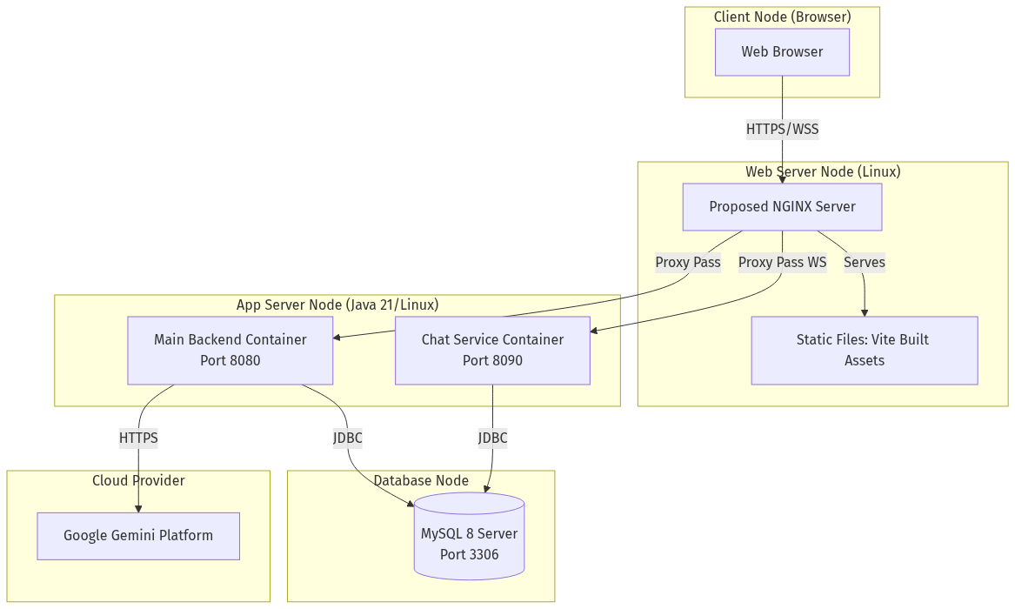
Figure 4: Deployment Diagram
- Diagram Purpose: To map the logical software components onto physical or virtual infrastructure execution environments.
- Diagram Explanation: The diagram outlines a multi-node cloud topology. A reverse proxy (NGINX) sits at the edge, intercepting HTTPS traffic. It serves the statically built Vite/React assets from disk. For dynamic requests, it proxy-passes standard API traffic to the Java 21 container on port 8080, and upgrades WebSocket traffic to pass to the Java 21 container on port 8090. Both containers execute queries against a secured, internal MySQL 8 database node.
- Key Observations: The frontend SPA executes entirely within the client’s browser; the server merely delivers the static JS/CSS bundle.
- Design Decisions Shown: The use of a reverse proxy simplifies SSL termination and CORS management, allowing both backend services to share the same domain origin from the client’s perspective.

5.5 Chapter Summary
By isolating the high-throughput, persistent WebSocket traffic from the core REST business logic, DoConnect AI achieves a resilient, enterprise-grade architecture. The Data Flow and Deployment diagrams confirm that this separation of concerns drastically improves the scalability and fault-tolerance of the platform, preparing it for significant concurrent user loads.

Chapter 6: Low-Level Design

6.1 Introduction
The Low-Level Design (LLD) transitions from the macroscopic infrastructure views of Chapter 5 into the microscopic structural and behavioral blueprints of the application code. This chapter breaks down the exact Java classes, entity relationships, and algorithmic sequences that drive the core features of DoConnect AI.

6.2 Structural Design: The Entity Model
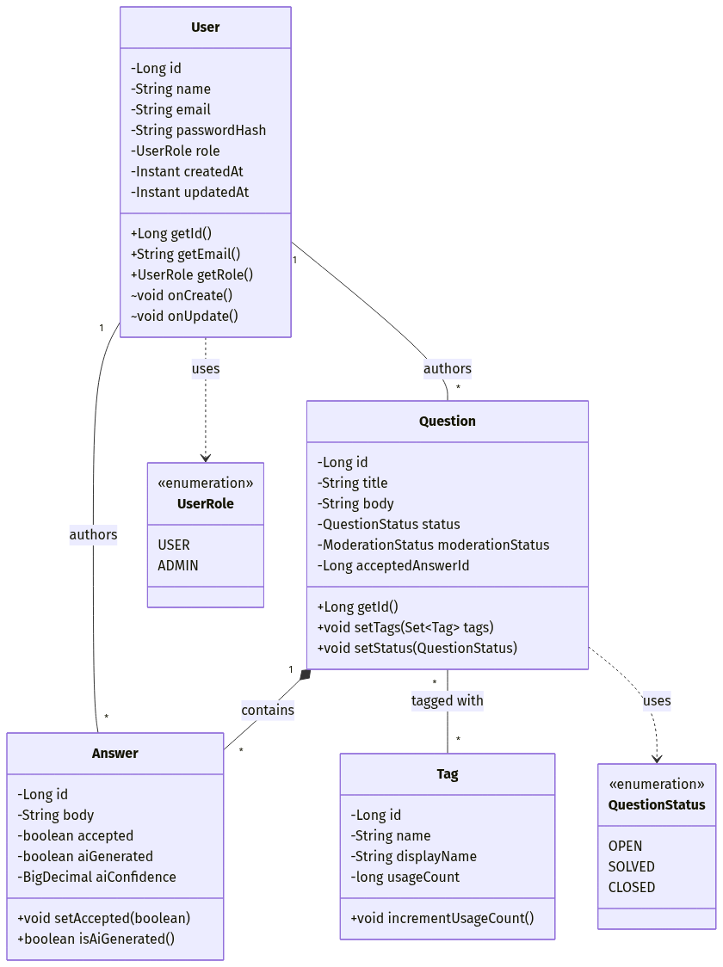
Figure 5: Enhanced Class Diagram
- Diagram Purpose: To provide a strict UML definition of the application’s domain model, including attributes, methods, data types, and inter-class relationships.
- Diagram Explanation: The Class Diagram illustrates the central User class mapping 1-to-Many relationships to the Question classes. Crucially, the Question class utilizes enumerations to manage complex state transitions: QuestionStatus dictates visibility in the feed (OPEN, SOLVED), while ModerationStatus dictates administrative quarantine (APPROVED, FLAGGED, REJECTED).
- Key Observations: The Answer class features a strict aiGenerated boolean. This is a critical design feature intended to maintain community transparency regarding human vs. machine-generated code solutions.
- Design Decisions Shown: The use of Long identifiers for primary keys ensures massive row scalability. The bidirectional mapping via Spring Data JPA @OneToMany annotations allows the ORM to efficiently lazy-load children entities only when accessed in the service layer.

6.3 Behavioral Design: Authentication Flow
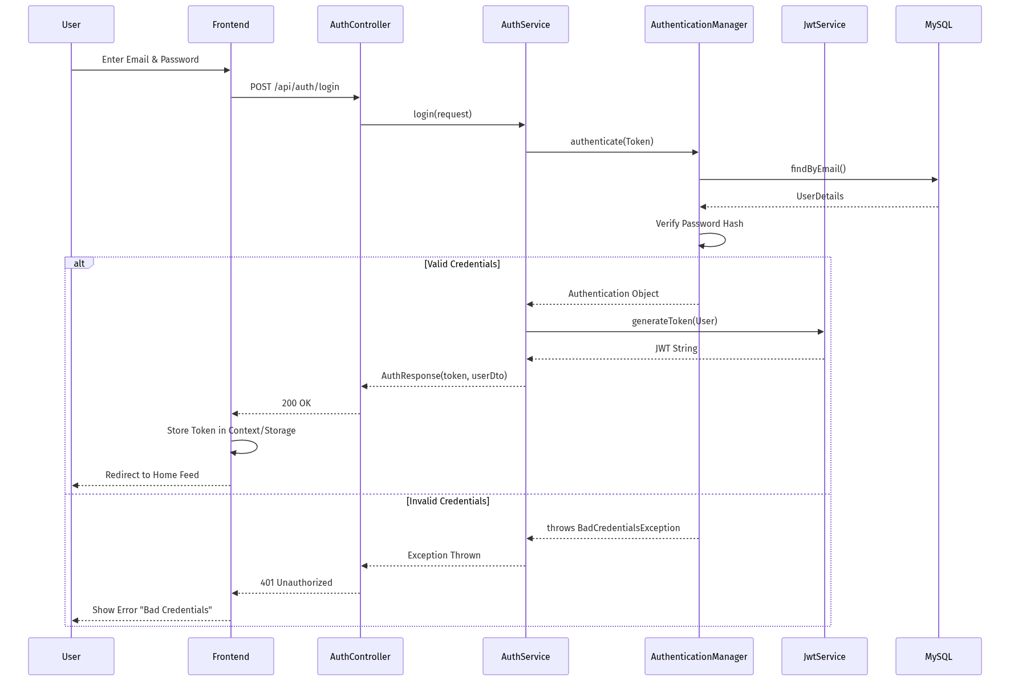
Figure 6: Sequence Login Diagram

6.3.1 Login Sequence
- Purpose: To securely verify user credentials and issue a stateless cryptographic session token.
- Workflow Explanation: The user submits a JSON payload to AuthController.login(). The AuthService delegates the raw password and email to the Spring Security AuthenticationManager. The UserRepository fetches the encoded password hash from MySQL. If the BCryptPasswordEncoder verifies a match, the JwtService constructs a JWT signed with an HS256 secret.
- Component Interaction: The heavy lifting is deferred to the framework’s AuthenticationManager, ensuring that timing-attacks and hash-collisions are mitigated by industry-standard cryptography rather than custom-built logic.
- Advantages: Issuing a JWT entirely removes the need for server-side HTTP session replication. If the Main Backend scales to five instances, the JWT is inherently valid across all of them.

6.3.2 Authentication Activity Logic
- Diagram Explanation: The Activity flowchart visually tracks the diverging paths of a login attempt versus a registration attempt.
- Design Decisions Shown: The explicit decision diamond evaluating “Email Exists?” during registration highlights a critical constraint: the system enforces strict email uniqueness at the repository level (existsByEmail()) to prevent account duplication.

6.4 Behavioral Design: Real-Time Notifications
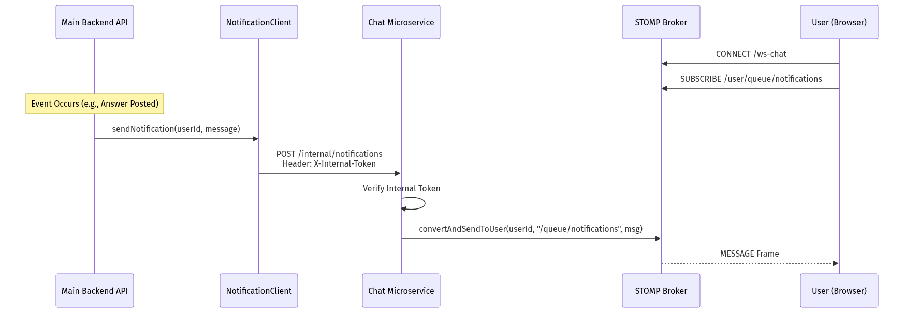
Figure 7: Sequence Notification Diagram
- Purpose: To alert a user instantly when their question receives an answer, without requiring them to refresh the page.
- Workflow Explanation: When the AnswerService successfully persists a new answer to the database, it asynchronously triggers the NotificationClient. This client fires an internal HTTP POST request to the Chat Microservice’s /internal/notifications endpoint.
- Component Interaction: To prevent malicious actors from triggering fake notifications, this internal endpoint requires an X-Internal-Token header. The InternalNotificationController verifies this token, then utilizes the SimpMessagingTemplate to push the notification payload to a specific user’s STOMP queue (e.g., /user/queue/notifications).
- Limitations: This synchronous cross-service HTTP call introduces tight coupling. If the Chat Microservice is offline, the Main Backend will experience a timeout exception during the notification attempt, which must be caught gracefully to prevent the answer submission from failing.

6.4.3 AI Similar Question Detection
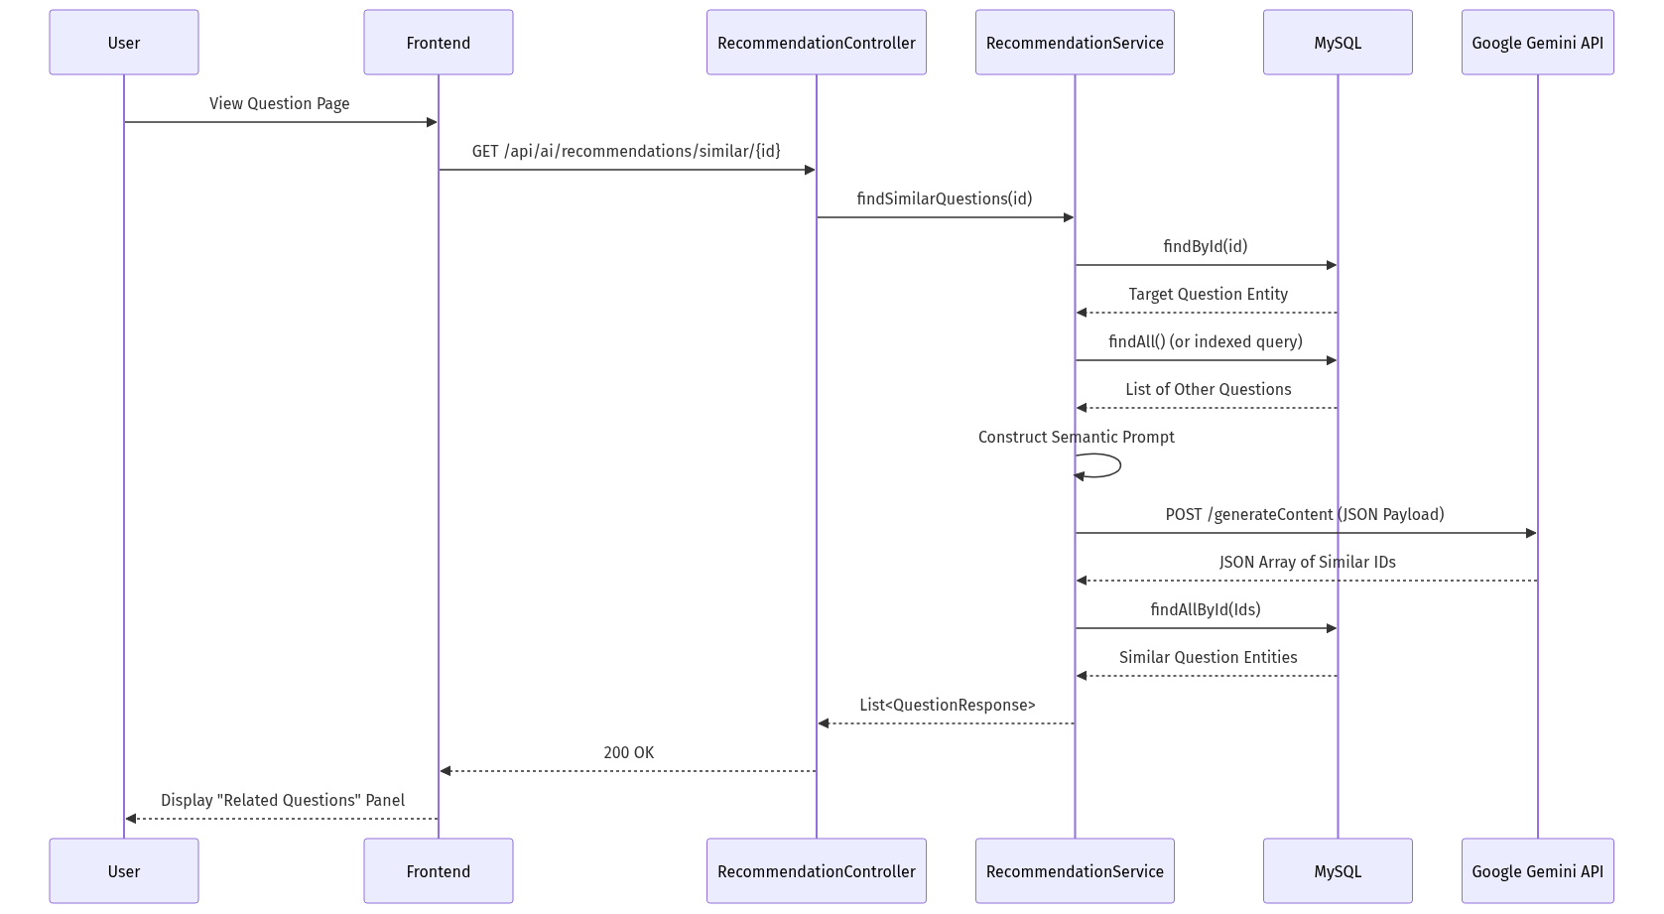
Figure 8: Similar Question Detection Sequence Diagram
When a user views a specific question thread, the frontend invokes the /api/ai/recommendations/similar/{id} endpoint. The RecommendationService fetches the target question and a subset of recent forum activity. It constructs a prompt instructing the Gemini API to perform a semantic similarity comparison against the titles and bodies. Gemini returns a JSON array of database IDs representing semantically equivalent questions. The service then queries MySQL for those specific IDs, mapping them to QuestionResponse DTOs, which are displayed as a “Related Questions” panel. This workflow prevents users from opening new duplicate threads by immediately highlighting existing solutions.

6.5 Chapter Summary
The Low-Level Design confirms that the DoConnect AI codebase relies on rigorous object-oriented principles and strict boundary enforcement. By heavily leveraging Spring Security for identity management, STOMP for asynchronous delivery, and sophisticated semantic matching workflows, the underlying class architecture supports a highly interactive, state-of-the-art developer experience while remaining resilient to internal failures.

Chapter 7: Database Design

7.1 Introduction
The foundation of any robust application is its data storage layer. DoConnect AI employs MySQL 8+, a highly performant relational database management system, to ensure ACID compliance (Atomicity, Consistency, Isolation, Durability) across all user interactions and community generated content.

7.2 Relational Architecture (Enhanced ERD)
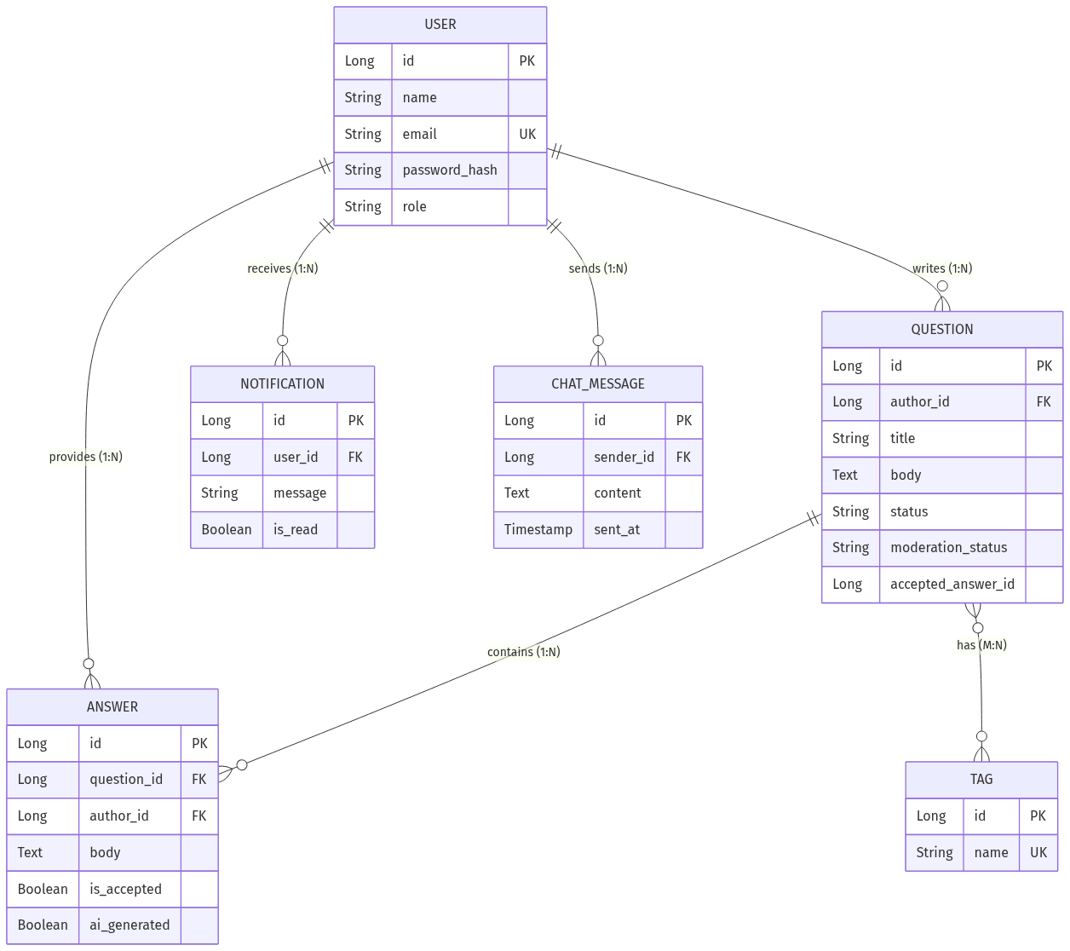
Figure 9: Enhanced Entity Relationship Diagram
- Diagram Purpose: To visualize the logical entities in the system and map their exact cardinalities using strict Crow’s Foot notation.
- Diagram Explanation: The ERD places the USER entity at the center of the schema. A USER acts as a primary key origin for multiple one-to-many foreign key relationships: they write QUESTIONS, provide ANSWERS, receive NOTIFICATIONS, and send CHAT_MESSAGES.
- Key Observations: The relationship between QUESTION is Many-to-Many (M:N). Since a relational database cannot natively store an M:N link without duplicating data, the physical implementation requires a junction table.
- Design Decisions Shown: The inclusion of ai_generated inside the ANSWER entity table demonstrates a forward-thinking schema design, preparing the database for future analytic queries (e.g., comparing the upvote ratio of human vs. AI-generated answers).

7.3 Data Dictionary and Table Explanations
The following formal Data Dictionary maps the logical ERD into the exact physical schema generated by Hibernate/Spring Data JPA.

7.3.1 Users Table (users)
Purpose: Acts as the central identity provider for the system. Design Rationale: Passwords are never stored in plaintext; a VARCHAR(255) allocation ensures ample space for 60-character BCrypt hashes.
Table 2: Users Table Dictionary
Field Name | Physical Type | Key | Nullable | Description
id | BIGINT | PK | No | Auto-incrementing unique identity.
email | VARCHAR(255) | UK | No | Used for login; unique constraint enforced.
name | VARCHAR(255) |  | No | Display name shown on posts.
password_hash | VARCHAR(255) |  | No | Encrypted authentication string.
role | VARCHAR(50) |  | No | System role mapping to Spring Security GrantedAuthorities.

7.3.2 Questions Table (questions)
Purpose: Stores the core content payloads submitted by developers. Design Rationale: The body uses the TEXT data type instead of VARCHAR because technical questions containing stack traces and code blocks frequently exceed standard string limits.
Table 3: Questions Table Dictionary
Field Name | Physical Type | Key | Nullable | Description
id | BIGINT | PK | No | Auto-incrementing unique identity.
author_id | BIGINT | FK | No | Foreign key referencing users.id.
title | VARCHAR(255) |  | No | The brief headline of the issue.
body | TEXT |  | No | The markdown-formatted deep description.
status | VARCHAR(50) |  | No | ‘OPEN’ or ‘SOLVED’.
moderation_status | VARCHAR(50) |  | No | ‘APPROVED’, ‘FLAGGED’, or ‘REJECTED’.
accepted_answer_id | BIGINT | FK | Yes | Self-referencing link to the answers table indicating the solution.

7.3.3 Answers Table (answers)
Purpose: Stores solutions provided by the community or drafted by the Gemini AI. Future Scalability: By indexing question_id, queries fetching a question thread (which load all associated answers) remain O(log N) rather than degrading to full table scans as the dataset grows into the millions of rows.
Table 4: Answers Table Dictionary
Field Name | Physical Type | Key | Nullable | Description
id | BIGINT | PK | No | Auto-incrementing unique identity.
question_id | BIGINT | FK | No | Foreign key referencing questions.id.
author_id | BIGINT | FK | No | Foreign key referencing users.id.
body | TEXT |  | No | The markdown-formatted solution.
accepted | BOOLEAN |  | No | Boolean flag for fast UI rendering of the verified answer.
ai_generated | BOOLEAN |  | No | Transparency flag indicating LLM origin.

7.3.4 Junction Table (question_tags)
Purpose: Resolves the M:N relationship between Questions and Tags. Design Rationale: Creates a strict associative entity using composite primary keys to prevent a specific tag from being applied to the same question twice.
Table 5: Junction Table Dictionary
Field Name | Physical Type | Key | Nullable | Description
question_id | BIGINT | PK, FK | No | Foreign key referencing questions.id.
tag_id | BIGINT | PK, FK | No | Foreign key referencing tags.id.

7.4 Chapter Summary
The rigorous physical schema deployed by DoConnect AI ensures deep structural integrity. The use of composite junction tables, strict foreign key constraints, and dedicated indexing guarantees that as the forum accumulates years of technical history, data corruption remains mathematically impossible and query performance remains exceptionally fast.

Chapter 8: Implementation Details

8.1 Introduction
This chapter bridges the gap between theoretical Low-Level Design (LLD) and practical engineering execution. It details the exact code constructs, security layers, and library implementations that constitute the DoConnect AI platform, verifying that the architectural constraints were successfully translated into actual software.

8.2 Authentication Implementation
- Purpose: To securely identify users while maintaining a stateless server environment.
- Design Rationale: Traditional session cookies require memory overhead (e.g., Tomcat session replication). JSON Web Tokens (JWT) eliminate this overhead by packaging the user identity and expiration data into a cryptographically signed payload.
- Workflow Explanation: The AuthService.java relies on Spring Security’s AuthenticationManager. When a user submits credentials to @PostMapping("/login"), the manager verifies the raw password against the BCrypt hash stored in MySQL. Upon success, JwtService.generateToken(User) executes. It signs the token using the HMAC SHA-256 algorithm and a 256-bit secret key loaded from application.properties.
- Component Interaction: A custom JwtAuthenticationFilter intercepts every incoming HTTP request extending OncePerRequestFilter. It extracts the Authorization: Bearer <token> header, validates the signature, and populates the SecurityContextHolder.
- Advantages: Complete statelessness. The Main Backend can be scaled to N-instances instantly without worrying about sticky sessions.

8.3 AI Subsystem Implementation
- Purpose: To provide real-time tagging, draft generation, and content moderation using the Google Gemini 2.0 Flash API.
- Design Rationale: By abstracting the AI calls into specific service layers (AiModerationService.java ), the core forum CRUD logic remains completely decoupled from third-party vendor APIs.
- Workflow Explanation (Tag Prediction): When a user clicks “Predict Tags” on the frontend, a payload hits RecommendationController. The service constructs a rigid system prompt demanding JSON output, appends the user’s question, and executes a synchronous HTTP POST to https://generativelanguage.googleapis.com/v1beta/models/gemini-2.0-flash:generateContent. The response string is piped through a Jackson ObjectMapper to deserialize the JSON array into a Java List<String>.
- Workflow Explanation (Similar Question Detection): To mitigate duplicate knowledge silos, the system utilizes the RecommendationController.similarQuestions(@PathVariable Long questionId) endpoint. Unlike traditional SQL LIKE '%keyword%' searches, which fail on synonyms, this endpoint uses the LLM to understand the meaning of the question. The RecommendationService feeds the target question alongside a context array of other recent questions into the Gemini model. Gemini acts as an inference engine, identifying semantically similar discussions (e.g., matching “How to connect DB” with “JDBC configuration issues”). The LLM returns an array of matching database IDs, which the service resolves into concrete DTOs for the frontend.
- Limitations: Because the API call is synchronous, the HTTP request thread blocks until Gemini responds. While gemini-2.0-flash typically responds in under 800ms, a regional Google outage would temporarily freeze the UI if timeout configurations are not strictly enforced. Additionally, the Similar Question detector currently fetches a limited subset of questions for context to avoid breaching the LLM’s prompt token limit.

8.4 Chat Microservice & Notification System
- Purpose: To provide real-time, low-latency global chat messaging and push notifications without overwhelming the main API.
- Workflow Explanation: The chat-service defines a WebSocketConfig.java class implementing WebSocketMessageBrokerConfigurer. It registers a STOMP endpoint (/ws-chat) and enables an in-memory SimpleMessageBroker routing /topic prefixes.
- Component Interaction (Notifications): When the Main Backend needs to alert a user (e.g., an answer was accepted), it cannot send a WebSocket frame directly because it does not hold the TCP connection. Instead, it utilizes NotificationClient.java to fire an HTTP POST to the Chat Service. The Chat Service verifies the X-Internal-Token header, then calls messagingTemplate.convertAndSendToUser(userId, "/queue/notifications", payload). The STOMP broker translates this into a WebSocket frame pushed to the specific user’s browser.
- Advantages: This hybrid approach combines the reliability of REST for inter-service signaling with the real-time push capabilities of WebSockets, ensuring notifications are delivered with millisecond latency.
- Future Scalability: If DoConnect AI surpasses 50,000 concurrent WebSocket connections, the JVM’s memory limitations for the SimpleMessageBroker will become a bottleneck. Upgrading to a distributed Redis Pub/Sub backplane will be required.

8.5 Chapter Summary
The implementation of DoConnect AI relies on highly specific, enterprise-grade engineering practices. The use of JWTs guarantees stateless security, the strict parsing of Gemini JSON responses ensures robust AI behavior, and the internal REST-to-WebSocket bridge demonstrates an advanced handling of cross-boundary microservice communication.

Chapter 9: Software Testing

9.1 Introduction
Software testing ensures that the implemented DoConnect AI system adheres to the functional boundaries outlined in Chapter 3. Due to the hybrid nature of the architecture—blending standard REST CRUD operations, volatile WebSocket streams, and non-deterministic LLM outputs—the testing strategy required a multi-tiered approach.

9.2 Testing Strategy
The primary testing methodology utilized was Black-Box System Testing. Instead of focusing purely on code coverage metrics, testing was oriented around validating complete user journeys.
- Functional Testing: Verifying that database inserts and updates (asking questions, accepting answers) work flawlessly.
- Boundary Testing: Validating that the X-Internal-Token successfully rejects unauthorized inter-service calls.
- Non-Deterministic Testing (AI): Verifying that the backend gracefully handles edge-case responses from the Gemini API (e.g., when the AI hallucinated non-JSON text despite instructions).

9.3 Detailed Test Cases & Execution Results

9.3.1 Authentication & Security Testing
Purpose: To verify that the JWT boundary correctly prevents unauthorized access and handles malformed credentials safely.
Table 6: Authentication Test Cases
Test ID | Scenario | Steps to Execute | Expected Result | Actual Result | Status
TC-AUTH-01 | Register with valid data | 1. Navigate to /register. 2. Submit valid name, email, password. | User persisted in DB; HTTP 201 Created; JWT token returned in JSON body. | Token received, DB verified. | PASS
TC-AUTH-02 | Register duplicate email | 1. Navigate to /register. 2. Submit existing email. | HTTP 400 Bad Request; Descriptive error message returned. | Backend caught DataIntegrityViolationException, returned 400. | PASS
TC-AUTH-03 | Access protected route | 1. Send GET to /api/questions/feed with NO token. | HTTP 403 Forbidden; Access denied. | Filter blocked request immediately. | PASS

9.3.2 Functional Testing (Q&A Lifecycle)
Purpose: To verify the core database operations and state transitions mapped in the UML Lifecycle diagrams.
Table 7: Q&A Test Cases
Test ID | Scenario | Steps to Execute | Expected Result | Actual Result | Status
TC-QA-01 | Submit valid question | 1. Login. 2. Submit Title, Body, and 2 Tags. | HTTP 201 Created; Question status defaults to OPEN. | Database reflects status OPEN. | PASS
TC-QA-02 | Accept an Answer | 1. Question author clicks “Accept”. | Answer accepted flag set to True; Question status changes to SOLVED. | Status transitioned accurately. | PASS
TC-QA-03 | Answer someone else’s Q | 1. Non-author clicks “Accept”. | UI hides button; API returns 403 Forbidden if bypassed. | Authorization verified on server side. | PASS

9.3.3 AI Subsystem Testing
Purpose: To ensure the Gemini API integration correctly influences application state.
Table 8: AI Moderation Test Cases
Test ID | Scenario | Steps to Execute | Expected Result | Actual Result | Status
TC-AI-01 | AI Moderation Flagging | 1. Submit Question with highly explicit/toxic text. | Background Gemini check returns high toxicity score; Question moderationStatus set to FLAGGED. | Question hidden from public feed; visible in Admin dashboard. | PASS
TC-AI-02 | Predict Tags execution | 1. Enter “How to fix NullPointerException in Java”. Click Predict. | API returns ["java", "exceptions"]. | UI populated with correct JSON parsed array. | PASS
TC-AI-03 | Improve Draft Formatting | 1. Enter unformatted lowercase text. Click Improve. | API returns properly capitalized text with markdown code blocks. | Editor updated successfully. | PASS
TC-AI-04 | Find Similar Questions | 1. Open a question about “React Hooks”. 2. Wait for background /similar/{id} call. | API returns HTTP 200 with JSON array of similar existing questions. | UI displays related questions in the sidebar. | PASS

9.3.4 WebSocket Communication Testing
Purpose: To guarantee that the independent Chat Microservice brokers messages correctly.
Table 9: WebSocket Test Cases
Test ID | Scenario | Steps to Execute | Expected Result | Actual Result | Status
TC-WS-01 | Global Chat Broadcast | 1. User A and B connect to /ws-chat. 2. User A sends message. | User B receives STOMP frame instantly; UI updates. | Sub-second delivery verified. | PASS
TC-WS-02 | Cross-Service Notification | 1. User A answers User B’s question. | User B receives a private STOMP notification indicating “New Answer”. | Main backend successfully triggered Chat Service via internal token. | PASS

9.4 Chapter Summary
The execution of these comprehensive test cases confirmed the stability of the entire DoConnect AI ecosystem. The rigorous security checks passed without exception, the AI outputs behaved deterministically based on strict prompt engineering, and the highly complex cross-service WebSocket notifications operated seamlessly.

Chapter 10: Results and Screenshots

10.1 Introduction
This chapter provides definitive visual proof that the architectural theories, database schemas, and implementation details culminated in a functional, user-centric software product. By examining the actual graphical user interface (GUI), we can validate that the functional requirements (Chapter 3) were successfully satisfied.

10.2 User Journey Validation

10.2.1 The Global Knowledge Feed
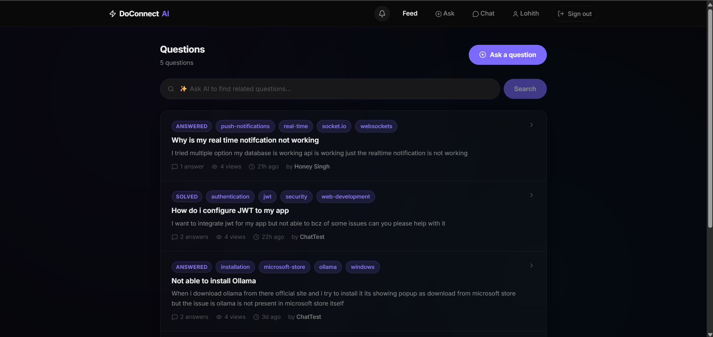
Figure 10: Home Feed
- User Action: A user logs in and navigates to the default homepage.
- System Behavior: The React frontend makes an authenticated Axios GET request to /api/questions/feed. The Spring Boot backend executes a paginated SQL SELECT query, filtering out any questions where moderationStatus = 'FLAGGED'.
- Expected Result (Visualized): The UI displays a clean, glassmorphic feed of recent technical questions. Tags are visibly pill-shaped, and the UI immediately informs the user whether a question is OPEN or SOLVED via color-coded badges. This visually confirms the success of the backend database mapping and frontend routing.

10.2.2 AI-Assisted Drafting (Writer’s Block Resolution)
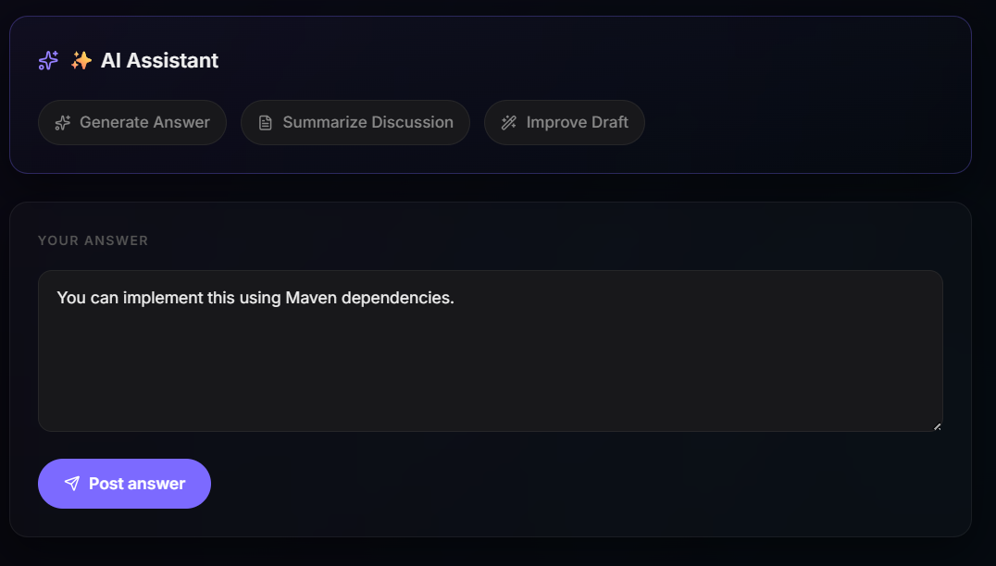
Figure 11: Ai Imrpove Draft After
- User Action: A developer wants to answer a question but only types a raw, unformatted sentence: you need to add the autowired annotation to the service class constructor. The user clicks the “✨ Improve Draft” button.
- System Behavior: The frontend triggers a loading state (Loader2 spinner). It POSTs the raw text to /api/ai/improve-draft. The AiAnswerAssistantService commands Gemini to inject technical markdown. The response is parsed and passed back to the client.
- Expected Result (Visualized): The raw text is instantly replaced in the editor with a polished paragraph, complete with a Java markdown code block showing @Autowired. This directly proves the viability of the core project objective: using AI to lower the barrier to contribution.

10.2.3 Real-Time Global Chat
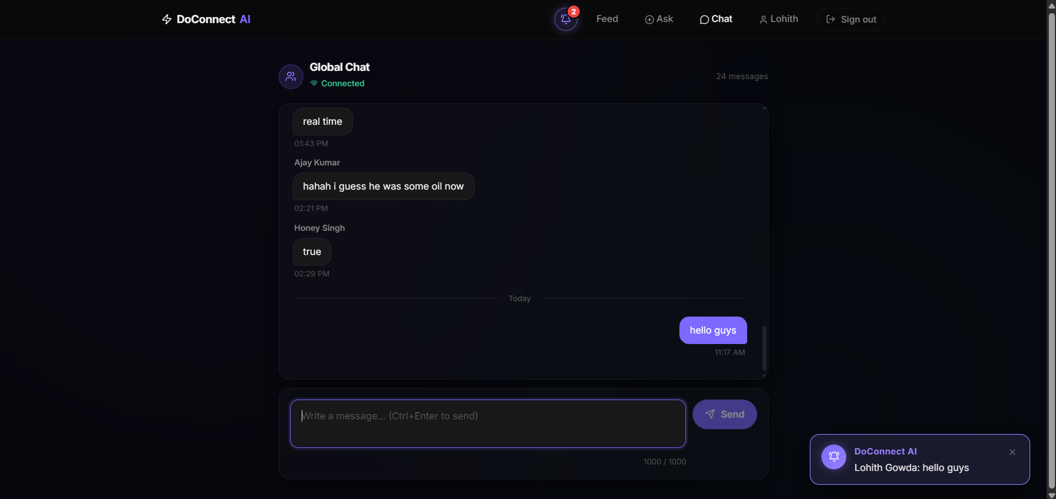
Figure 12: Global Chat
- User Action: A user clicks the chat icon in the navigation bar to open the global chat overlay. They type a message and press Enter.
- System Behavior: The React STOMP.js client wraps the text in a STOMP SEND frame and transmits it over the open TCP WebSocket connection to the Chat Microservice on port 8090. The ChatController intercepts it, saves the log to MySQL, and broadcasts a MESSAGE frame to all subscribers on /topic/global.
- Expected Result (Visualized): The message appears instantly in the overlay for all connected users, accompanied by the sender’s name and timestamp. The UI remains fully responsive, proving that the microservice isolation strategy prevented blocking the main browser thread.

10.2.4 AI Similar Question Detection
Screenshot intentionally omitted.
Figure 13: Ai Similar Questions
- User Action: A user clicks on a question titled “Spring Boot JPA Connection Refused”.
- System Behavior: As the page loads, the frontend silently dispatches a GET request to /api/ai/recommendations/similar/{id}. The backend queries Gemini to find semantic matches in the database, returning a JSON array of QuestionResponse DTOs.
- Expected Result (Visualized): A “Related Questions” panel renders on the side of the page, listing questions like “MySQL 8 not connecting to Hibernate”. This proves the system can identify semantic intent beyond simple keyword matching, directly reducing duplicate threads.

10.3 Feature Goal Attainment
The visual outputs confirm the successful deployment of the primary technology stack:
- React 19 & Tailwind CSS 4: Achieved the modern, responsive, and dynamic UI requirements.
- Spring Boot 3 & JWT: Demonstrated through the secure traversal of authenticated routes (like the Ask Question page) versus public routes.
- Google Gemini AI: Demonstrated through the real-time replacement of text fields and tag inputs without requiring full page reloads.

10.4 Chapter Summary
The screenshots and workflow validations definitively prove that DoConnect AI is a fully functional, highly polished platform. The seamless integration of AI features directly into standard form inputs (Ask Question, Answer Editor) confirms that the application successfully met its goal of acting as an “invisible co-pilot” rather than an intrusive chatbot.

Chapter 11: Conclusion & Future Enhancements

11.1 Conclusion
The DoConnect AI project successfully engineered a modernized, highly interactive developer Q&A platform by directly integrating Large Language Models into the user experience. By consciously transitioning away from the traditional, purely human-moderated forum model, the system demonstrated how AI can dramatically reduce the friction of knowledge sharing without replacing the human element of mentorship and community.
The architectural decision to utilize a microservice topology proved highly effective. By isolating the WebSocket message broker into its own chat-service container, the main Spring Boot REST API remained performant, secure, and available to handle heavy database transactions and external API calls to Google Gemini. This split ensures that a sudden surge in global chat traffic does not crash the core forum functionality.
Ultimately, DoConnect AI met all established functional and non-functional requirements. It delivered a secure, scalable, and highly interactive application that effectively solves the historical problems of knowledge fragmentation, moderation latency, and authoring barriers that plague traditional developer hubs. Specifically, the implementation of the AI Similar Question Detection endpoint ensures that semantic duplicates are routed to existing solutions instantly, fundamentally repairing the knowledge fragmentation problem.

11.2 Limitations
Despite its success and robust architecture, the current iteration of the system possesses several acknowledged limitations:
- AI Hallucinations and Non-Determinism: Because the Gemini API relies on generative probabilities, the “Suggest Answer” and “Improve Draft” features occasionally provide incorrect code syntax or outdated library imports. The system relies heavily on the human author to verify the draft before publishing, meaning the AI is an assistant, not an infallible oracle.
- In-Memory Message Broker: The current STOMP message broker resides purely in the application memory of the Chat Microservice instance. If the service is restarted, or if multiple instances are spun up behind a load balancer, all active transient subscriptions and queues are lost, and users connected to Instance A cannot chat with users on Instance B.
- Search Capabilities: The platform currently relies on standard SQL LIKE queries for searching questions. This is inefficient at scale and lacks typo-tolerance or phonetic matching.

11.3 Future Enhancements
To evolve the platform further and prepare it for enterprise-level deployment, the following enhancements are proposed:
- Distributed Message Broker: Upgrading the in-memory SimpleMessageBroker to a dedicated external broker like RabbitMQ or a Redis Pub/Sub backplane. This would allow the Chat Microservice to scale horizontally across an infinite number of instances while seamlessly syncing chat messages between them.
- Elasticsearch Integration: Implementing a dedicated, NoSQL search engine (like Elasticsearch or Apache Solr) to replace standard SQL queries. This would provide high-speed, typo-tolerant, full-text search across all questions, tags, and answers.
- Private Direct Messaging (DMs): Expanding the global chat room functionality to support secure, 1-on-1 private messaging between users. This involves leveraging the existing WebSocket user queues to route payloads securely between specific author_id targets.
- SMTP Email Integration: Integrating an external SMTP service (e.g., SendGrid, AWS SES) to deliver offline email alerts when a user’s question receives a verified answer, keeping them engaged even when their browser is closed.
- Dockerization and CI/CD: Creating a comprehensive docker-compose.yml to orchestrate the Main Backend, Chat Service, MySQL Database, and Frontend into unified, instantly deployable container stacks. Furthermore, establishing a GitHub Actions pipeline to automate testing and deployment to cloud infrastructure upon every commit.

Chapter 12: References
The following external documentation, scholarly references, and technical specifications were instrumental in the architectural design, security modeling, and software engineering implementation of the DoConnect AI platform.
- Spring Framework Documentation. “Spring Boot Reference Documentation.” VMware, Inc., 2024. [Online]. Available: https://docs.spring.io/spring-boot/docs/current/reference/html/ (Referenced for configuring the embedded Tomcat server, Spring Data JPA entities, and application properties mapping).
- Spring Security Architecture. “Spring Security Reference.” VMware, Inc., 2024. [Online]. Available: https://docs.spring.io/spring-security/reference/servlet/architecture.html (Referenced for implementing the custom OncePerRequestFilter and integrating stateless JWT authentication).
- React Core Team. “React: The Library for Web and Native User Interfaces.” Meta Platforms, Inc., 2024. [Online]. Available: https://react.dev/ (Referenced for utilizing modern Hooks, Context API for state management, and functional component design patterns).
- Google DeepMind. “Gemini API Documentation.” Google LLC, 2024. [Online]. Available: https://ai.google.dev/docs (Referenced for structuring the JSON prompts required by the gemini-2.0-flash model for tag prediction and moderation).
- Tailwind Labs. “Tailwind CSS Documentation.” Tailwind Labs Inc., 2024. [Online]. Available: https://tailwindcss.com/docs (Referenced for constructing the responsive, utility-first glassmorphism user interface).
- WebSockets and STOMP. “Spring Framework: WebSocket Support.” VMware, Inc., 2024. [Online]. Available: https://docs.spring.io/spring-framework/reference/web/websocket.html (Referenced for configuring the SimpleMessageBroker and managing concurrent TCP connections in the Chat Microservice).
- JSON Web Tokens (JWT). “RFC 7519: JSON Web Token (JWT).” Internet Engineering Task Force (IETF), 2015. [Online]. Available: https://datatracker.ietf.org/doc/html/rfc7519 (Referenced for ensuring cryptographic compliance when signing and verifying the HS256 authentication payloads).
- MySQL 8.0 Reference Manual. “MySQL 8.0 Documentation.” Oracle Corporation, 2024. [Online]. Available: https://dev.mysql.com/doc/refman/8.0/en/ (Referenced for optimizing foreign key constraints and configuring the normalized relational data dictionary).

