Software Requirements Specification

for

Intranet portal for MU

Version 1.0

Prepared by

Group Name: Elite Executors

|  |  |  |
| --- | --- | --- |
| Merugu MouryaAdithya | SE22UARI095 | [se22uari095@mahindrauniversity.edu.in](mailto:se22uari095@mahindrauniversity.edu.in) |
| Padigala Krishna Chaitanya | SE22UARI121 | [se22uari121@mahindrauniversity.edu.in](mailto:se22uari121@mahindrauniversity.edu.in) |
| I Mithun Reddy | SE22UARI057 | [se22uari057@mahindrauniversity.edu.in](mailto:se22uari057@mahindrauniversity.edu.in) |
| Jagruth Chilamanthula | SE22UARI058 | [se22uari058@mahindrauniversity.edu.in](mailto:se22uari058@mahindrauniversity.edu.in) |
| Tejas Nagireddy | SE22UARI107 | [se22uari107@mahindrauniversity.edu.in](mailto:se22uari107@mahindrauniversity.edu.in) |

|  |  |
| --- | --- |
| Instructor: | Avinash Arun Chauhan |
| Course: | Software Engineering |
| Lab Section: | *AI [Wednesday 10:30 to 12:30]* |
| Teaching Assistant: | *Murali Krishna* |
| Date: | 10-03-25 |

Contents

Contents ii

Revisions ii

1 Introduction 1

1.1 Document Purpose 1

1.2 Product Scope 1

1.3 Intended Audience and Document Overview 1

1.4 Definitions, Acronyms and Abbreviations 1

1.5 Document Conventions 1

1.6 References and Acknowledgments 2

2 Overall Description 2

2.1 Product Overview 2

2.2 Product Functionality 3

2.3 Design and Implementation Constraints 3

2.4 Assumptions and Dependencies 3

3 Specific Requirements 4

3.1 External Interface Requirements 4

3.2 Functional Requirements 4

3.3 Use Case Model 5

4 Other Non-functional Requirements 6

4.1 Performance Requirements 6

4.2 Safety and Security Requirements 6

4.3 Software Quality Attributes 6

5 Other Requirements 7

Appendix A – Data Dictionary 8

Appendix B - Group Log 9

Revisions

| Version | Primary Author(s) | Description of Version | Date Completed |
| --- | --- | --- | --- |
| Draft Type and Number | Full Name | Information about the revision. This table does not need to be filled in whenever a document is touched, only when the version is being upgraded. | 00/00/00 |

# 

# Introduction

## Document Purpose

This document provides a detailed Software Requirements Specification (SRS) for the Intranet Portal designed for Mahindra University. The portal aims to facilitate various university-related activities for students, faculty, and administrators by providing an efficient digital platform. The document outlines the functional and non-functional requirements, constraints, and system design considerations.

The scope of this document includes defining the features of the system, user roles, and system interactions.

## Product Scope

The intranet portal is a web-based system aimed at enhancing the efficiency of university operations by digitizing and streamlining various academic and administrative functions. The system will provide features such as:

* Role based login (Students, Faculty and Admin)
* Club activities and event management
* University-wide announcements
* Faculty-student feedback System
* Complaint tracking and resolution

By centralizing these functions, the system will improve communication between students, faculty, and administrators, reduce paperwork, and enhance the overall user experience within Mahindra University.

## Intended Audience and Document Overview

This document is intended for the following stakeholders:

* Developers: To understand system requirements and implementation details.
* Project Managers: To track the progress and ensure that the requirements are met.
* University Administration: To review and approve the system specifications.
* Faculty Members and Students: To understand how the system meets their needs.
* Testers: To validate the system against the requirements.

Document Overview:

* Section 2: Describes the system overview, functionality, constraints, and dependencies.
* Section 3: Lists specific requirements, including functional and interface requirements.
* Section 4: Covers non-functional requirements such as performance, security, and quality attributes.

## Definitions, Acronyms and Abbreviations

* MERN Stack – MongoDB, Express.js, React.js, Node.js.
* CRUD – Create, Read, Update, Delete.
* JWT – JSON Web Token (for authentication).
* SSO – Single Sign-On.
* UI – User Interface.
* DBMS – Database Management System.

## Document Conventions

* This document follows the IEEE SRS format.
* Font: Arial 11pt, single-spaced.
* Headings: Bold and numbered.
* Use Case Identifiers: Prefixed with 'U' (e.g., U1, U2).

## References and Acknowledgments

* IEEE Standard for Software Requirements Specification.
* MongoDB, Express.js, React.js, and Node.js official documentation.

# Overall Description

## Product Overview

The Intranet Portal for Mahindra University is a self-contained web application designed to facilitate academic and administrative functions. It replaces traditional paper-based or mail-based processes with a digital solution that enhances user experience, reduces inefficiencies, and improves accessibility.

The system consists of three primary user roles:

1. **Students**: Interact with the portal to manage Complaints, view and register clubs, get university announcements, give faculty feedback, and participate in university events.
2. **Faculty**: Upload course resources, monitor student performance, and manage their availability for student appointments.
3. **Administrators**: Oversee the entire system, manage user accounts, announcements, clubs and monitor complaints.

The diagram below illustrates the high-level system architecture:

(Diagram Placeholder: High-level interaction between users and system components)

## Product Functionality

The core functionalities of the intranet portal include:

* **Announcements**: Displays university-wide and course-specific notifications.
* **Club Management**: Facilitates club announcements and event registrations.
* **Feedback:** Takes the feedback filled by students and reflects to the admin.
* **Complaint Tracking**: Allows students to report issues and track resolution status.
* **Food menu**: display weekly mess menu

## Design and Implementation Constraints

* The system must be developed using the **MERN stack**.
* Authentication is limited to **University ID and password**.
* **Role-based access control (RBAC)** must be enforced.
* The system should be **scalable** to support future enhancements.

## Assumptions and Dependencies

* University IT will provide **authentication services**.
* The system requires **internet access** for operation.
* Future enhancements may require integration with **external university systems**.

# Specific Requirements

## External Interface Requirements

### User Interfaces

Web-based responsive design.

### Hardware Interfaces

Accessible from standard computers and mobile devices.

### Software Interfaces

Built using MongoDB, Express.js, React.js, and Node.js.

## Functional Requirements

*< Functional requirements capture the intended behavior of the system. This behavior may be expressed as services, tasks or functions the system is required to perform. This section is the direct continuation of section 2.2 where you have specified the general functional requirements. Here, you should list in detail the different product functions.*

### F1: The system shall authenticate users using University ID and password.

### F2: The system shall allow students to explore various clubs and register.

### F3: Students shall be able to give feedback for faculty.

### F4: The system shall send announcements to students.

### F5: Students can view food menu.

### F6: The complaint system shall track and update complaint status.

## Use Case Model

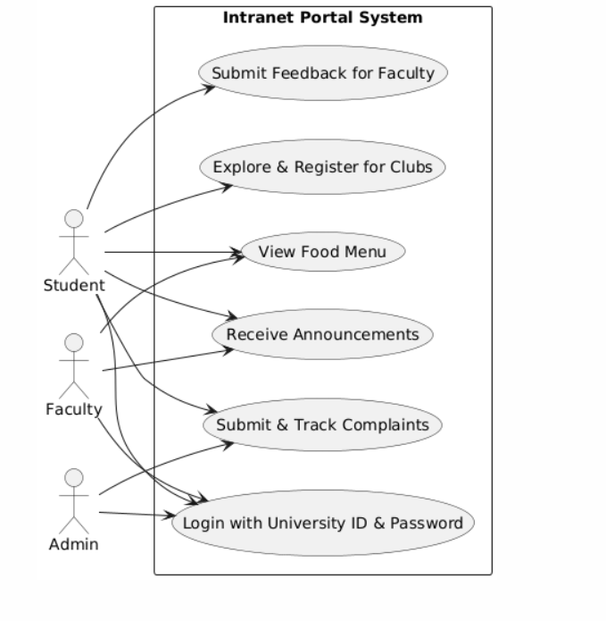

### Use Case #1 (use case name and unique identifier – e.g. U1)

TO DO: Provide a specification for each use case diagram

**Author –** Identify team member who wrote this use case

**Purpose** - What is the basic objective of the use-case. What is it trying to achieve?

**Requirements Traceability –** Identify all requirements traced to this use case

**Priority** - What is the priority. Low, Medium, High. Importance of this use case being completed and functioning properly when system is depolyed

**Preconditions** - Any condition that must be satisfied before the use case begins

**Post conditions** - The conditions that will be satisfied after the use case successfully completes

**Actors** – Actors (human, system, devices, etc.) that trigger the use case to execute or provide input to the use case

**Extends –** If this is an extension use case, identify which use case(s) it extends

**Flow of Events**

* 1. Basic Flow - flow of events normally executed in the use-case
  2. Alternative Flow - a secondary flow of events due to infrequent conditions
  3. Exceptions - Exceptions that may happen during the execution of the use case

**Includes** (other use case IDs)

**Notes/Issues** - Any relevant notes or issues that need to be resolved

# Other Non-functional Requirements

## Performance Requirements

* The system should support up to **5,000 concurrent users**.
* The system should respond within **2 seconds for database queries**.

## Safety and Security Requirements

* Role-based authentication for secure access.
* Data encryption to protect user information.
* Activity logging for security audits.

## Software Quality Attributes

* **Reliability:** System uptime should be at least **99.9%**.
* **Usability:** UI should be **intuitive** and require **minimal training**.
* **Maintainability:** Modular architecture for easy updates.

# Other Requirements

<This section is **Optional.** Define any other requirements not covered elsewhere in the SRS. This might include database requirements, internationalization requirements, legal requirements, reuse objectives for the project, and so on. Add any new sections that are pertinent to the project.>

Appendix A – Data Dictionary

*<Data dictionary is used to track all the different variables, states and functional requirements that you described in your document. Make sure to include the complete list of all constants, state variables (and their possible states), inputs and outputs in a table. In the table, include the description of these items as well as all related operations and requirements.>*

Appendix B - Group Log

<Please include here all the minutes from your group meetings, your group activities, and any other relevant information that will assist in determining the effort put forth to produce this document>