SIMATS ENGINEERING (SAVEETHA SCHOOL OF ENGINEERING)
Department of Computer Science and Engineering

CO2 ASSESSMENT TOOL 2 – Architecture Design Assignment

Course Code: | CSA10 / CSA1063 | Course Title: | Software Engineering
CO Assessed: | CO2 | Assessment: | Assessment Tool 2 – Architecture Design Assignment
Weightage: | 20% | Total Marks: | 25
CO2 Statement: | Perform detailed requirements analysis, design scalable architectures, and prioritize features with a focus on cross-disciplinary skills
Student Name: | L.Mithun Kumar Reddy | Reg. No.: | 192365017
Date: | 26/10/2026 | Duration: | 60 minutes
Code of Conduct1
I L.Mithun Kumar Reddy/192365017 (Name / Reg No) certify that this submission is my original work and that I have adhered to the guidelines specified for this assessment. I understand that any violation of academic integrity rules will result in disciplinary action.
Signature of the Student: Mithun Reddy
Annexure A – Architecture Design Assignment

Instructions to Students:
Each student will be assigned an individual software project problem statement. Based on the assigned problem, analyze the system requirements and design an appropriate software architecture by applying software engineering principles. Your submission should demonstrate your ability to select, justify, and evaluate a suitable architectural style.

Question
Based on your assigned problem statement, perform an Architecture Design Analysis and prepare an architecture design report by answering the following questions:

Analyze System Requirements
  - Study the given problem statement and identify the system objectives.
  - Analyze the functional and non-functional requirements that influence the software architecture.
  - Identify key quality attributes such as scalability, maintainability, reliability, availability, performance, and security.
Answer:
Problem statement: Farmers identify crop diseases late and lose yield. Create an app where farmers upload leaf images, receive disease identification and treatment guidance, and agricultural officers monitor regional outbreaks.
a) System objectives
• Let a farmer upload a leaf image and receive a disease name and a confidence level within a few seconds.
• Give practical treatment and prevention guidance in the farmer's own language.
• Save every diagnosis with its location and date, so that regional disease data builds up automatically.
• Give agricultural officers a dashboard and map to monitor outbreaks by region, crop and time, and to send advisories.
• Reduce crop loss by shortening the time between the first symptom and the first treatment.
b) Functional requirements that influence the architecture
Not every requirement affects the structure of the system equally. The ones below are the functional requirements that most strongly shape the architecture.
Functional requirement | How it influences the architecture
Farmers upload leaf images and get a diagnosis | Images are large and the analysis takes time, so uploading and analysing must be handled separately. This calls for a dedicated image-handling service, object storage and a machine-learning inference component.
Treatment guidance in regional languages | The content changes often and must be maintained by experts without redeploying the app, so it needs its own content service and database.
Reports saved with GPS location and history | Location-based queries are needed, so the data layer must support geospatial data (for example PostgreSQL with PostGIS).
Officers monitor regional outbreaks on a dashboard and map | Aggregating thousands of reports is very different from handling a single upload. It needs a separate analytics service and a cache so that dashboards do not slow down the farmers' requests.
Alerts and advisories by app and SMS | Sending messages to thousands of farmers must not block other work, so it should be asynchronous and handled by a notification service connected to external SMS and push providers.
Offline submission in poor network areas | The mobile client needs a local queue, and the server must accept uploads that arrive late and may be repeated.
Three user roles (farmer, officer, administrator) | A central authentication and role-based access control point is needed, which is best placed in an API gateway and an auth service.
Model and disease-library updates by the administrator | The detection model must be replaceable without touching other parts of the system, so it is kept in a model registry behind its own service.

c) Non-functional requirements that influence the architecture
Non-functional requirement | Target | Architectural implication
Response time | Diagnosis within 5 seconds; dashboard within 3 seconds | Image compression on the device, a cache for frequent reads, and a separate inference service that can be scaled.
Concurrency | 1,000 or more simultaneous users | Stateless services behind a load balancer so that more copies can be added when demand rises.
Availability | 99% or higher | Redundant instances, health checks, automatic restart and database replication.
Security | Encrypted data, role-based access | A single gateway for authentication, TLS everywhere, encrypted storage and an audit log.
Usability and reach | Low-end phones, weak networks | Lightweight client, small payloads, offline queue and SMS as a fallback channel.
Maintainability and extensibility | New crops, languages and models without a redesign | Loosely coupled modules with clear interfaces, so each can change on its own.
Accuracy and transparency | 90% or higher, with confidence shown | The model is a replaceable component, and the confidence value is passed all the way to the user.

d) Key quality attributes
From the requirements above, six quality attributes matter most for this system and drive the architectural decisions. They are listed here in order of importance.
Quality attribute | Why it matters for this system
Performance | A farmer standing in a field will not wait long for a result. A slow system also delays warnings, which defeats the purpose of early detection.
Availability | Disease outbreaks do not wait for working hours. If the service is down during a spread, farmers and officers lose the early-warning benefit.
Scalability | Usage will be uneven. It will rise sharply in the sowing and monsoon seasons and when an outbreak is announced, and the system must cope without a redesign.
Reliability | A lost report or a wrong result damages trust. Uploads must never disappear, and the confidence level must be honest.
Security | The system holds personal details, farm locations and official outbreak data, so only the right people may see or change it.
Maintainability | Diseases, crops, treatments and models keep changing, so the system must be easy to update and extend.

Select a Suitable Software Architecture
  - Select an appropriate architectural style for the proposed system (e.g., Layered Architecture, Client-Server, MVC, Microservices, Event-Driven, Service-Oriented Architecture, Serverless, or Hybrid Architecture).
  - Justify why the selected architecture is the most suitable for the given problem.
Answer:
Selected architecture: a Hybrid Architecture that combines a Layered structure, Service-Oriented (modular services behind an API gateway) and an Event-Driven messaging backbone. At the outermost level it works as a Client–Server system, where mobile and web clients talk to services running in the cloud.
a) Styles considered
Style | Strengths for this problem | Weaknesses for this problem | Verdict
Simple Layered / Monolith | Easy to build and deploy; good for a small team. | Heavy image analysis and dashboard queries would compete for the same resources. Scaling means copying the whole application, and one failure can bring everything down. | Not enough on its own
MVC | Good for separating the user interface from logic. | It organises one application and says nothing about scaling, messaging or integration. It can be used inside the web and mobile clients. | Used inside clients only
Pure Microservices | Independent scaling and deployment. | Many tiny services bring high operational cost, complex testing and DevOps skills that a small project team may not have. | Too heavy as a whole
Serverless | Pay per use; scales automatically. | Cold starts delay inference, long-running model loading is awkward, and there is a risk of being tied to one vendor. | Partly useful (notifications)
Pure Event-Driven | Excellent for alerts and loose coupling. | A farmer needs an immediate answer to a request, which is naturally a request-response interaction. Pure events make that harder to follow. | Used for background work only
Hybrid (selected) | Takes the strengths of each part: layers for clarity, services for independent scaling, events for background work. | More design effort than a monolith; needs good monitoring. | Best fit

b) Why the hybrid architecture is the most suitable
• It matches the two very different workloads. The farmer side is a quick request and answer (upload, result). The officer side is heavy aggregation and alerting. With separate services, each side can be scaled on its own, so a flood of uploads does not slow the dashboard.
• It keeps slow work away from the user. Disease detection and sending SMS messages happen in the background through the event bus. The farmer gets a fast acknowledgement, and thousands of alerts can go out without blocking anything.
• It supports poor networks. The queue-based design accepts late or repeated uploads safely, which suits the offline-first needs of rural users.
• It protects availability. If the notification service fails, farmers can still scan leaves, and the pending messages wait in the queue and are sent once the service returns.
• It makes the machine-learning model replaceable. The model sits behind the detection service, so it can be retrained and replaced without changing the rest of the system.
• It is practical for the team. It uses a small number of well-defined services (eight) instead of dozens of micro-services, so it stays manageable while still being scalable and easy to maintain.
• It provides a clean security boundary. All traffic enters through one gateway, where authentication, role checks and rate limiting are enforced consistently.

Draw the Software Architecture Diagram
  - Design a clear architecture diagram illustrating the overall structure of the proposed system.
  - Include all major layers/components, databases, external systems, APIs, and communication mechanisms.
  - Use appropriate software architecture notations and labels.
Answer:
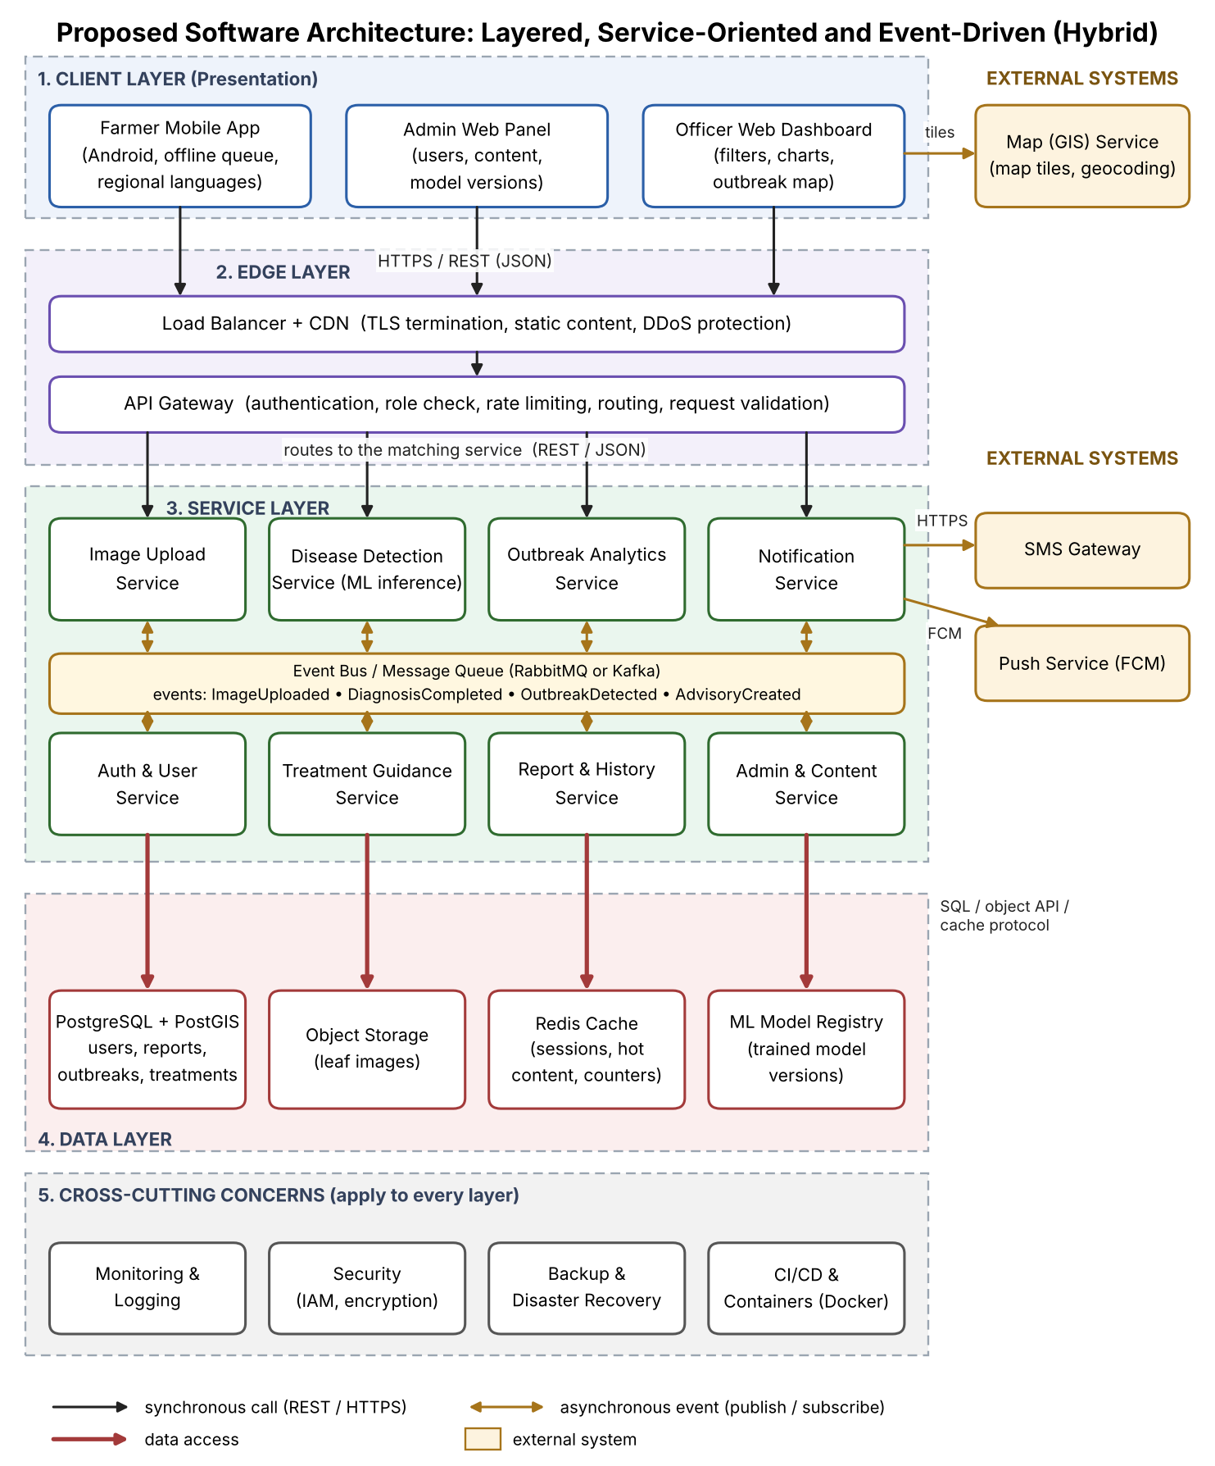
Figure 1: Software Architecture Diagram of the Crop Disease Detection and Reporting App
How to read the diagram
The diagram is organised in five horizontal layers. A Client Layer at the top holds the farmer app, the officer dashboard and the admin panel. Requests pass through the Edge Layer, where a load balancer and API gateway protect and route the traffic. The Service Layer contains eight independent services, grouped around an Event Bus that carries background messages. The Data Layer holds the database, image storage, cache and model registry. Cross-cutting concerns such as security, monitoring and backup apply to every layer. External systems (map service, SMS gateway and push service) are shown in amber on the right.
The notation is explained in the legend at the bottom of the figure: black arrows are synchronous REST calls over HTTPS, double-headed amber arrows are asynchronous publish/subscribe events, bold red arrows are data access, and rounded boxes are components.
Communication | Mechanism | Used between
Synchronous request–response | HTTPS with REST and JSON | Clients to gateway, gateway to services, services to external APIs
Asynchronous messaging | Publish/subscribe through a message broker (RabbitMQ or Kafka) | Upload, detection, analytics, notification and report services
Data access | SQL (PostgreSQL), object storage API, Redis protocol | Services to the data layer
External integration | HTTPS APIs (SMS, map) and Firebase Cloud Messaging (push) | Notification service, dashboard and the external providers

Explain Components and Their Interactions
  - Describe the purpose and responsibilities of each architectural component.
  - Explain how the components communicate and exchange data.
  - Illustrate the overall workflow of the system.
Answer:
a) Purpose and responsibilities of each component
Component | Purpose and responsibilities | Interacts with
Farmer Mobile App | The farmer's main interface. It captures or selects the leaf photo, compresses it, attaches the GPS location and crop, shows the result and advice, keeps a local queue when offline, and supports regional languages. | API Gateway (HTTPS)
Officer Web Dashboard | Lets officers filter reports by region, crop and date, view the outbreak map and charts, verify reports and send advisories. | API Gateway; Map service
Admin Web Panel | Lets the administrator manage users, disease and treatment content, and upload new model versions. | API Gateway
Load Balancer + CDN | Shares incoming traffic across service instances, ends TLS connections, serves static content quickly and absorbs traffic spikes. | Clients; API Gateway
API Gateway | The single entry point. It checks identity tokens and roles, limits request rates, validates requests and routes each one to the correct service. | All services
Auth & User Service | Handles registration, OTP verification, login, password reset, profiles and role management, and issues secure tokens. | Gateway; database; cache
Image Upload Service | Receives the image, checks its format, size and quality, stores it in object storage, saves report details and publishes an ImageUploaded event. | Object storage; event bus
Disease Detection Service | Listens for ImageUploaded events, loads the active model from the registry, analyses the image, and publishes a DiagnosisCompleted event with the disease and confidence. Low-confidence cases are flagged for expert review. | Event bus; model registry
Treatment Guidance Service | Provides treatment, dosage, precautions and prevention advice for a disease in the requested language. | Database; cache
Report & History Service | Stores every diagnosis result, serves a farmer's past reports, and lets officers verify or reject reports. | Database; event bus
Outbreak Analytics Service | Counts cases by region, crop and time, detects when a threshold is crossed, and publishes an OutbreakDetected event. It also prepares dashboard data and downloadable reports. | Database (PostGIS); cache; event bus
Notification Service | Receives OutbreakDetected and AdvisoryCreated events and sends push messages and SMS to the right farmers, tracking delivery and retrying failures. | Event bus; SMS gateway; push service
Admin & Content Service | Manages the disease library, treatment content, user administration and model versions, and records an audit log. | Database; model registry
Event Bus / Message Queue | Carries events between services so that they do not have to wait for each other. It stores messages until they are processed. | Services
PostgreSQL + PostGIS | The main database for users, reports, outbreaks and treatment content, with support for location-based queries. | Services
Object Storage | Stores the leaf images safely and cheaply, away from the database. | Upload and detection services
Redis Cache | Holds sessions, frequently used treatment content and dashboard counters to speed up responses. | Services
ML Model Registry | Stores trained model files with version numbers, so that a model can be rolled out or rolled back easily. | Detection and admin services
External systems | The map service supplies map tiles and geocoding, the SMS gateway delivers text messages, and the push service delivers app notifications. | Dashboard; Notification Service

b) How the components communicate and exchange data
Components talk to each other in two ways. When an answer is needed straight away, such as logging in, opening a report or loading treatment advice, the caller makes a synchronous REST call over HTTPS and exchanges data as JSON. When the work can happen in the background, such as analysing an image or sending hundreds of SMS messages, the service publishes an event to the message broker, and any interested service picks it up. This means the services never need to know about each other directly. They only agree on the event format.
Images travel as compressed binary uploads and are stored in object storage. Only a reference (a file ID) is passed between services and saved in the database, which keeps messages small and fast. Every request carries a signed token that the gateway verifies before anything else happens.
c) Overall workflow of the system
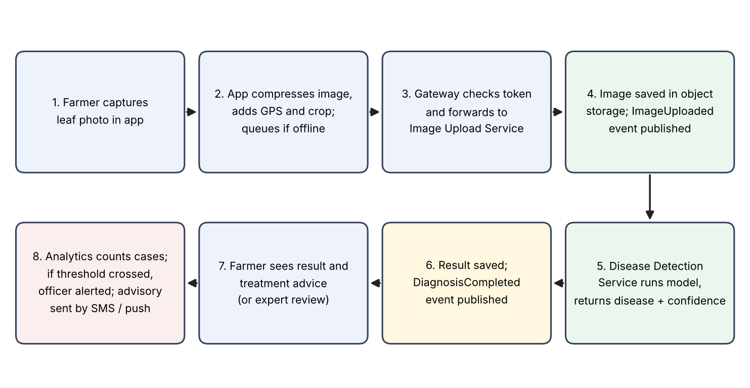
Figure 2: End-to-end workflow, from leaf photo to treatment advice and outbreak alert
The workflow in words is as follows. The farmer photographs a leaf, and the app compresses the image, adds the location and sends it. If there is no network, the app keeps it and tries again later. The gateway checks the farmer's token and passes the request to the Image Upload Service, which saves the image and announces an ImageUploaded event. The Disease Detection Service picks up that event, runs the model and announces DiagnosisCompleted. The Report Service saves the result, and the farmer sees the disease, the confidence level and the treatment advice. If the confidence is low, the farmer is offered an expert review instead.
At the same time, the Outbreak Analytics Service reads each completed diagnosis and updates its regional counts. When the number of cases of one disease in an area crosses the agreed threshold, it announces OutbreakDetected. The officer sees the highlighted area on the dashboard, verifies the reports and writes an advisory. The Notification Service then sends that advisory to farmers in the affected area by app notification and SMS.

Discuss Quality Attributes
  - Evaluate how the proposed architecture addresses the following aspects: Scalability, Security, Performance, Reliability, Maintainability, Availability.
Answer:
The table shows, for each quality attribute, what the architecture does to achieve it and what the expected outcome is.
Quality attribute | How the proposed architecture addresses it | Expected outcome
Scalability | Services are stateless and sit behind a load balancer, so more copies can be started when traffic increases. The detection and analytics services can be scaled separately from the rest. The database uses read replicas and caching, and object storage grows as needed. The message queue absorbs sudden bursts of uploads. | Can grow from a pilot district to a whole state without redesign; peak seasons are handled by adding instances.
Security | All traffic uses HTTPS/TLS. The gateway checks tokens and roles, and applies rate limiting against abuse. Passwords are stored as salted hashes, and data and images are encrypted at rest. Each service has only the access it needs, and an audit log records sensitive actions. User consent is recorded for location data. | Farmers can never see officer data, and personal data is protected from misuse or leaks.
Performance | Images are compressed on the phone, which reduces upload time. A Redis cache serves treatment content and dashboard counters quickly. Slow jobs (analysis, messaging) run in the background and do not hold up requests. A CDN delivers static content close to the user. Model inference runs on a dedicated service that can use more powerful hardware. | Diagnosis in about 5 seconds and dashboard pages in under 3 seconds under normal load.
Reliability | The message queue keeps events until they are processed, so nothing is lost if a service is briefly down. Failed uploads and messages are retried automatically. Operations are designed to be safe to repeat, so a retried upload does not create a duplicate. The database is backed up daily, and the confidence level is always shown, so uncertain results are not presented as facts. | No submitted report is lost, and results are consistent and honest.
Maintainability | The system is split into small services with clear responsibilities and documented APIs, so a change in one area rarely touches another. The model and the treatment content can be updated without changing code. Containers and automated build and deployment (CI/CD) make releases repeatable. Central logging and monitoring make problems easy to find. | New crops, languages or models can be added with limited effort, and bugs are easier to isolate.
Availability | Each service runs as at least two instances with health checks and automatic restarts. The load balancer avoids unhealthy instances. The database has a standby replica for failover, and backups and disaster-recovery plans are in place. Because services are independent, one failing service (for example, notifications) does not stop farmers from scanning leaves. | 99% or better uptime, and graceful degradation instead of a complete outage.

Justify Architectural Decisions
  - Explain the rationale behind your architectural choices.
  - Discuss the trade-offs considered while selecting the architecture.
  - Explain how the chosen architecture supports future enhancements, system integration, and long-term maintainability.
Answer:
a) Rationale behind the main architectural choices
Decision | Rationale
Hybrid of layered, service-oriented and event-driven styles | No single style fits both the quick request-and-answer needs of the farmer and the heavy background needs of analytics and alerts. Combining them uses each where it works best.
API Gateway as the single entry point | It gives one place to enforce security, rate limits and routing, and hides the internal structure from clients.
Eight focused services, not many tiny ones | It gives independent scaling and clear ownership without the heavy operational cost of full micro-services.
Message broker for background work | It decouples services, absorbs traffic bursts, and prevents lost work if a service is down.
PostgreSQL with PostGIS | A mature, reliable database with strong location queries, which are central to outbreak mapping.
Object storage for images | Images are large; keeping them out of the database keeps the database fast and storage cheap.
Separate ML model registry and inference service | The model changes often, so it must be easy to replace, test and roll back.
Redis cache | Reduces repeated database reads and improves response times.
Offline-first mobile client | Rural users often have no network, and a system that works only online would leave them out.

b) Trade-offs considered
• Simplicity versus scalability. A monolith would be simpler and quicker to build, but it would be hard to scale and less reliable. We accepted extra design effort to gain independent scaling and fault isolation.
• Number of services versus operational cost. More services give finer control but need more monitoring, testing and deployment work. We chose a moderate number of services as a balance.
• Immediate versus eventual consistency. Event-driven processing means a dashboard may lag a few seconds behind a new report. This is acceptable because outbreak monitoring does not need to be instantaneous, and the benefit is much better resilience.
• Cloud inference versus on-device inference. Running the model on the server keeps the app small and the model easy to update, but needs a network connection. Offline queuing is used to reduce this limitation, and an on-device model remains a future option.
• Cost versus availability. Running redundant instances and replicas costs more, but outbreak warnings are time-critical, so higher availability is worth the cost.
• Managed services versus self-hosting. Using managed cloud services for the database, queue and storage reduces effort, at the price of some vendor dependence. Standard protocols are used so that migration stays possible.
c) Support for future enhancements, integration and long-term maintainability
Future enhancements. Because each capability is a separate service, new features can be added without disturbing the existing ones. For example, a weather-based disease risk service, soil and fertilizer advice, a voice assistant in more languages, live chat with experts or on-device detection for fully offline use can each be added as a new service that listens to the same events.
System integration. The API gateway and the event bus give clear, standard connection points. Government agriculture portals, e-governance systems, weather providers, drone or satellite imagery, and market-price services can be integrated through REST APIs or by subscribing to events, without changes to the core services.
Long-term maintainability. Clear service boundaries, documented APIs, containerised deployment with automated pipelines, central logging and monitoring, and versioned models and APIs mean that individual parts can be upgraded, replaced or scaled over time. Old and new versions can run side by side, so updates do not interrupt farmers during the crop season.
Conclusion. The hybrid architecture best balances speed for the farmer, insight for the officer, and flexibility for the development team. It meets the key quality attributes of performance, availability, scalability, reliability, security and maintainability, and leaves room for the system to grow as new crops, regions and technologies are added.

Rubrics for Calculation

Criteria | Excellent (4 Marks) | Good (3 Marks) | Satisfactory (2 Marks) | Needs Improvement (1 Mark)
System Requirement Analysis (30%) | Thoroughly analyzes the problem statement, accurately identifies functional and non-functional requirements, and clearly explains quality attributes influencing the architecture. | Analyzes most requirements with minor omissions or limited explanation. | Identifies only basic requirements with partial analysis. | Requirement analysis is incomplete, inaccurate, or lacks clarity.
Selection of Software Architecture (25%) | Selects the most appropriate architectural style with strong technical justification aligned to system requirements. | Selects a suitable architecture with reasonable justification. | Architecture is partially suitable with limited justification. | Inappropriate architecture selected or justification is missing.
Architecture Diagram and Component Design (20%) | Produces a clear, complete, and well-structured architecture diagram with all major components, interfaces, and interactions accurately represented. | Diagram is mostly complete with minor omissions or notation issues. | Diagram includes only essential components and lacks sufficient detail. | Diagram is incomplete, unclear, or technically incorrect.
Component Interaction and Quality Attribute Analysis (15%) | Clearly explains component responsibilities, interactions, and thoroughly discusses scalability, security, performance, reliability, maintainability, and availability. | Explains most components and quality attributes with minor gaps. | Provides limited explanation of interactions and addresses only some quality attributes. | Component interactions and quality attributes are poorly explained or missing.
Architectural Justification and Technical Presentation (10%) | Provides strong justification for architectural decisions, discusses trade-offs and future enhancements, and presents a well-organized, professional report. | Provides adequate justification with minor gaps; report is well organized. | Limited justification with minimal discussion of trade-offs or future scope; report needs improvement. | Justification is weak or absent; report lacks organization and technical clarity.

Criteria | Mark
System Requirement Analysis (30%) | 4.5 /5
Selection of Software Architecture (25%) | 4.5 /5
Architecture Diagram and Component Design (20%) | 4 /5
Component Interaction and Quality Attribute Analysis (15%) | 4.5 /5
Architectural Justification and Technical Presentation (10%) | 4.5 /5
TOTAL | 22 /25 (before AI adjustment) | 20.5 /25 (final)

EVALUATOR FEEDBACK
Student: L. Mithun Kumar Reddy (192365017) | CSA10 / CSA1063 Software Engineering | CO2 – Assessment Tool 2: Architecture Design Assignment
1. Score summary
Criterion (weight) | Marks | Remark
System Requirement Analysis (30%) | 4.5 / 5 | Requirements are linked to architectural impact, and six quality attributes are ranked with reasons. Few NFR targets are justified (why 1,000 users, why 99%).
Selection of Software Architecture (25%) | 4.5 / 5 | Six styles compared with strengths, weaknesses and verdicts; hybrid choice is well argued. Choice between RabbitMQ and Kafka is left open.
Architecture Diagram and Component Design (20%) | 4 / 5 | Clear five-layer diagram with legend and external systems, but some links are wrong or missing (see section 3).
Component Interaction and Quality Attribute Analysis (15%) | 4.5 / 5 | All 19 components and all six attributes covered with outcomes. Result delivery to the farmer after async detection is not explained.
Architectural Justification and Technical Presentation (10%) | 4.5 / 5 | Rationale, six trade-offs and future scope covered; well organised. No technology-stack or deployment view.
Total before AI adjustment | 22 / 25
AI-content deduction (about 90% AI) | – 1.5
FINAL MARK | 20.5 / 25

2. AI-content assessment and mark adjustment
Estimated AI-generated content: about 90%. This is my judgement from the writing and figures, not a detection-tool result, so confirm it with a viva or a detector report before any disciplinary use.
• Every section uses the same pattern: a lead-in sentence, a three-column table, then a polished "Conclusion." paragraph.
• Tidy, balanced trade-off bullets ("X versus Y. We accepted…") and generic phrasing such as "graceful degradation" and "without a redesign".
• The diagrams are cleanly generated, with consistent colours, event names and a legend, and the text describes them in the same vocabulary.
• No student-specific decisions: no chosen language or framework for the app, no cost estimate, no sketch or draft work.
• The problem statement and requirements are reused almost unchanged from the other assessment in the same style, which suggests one generated source.
Adjustment rule applied: no deduction at or below 75% AI content; above 75% the deduction scales proportionally up to 2.5 marks (reached at 100%). Deduction = 2.5 × (90 − 75) / 25 = 1.5 marks. Final mark = 22 − 1.5 = 20.5 / 25.
3. Detailed feedback
Strengths
• Requirements are traced to architectural consequences (for example, large images lead to a separate upload service, object storage and an inference component).
• The style comparison table is honest about weaknesses and uses MVC and serverless in the right roles.
• Eight services, an event bus, a gateway, a model registry and PostGIS suit the workload; the trade-offs (eventual consistency, cost vs availability) are realistic.
Weaknesses in the architecture diagram (Figure 1)
• The data-access arrows imply a one-to-one mapping: Auth to PostgreSQL, Treatment Guidance to Object Storage, Report & History to Redis, and Admin & Content to ML Model Registry. This is wrong. Image Upload and Detection should connect to Object Storage, Detection to the Model Registry, and most services to PostgreSQL.
• The API Gateway arrows reach only the top four services; Auth, Treatment, Report and Admin services have no inbound link from the gateway.
• The Farmer and Officer path to the Report service, and the Outbreak-to-Notification event flow, are only implied by the event bus box.
• Notation is a custom box-and-arrow style, not a recognised notation such as UML component or C4; state this or use one.
Weaknesses in the workflow (Figure 2) and interactions
• The workflow is a single linear chain. It omits the offline retry loop, the low-confidence expert-review branch, and the separate officer verification and advisory step that the text describes.
• The text says the farmer gets a result in about 5 seconds, yet detection runs asynchronously over the event bus. Explain how the result returns (polling, WebSocket or push) and how the 5-second target is measured.
• A sequence diagram for the upload-to-diagnosis path would show the interactions precisely.
Other points
• Stray "1" after "Code of Conduct" in the header.
• Add a technology stack (client framework, backend language, cloud provider), a deployment view and a rough cost estimate.
• Discuss security threats specific to this system, such as adversarial or poisoned images and misuse of the SMS advisory feature.
4. Recommendation
The report is technically sound and complete for every part of the question. To raise both quality and originality, redraw the diagram yourself, correct the data-access and gateway links, add a sequence diagram and a deployment view, state your own technology choices with reasons, and be ready to explain every decision orally.

