CSA6303 - THREAT INTELLIGENCE AND NETWORK SECUR

Assessment Tool 1: CONCEPT MAPPING
Faculty : Dr.V.Parthipan SLOT A

Topics: Network Security Fundamentals | Security Goals (CIA Triad) | Types of Network Threats
|Introduction to Threat Intelligence Types of Threat Intelligence (Strategic, Tactical, perational) — Threat Intelligence Lifecycle — Applications in IT Industry

CO1: Interpret security principles, network threats, and the role of threat intelligence in cybersecurity.

Total: 50
Student Name : L.Mithun Kumar Reddy Register number:192365017

Code of Conduct:

I L.Mithun Kumar Reddy (Name / Reg No) certify that this submission is my original work and that I have adhered to the guidelines specified for this assessment. I understand that any violation of academic integrity rules will result in disciplinary action.

Mithun Reddy
Signature of the student

CO1 – Concept Mapping Questions

No. | Concept-Mapping Question
1 | Construct a comprehensive concept map explaining the foundations of Network Security. Connect network security fundamentals with security objectives, the CIA Triad (Confidentiality, Integrity, and Availability), network assets, vulnerabilities, threats, and protective measures, and explain how these concepts collectively support secure network operations.

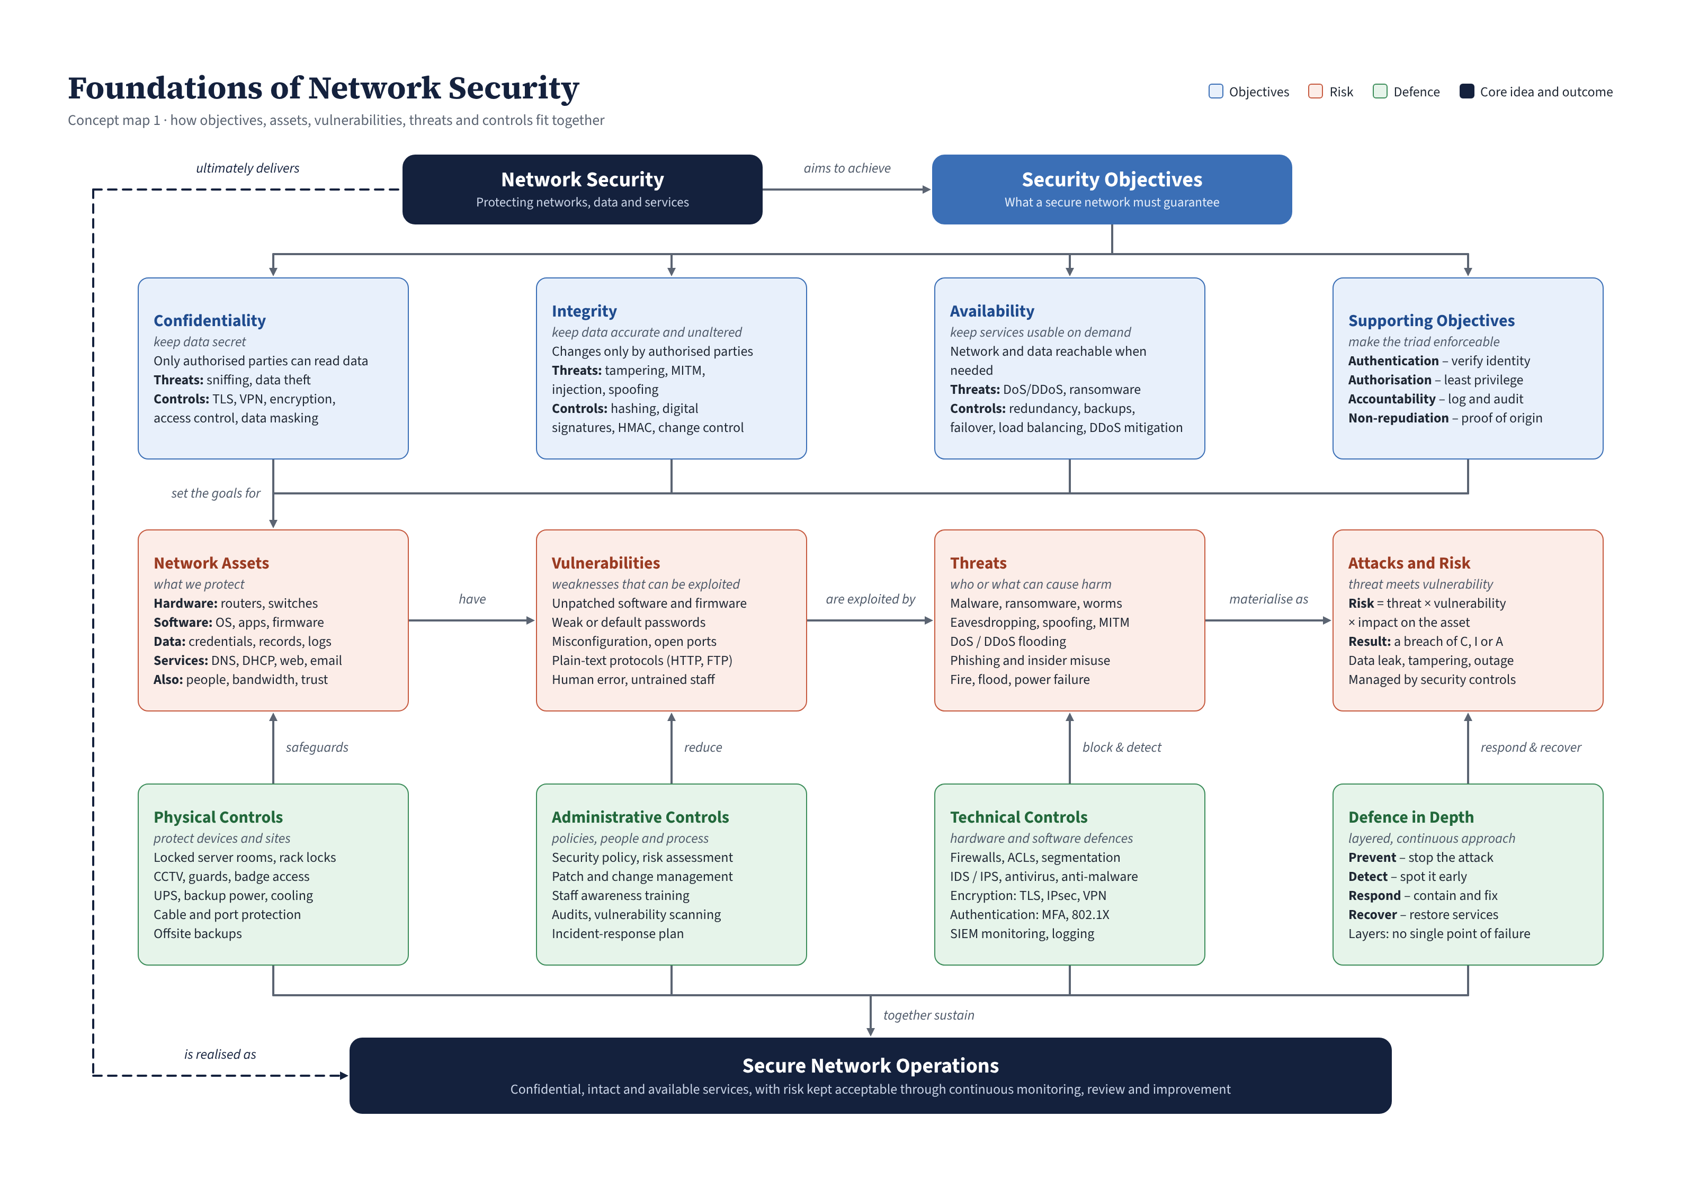

2 | Develop a concept map illustrating the CIA Triad as the foundation of network security. Relate Confidentiality, Integrity, and Availability to different types of network threats and demonstrate how a single threat can affect one or more security goals.

