SIMATS ENGINEERING
CSA6303- Threat Intelligence and Network Security A1-Threat Intelligence Report
Assessment Questions

Subject | Threat Intelligence | Total Marks | 50
Questions | 5 (all compulsory) | Marks per Question | 10
Reg. No | 192365017 | Name | L.Mithun Kumar Reddy
Faculty | Dr.V.Parthipan | Slot | A
Instructions: Answer all questions. Each question carries 5 marks. Support answers with examples and diagrams where appropriate.
CO3: Perform threat analysis using intelligence models and utilize industry tools for monitoring and detection.

Code of Conduct:

I L.Mithun Kumar Reddy/192365017 (Name / Reg No) certify that this submission is my original work and that I have adhered to the guidelines specified for this assessment. I understand that any violation of academic integrity rules will result in disciplinary action.

Signature of Student: Mithun Reddy

Questions :
- Threat Hunting Techniques: An organization suspects that an attacker has gained unauthorized access to its internal network. The security team observes unusuallogin times, unexpected processes, and connections to unfamiliar external servers. Describe the proactive threat-hunting techniques you would use to investigate the activity and identify potential threats. [10]

Answer 1: Threat-Hunting Techniques
1. Introduction
Threat hunting is the proactive, analyst-driven search through networks, endpoints and logs for adversaries that have evaded automated controls. Here the indicators – unusual login times, unexpected processes and connections to unfamiliar external servers – suggest possible credential compromise, persistence and command-and-control (C2). The hunt is therefore treated as a hypothesis-driven investigation, not a reaction to a single alert.
2. Step 1 – Form hypotheses (hypothesis-driven hunting)
- H1: A valid account was compromised and is being used outside normal hours (MITRE ATT&CK T1078 – Valid Accounts).
- H2: Malware or a living-off-the-land tool (PowerShell, WMI, PsExec) is running and has persistence (T1059, T1053, T1547).
- H3: Infected hosts beacon to an attacker server over HTTP/HTTPS/DNS (T1071, T1573) and may be moving laterally (T1021).
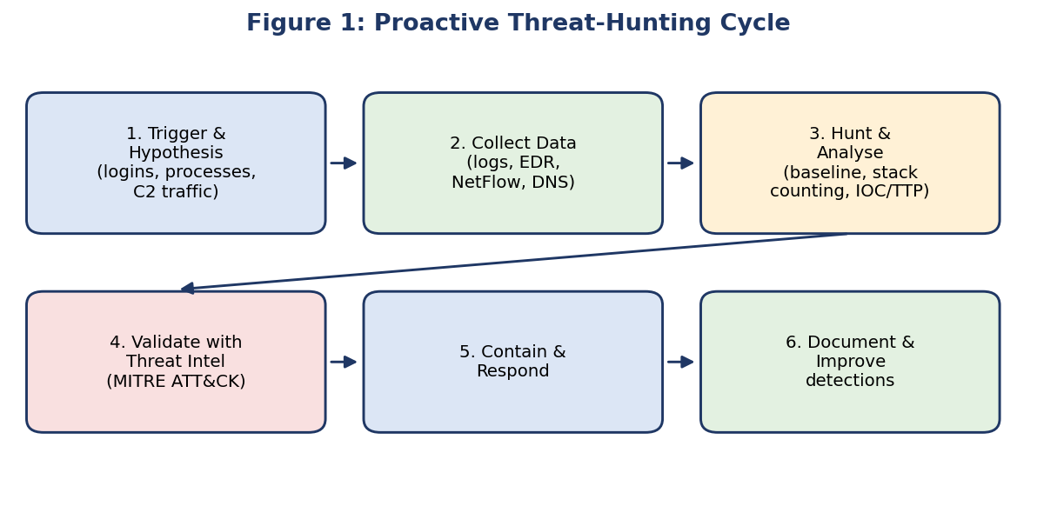
3. Step 2 – Data collection and scoping
Collect and preserve evidence from: Windows Security/Sysmon logs (Event IDs 4624, 4625, 4648, 4688, 4672, 7045, Sysmon 1/3/11), Active Directory/VPN/IdP logs, EDR telemetry, firewall, proxy and DNS logs, NetFlow/PCAP and email gateway logs. Synchronise time (NTP) and take forensic images/memory dumps of suspect hosts to keep the chain of custody.
4. Step 3 – Core hunting techniques
Technique | How it is applied in this case | What it reveals
Baselining and anomaly (behaviour) analysis | Compare each user’s normal logon hours, source IPs, geo-location and hosts against current activity; UEBA risk scores. | Off-hours logins, impossible travel, rare source devices.
Stacking / frequency (stack counting) | Count process names, parent-child pairs, scheduled tasks, services and destination domains across all hosts and review the least-frequent items. | Rare binaries, unusual services, one-off outbound domains.
Indicator (IOC) hunting | Search for known bad IPs, domains, file hashes and registry keys from threat-intel feeds (MISP, AlienVault OTX, VirusTotal). | Confirms known malware families or campaigns.
TTP / ATT&CK-based hunting | Map behaviours to ATT&CK techniques, e.g. Office app spawning cmd.exe/PowerShell, LSASS access, encoded PowerShell, new Run keys. | Finds unknown malware by behaviour, not signature.
Network traffic analysis | Look for beaconing (regular intervals/equal packet sizes), long DNS names/DGA, rare user-agents, JA3/TLS anomalies, large uploads. | C2 channels, tunnelling, exfiltration.
Authentication and lateral-movement hunting | Hunt for failed-then-successful logons, Pass-the-Hash (4624 type 3 with NTLM), RDP/SMB from workstations to servers, new admin group members. | Credential theft and spreading.
Endpoint and persistence hunting | Check autoruns, services, WMI subscriptions, scheduled tasks, startup folders, unsigned/ masquerading binaries, process injection. | Foothold and persistence mechanisms.

5. Step 4 – Investigate, pivot and build a timeline
Start with the earliest suspicious event (e.g. a 02:13 AM login from a new IP) and pivot: account → host → process → network connection → destination domain/IP. Check the unexpected process’s path, hash, signer, parent process, command line and network sockets; look up the external IP/domain’s reputation, WHOIS age and passive DNS. Build a timeline of initial access, execution, persistence, privilege escalation, lateral movement and C2 to define the scope of the compromise.
6. Step 5 – Containment, eradication and recovery
- Isolate affected hosts with EDR network containment; block malicious IPs/domains at the firewall, proxy and DNS sinkhole.
- Disable/reset compromised accounts, revoke sessions and tokens, rotate service and privileged credentials (including KRBTGT if domain compromise is confirmed).
- Remove persistence, patch the exploited weakness, re-image if integrity cannot be guaranteed, then monitor closely.
7. Step 6 – Document and improve
Record findings, IOCs and TTPs, convert successful hunts into permanent SIEM/EDR detection rules, enforce MFA and least privilege, and update the incident-response playbook. Each hunt thus feeds the next one (the loop in Figure 1).
8. Example
A hunt query finds user j.kumar logging in at 02:13 from a foreign IP; EDR shows powershell.exe -enc … spawned by winword.exe; the proxy shows beaconing every 60 s to a 5-day-old domain that VirusTotal flags. Conclusion: phishing-delivered malware with C2 – host isolated, account reset, IOCs blocked and a new detection rule created.
9. Conclusion
Combining hypothesis-driven hunting, baselining, stacking, IOC/TTP searches and network analysis lets the team detect the intruder early, determine its full scope, contain it and strengthen defences against recurrence.
- SIEM Tools and Security Monitoring : A company implements a SecurityInformation and Event Management (SIEM) system to monitor its network. The system generates multiple alerts about suspicious login attempts and unusual outbound connections. Explain how the SIEM system can collect and analyze security events, correlate alerts, and help security analysts prioritize potential threats.
[10]
Answer 2: SIEM Tools and Security Monitoring
1. Introduction
A SIEM (Security Information and Event Management) platform – e.g. Splunk Enterprise Security, IBM QRadar, Microsoft Sentinel, Elastic Security or ArcSight – centralises logs from across the organisation, normalises them, correlates events and raises prioritised alerts for analysts. It combines SIM (log storage/reporting) and SEM (real-time monitoring and correlation).
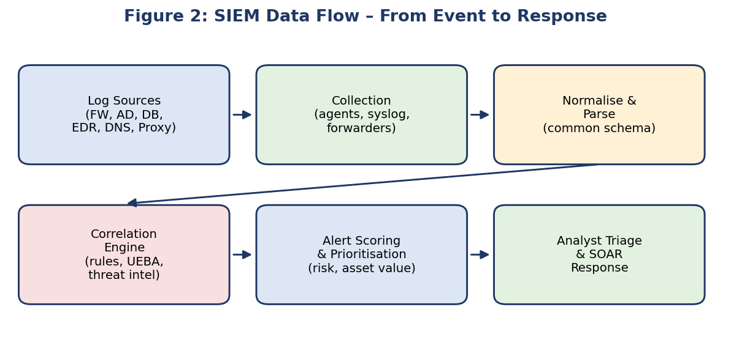
2. Collection of security events
- Sources: firewalls, IDS/IPS, VPN, Active Directory/IdP, servers, endpoints/EDR, DNS, proxy, email gateway, databases, cloud (AWS CloudTrail, Azure AD) and applications.
- Methods: agents (Universal Forwarder, Beats, Winlogbeat), syslog, WMI/WEF, API pulls and SNMP/NetFlow.
- Processing: parsing, normalisation into a common schema (timestamp, user, source/destination IP, action), enrichment with asset criticality, geo-IP, user identity and threat-intelligence data, and secure, time-synchronised, tamper-resistant storage for forensics and compliance.
3. Analysis of events
- Rule-based detection: e.g. more than 5 failed logins in 5 minutes.
- Statistical/behavioural analysis (UEBA): deviations from each user’s or host’s baseline.
- Threat-intelligence matching: destination IPs/domains/hashes compared with IOC feeds.
- Searching and dashboards: ad-hoc queries (SPL/KQL/Lucene), visualisation and trend analysis.
4. Correlation of alerts
Correlation links separate, low-value events into one meaningful incident by common entities (user, host, IP) within a time window. In this scenario the SIEM correlates:
Step | Event observed | Meaning
1 | Many failed logins (4625) for one account from one external IP | Brute force / password spraying
2 | Successful login (4624) from the same IP, out of hours | Credential compromise (ATT&CK T1110 → T1078)
3 | New process / PowerShell on that user’s workstation | Execution
4 | Unusual outbound connection to a rare/new domain or large upload | C2 or data exfiltration (T1071, T1041)

Individually, each event may be dismissed as noise; together they form a high-severity kill-chain incident (Reconnaissance → Access → Execution → C2 → Exfiltration). Correlation also removes duplicates, reduces false positives and shows the attack path.
5. Prioritisation of threats
- Risk scoring: severity × asset criticality × confidence × user privilege (a domain admin account or database server scores higher than a kiosk PC).
- Context enrichment: threat-intel reputation, vulnerability status, geo-location, time of day and past behaviour.
- Mapping to MITRE ATT&CK and kill-chain stage – alerts later in the chain are escalated first.
- Tiering and SOAR: Tier-1 triages, Tier-2/3 investigate critical alerts; SOAR playbooks automate enrichment, blocking an IP, disabling an account or opening a ticket, keeping response times short.
6. Benefits and limitations
Benefits: centralised visibility, faster detection and response (lower MTTD/MTTR), reduced alert fatigue, audit trails and compliance reporting (ISO 27001, PCI-DSS, GDPR). Limitations: needs good log coverage, rule tuning and skilled analysts; poorly tuned rules create false positives.
7. Conclusion
By collecting, normalising, analysing and correlating events and then scoring them by risk, the SIEM turns thousands of raw alerts into a few prioritised incidents, allowing analysts to concentrate on the real threats – here, a probable compromised account that is communicating externally.
- Security Monitoring and Anomaly Detection: A company's securitymonitoring dashboard identifies a sudden increase in outbound network traffic during non-working hours. The activity originates from a database server that normally transfers only small amounts of data. Explain how you would investigate the anomaly, identify possible data exfiltration, and recommend suitable monitoring and prevention measures. [10]
Answer 3: Security Monitoring and Anomaly Detection
1. Introduction
A database server that normally sends little data but suddenly produces heavy outbound traffic at night is a classic indicator of data exfiltration (ATT&CK TA0010), although backups, replication or a batch job could also explain it. The investigation must therefore confirm or rule out malicious activity quickly while preserving evidence.
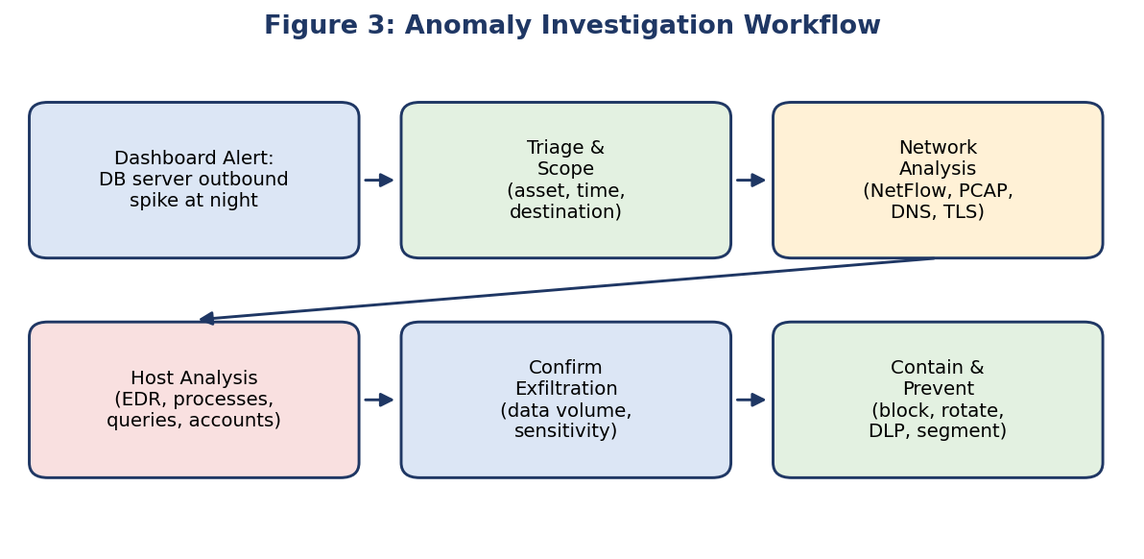
2. Step 1 – Triage and validate
- Confirm the alert is real (not a monitoring error) and record time window, volume, protocol, ports and destination IPs/domains.
- Compare with the baseline (normal bytes/day, peak hours) and check the change calendar for approved backups, migrations, ETL or patch jobs.
- Identify data owner and classification (PII, financial, IP) to judge impact.
3. Step 2 – Network investigation
- NetFlow/IPFIX, firewall and proxy logs: destination, volume, direction, duration, upload/download ratio.
- Destination reputation: threat-intel lookup, WHOIS age, geo-location, hosting provider; rare or newly registered destinations are suspicious.
- Packet capture / Zeek / Wireshark: protocol anomalies – large DNS TXT queries (DNS tunnelling), ICMP tunnelling, FTP/SFTP, HTTPS uploads to cloud storage (Mega, Dropbox), unusual ports, compressed/encrypted archives.
- Beaconing and TLS analysis: regular intervals, JA3 fingerprints, self-signed certificates.
4. Step 3 – Host and database investigation
- EDR/process logs: unexpected processes, archive tools (7z, rar, tar), curl/wget/scp/rclone, PowerShell or reverse shells; check parent processes.
- Database audit logs: large SELECT/dump/export queries, unusual tables accessed, new users, privilege changes, queries from unusual accounts or IPs, use of xp_cmdshell or similar features.
- Authentication logs: who logged in (RDP/SSH/VPN), from where, and any service-account misuse or SQL injection traces in web-server logs.
- File system: new files in temp folders, large staging archives, scheduled tasks/cron jobs and persistence.
5. Step 4 – Identify and confirm exfiltration
Indicators that make exfiltration likely: transfer volume far above baseline; data leaving to an unknown external host; staging/compression before transfer; access by an unusual account at off-hours; match between queried tables and outbound volume; threat-intel hit on the destination. Quantify what, how much, to whom and via which account by correlating DB audit, EDR and network records on a single timeline.
6. Step 5 – Immediate containment
- Block the destination at the firewall/proxy and throttle or isolate the database server (keep it powered on to preserve memory evidence).
- Disable or rotate the suspect account and service credentials; kill malicious sessions.
- Capture forensic images and memory, preserve logs, and invoke the incident-response plan (notify management and, if personal data is involved, legal/regulators as required, e.g. GDPR 72-hour rule).
7. Recommended monitoring measures
Measure | Purpose
SIEM alerts and UEBA baselines | Alert on outbound volume or time-of-day deviations for critical servers.
NetFlow/NDR (Zeek, Darktrace, Vectra) | Detect beaconing, tunnelling and unusual destinations.
Database Activity Monitoring (DAM) | Log and alert on bulk queries, exports and privilege changes.
EDR on servers | Detect staging tools, shells and suspicious process chains.
DNS and proxy monitoring | Spot DNS tunnelling, uploads to file-sharing/cloud sites.
Threat-intelligence feeds | Block and alert on known malicious IPs and domains.

8. Recommended prevention measures
- DLP and egress filtering: default-deny outbound rules; only allow whitelisted destinations/ports for database servers.
- Network segmentation and micro-segmentation; DB servers in a restricted zone with no direct internet access.
- Least privilege, MFA and PAM for DBAs; remove unused accounts; regular access reviews.
- Encryption of data at rest and in transit, tokenisation or masking of sensitive fields.
- Patch management, vulnerability scans and secure coding to prevent SQL injection; hardened configurations.
- Regular backups, tested incident-response playbooks, staff awareness and periodic threat hunts.
9. Conclusion
A structured process – validate, analyse network and host data, confirm what was taken, contain, then harden – allows the organisation to distinguish legitimate activity from exfiltration, limit loss and reduce the chance of recurrence through continuous monitoring, DLP and strong access controls.
- Tools Used in the IT Industry for Threat Hunting: An IT organization suspectsthat malware has infected several employee workstations. The security team has access to SIEM software, endpoint detection tools, network traffic analyzers, and vulnerability scanners. Select suitable tools for investigating the incident and explain how each tool can help identify, analyze, and contain the threat.
[10]
Answer 4: Tools Used in the IT Industry for Threat Hunting
1. Introduction
Suspected malware on several workstations requires tools that provide log visibility (SIEM), host-level detail and response (EDR), network visibility (traffic analysers) and exposure assessment (vulnerability scanners). Used together they follow the incident-response lifecycle: identify → analyse → contain → eradicate → recover.
2. Suitable tools and their role
Tool category | Examples | How it helps identify / analyse | How it helps contain
SIEM | Splunk, IBM QRadar, Microsoft Sentinel, ELK/Elastic | Aggregates logs from all workstations; searches for common IOCs (hash, domain, process name); correlates logins, process creation and DNS to reveal which machines are affected and the infection timeline. | Alerts and SOAR playbooks trigger blocking, ticketing and account lockout; creates detection rules for similar activity.
Endpoint Detection and Response (EDR) | CrowdStrike Falcon, Microsoft Defender for Endpoint, SentinelOne, Carbon Black | Shows process trees, file/registry changes, persistence, memory injection and network connections per host; hunts the IOC across all endpoints; sandbox/ behavioural verdicts. | Network-isolates infected hosts, kills processes, quarantines files and performs remote remediation or rollback.
Network traffic analysers | Wireshark, Zeek, Suricata/Snort, NetFlow/NDR (Darktrace, Vectra) | Capture and inspect packets; detect C2 beaconing, DNS tunnelling, malicious downloads, lateral SMB/RDP traffic and data uploads; extract files for analysis. | IPS signatures and firewall/DNS rules block C2 domains and IPs; identifies other hosts talking to the same server.
Vulnerability scanners | Nessus, Qualys, OpenVAS, Rapid7 InsightVM | Find missing patches, weak configurations and exposed services that the malware may have exploited; determines which other systems are at risk. | Drives patching and hardening to remove the entry point and prevent re-infection.
Threat-intelligence and malware-analysis tools | VirusTotal, MISP, AlienVault OTX, Cuckoo/ANY.RUN sandbox, YARA | Check hashes, URLs and IPs; detonate samples safely; identify the malware family and its TTPs; generate extra IOCs. | Supplies blocklists and YARA/Sigma rules for rapid detection and blocking.
Forensic and memory tools (optional) | Velociraptor, Volatility, Autoruns, Process Explorer | Examine memory, persistence and artefacts on affected systems. | Supports eradication and evidence preservation.

3. Recommended workflow using the tools
- Identify: SIEM alert/IOC search finds the first suspicious workstation; EDR confirms the malicious process and lists all other endpoints with the same hash or behaviour.
- Analyse: Wireshark/Zeek reveal the C2 domain and protocol; hashes are submitted to VirusTotal/sandbox; vulnerability scanner reports show how the malware got in (e.g. unpatched software).
- Contain: isolate hosts with EDR, block domains/IPs on the firewall and DNS, disable compromised accounts and segment the network.
- Eradicate and recover: remove malware and persistence, patch vulnerabilities, restore from clean backups or re-image, reset credentials.
- Improve: convert findings into SIEM/EDR rules, rescan with the vulnerability scanner and continue monitoring.
4. Conclusion
SIEM gives breadth, EDR gives depth on endpoints, network analysers expose communication and spread, and vulnerability scanners remove the weaknesses exploited. Their combined use gives rapid detection, accurate scoping and effective containment of the malware outbreak.
- Integrated Threat Hunting and Incident Reporting: A company detectssuspicious user logins, connections to a malicious domain, and an unknown process running on an employee workstation. The security team uses Splunk or the ELK Stack to analyze logs and a threat intelligence platform to verify suspicious indicators. Describe the complete threat-hunting process, including data collection, log correlation, threat investigation, malware analysis if required, risk assessment, and preparation of a threat-hunting report with recommended remediation actions. [10]
Answer 5: Integrated Threat Hunting and Incident Reporting
1. Introduction
The scenario – suspicious user logins, connections to a malicious domain and an unknown process on a workstation – points to a compromised account and a possible malware infection with C2. A complete hunt follows eight connected stages, using Splunk/ELK for log analysis and a threat-intelligence platform (TIP) such as MISP, VirusTotal or AlienVault OTX to verify indicators.
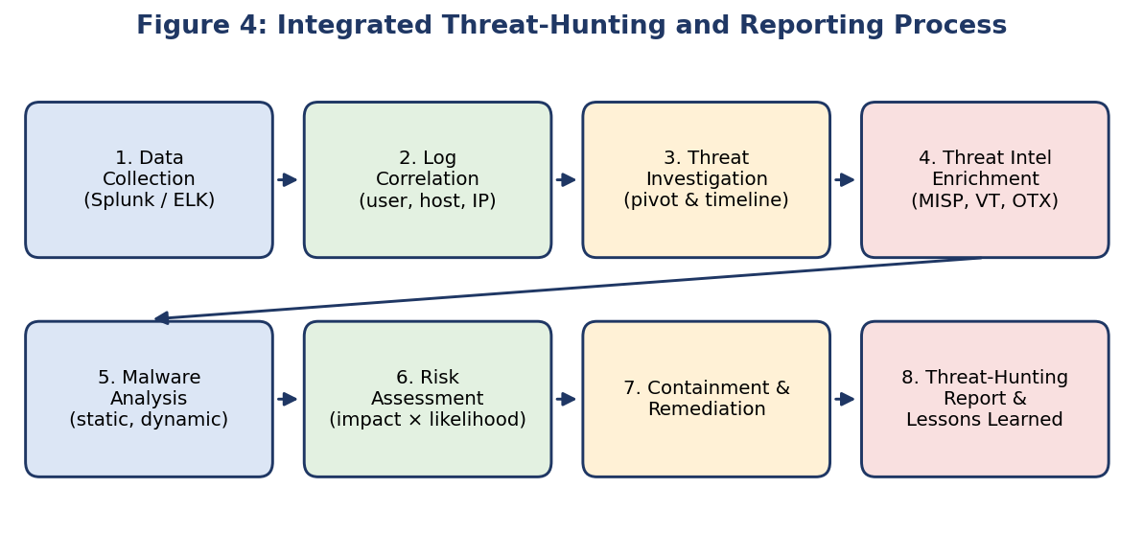
2. Stage 1 – Data collection
- Ingest Windows Security and Sysmon logs, AD/VPN/IdP logs, EDR telemetry, DNS, proxy, firewall and NetFlow logs into Splunk (Universal Forwarder) or ELK (Beats → Logstash → Elasticsearch → Kibana).
- Ensure time synchronisation, parse and normalise fields (user, host, IP, process, domain), and preserve original logs and disk/memory images with chain of custody.
3. Stage 2 – Log correlation
Correlate events by user, host and IP within a time window. Example Splunk-style searches:
- Logins: index=wineventlog EventCode=4624 OR 4625 user=jdoe | stats count by src_ip, host, _time
- Processes: index=sysmon EventCode=1 host=WS-045 | table _time Image ParentImage CommandLine Hashes
- DNS/proxy: index=dns host=WS-045 | stats count by query | sort count
Result: failed logins → successful login from a new IP → unknown process started → DNS query/connection to the suspicious domain – a single attack chain.
4. Stage 3 – Threat investigation
- Pivot from the user to host, process, parent process, command line, file path, hash and network connection; build a timeline.
- Look for persistence (Run keys, scheduled tasks, services), credential dumping (LSASS access), lateral movement (RDP/SMB/PsExec) and other hosts contacting the same domain.
- Map the activity to MITRE ATT&CK (T1078, T1059, T1547, T1071) to describe attacker behaviour.
5. Stage 4 – Threat-intelligence enrichment
Submit the domain, IP and file hash to the TIP: check reputation, first-seen date, associated malware families/campaigns, related IOCs and detection ratio. Confirmed matches raise confidence from “suspicious” to “confirmed malicious” and supply further IOCs to hunt for in Splunk/ELK across the whole environment.
6. Stage 5 – Malware analysis (if required)
- Static analysis: hash, strings, PE headers, imports, packer detection, YARA matching.
- Dynamic analysis: run in an isolated sandbox (Cuckoo, ANY.RUN) with Procmon, Regshot and Wireshark to observe file, registry, process and network behaviour.
- Memory/behaviour analysis: Volatility to find injected code or hidden processes; extract C2 addresses, mutexes and configuration.
- Outputs: malware family, capabilities (keylogging, download, exfiltration), IOCs and detection rules.
7. Stage 6 – Risk assessment
Factor | Assessment | Notes
Likelihood | High | Confirmed malicious domain and active process; account already used.
Impact | Medium–High | Depends on user privilege, data on the host and lateral movement.
Scope | Number of hosts/accounts | Hosts contacting the same IOC; compromised credentials.
Overall risk | High (risk = likelihood × impact) | Prioritise containment; escalate to incident response.

8. Stage 7 – Containment and remediation
- Immediate: isolate the workstation via EDR, block the domain/IP and hash, disable/reset the user’s credentials, revoke sessions and enforce MFA.
- Eradication: remove the malware and persistence, patch exploited software, re-image the machine if integrity is doubtful, and search for IOCs on all other endpoints.
- Recovery: restore from clean backups, monitor intensively for re-infection.
- Long term: least privilege, application whitelisting, email filtering, user awareness training, new Splunk/ELK detection rules and dashboards.
9. Stage 8 – Threat-hunting report
Report section | Content
Executive summary | Brief description, severity, business impact and outcome for management.
Scope and hypothesis | Systems, users and time period; hunting hypothesis and data sources used.
Methodology and tools | Splunk/ELK queries, TIP checks, EDR and sandbox used.
Findings and timeline | Chronological sequence of events with evidence (screenshots, log excerpts).
IOCs and TTPs | IPs, domains, hashes, file paths, registry keys; ATT&CK technique mapping.
Risk assessment | Likelihood, impact, affected assets and data.
Actions taken | Containment, eradication and recovery steps performed.
Recommendations | Short-term fixes, long-term controls, new detections and policy changes.
Lessons learned and appendices | Gaps in visibility, process improvements, raw evidence and query list.

10. Conclusion
The integrated process – collecting data, correlating logs, investigating, enriching with threat intelligence, analysing malware, assessing risk, remediating and documenting – converts scattered alerts into a verified incident with clear actions. The final report preserves knowledge, supports compliance and improves future detection and response.

