Component Library Working Model

Purpose
Code-first design system. Component source in Git is the design record.
Repos:
- https://github.com/mithya-team/mithya-ui-libs
- https://github.com/mithya-team/mithya-pilot-client
This document is the working contract for those two repos.

Repositories
Web and React Native are packages in one lib repo. The client repo has two apps.
Repo | What it holds
https://github.com/mithya-team/mithya-ui-libs | packages/web (React + Tailwind), packages/native (React Native + Unistyles), registry JSON, playgrounds
https://github.com/mithya-team/mithya-pilot-client | apps/web, apps/native, theme values, product components, locked ui copies, feature code
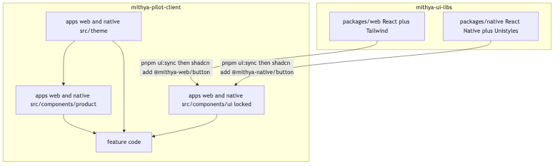
Repos and install flow
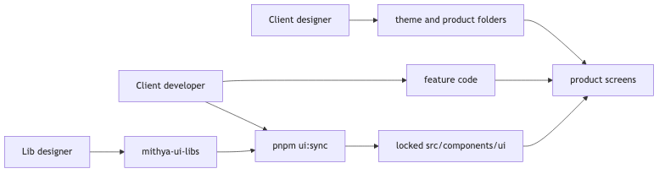
Who edits which folders
Generic libs own reusable primitives, public API, visual identity of those primitives, registry JSON, tags, changelogs.
Each client app owns theme values, product-only components, icons that are not generic, and screen composition.
Developers install pinned registry items and stitch data, routing, and product UI. They do not restyle src/components/ui.

How designers work

Lib designer — mithya-ui-libs
Owns primitives in packages/web and packages/native.
- Change or add source in the matching package.
- Show every variant and state in the package playground.
- Run pnpm build:registry.
- Review the playground. Then tag (example: v0.1.0). Tags are immutable.
Skill in that repo: .cursor/skills/ui-lib-component/SKILL.md.
Do not put client theme values in lib component source. Libs own token names (token-contract.json).

Client designer — mithya-pilot-client
Owns apps/web/src/theme, apps/native/src/theme, and apps/*/src/components/product.
- Set color, space, type values in theme files.
- Build product-only UI under src/components/product.
- Compose screens from locked primitives + product components.
Do not edit apps/*/src/components/ui.
Skill in that repo: .cursor/skills/client-ui-component/SKILL.md.

How developers work

Client developer — mithya-pilot-client
Package manager is pnpm. Do not run npm i. npm i re-runs Unistyles prepare (bob build) and fails.
pnpm install
pnpm ui:init
pnpm ui:sync
pnpm --filter web dev
pnpm --filter native ios
Native Unistyles uses Nitro. Use a dev client (expo run:ios). Expo Go is not supported. Clone to a path without spaces (Expo iOS scripts split on space).
- Install pinned items with pnpm ui:sync.
- Write feature / page code. Call APIs. Wire routing.
- Need a new reusable primitive? Open a GitHub issue on mithya-ui-libs. Do not patch the copied shell.

Lib developer / agent — mithya-ui-libs
Same rules as lib designer for source. Follow .cursor/skills/ui-lib-component/SKILL.md.

What we are not doing
- npm package as the consumer install path.
- Theme values shipped inside locked registry files.
- Community kits as the Mithya system (React Native Reusables, shadniwind, appCN, native-shadcn). Those prove the CLI works. They are other design systems.

Distribution
Official shadcn CLI on both platforms. The CLI copies files. It does not require Tailwind on native.
Command after project setup: shadcn add @mithya-web/button and shadcn add @mithya-native/button.
@mithya-web is not registered with shadcn. pnpm ui:init writes the URL map into that app’s components.json once. Do not use @mithya-web/button@v1 — invalid. Pin lives in the mapped URL (tag path or params.version).
pnpm ui:init
pnpm dlx shadcn add @mithya-web/button
pnpm dlx shadcn add @mithya-native/button
ui:init equivalent:
pnpm dlx shadcn registry add @mithya-web=https://mithya-team.github.io/mithya-ui-libs/web/v0.1.0/{name}.json
pnpm dlx shadcn registry add @mithya-native=https://mithya-team.github.io/mithya-ui-libs/native/v0.1.0/{name}.json
Pilot registry server in mithya-ui-libs: pnpm serve → http://127.0.0.1:3333/web/v0.1.0/{name}.json (same for /native/).
Bump version = change the pin in components.json (or ui:init --version v1.3.0), then pnpm ui:sync with UI-Reason: refresh.
Public lib repo is the source. GitHub Pages (not yet enabled) or pnpm serve for JSON. No npm publish of components. No official shadcn directory PR.
Fallback with no @ map: shadcn add mithya-team/mithya-ui-libs/web/button#v0.1.0 once registry.json is at the repo root (today it lives under registry/web/ and registry/native/). Prefer the @ form after ui:init.
Wrap installs in pnpm ui:sync. Never latest. Never unpinned main in prod.
Native items set explicit files[].target. Native components.json may use empty Tailwind config/css. Unistyles does not ship a registry. shadniwind is a copy-pattern only. Do not add @shadniwind/*.

Folder contract in the client repo
Paths are per app (apps/web, apps/native):
Path | Owner | Git
src/components/ui/** | Generic lib via CLI | Locked
ui.lock.json | Generated by ui:sync | Locked
src/theme/** | Client designer | Unlocked
src/components/product/** | Client designer | Unlocked
Feature / page code | Client developer | Unlocked
Do not put product components in src/components/ui.

Theme split
Libs own semantic token names. Client owns values.
Web: client src/theme/theme.css defines CSS variables. Installed components use semantic Tailwind utilities only (bg-surface, text-fg-muted). Copied files live under src/components/ui, so Tailwind scans them in-repo.
Native: client src/theme/unistyles.ts calls StyleSheet.configure once, before any UI import (apps/native/index.ts imports it first). Theme objects satisfies NativeTheme. Components use StyleSheet.create((theme) => …) and semantic keys only.
Registry may ship a type/contract file (native-theme.ts) that is locked. It must not ship filled color/spacing values. Values stay in unlocked src/theme/.
Light, dark, system: the app selects the mode. Components consume the configured theme.

As-is rule (copy model)
shadcn copy does not give as-is by default. Integrity is:
- ui.lock.json — item, version, path, sha256.
- pre-commit — src/components/ui/** changes allowed only with UI_SYNC=1 and hash verify.
- commit-msg — UI commits are UI-only (those files + ui.lock.json). Message trailers required.
- pnpm verify:ui — refetch the pinned registry artifact and diff. Local lock is a cache.
git commit --no-verify is why CI refetch exists.

pnpm ui:sync
Fetches the pinned items, writes files, writes ui.lock.json, prints the commit command.
Legitimate reasons only:
- first-install
- refresh (version bump or re-copy of the same pin)
ui(web): button@v0.1.0
UI-Reason: first-install
UI-Version: v0.1.0
Hook rejects mixed commits (feature code + ui/). Hook rejects UI commits without trailers. Hook rejects hash mismatch.

Process — create or update a component
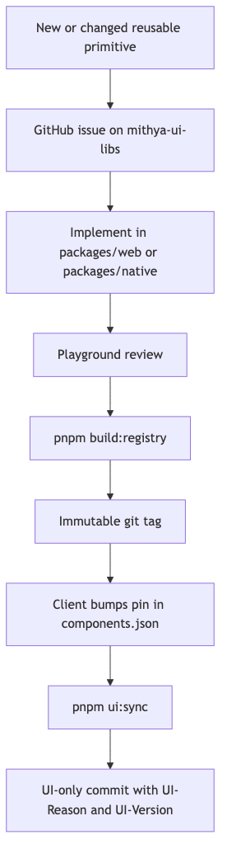
Primitive change flow

Reusable primitive (mithya-ui-libs)
Follow .cursor/skills/ui-lib-component/SKILL.md.
- Issue on https://github.com/mithya-team/mithya-ui-libs
- Implement in packages/web and/or packages/native
- Playground review
- pnpm build:registry
- Git tag
- Client pin bump + pnpm ui:sync + UI-only commit

Product-only (mithya-pilot-client)
Follow .cursor/skills/client-ui-component/SKILL.md.
Add files under src/components/product or change src/theme. No tag. No ui:sync.

Platform implementations
Separate libs. No shared component source. Shared semantic token names where useful.
- Web: React + Tailwind CSS.
- Native: React Native + Unistyles.
Do not introduce NativeWind or Uniwind unless this document is revised.
Unistyles rules:
- StyleSheet.configure once in client theme, before UI imports.
- StyleSheet.create for ordinary styles.
- Do not use useUnistyles for ordinary styling.
- Do not add a second theme provider.

Component contract
Each released component is a stable product API:
- Props, variants, sizes, tones, states.
- Controlled and uncontrolled behavior.
- Forwarded refs and supported imperative behavior.
- Explicit typed slots.
- Disabled, loading, error, empty, selected, read-only.
- Keyboard, pointer, touch, focus, gesture.
- Accessibility: labels, roles, announcements, focus order.
- Test hooks when product automation needs them.
- Overflow, localization, RTL, large text.
Unsupported reusable needs become issues, then public API.

Customization boundary
Applications place components. The lib owns primitive visuals.
No unrestricted root className or style on public primitives. Restricted layout on the outer element. Restricted textLayout on owned text.
Parent composition for position:
<div className="absolute top-8 right-8">
<Button>Save</Button>
</div>

Web layout allowlist
Positioning, external spacing (margin), sizing, parent-layout participation, overflow. No padding, gap, alignItems, justifyContent, color, background, border, typography, shadow, filter, animation, or transform on layout.
textLayout: whiteSpace, overflowWrap, wordBreak, hyphens, textOverflow, library lineClamp.

Native layout allowlist
Position, margin, sizing, alignSelf, flex, display, overflow.
textLayout: numberOfLines, ellipsizeMode, allowFontScaling, maxFontSizeMultiplier, adjustsFontSizeToFit, minimumFontScale.
Same bans as web for internal appearance. Translation transforms stay on wrappers.

Slots and composition
Typed slots only (iconLeft, header, emptyState, …). Slots are not a restyle hatch. Raw internals stay private unless another lib component needs them.

Icons, fonts, animation, dependencies
Phosphor is the generic icon set.
Generic reusable icons: generic lib / registry item. Client-specific icons: client app (src/components/product or src/assets), not the generic lib.
Fonts and motion: tokens. New large UI/icon/animation runtimes need a lib issue.
Registry items declare npm deps the CLI must install (Unistyles, Phosphor, …).

Agent rules
Lib agents (in mithya-ui-libs):
- Semantic tokens only. No hex/rgb/hsl, no arbitrary visual Tailwind, no primitive token names in component source.
- No root className/style escape hatches.
- New need → variant/prop in the lib, not a one-off in a consumer.
- Load .cursor/skills/ui-lib-component/SKILL.md.
Client agents (in mithya-pilot-client):
- Do not edit src/components/ui/**.
- Theme and product UI only in unlocked paths.
- Install via pnpm ui:sync, never by hand-copy.
- Load .cursor/skills/client-ui-component/SKILL.md.
Formatting is not a quality gate.

Quality gates

mithya-ui-libs
- Playground review before tag.
- pnpm build:registry produces registry/web|native/v*/{name}.json.
- Semantic tokens only in component source.

mithya-pilot-client
scripts/check-ui-lock.sh on pre-commit:
- UI staged paths only with UI_SYNC=1.
- Hashes match refetch of components.json pins.
- Commit trailers UI-Reason + UI-Version.
- Theme/product paths unrestricted by this script.
Web smoke: pnpm --filter web test:e2e (Playwright).
Native smoke: Maestro apps/native/maestro/smoke.yaml on the iOS simulator after pnpm --filter native ios.

Issues, releases, support
Labels: component:new, component:change, component:bug, platform:web, platform:native, theme, icon-or-asset, accessibility, behavior, project-specific, needs-design-decision, accepted.
## Problem / use case
## Target platform
Web / React Native / both (separate implementations)
## Requested change
New component / new variant / new prop / behavior change
## Existing component considered
## Proposed API
## Required states and interactions
## Ref, accessibility, and test-hook requirements
## Icon or asset requirements
## Is this shared-system or project-specific?
Tags are immutable. Old tags stay installable. Only latest gets fixes. Client pins the tag.

Pilot
Greenfield. Repos are public.
- Lib: https://github.com/mithya-team/mithya-ui-libs — packages/web, packages/native, registry JSON, pnpm serve on 127.0.0.1:3333
- Client: https://github.com/mithya-team/mithya-pilot-client — apps/web, apps/native, ui:sync, lock hooks
Attack tests (web + native): edit ui/button → verify fail; forged lock hashes → refetch fail; theme/product edit → pass; mixed ui+feature without UI_SYNC → hook fail.
Pass: product/theme can change; generic UI cannot, except by versioned sync commit.

After the pilot — host
Default command: shadcn add @mithya-web/button after pnpm ui:init.
ui:init writes @mithya-web and @mithya-native into components.json. Do not PR the official shadcn directory.
Now: localhost pnpm serve from mithya-ui-libs.
Next: enable GitHub Pages on mithya-ui-libs. Theme values stay in the client repo.
GitHub item address (optional): mithya-team/mithya-ui-libs/...#tag only after a root registry.json.
Role | Access
Lib designer | Write https://github.com/mithya-team/mithya-ui-libs ; tag after playground review
Everyone else | Clone https://github.com/mithya-team/mithya-pilot-client ; ui:init once, then shadcn add @mithya-web/button
Client CI | Public fetch; no registry PAT

