You are here

Home > [Microservices](https://javatechonline.com/microservices/) >

**How to Implement Distributed Tracing Logging using Sleuth Zipkin**

* [Microservices](https://javatechonline.com/microservices/)

* [java](https://javatechonline.com/java/)

* [Sleuth & Zipkin](https://javatechonline.com/sleuth-zipkin/)

* [Spring Cloud](https://javatechonline.com/spring-cloud/)

*by*[*devs5003*](https://javatechonline.com/author/erdsingh24/)*- April 21, 2021*1

Last Updated on March 10th, 2024

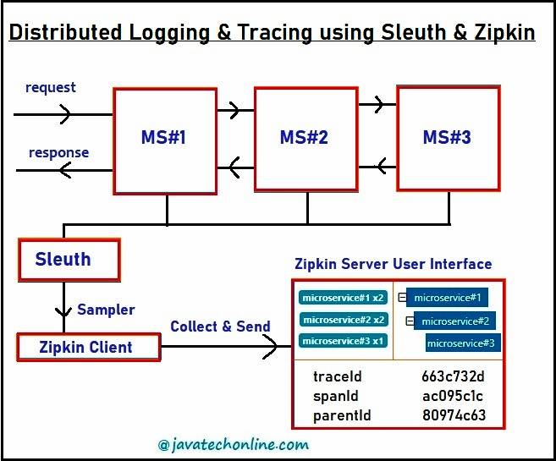In [Microservices Architecture](https://javatechonline.com/microservices-architecture/) based Applications, there are multiple services which interact with each other. In order to serve a client request, one request may involve multiple microservices call to get the response. If any exception occurs or any latency issue appears during such calls, then how will we identify the root cause of the issue? Of course, we will make use of Spring Cloud Sleuth & Zipkin to support distributed logging & Tracing. Therefore, we are going to learn about ‘How to implement Distributed Tracing Logging using Sleuth Zipkin Spring Boot’ and related concepts accordingly.

If we are working on a Standard application, we can implement logging by adding one log file to identify any exception or other issues like response timings or latency etc. However, in case of Microservices based applications, there are multiple small applications. Therefore, we will have to maintain multiple log files such as at least one log file per application. In this case, correlating the logs to a particular request chain becomes difficult. Hence, identifying the root cause of the issue also becomes complicated.

In order to overcome from such kind of issues, we make use of Spring Cloud Sleuth and Zipkin. Let’s discuss our topic ‘How to Implement Distributed Tracing Logging using Sleuth Zipkin Spring Boot?’ And related concepts accordingly.

Table of Contents

* [What is Logging & Tracing?](https://javatechonline.com/distributed-tracing-logging-using-sleuth-zipkin/#What_is_Logging_Tracing)
* [What is Sleuth and Zipkin used for ?](https://javatechonline.com/distributed-tracing-logging-using-sleuth-zipkin/#What_is_Sleuth_and_Zipkin_used_for)
  + [Sleuth](https://javatechonline.com/distributed-tracing-logging-using-sleuth-zipkin/#Sleuth)
  + [Zipkin](https://javatechonline.com/distributed-tracing-logging-using-sleuth-zipkin/#Zipkin)
* [How to download & setup Zipkin Server?](https://javatechonline.com/distributed-tracing-logging-using-sleuth-zipkin/#How_to_download_setup_Zipkin_Server)
  + [Other sources to get Zipkin jar](https://javatechonline.com/distributed-tracing-logging-using-sleuth-zipkin/#Other_sources_to_get_Zipkin_jar)
* [How to Implement Distributed Tracing Logging using Sleuth Zipkin Spring Boot?](https://javatechonline.com/distributed-tracing-logging-using-sleuth-zipkin/#How_to_Implement_Distributed_Tracing_Logging_using_Sleuth_Zipkin_Spring_Boot)
  + [Step#1 : Create a Spring Boot Project using STS(Spring Tool Suite)](https://javatechonline.com/distributed-tracing-logging-using-sleuth-zipkin/#Step1_Create_a_Spring_Boot_Project_using_STSSpring_Tool_Suite)
  + [Step#2: Modify application.properties file](https://javatechonline.com/distributed-tracing-logging-using-sleuth-zipkin/#Step2_Modify_applicationproperties_file)
  + [Step#3: Create AppConfig.java to Setup Configurations](https://javatechonline.com/distributed-tracing-logging-using-sleuth-zipkin/#Step3_Create_AppConfigjava_to_Setup_Configurations)
  + [Step#4: Write a RestController to implement a Microservice](https://javatechonline.com/distributed-tracing-logging-using-sleuth-zipkin/#Step4_Write_a_RestController_to_implement_a_Microservice)
  + [Step#5: Write two more applications just like above](https://javatechonline.com/distributed-tracing-logging-using-sleuth-zipkin/#Step5_Write_two_more_applications_just_like_above)
  + [AppConfig.java for Service #2](https://javatechonline.com/distributed-tracing-logging-using-sleuth-zipkin/#AppConfigjava_for_Service_2)
  + [application.properties for Service #2](https://javatechonline.com/distributed-tracing-logging-using-sleuth-zipkin/#applicationproperties_for_Service_2)
  + [RestController for Service #2](https://javatechonline.com/distributed-tracing-logging-using-sleuth-zipkin/#RestController_for_Service_2)
  + [AppConfig.java for Service #3](https://javatechonline.com/distributed-tracing-logging-using-sleuth-zipkin/#AppConfigjava_for_Service_3)
  + [application.properties for Service #3](https://javatechonline.com/distributed-tracing-logging-using-sleuth-zipkin/#applicationproperties_for_Service_3)
  + [RestController for Service #3](https://javatechonline.com/distributed-tracing-logging-using-sleuth-zipkin/#RestController_for_Service_3)
* [How to test the application as a whole?](https://javatechonline.com/distributed-tracing-logging-using-sleuth-zipkin/#How_to_test_the_application_as_a_whole)
* [Messages from Log Files](https://javatechonline.com/distributed-tracing-logging-using-sleuth-zipkin/#Messages_from_Log_Files)
  + [Microservice#1 : Log messages](https://javatechonline.com/distributed-tracing-logging-using-sleuth-zipkin/#Microservice1_Log_messages)
  + [Microservice#2 : Log messages](https://javatechonline.com/distributed-tracing-logging-using-sleuth-zipkin/#Microservice2_Log_messages)
  + [Microservice#3 : Log messages](https://javatechonline.com/distributed-tracing-logging-using-sleuth-zipkin/#Microservice3_Log_messages)
* [Conclusion](https://javatechonline.com/distributed-tracing-logging-using-sleuth-zipkin/#Conclusion)

**What is Logging & Tracing?**

**Tracing :** Tracing is a process of finding an execution path or a flow of multiple microservices to serve a request.

**Logging :** Logging is a process of admitting all log messages for a trace. These messages can be of any type such as DEBUG, INFO, WARN, ERROR etc.

Here, we will be implementing Logging and Tracing for multiple Microservices involved in serving one request. We also call it ‘Distributed Tracing and Logging’. Once it is implemented one time, then developer doesn’t need to check the code again to find the flow either for testing purpose or for debug purpose.

**What is Sleuth and Zipkin used for ?**

**Sleuth**

Sleuth provides unique ids for the request flow. Further, the developer uses these ids to find out the flow of execution with the help of tools like Zipkin, ELK etc. Generally it has two ids : Trace id and Span Id. Trace Id is applicable for a complete flow. If the developer gets this Id, he/she can find the flow of execution in all microservices involved.

However, Span Id is applicable to the flow of one microservice. If the developer gets this Id, he/she can find the flow of execution in a particular microservice. Moreover, there is a concept of parent id which is applicable to a particular microservice like span id. During the flow of execution, span id of the previous microservice becomes the parent id of the next microservice as shown below.

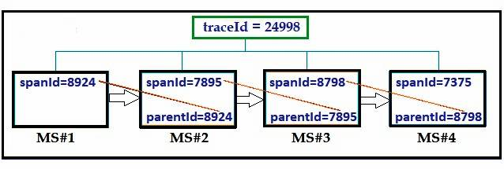

**Zipkin**

We use Zipkin in two parts : Zipkin Client and Zipkin Server. Zipkin Client contains Sampler which collects data from microservices with the help of Sleuth and provides it to the Zipkin Server. In order to utilize the benefits of both tools, we should always add Zipkin Client’s dependency along with Sleuth in every microservice.

However, there must be only one centralized Zipkin Server, which collects all data from Zipkin Client and display it as a UI. Hence, after making a request developer should look into Zipkin Server to find trace id, span id and even flow of execution. From here itself, Open Log files to check Log lines that are related to the current trace Id.

**How to download & setup Zipkin Server?**

In order to check the flow of execution in microservices chain, we need to download & setup Zipkin Server in our system. Please follow below steps to get it done.

1) Download ZIPKIN from the Link below:  
[Zipkin Download](https://www.mediafire.com/file/jmpqrenm0yudehy/ZipkinExecutable.zip/file)

2) Extract to a folder ‘ZipkinExecutable’. The downloaded file name should be like ‘ZipkinExecutable.zip’

3) Open command prompt at the above location where your extracted folder exists.  
For example: Let’s assume that your location is C:/Downloads/ZipkinExecutable/>

4) Run Jar file by using below command:  
> java -jar zipkin-server-2.12.9-exec.jar  
If Zipkin Server started successfully, you will see message something like “Started ZipkinServer in 14.094 seconds (JVM running for 15.452)”

5) Open your Browser and Enter URL:  
http://localhost:9411/zipkin/

6) Click on ‘Find Traces’ button. It will display ‘Showing: 0 of 0‘

Other sources to get Zipkin jar

1) Download from [zipkin.io](https://zipkin.io/pages/quickstart) page

2) You can also add following dependency to add zipkin-2.5.2.jar to your project. You can select the version as per your requirement.

**<dependency>**

**<groupId>io.zipkin.zipkin2</groupId>**

**<artifactId>zipkin</artifactId>**

**<version>2.5.2</version>**

**</dependency>**

**How to Implement Distributed Tracing Logging using Sleuth Zipkin Spring Boot?**

In order to implement Distributed Tracing Logging using Sleuth Zipkin Spring Boot, we will do three major tasks as below:

1. Develop three Microservices applications using Spring Boot which will interact with each other.

2. Implement distributed logging & tracing using Spring Cloud Sleuth

3. Test distributed logging & tracing using Zipkin Server

Let’s start with developing application step by step.

Step#1 : Create a Spring Boot Project using STS(Spring Tool Suite)

Here, we will use STS(Spring Tool Suite) to create our Spring Boot Project. If you are new to Spring Boot, visit Internal Link to [create a sample project in spring boot using STS](https://javatechonline.com/saving-data-into-database-using-spring-boot-data-jpa-step-by-step-tutorial/#Step_1_Creating_Starter_Project_using_STS). While creating a project in STS add starters ‘Sleuth’, ‘Zipkin Client’, ‘Spring Web’ in order to get features of them.

Step#2: Modify application.properties file

**server.port=8081**

**spring.application.name=microservice#1**

**logging.file.name=D:/myLogs/serviceOne.log**

**#can include eureka details also—-**

Step#3: Create AppConfig.java to Setup Configurations

**import org.springframework.context.annotation.Bean;**

**import org.springframework.context.annotation.Configuration;**

**import org.springframework.web.client.RestTemplate;**

**import brave.sampler.Sampler;**

**@Configuration**

**public class AppConfig {**

//Collects data from Sleuth and provides it to Zipkin Client

**@Bean**

**public Sampler samplerOb() {**

**//return Sampler.NEVER_SAMPLE;**

**return Sampler.ALWAYS_SAMPLE;**

**}**

//Creates RestTemplate Object

**@Bean**

**public RestTemplate rt() {**

**return new RestTemplate();**

**}**

**}**

Step#4: Write a RestController to implement a Microservice

Write a RestController like below:

**import org.slf4j.Logger;**

**import org.slf4j.LoggerFactory;**

**import org.springframework.beans.factory.annotation.Autowired;**

**import org.springframework.web.bind.annotation.GetMapping;**

**import org.springframework.web.bind.annotation.RestController;**

**import org.springframework.web.client.RestTemplate;**

**@RestController**

**public class AppOneRestController {**

**private Logger log = LoggerFactory.getLogger(AppOneRestController.class);**

**@Autowired**

**private RestTemplate restTemplate;**

**@GetMapping("/m1")**

**public String methodOne() {**

**log.info("Inside microservice#1");**

**String response = restTemplate.getForObject("http://localhost:8082/m2", String.class);**

**log.info("response by microservice#1 " + response);**

**return "returning from microservice#1";**

**}**

**}**

Step#5: Write two more applications just like above

As similar to above code also define two more applications. For example, let’s say MyServiceTwo and MyServiceThree. However, Config Files will be similar but properties may differ. Also change the code of RestController accordingly.

AppConfig.java for Service #2

Same as for Service #1

application.properties for Service #2

**server.port=8082**

**spring.application.name=microservice#2**

**logging.file.name=D:/myLogs/serviceTwo.log**

RestController for Service #2

**import org.slf4j.Logger;**

**import org.slf4j.LoggerFactory;**

**import org.springframework.beans.factory.annotation.Autowired;**

**import org.springframework.web.bind.annotation.GetMapping;**

**import org.springframework.web.bind.annotation.RestController;**

**import org.springframework.web.client.RestTemplate;**

**@RestController**

**public class AppTwoRestController {**

**private Logger log = LoggerFactory.getLogger(AppTwoRestController.class);**

**@Autowired**

**private RestTemplate restTemplate;**

**@GetMapping("/m2")**

**public String methodTwo() {**

**log.info("Inside microservice#2");**

**String response = restTemplate.getForObject("http://localhost:8083/m3", String.class);**

**log.info("response by microservice#2 " + response);**

**return "returning from microservice#2";**

**}**

**}**

AppConfig.java for Service #3

Same as for Service #1

application.properties for Service #3

**server.port=8083**

**spring.application.name=microservice#3**

**logging.file.name=D:/myLogs/serviceThree.log**

RestController for Service #3

**import org.slf4j.Logger;**

**import org.slf4j.LoggerFactory;**

**import org.springframework.beans.factory.annotation.Autowired;**

**import org.springframework.web.bind.annotation.GetMapping;**

**import org.springframework.web.bind.annotation.RestController;**

**import org.springframework.web.client.RestTemplate;**

**@RestController**

**public class AppThreeRestController {**

**private Logger log = LoggerFactory.getLogger(AppThreeRestController.class);**

**@Autowired**

**private RestTemplate restTemplate;**

**@GetMapping("/m3")**

**public String methodThree() {**

**log.info("Inside microservice#3");**

**log.info("done with microservice#3 " );**

**return "returning from microservice#3";**

**}**

**}**

**How to test the application as a whole?**

Lets follow below steps to test the whole application. Screenshots are also provided to make testing easier.

1) Start Zipkin Server

2) Start All Microservices one by one

3) Enter URL: http://localhost:8081/m1

4) Open a new browser window and enter http://localhost:9411/zipkin

5) Click on Find Trace. You will see details of three running microservices highlighted in green color.

6) Click on Blue color bar. You will see trace record of each microservice.

7) Click on any one option. Let’s click on ‘microservice#2’. A new popup window will appear with all the details.

8) Click on ‘Show IDs’, you will find details of traceId, spanId and parentId. Now, copy traceId from here.

9) Open Log files and search(ctrl+F) with traceId to see all log lines related to current request.

For example, once we enter URL ‘http://localhost:9411/zipkin’ and click on ‘Find traces’ button, we will see below screen.

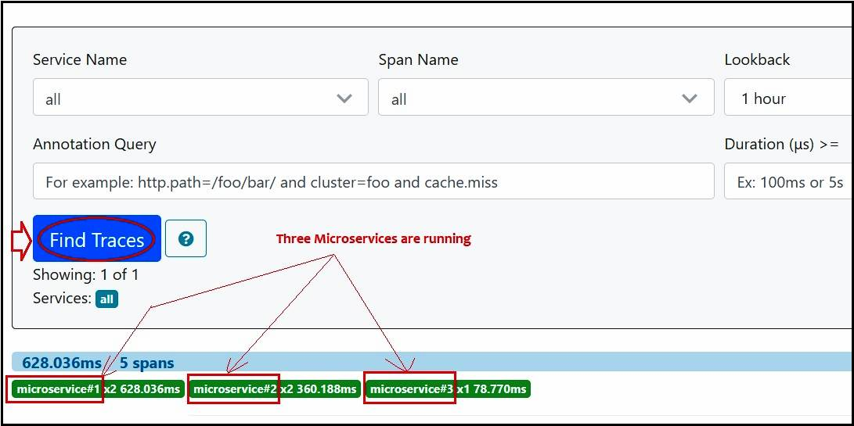

Now, Let’s click on blue bar just above the microservices highlighted in green color. We will get a screen something like below.

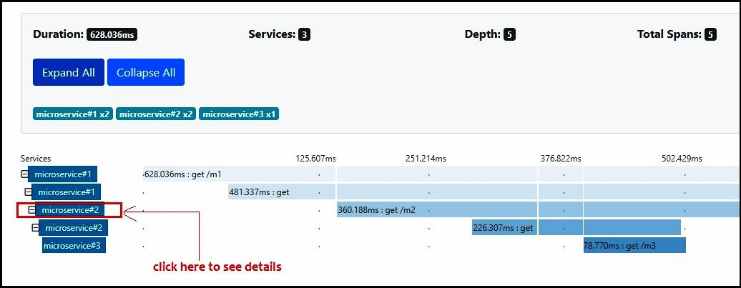

In order to find out the trace Ids for a particular microservice click on any microservice as highlighted above. For example, we click on microservice#2. Now, We will get a popup window something like below.

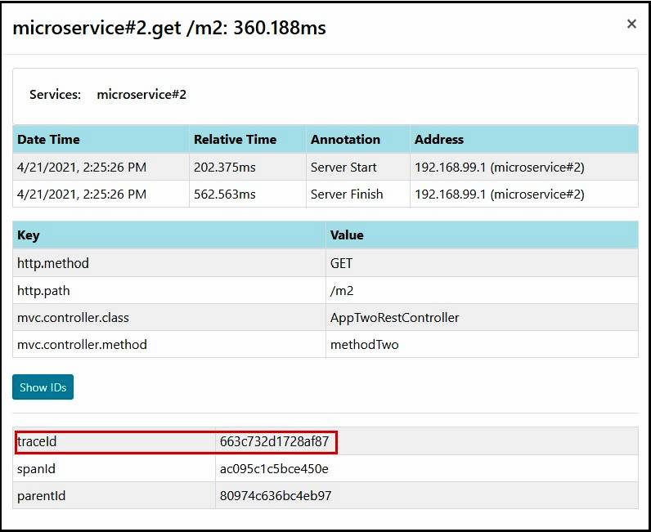

Finally, copy the trace Id from here and look into respective log files to see the log messages. Furthermore, we have provided log messages generated after running this example for all three microservices in the next section.

**Messages from Log Files**

Below are the messages generated from Log files for respective Microservice.

**Microservice#1 : Log messages**

**2021-04-21 23:53:27.880 INFO [microservice#1,663c732d1728af87,663c732d1728af87] 56972 --- [http-nio-8081-exec-3] c.d.s.zipkin.rest.AppOneRestController : Inside microservice#1**

**2021-04-21 23:53:28.064 INFO [microservice#1,663c732d1728af87,663c732d1728af87] 56972 --- [http-nio-8081-exec-3] c.d.s.zipkin.rest.AppOneRestController : response by microservice#1 returning from microservice#2**

**Microservice#2 : Log messages**

**2021-04-21 23:53:27.939 INFO [microservice#2,663c732d1728af87,ac095c1c5bce450e] 21528 --- [http-nio-8082-exec-1] c.d.s.zipkin.rest.AppTwoRestController : Inside microservice#2**

**2021-04-21 23:53:28.045 INFO [microservice#2,663c732d1728af87,ac095c1c5bce450e] 21528 --- [http-nio-8082-exec-1] c.d.s.zipkin.rest.AppTwoRestController : response by microservice#2 returning from microservice#3**

**Microservice#3 :**Log messages

**2021-04-21 23:53:28.020 INFO [microservice#3,663c732d1728af87,79a65229aacee4d2] 43752 --- [http-nio-8083-exec-1] c.d.s.z.rest.AppThreeRestController : Inside microservice#3**

**2021-04-21 23:53:28.021 INFO [microservice#3,663c732d1728af87,79a65229aacee4d2] 43752 --- [http-nio-8083-exec-1] c.d.s.z.rest.AppThreeRestController : done with microservice#3**

We can see occurrences of trace id : ‘663c732d1728af87’ in all three microservices as it is common for all. However, span Id is specific for each microservice. Moreover, since microservice#1 is the parent microservice, hence both ids are same for it.

**Conclusion**

After going through all the theoretical & example part of ‘How to Implement Distributed Tracing Logging using Sleuth Zipkin Spring Boot?’, finally, we should be able to implement logging & tracing concept using Sleuth and Zipkin as a whole. Similarly, we expect from you to further apply this knowledge in your project correspondingly. Additionally, having familiarity of terminologies explained in this article is very crucial to implement microservices for a developer particularly in Java. Furthermore, we will also be updating the article time to time accordingly if any need arises. In addition, feel free to provide your comments in comments section below.