Factorymethod: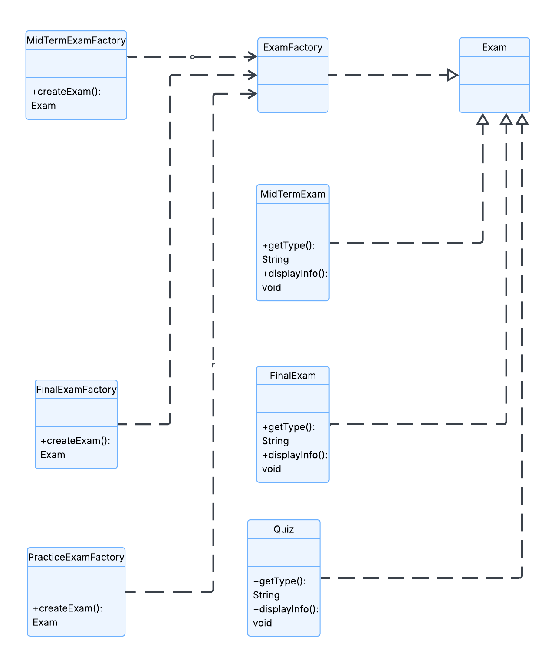

Abstact method: 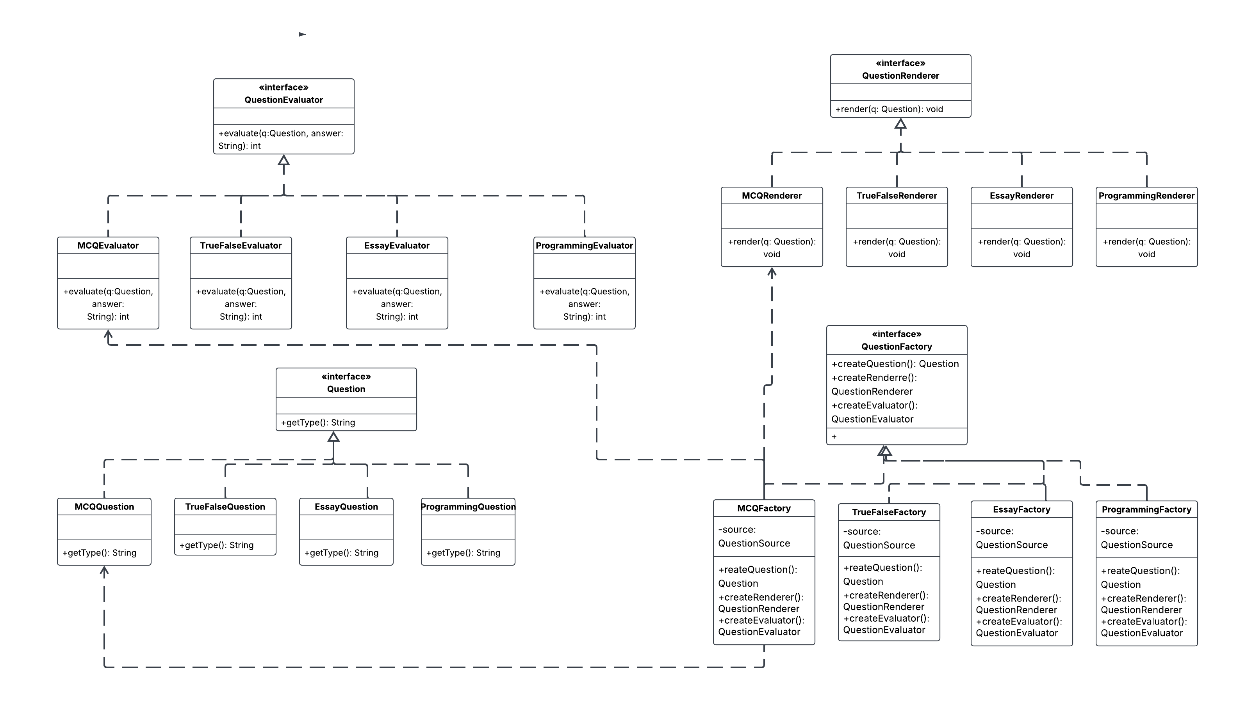

Builder Pattern & Question sourcing: 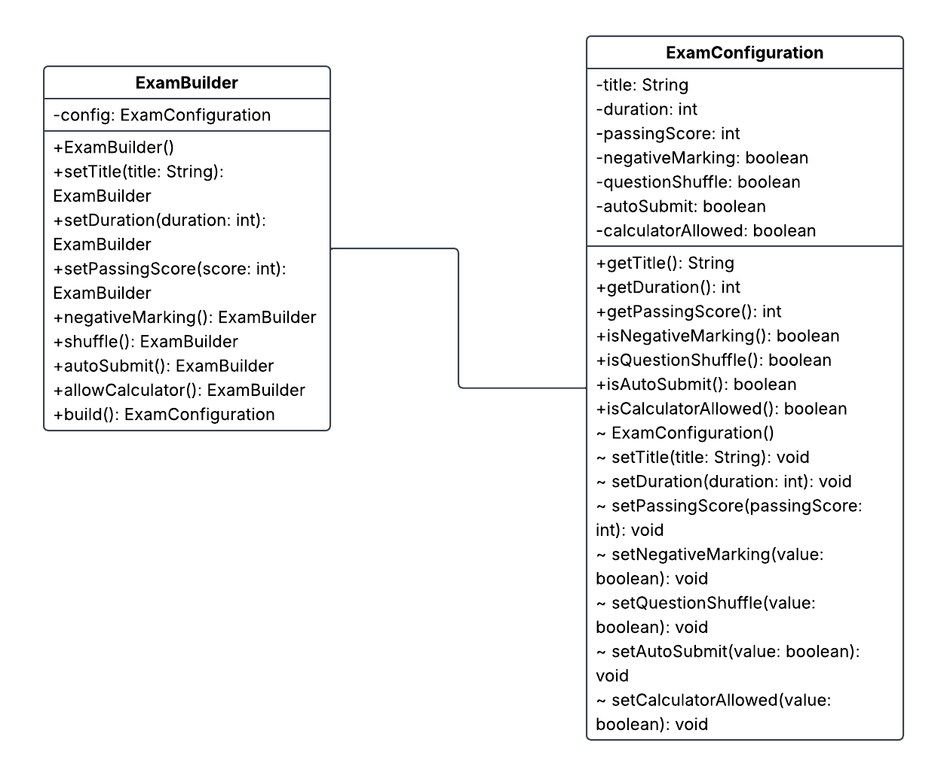

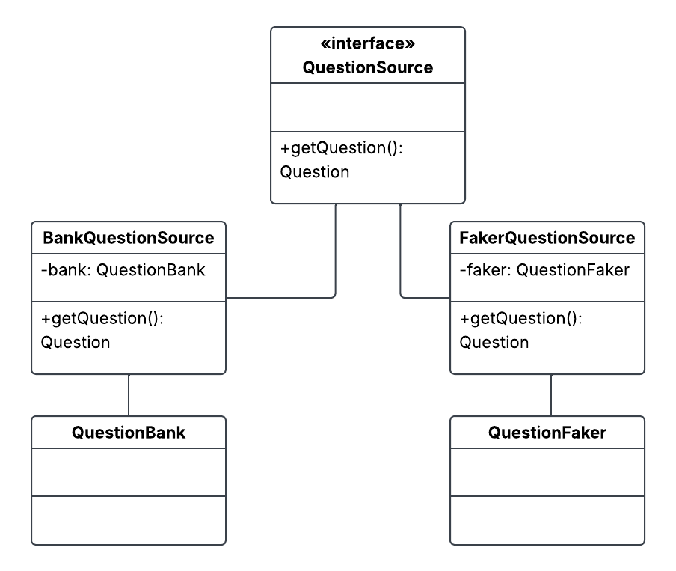
github repo: https://github.com/mitimugdho/designPattern.git

claude chats: https://claude.ai/share/9fe38903-84f3-4b44-89ed-b7ecd11141a8

