Microscopy and Microanalysis 2023

A03 - Standards and Reference Materials and their Applications in Quantitative Microanalysis

Session Chair: Emma Bullock, Will Nachlas, Andrw Mott

**An Atlas of Fourier Transforms ~~for Educational Purposes~~**

Miti Shah1, Suk Hyun Sung1, Robert Hovden1,2

1.  Department of Materials Science and Engineering, University of Michigan, Ann Arbor, MI, USA

2. Applied Physics Program, University of Michigan, Ann Arbor, MI, USA

The relation between real and Fourier space is essential to the study of matter. This is especially true for electron microscopy which leverages real and reciprocal space for the measurement of materials, instrument operation, and data analysis. Thus, a deep intuition for Fourier transforms across dimensions is required for experts in the field. However, mastery of the frequency domain can take years, sometimes decades, to develop. Here, we introduce a library of Fourier transforms as an advanced and introductory reference or education manual.

*The Atlas of Fourier Transforms* is a curated compilation of 2D structures and their Fourier transforms. For beginners, the atlas is an advanced course in Fourier transforms—images graphically explain the underlying mathematics. As the atlas progresses, so does the complexity of each transform. Concepts in symmetry, rotation, translation, addition, multiplication, order, and disorder are introduced and combined. For the experienced, it provides an essential reference to a comprehensive dictionary of structures and their Fourier transform.

To illustrate, Figure 1 shows two representative pages taken from *The Atlas of Fourier Transforms*. Pages are presented as diptych pairs: on the left, the real-space structure and on the right, the corresponding Fourier-transform. While each real-space structure is made from real values, the structure in Fourier space contains complex values comprised of amplitude and phase. Here, the amplitude and phase are mapped to colors on the Munsell sphere: the amplitude is mapped to intensity value between black and white; phase is represented by the color hue. In the quantum mechanics of electron scattering only the amplitude is observable, however, the phase often plays an important role in the structure of the measured amplitude. Through computation, atlas provides referenceable intuition into the structure of phase in Fourier space.

Each row in Figure 1 teaches a concept about emergent structure in Fourier space.

**The first row** of images are simple shapes and their Fourier transforms. As shown, reflecting the half circle presents itself as a phase change in the Fourier transform. The addition of the two half circles results in the circle shown in the last column. Due to the symmetry, there is no phase change seen in the Fourier transform of the circle. **The second row** of images shows the relationship between convolution in real space and multiplication in the frequency domain. The image shows a periodic triangular mask when applied to a crystal lattice structure. This is a multiplication in real space, and thus results in a convolution of the two transforms in k-space (also known as frequency space). The image in the last column of the second row is the result when masking with the inverse of the periodic mask shown. **The third row** contains a subset of aperiodic structures contained in the atlas. The image in the second column is the 2D representation of the Fibonacci sequence, where the location of atoms is based on the location of 1’s in a 2D fibonacci matrix.2 The third image in the row is a Danzer tiling, an aperiodic tiling of a plane through inflation of a set of basic shapes. **The last row** showcases a subset of disordered plates found in the Atlas. The first image represents correlated disorder, where vacancies are determined to generate specific inconsistencies in the Fourier transform. The remaining images are examples of polycrystals and topological disorders. The atlas also includes other types of disorders and their transforms, such as stacking faults, interstitial disorder, and non-invertible crystal structures.

~~An example of real and frequency space images is displayed in Figure 1, arranged in a 4x3 grid. The real space images are depicted as squares, however, prior to calculating the fourier transform, they are circularly masked and padded. This counteracts the potential edge effects and avoids the possible convolution with the square Fourier transform. The Fourier transforms are shown in the next page in the same grid position as its corresponding image.~~

~~Digitally constructing the images and taking their Fourier transform allows for greater details and complexity. For example, images such as spatially separate atoms, and randomized disorder can be constructed. This allows for the generation of more complex structures (such as aperiodic structures) and even simpler structures (such as a crystal lattice), which cannot be physically made. Additionally, the phase of the Fourier transform can be retained, which gives more detail about the image in the frequency domain. The atlas represents the phase of the image through changing the color of the image, while the amplitude is shown through the luminosity.~~

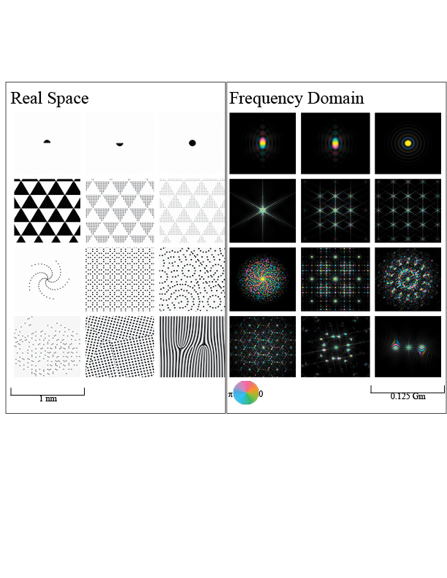

**Figure 1:** Real space images alongside their 2D Fourier transforms. Real space images include simple shapes, periodic masking of crystalline structures, aperiodic structures and disordered structures.

References:

[1] Harburn, G., Taylor, C., & Welberry, T. R. (1983). *Atlas of Optical Transforms*. London: Bell and Hyman.

[2] Dallapiccola, Ramona & Gopinath, Ashwin & Stellacci, Francesco & Negro, Luca. (2008). Quasi-periodic distribution of plasmon modes in two-dimensional Fibonacci arrays of metal nanoparticles. Optics express. 16. 5544-55. 10.1364/OE.16.005544.