Display weather data with

OpenWeatherMap API

# Introduction

This document give the high level overview of the Weather Application. The application provides basic weather information either based on user location or the city name. The Key Focus is on the rain information and rain forecast.

The Application calls OpenWeatherMap APIs to fetch the weather information based on user location or user input.

Please refer to [the document](https://github.com/mitishag/OpenWeather/blob/b0ef3e1dcf80cef009fd3c8c4386d41dceb7d4e1/OWMApp.pdf) to understand how the API calls are made as well as the data flow between application and OpenWeatherMap servers.

# Pre-requisites for using the application

* The browser from which the application is used, should have [Geolocation](Weather-App-JavaScript-master) [support.](https://caniuse.com/#feat=geolocation)
* User should provide consent to provide access to geolocation.

# Functionalities/Features

The application shows below weather information:

* A Visual representation of current weather by using appropriate icon.
* The current temperature value in Celsius/Fahrenheit unit.
* Current weather description (e.g. clear sky, Thunderstorm, Cloudy etc.).
* The user's current city and country based on geolocation (e.g. London, GB).
* The rain forecast for the day with the icon and description.
* A Chart displaying the rain probability for next 24 hours and the amount of rain in MM

The main functionalities provided by this application are given below:

1. Provide weather information based on User’s current Location or entered by user.
2. Temperature conversion from Celsius to Fahrenheit or vice versa

# Technologies/Third Parties

* The application is built using JavaScript and HTML.
* The API provider is [Open Weather Map](http://www.openweathermap.org/) .
* Chart.js is used to display the rain forecast on the application.

# Steps to use the Application

* 1. Use this [link](https://s3.eu-central-1.amazonaws.com/www.my-weather-app.com/index.html) to access the application.
  2. Provide the consent to access the user location   
     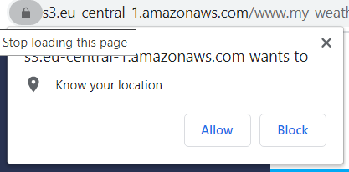
  3. As default, browser will take your current location to display weather.
  4. To search for weather in a particular city, enter the city and click on Search button.

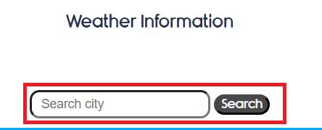

* 1. Click on the temperature value to convert from Celsius to Fahrenheit and vice versa.  
       
     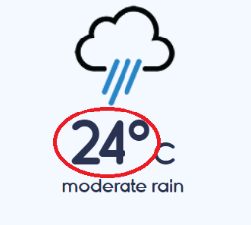

# Future Scope

1. Support for Older browsers by using IP based location lookup.
2. Check for valid City/address and provide auto complete.
3. Background refresh at scheduled interval.