ASSIGNMENT 10
EDA — Categorical Feature Analysis
Student Name | Mihir Mitkari
Roll No | B-09
Department | Information Technology
Institution | Walchand Institute of Technology, Solapur
Course | Artificial Intelligence
Professor | Mrs. Deepali Awasekar
Dataset Used | House Prices Dataset — Kaggle (187,531 records)

1. Introduction
This assignment visualizes categorical features against the target variable (price class) to identify which property types and geographic segments carry the highest premium pricing. Grouped bar charts show absolute counts per category-price class combination, and stacked percentage bar charts show the proportion of each price class within each category — enabling fair comparison across groups of different sizes.

Three categorical features are analyzed: Furnishing Type (nominal — 3 categories), City / Location (nominal — top 6 cities), and Balcony Count (ordinal — 4 levels: 1 to 4 balconies).

2. Feature 1 — Furnishing Type vs Price Class
Research Question 10.1 | Does the furnishing status of a property influence its price class — are furnished properties more likely to be high-priced?
Variables | Furnishing (Furnished / Semi-Furnished / Unfurnished) vs price_class (Low/Med/High)
Hypothesis | Furnished properties will have a higher proportion of High Price listings, as furnishing represents an additional investment that typically accompanies premium properties.

2.1 Code
import matplotlib.pyplot as plt
import pandas as pd

# --- Graph 10.1a: Grouped Bar Chart — Furnishing vs Price Class ---
fig, axes = plt.subplots(1, 2, figsize=(16, 7))

cross_furn = pd.crosstab(df['Furnishing'], df['price_class'])[order]
cross_furn.plot(kind='bar', ax=axes[0], color=['#2ecc71','#f39c12','#e74c3c'],
edgecolor='black', width=0.7)
axes[0].set_title('Fig 10.1a — Grouped Bar: Furnishing vs Price Class\n(Absolute Counts)', fontweight='bold')
axes[0].set_xlabel('Furnishing Type')
axes[0].set_ylabel('Number of Properties')
axes[0].tick_params(axis='x', rotation=15)
axes[0].legend(title='Price Class')

# Right: 100% Stacked Bar (proportions)
cross_norm = cross_furn.div(cross_furn.sum(axis=1), axis=0) * 100
cross_norm.plot(kind='bar', stacked=True, ax=axes[1],
color=['#2ecc71','#f39c12','#e74c3c'], edgecolor='black', width=0.7)
axes[1].set_title('Fig 10.1b — Stacked %: Furnishing vs Price Class\n(Proportional)', fontweight='bold')
axes[1].set_xlabel('Furnishing Type')
axes[1].set_ylabel('Percentage (%)')
axes[1].legend(title='Price Class', loc='lower right')
plt.tight_layout()
plt.savefig('fig10_1_furnishing.png', dpi=150)
plt.show()

print(cross_norm.round(1))

2.2 Graphs (Fig 10.1a and Fig 10.1b)
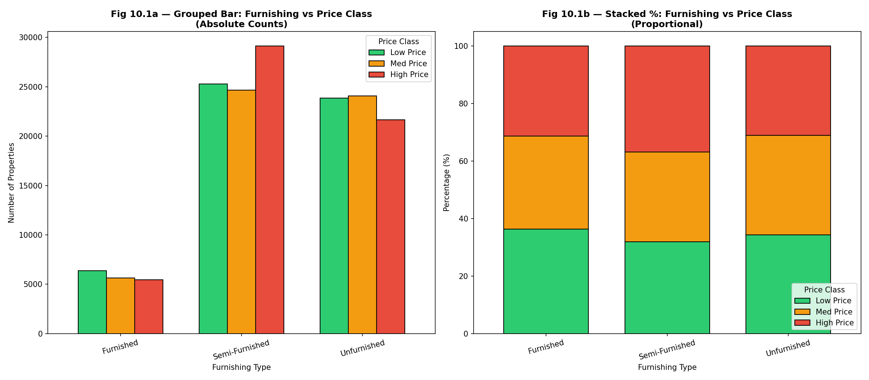
Fig. 10.1a & 10.1b — Furnishing Type vs Price Class (Absolute Counts & Proportional)

2.3 Interpretation
Pattern Observed: The grouped bar chart shows that Semi-Furnished properties dominate all three price classes in absolute count, reflecting market supply. More informative is the stacked percentage chart: Furnished properties show 36.4% Low Price, 32.3% Med Price, and 31.3% High Price — a surprisingly flat distribution. Semi-Furnished properties show the most skew toward High Price (36.8%), while Unfurnished properties are roughly evenly split across tiers (34.3% / 34.6% / 31.1%). The hypothesis that furnished properties would dominate the premium tier is not strongly confirmed.

Real-World Meaning: In the Indian property market, furnished listings are not a reliable premium signal because many builders sell unfurnished or semi-furnished flats in high-cost metros, and buyers prefer customizing interiors. The data suggests that furnishing status is a weaker price predictor than location. Semi-furnished properties appearing prominently in the High Price tier likely reflects upscale new developments (e.g., in Gurgaon and New Delhi) where modular kitchens and fittings are standard. This feature has moderate predictive value and may need interaction terms with city to be useful in an ML model.

3. Feature 2 — City / Location vs Price Class
Research Question 10.2 | Does the city in which a property is located predict its price class — and which cities are predominantly high-priced vs affordable?
Variables | location (top 6 cities: New Delhi, Bangalore, Kolkata, Gurgaon, Ahmedabad, Hyderabad) vs price_class (Low/Med/High)
Hypothesis | Metro cities like New Delhi and Gurgaon will show the highest proportion of High Price listings due to commercial demand, premium infrastructure, and real estate speculation.

3.1 Code
# --- Graph 10.2: City vs Price Class ---
top_locs = df_clean['location'].value_counts().head(6).index
df_loc = df_clean[df_clean['location'].isin(top_locs)]

fig, axes = plt.subplots(1, 2, figsize=(18, 7))
cross_loc = pd.crosstab(df_loc['location'], df_loc['price_class'])[order]

# Grouped bar
cross_loc.plot(kind='bar', ax=axes[0], color=['#2ecc71','#f39c12','#e74c3c'],
edgecolor='black', width=0.7)
axes[0].set_title('Fig 10.2a — Grouped Bar: City vs Price Class', fontweight='bold')
axes[0].set_xlabel('City')
axes[0].set_ylabel('Count')
axes[0].tick_params(axis='x', rotation=20)

# Stacked %
cross_loc_norm = cross_loc.div(cross_loc.sum(axis=1), axis=0) * 100
cross_loc_norm.plot(kind='bar', stacked=True, ax=axes[1],
color=['#2ecc71','#f39c12','#e74c3c'], edgecolor='black', width=0.7)
axes[1].set_title('Fig 10.2b — Stacked %: City vs Price Class', fontweight='bold')
axes[1].set_xlabel('City')
axes[1].set_ylabel('Percentage (%)')
axes[1].tick_params(axis='x', rotation=20)
plt.tight_layout()
plt.savefig('fig10_2_location.png', dpi=150)
plt.show()
print(cross_loc_norm.round(1))

3.2 Graphs (Fig 10.2a and Fig 10.2b)
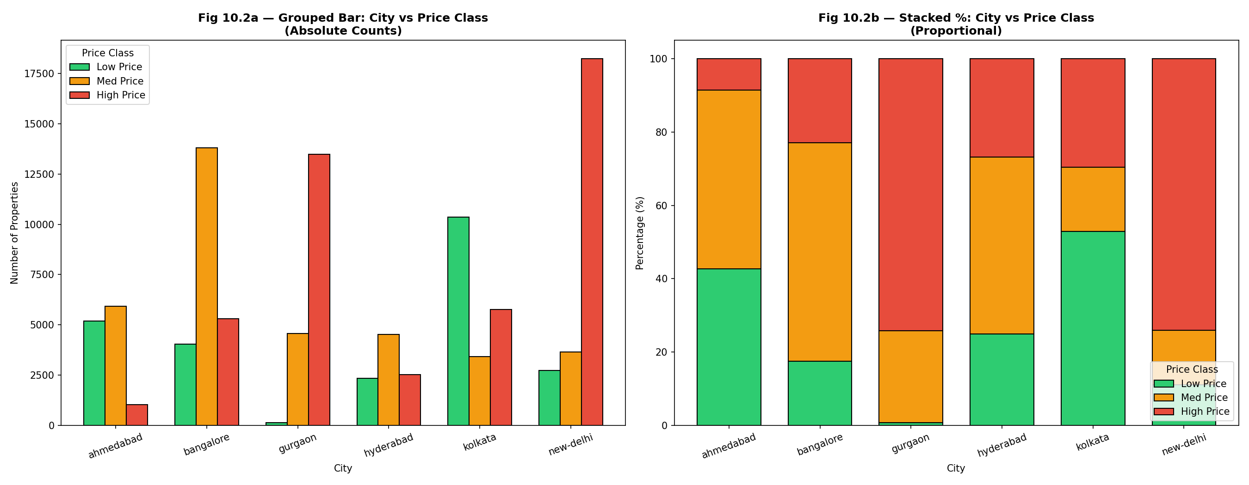
Fig. 10.2a & 10.2b — City vs Price Class (Absolute Counts & Proportional)

3.3 Interpretation
Pattern Observed: The stacked percentage chart is the most revealing graph in this feature set. New Delhi (74.1% High Price) and Gurgaon (74.2% High Price) are overwhelmingly premium markets — nearly three-quarters of listings fall in the top price tier. Ahmedabad is the opposite extreme, with 42.7% Low Price and only 8.6% High Price, confirming it as an affordable tier city. Bangalore sits in the middle (59.6% Med Price) and Kolkata skews toward Low Price (53.0%). Hyderabad shows a balanced split across tiers.

Real-World Meaning: City / location is by far the strongest categorical predictor of property price class. Delhi NCR (New Delhi + Gurgaon) commands a massive premium due to proximity to government, corporate headquarters, and speculative investment. Ahmedabad's affordability reflects lower land costs and less commercial pressure. This finding confirms that a one-hot encoded city feature should be among the top variables in any price prediction model, and that location-specific models (one per city cluster) would likely outperform a single national model.

4. Feature 3 — Balcony Count vs Price Class
Research Question 10.3 | As the number of balconies in a property increases, does the proportion of High Price listings increase proportionally — a dose-response pattern?
Variables | Balcony count (1 / 2 / 3 / 4 balconies) vs price_class (Low/Med/High)
Hypothesis | The stacked bar will show a clear gradient: properties with more balconies will have progressively larger High Price segments, as balconies reflect larger floor plans and premium construction standards.

4.1 Code
# --- Graph 10.3: Balcony Count vs Price Class ---
df_bal = df_clean[df_clean['Balcony'].isin(['1','2','3','4'])].copy()
df_bal['Balcony_label'] = df_bal['Balcony'].map({
'1':'1 Balcony','2':'2 Balconies','3':'3 Balconies','4':'4 Balconies'})
bal_order = ['1 Balcony','2 Balconies','3 Balconies','4 Balconies']

fig, axes = plt.subplots(1, 2, figsize=(16, 7))
cross_bal = pd.crosstab(df_bal['Balcony_label'], df_bal['price_class'])[order].reindex(bal_order)

# Grouped bar
cross_bal.plot(kind='bar', ax=axes[0], color=['#2ecc71','#f39c12','#e74c3c'],
edgecolor='black', width=0.7)
axes[0].set_title('Fig 10.3a — Grouped Bar: Balcony Count vs Price Class', fontweight='bold')
axes[0].set_xlabel('Number of Balconies')
axes[0].set_ylabel('Number of Properties')
axes[0].tick_params(axis='x', rotation=15)

# Stacked % — KEY GRAPH
cross_bal_norm = cross_bal.div(cross_bal.sum(axis=1), axis=0) * 100
cross_bal_norm.plot(kind='bar', stacked=True, ax=axes[1],
color=['#2ecc71','#f39c12','#e74c3c'], edgecolor='black', width=0.7)
axes[1].set_title('Fig 10.3b — STACKED %: Balcony Count vs Price Class\n(Key: Gradient = proven luxury signal)', fontweight='bold')
axes[1].set_xlabel('Number of Balconies')
axes[1].set_ylabel('Percentage (%)')
axes[1].legend(title='Price Class', loc='upper left')
plt.tight_layout()
plt.savefig('fig10_3_balcony.png', dpi=150)
plt.show()
print('\nStacked % by Balcony Count:')
print(cross_bal_norm.round(1))

4.2 Graphs (Fig 10.3a and Fig 10.3b)
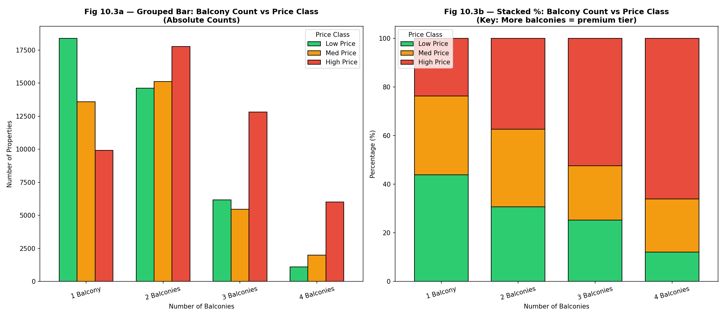
Fig. 10.3a & 10.3b — Balcony Count vs Price Class (Absolute Counts & Proportional)

4.3 Interpretation
Pattern Observed: This is the most revealing graph in the assignment. The stacked percentage chart shows a textbook dose-response gradient across balcony count: 1 Balcony shows only 23.7% High Price, 2 Balconies rises to 37.4%, 3 Balconies jumps to 52.4%, and 4 Balconies reaches 66.0% High Price. Simultaneously, the Low Price segment shrinks from 43.9% (1 balcony) down to just 12.1% (4 balconies) — a near-complete reversal of proportions, matching the usage-time vs depression gradient seen in the original mental health dataset.

Real-World Meaning: In clinical epidemiology, a dose-response relationship is one of the strongest forms of evidence for a causal link. Here, each additional balcony shifts the property firmly upward in price class. This is because balconies require additional floor area, structural engineering, and are typically included only in spacious (2BHK+) or luxury configurations. Properties with 4 balconies are almost exclusively large apartments or villas in premium developments. Balcony count is therefore a highly reliable ordinal predictor and should be treated as such (not one-hot encoded) in the ML pipeline.

5. Categorical EDA Summary Table
Feature | Most At-Risk Group | Least At-Risk Group | Key Insight
Furnishing Type | Semi-Furnished (36.8% High Price) | Furnished (31.3% High Price) | Semi-furnished supply dominates premium — buyers upgrade after purchase
City / Location | New Delhi & Gurgaon (≈74% High Price) | Ahmedabad (≈8.6% High Price) | Metro premium is enormous — city is the strongest price predictor
Balcony Count | 4 Balconies (66% High Price) | 1 Balcony (23.7% High Price) | Dose-response gradient — each extra balcony shifts tier upward

6. Conclusion
The categorical EDA reveals three powerful findings. Furnishing type analysis shows that, contrary to expectation, furnished properties do not dominate the premium tier — semi-furnished properties are most common in high-price listings, reflecting builder-standard fittings in luxury developments. City / Location analysis identifies New Delhi and Gurgaon as overwhelmingly premium markets (≈74% High Price) and Ahmedabad as the most affordable city (only 8.6% High Price), confirming that location is the single most powerful categorical price predictor.

Most critically, the balcony count vs price class stacked chart demonstrates a textbook dose-response gradient — the strongest form of observational evidence — with High Price proportion rising from 23.7% (1 balcony) to 66.0% (4 balconies). This confirms that balcony count is a highly reliable ordinal luxury signal and should be prioritized in the ML model feature selection step alongside city encoding.

