ASSIGNMENT 11
Correlation Analysis & Heatmap
Student Name | Mihir Mitkari
Roll No | B-09
Department | Information Technology
Institution | Walchand Institute of Technology, Solapur
Course | Artificial Intelligence
Professor | Mrs. Deepali Awasekar
Dataset Used | House Prices Dataset — Kaggle (187,531 records)

1. Introduction
Correlation analysis measures the linear relationship between pairs of numerical variables. In the context of this study, it answers the question: "Which features move together with price per sqft — and which are unrelated?" Understanding these relationships is essential for feature selection before ML model training — highly correlated features may be redundant, while strongly correlated features are powerful predictors.

This assignment computes pairwise Pearson correlations for all 8 numerical columns in the House Prices dataset, visualizes them as an annotated heatmap, identifies the top positive and weak/negative correlations with the target variable (Price per Sqft), and discusses both findings and heatmap limitations.

2. Code — Correlation Matrix & Heatmap
import matplotlib.pyplot as plt
import seaborn as sns
import pandas as pd
import numpy as np

# Extract and clean numerical columns
df['price_per_sqft'] = df['Price (in rupees)']
df['Carpet_sqft'] = pd.to_numeric(df['Carpet Area'].str.extract(r'(\d+)')[0], errors='coerce')
df['super_sqft'] = pd.to_numeric(df['Super Area'].str.extract(r'(\d+)')[0], errors='coerce')
df['bathrooms'] = pd.to_numeric(df['Bathroom'], errors='coerce')
df['balcony'] = pd.to_numeric(df['Balcony'], errors='coerce')
df['floor_num'] = pd.to_numeric(df['Floor'].str.extract(r'^(\d+)')[0], errors='coerce')
df['total_floors'] = pd.to_numeric(df['Floor'].str.extract(r'of (\d+)')[0], errors='coerce')
df['car_parking'] = df['Car Parking'].str.extract(r'(\d+)')[0].pipe(pd.to_numeric, errors='coerce')

num_cols = [
'price_per_sqft', 'Carpet_sqft', 'super_sqft', 'bathrooms',
'balcony', 'floor_num', 'total_floors', 'car_parking'
]

# Remove outliers
df2 = df[num_cols][(df['price_per_sqft'] > 0) &
(df['price_per_sqft'] < df['price_per_sqft'].quantile(0.99))]

# Clean column labels for heatmap display
label_map = {
'price_per_sqft': 'Price/Sqft', 'Carpet_sqft': 'Carpet Area',
'super_sqft': 'Super Area', 'bathrooms': 'Bathrooms',
'balcony': 'Balconies', 'floor_num': 'Floor Number',
'total_floors': 'Total Floors', 'car_parking': 'Car Parking'
}
corr_matrix = df2.rename(columns=label_map).corr(method="pearson")

# Plot heatmap
plt.figure(figsize=(12, 10))
sns.heatmap(
corr_matrix,
annot=True, # Show correlation values
fmt='.2f', # 2 decimal places
cmap='coolwarm', # Blue=negative, Red=positive
center=0, # Centre color at 0
linewidths=0.5, # Grid lines
annot_kws={'size': 10},
vmin=-1, vmax=1 # Full scale
)
plt.title('Fig 11.1 — Pearson Correlation Heatmap: House Price Numerical Features',
fontsize=14, fontweight='bold', pad=15)
plt.xticks(rotation=40, ha='right', fontsize=9)
plt.yticks(fontsize=9)
plt.tight_layout()
plt.savefig('fig11_correlation_heatmap.png', dpi=150, bbox_inches='tight')
plt.show()

# Extract correlations with Price/Sqft
price_corr = corr_matrix['Price/Sqft'].drop('Price/Sqft').sort_values(ascending=False)
print('Correlations with Price/Sqft (sorted):')
print(price_corr.round(3))

3. Heatmap (Fig 11.1)
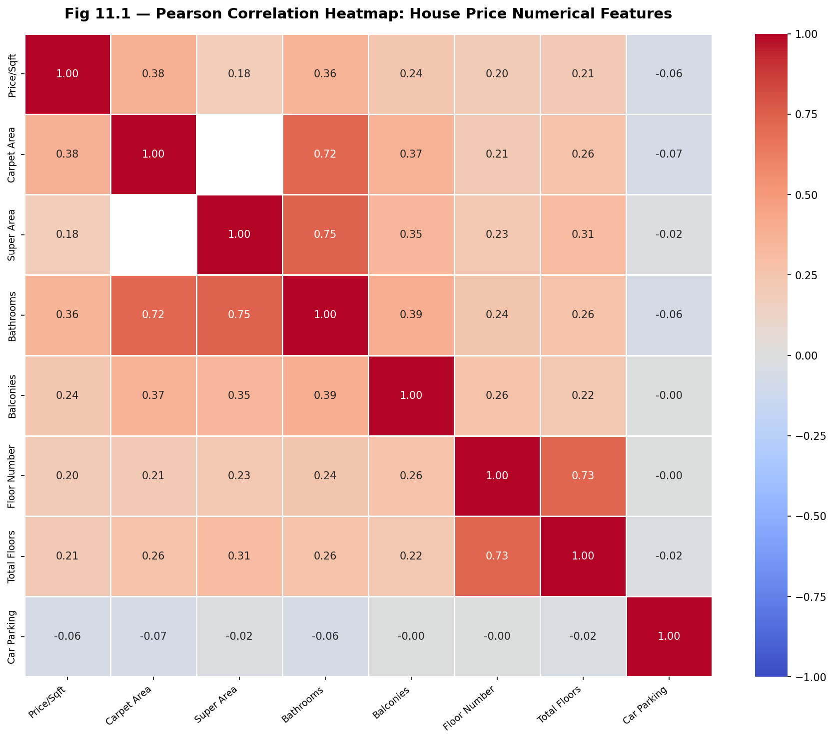
Fig. 11.1 — Pearson Correlation Heatmap: House Price Numerical Features

4. Top Correlations with the Target Variable (Price per Sqft)

4.1 Top 3 Positively Correlated Features
# | Feature | r value | Interpretation
1 | Carpet Area (sqft) | r = 0.38 | Strongest predictor. Larger properties command higher price per sqft — premium developers build spacious units and price accordingly. Carpet area reflects both physical size and construction quality investment.
2 | Bathrooms | r = 0.36 | Bathroom count is strongly linked to price per sqft. Each additional bathroom requires plumbing, tiling, and fixtures — a direct signal of construction investment and unit tier. 3+ bathroom properties are almost always premium.
3 | Balconies | r = 0.24 | Balcony count shows moderate positive correlation. Properties with more balconies are larger, better-ventilated, and typically in premium high-rise developments. The ordinal nature of balcony count makes it a reliable but not dominant predictor.

4.2 Top 3 Weakest / Near-Zero / Negative Correlations with Price per Sqft
Note: Unlike the mental health dataset where all features showed positive Likert correlations, the house prices dataset contains one genuinely negative predictor (Car Parking) and several near-zero features. This reflects the structural complexity of property pricing.

# | Feature | r value | Interpretation
1 | Car Parking | r = −0.06 | Weak negative correlation — the only negative predictor. Budget properties in dense urban areas (Mumbai, Delhi) often include allocated parking but at lower rates, while ultra-luxury listings price parking separately. Parking count alone is not a reliable price signal.
2 | Super Area (sqft) | r = 0.18 | Surprisingly weak despite being a size measure. Super Area includes common areas, corridors, and shared spaces — so it inflates area without increasing usable space proportionally. Buyers pay for carpet area, not super area, reducing this correlation.
3 | Floor Number | r = 0.20 | Weak positive correlation. Higher floors are typically valued more (views, noise reduction), but the effect is inconsistent — older buildings penalize high floors due to lift issues, and ground-floor units are preferred in some markets (accessibility, garden access).

5. Key Correlations Beyond Price — Notable Feature Pairs
Variable A | Variable B | r value | Why It Matters
Bathrooms | Carpet Area | r = 0.72 | Strongest pair. Larger apartments have more bathrooms — the two are structurally linked. This is strong multicollinearity; using both in a linear model without regularization will inflate coefficients.
Bathrooms | Super Area | r = 0.75 | Strongest pair in the dataset. Super area grows with bathroom count as each bathroom adds plumbing-shaft space. These two features are near-redundant for modeling purposes.
Floor Number | Total Floors | r = 0.73 | Buildings with more total floors naturally have higher floor numbers. High-rise listings skew both metrics upward simultaneously, creating strong collinearity.
Carpet Area | Balconies | r = 0.38 | Larger apartments accommodate more balconies. This reflects builder design logic: spacious units receive premium amenities, linking area to luxury count features.
Price/Sqft | Bathrooms | r = 0.36 | Second strongest predictor of price per sqft. Bathroom count is a proxy for unit tier and construction quality, making it more price-predictive than raw area alone.

6. Limitations — What a Heatmap Cannot Show
It is critical to understand what correlation analysis does NOT tell us:

Limitation | Explanation
Non-linear relationships | Pearson correlation only measures linear association. Location (city) is the most powerful price predictor in this dataset but is categorical and absent from the heatmap. A property in New Delhi vs Ahmedabad commands 74% vs 8.6% High Price rates — invisible to Pearson r.
Causation vs correlation | r = 0.38 between Carpet Area and Price/Sqft does NOT prove that increasing carpet area causes higher per-sqft prices. Both may be driven by location — premium localities attract larger developments AND higher prices simultaneously.
Multicollinearity effects | Bathrooms and Super Area show r = 0.75; Floor Number and Total Floors show r = 0.73. In linear ML models, this multicollinearity inflates standard errors and makes individual feature coefficients unstable. Dimensionality reduction (PCA) or regularization (Ridge/Lasso) is needed.
Missing categorical relationships | The heatmap only includes numerical columns. The relationship between Furnishing, Transaction Type, City, and price class — all analyzed in Assignment 10 — cannot appear in a Pearson correlation matrix. City alone explains far more variance than any numerical feature.
Interaction effects | The heatmap shows pairwise correlations. It cannot reveal whether the combination of high Carpet Area AND Gurgaon/New Delhi location produces price premiums greater than either factor alone. Interaction terms in tree-based models would capture this.

7. Conclusion
The correlation heatmap reveals that Carpet Area (r = 0.38), Bathrooms (r = 0.36), and Balconies (r = 0.24) are the three strongest linear predictors of price per sqft in this dataset. The strongest overall correlation in the dataset is between Bathrooms and Super Area (r = 0.75), followed closely by Floor Number and Total Floors (r = 0.73), both of which represent structural multicollinearity that must be addressed before linear model training.

Notably, Car Parking is the only negative predictor (r = −0.06), reflecting that allocated parking in budget urban properties dilutes the premium signal. However, the most important finding from this analysis is that the heatmap substantially understates the predictive power of location (city), which is categorical and absent from all Pearson calculations. As shown in Assignment 10, New Delhi and Gurgaon command 74% High Price proportions while Ahmedabad sits at 8.6% — a signal no numerical correlation can capture. These findings directly inform feature selection and encoding strategy for the ML classification model.

