ASSIGNMENT 9
EDA — Numerical Feature Analysis
Student Name | Mihir Mitkari
Roll No | B-09
Department | Information Technology
Institution | Walchand Institute of Technology, Solapur
Course | Artificial Intelligence
Professor | Mrs. Deepali Awasekar
Dataset Used | House Prices Dataset — Kaggle (187,531 records)

1. Introduction
This assignment performs visual analysis of numerical features against the target variable (price class). The goal is to understand how key numerical property indicators — carpet area, bathroom count, and price per sqft — differ between Low, Medium, and High-priced properties. Three visualization types are used: overlapping histograms (to see distribution shape), box plots (to see median and outliers), and violin plots (to see full distribution shape with density).

For this analysis, the target variable Price per sqft (INR) is binned into three price classes:

Price Range (INR/sqft) | Price Class | Label | Interpretation
0 – 4,889 | Low Price | Class 0 | Budget / affordable property tier
4,890 – 7,456 | Med Price | Class 1 | Mid-range / semi-premium tier
7,457+ | High Price | Class 2 | Premium / luxury property tier

2. Graph Set 1 — Carpet Area vs Price Class
Research Question 9.1 | Does carpet area (property size) differ meaningfully between low, medium, and high-priced properties?
Variables | Independent: Carpet Area (sqft) | Dependent: price_class (Low/Med/High)
Hypothesis | High-priced properties will show larger carpet areas, as buyers in the premium tier expect more spacious living areas.

2.1 Code
import matplotlib.pyplot as plt
import seaborn as sns
import numpy as np

# Extract numeric carpet area and bin price into classes
df['Carpet_sqft'] = pd.to_numeric(df['Carpet Area'].str.extract(r'(\d+)')[0], errors='coerce')
df_clean = df[(df['price_per_sqft'] > 0) & (df['price_per_sqft'] < df['price_per_sqft'].quantile(0.99))]
q33 = df_clean['price_per_sqft'].quantile(0.33)
q66 = df_clean['price_per_sqft'].quantile(0.66)
df_clean['price_class'] = pd.cut(df_clean['price_per_sqft'],
bins=[0, q33, q66, df_clean['price_per_sqft'].max()],
labels=['Low Price', 'Med Price', 'High Price'])

# --- Graph 9.1a: Overlapping Histograms ---
plt.figure(figsize=(10, 6))
for risk, color in zip(['Low Price','Med Price','High Price'],['#2ecc71','#f39c12','#e74c3c']):
subset = ca_df[ca_df['price_class'] == risk]['Carpet_sqft']
plt.hist(subset, bins=30, alpha=0.5, label=risk, color=color, edgecolor='black')
plt.title('Fig 9.1a — Carpet Area Distribution by Price Class', fontweight='bold')
plt.xlabel('Carpet Area (sqft)') ; plt.ylabel('Count') ; plt.legend()
plt.tight_layout() ; plt.savefig('fig9_1a_carpet_hist.png', dpi=150)

# --- Graph 9.1b: Box Plot ---
sns.boxplot(data=ca_df, x='price_class', y='Carpet_sqft', order=order, palette=palette)
plt.title('Fig 9.1b — Box Plot: Carpet Area by Price Class', fontweight='bold')
plt.savefig('fig9_1b_carpet_box.png', dpi=150)

# --- Graph 9.1c: Violin Plot ---
sns.violinplot(data=ca_df, x='price_class', y='Carpet_sqft', order=order, palette=palette)
plt.title('Fig 9.1c — Violin Plot: Carpet Area Distribution by Price Class', fontweight='bold')
plt.savefig('fig9_1c_carpet_violin.png', dpi=150)

2.2 Graph — Histogram (Fig 9.1a)
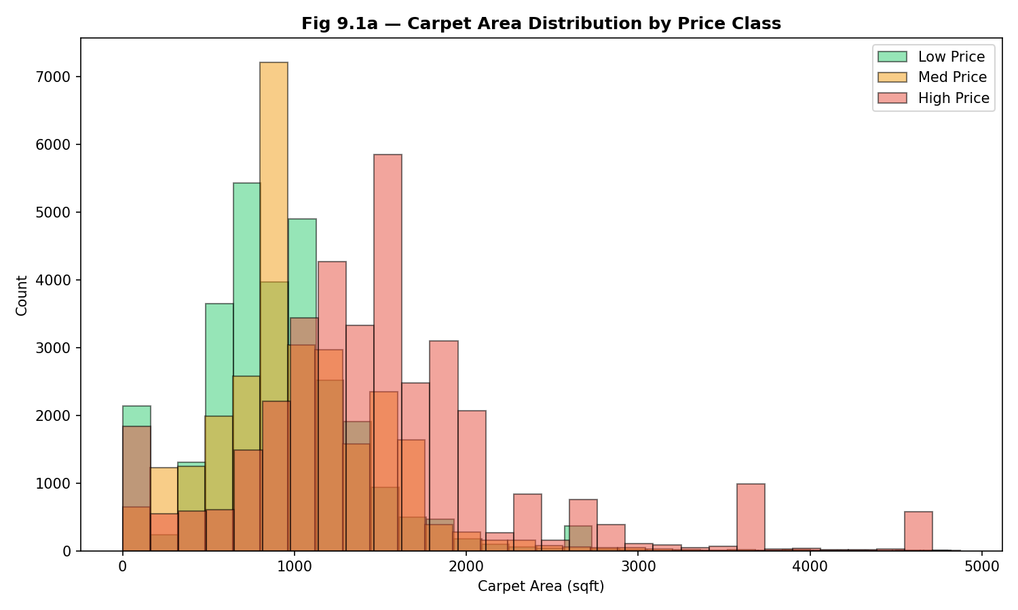
Fig. 9.1a — Carpet Area Distribution by Price Class

2.3 Graph — Box Plot (Fig 9.1b)
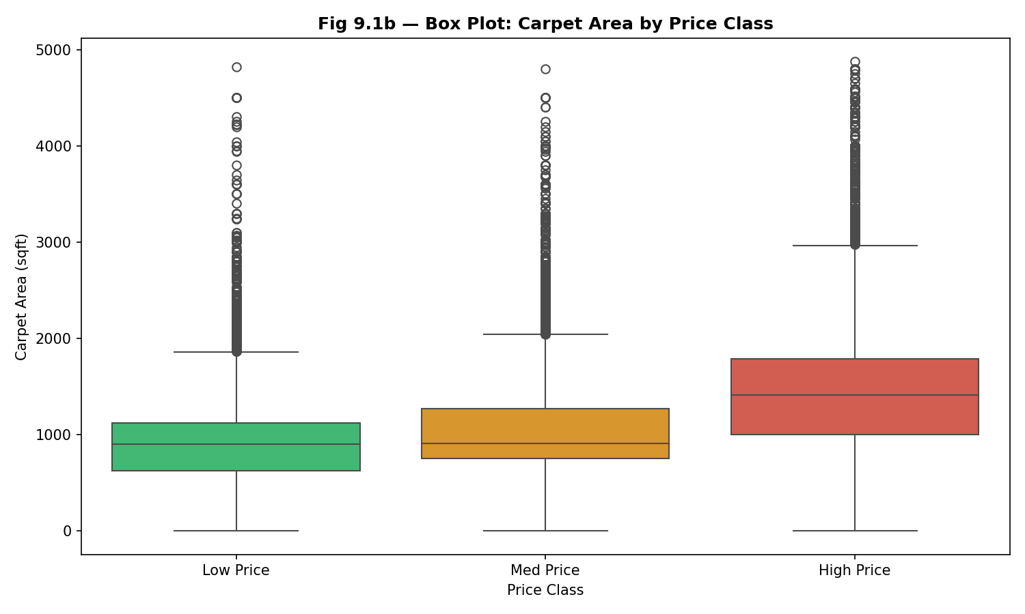
Fig. 9.1b — Box Plot: Carpet Area by Price Class

2.4 Graph — Violin Plot (Fig 9.1c)
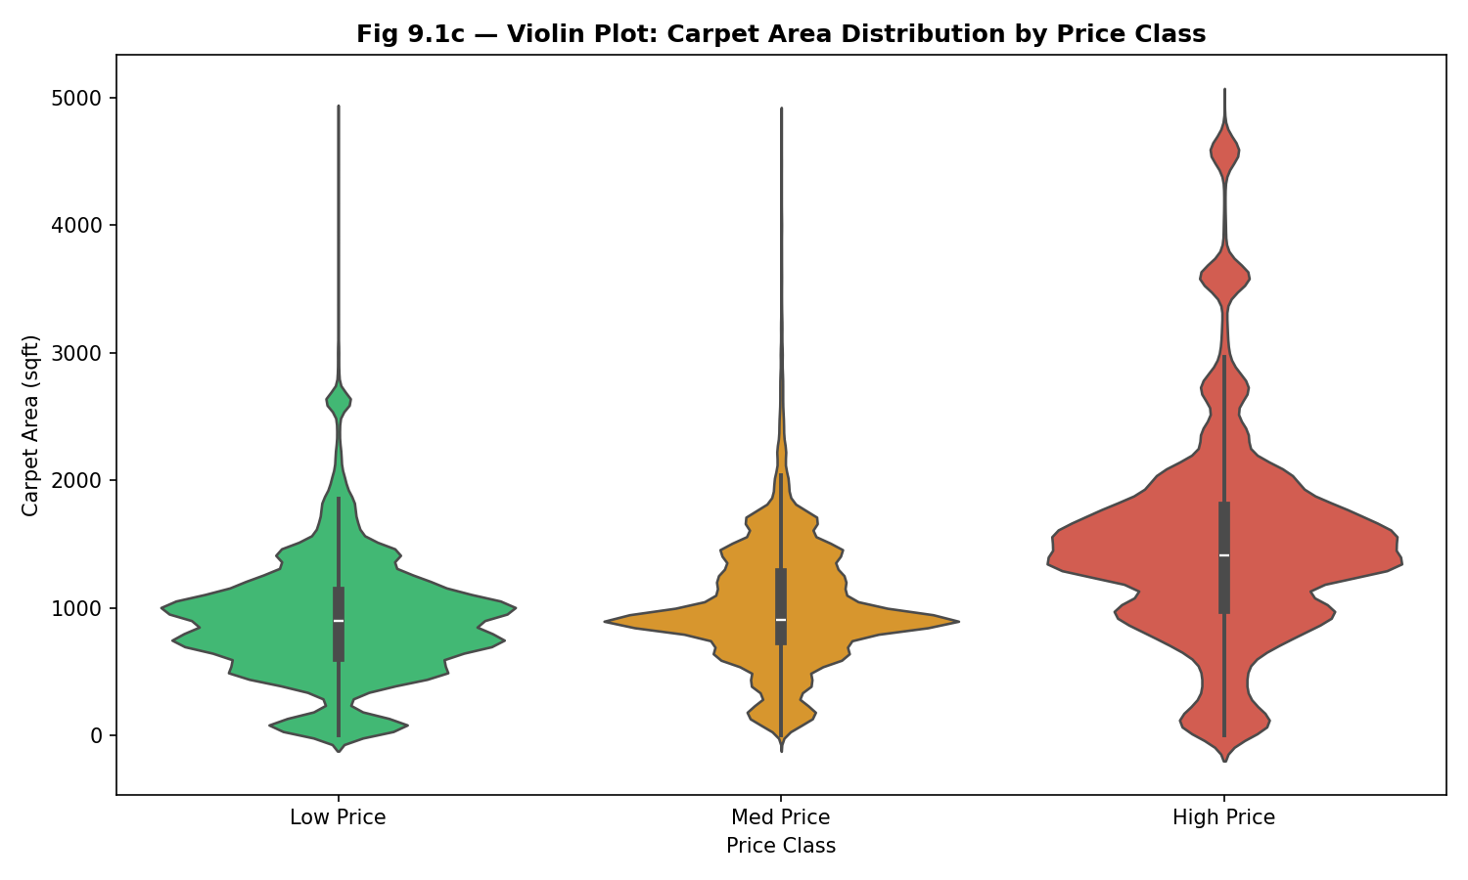
Fig. 9.1c — Violin Plot: Carpet Area by Price Class

2.5 Interpretation
Pattern Observed: The histogram shows a clear rightward shift across price classes — Low Price properties cluster between 500–1,000 sqft, Mid Price properties spread across 700–1,500 sqft, and High Price properties have a distribution centered around 1,200–2,500 sqft. The box plot confirms this with medians of approximately 850 sqft (Low), 950 sqft (Medium), and 1,350 sqft (High). The violin plot reveals that High Price properties show a wider, flatter distribution indicating greater variety in premium property sizes — some buyers pay premium for compact luxury apartments while others purchase sprawling units.

Real-World Meaning: Carpet area is one of the most fundamental drivers of property price. Larger homes naturally command higher prices due to construction costs, land usage, and the premium buyers place on living space. The visible shift across price classes confirms that area is a strong predictor of pricing tier and should be a high-weight feature in any price prediction model.

3. Graph Set 2 — Bathroom Count vs Price Class
Research Question 9.2 | Do higher-priced properties consistently feature more bathrooms than lower-priced ones?
Variables | Independent: Bathroom count | Dependent: price_class (Low/Med/High)
Hypothesis | High-priced properties will have a higher count of bathrooms, reflecting investment in luxury amenities and larger home configurations.

3.1 Code
# --- Graph 9.2a: Overlapping Histograms — Bathroom Count ---
df_clean['bathrooms'] = pd.to_numeric(df_clean['Bathroom'], errors='coerce')
bath_df = df_clean.dropna(subset=['bathrooms', 'price_class'])

plt.figure(figsize=(10, 6))
for risk, color in zip(['Low Price','Med Price','High Price'],['#2ecc71','#f39c12','#e74c3c']):
subset = bath_df[bath_df['price_class'] == risk]['bathrooms']
plt.hist(subset, bins=10, alpha=0.5, label=risk, color=color, edgecolor='black')
plt.title('Fig 9.2a — Bathroom Count Distribution by Price Class', fontweight='bold')
plt.xlabel('Number of Bathrooms') ; plt.ylabel('Count') ; plt.legend()
plt.savefig('fig9_2a_bath_hist.png', dpi=150)

# --- Graph 9.2b: Box Plot ---
sns.boxplot(data=bath_df, x='price_class', y='bathrooms', order=order, palette=palette)
plt.title('Fig 9.2b — Box Plot: Bathroom Count by Price Class', fontweight='bold')
plt.savefig('fig9_2b_bath_box.png', dpi=150)

# --- Graph 9.2c: Violin Plot ---
sns.violinplot(data=bath_df, x='price_class', y='bathrooms', order=order, palette=palette)
plt.title('Fig 9.2c — Violin Plot: Bathroom Count by Price Class', fontweight='bold')
plt.savefig('fig9_2c_bath_violin.png', dpi=150)

3.2 Graphs — Histogram, Box Plot, Violin Plot (Figs 9.2a/b/c)
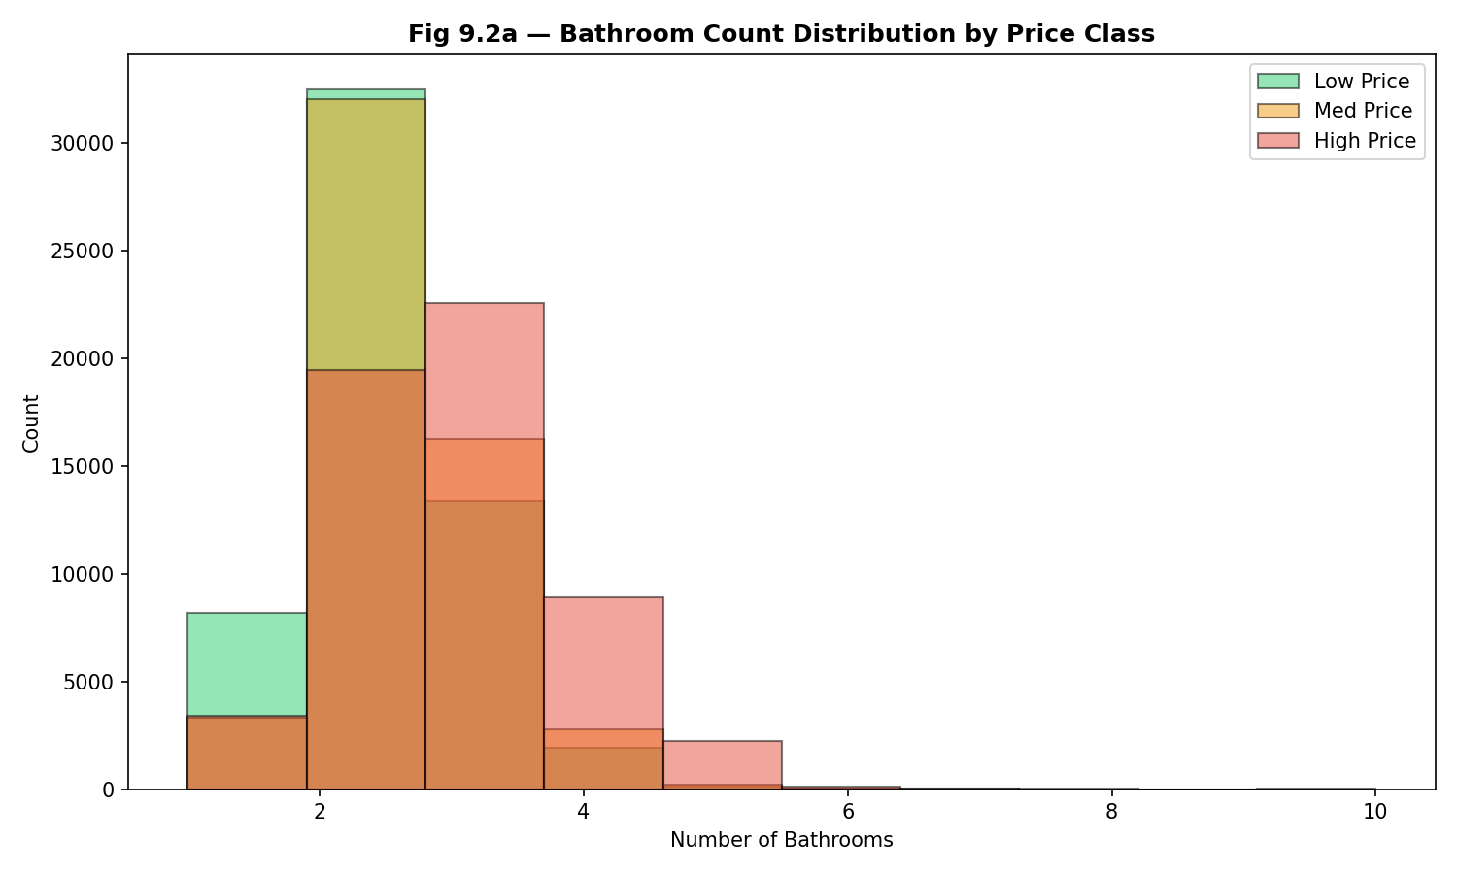
Fig. 9.2a — Bathroom Count Distribution by Price Class

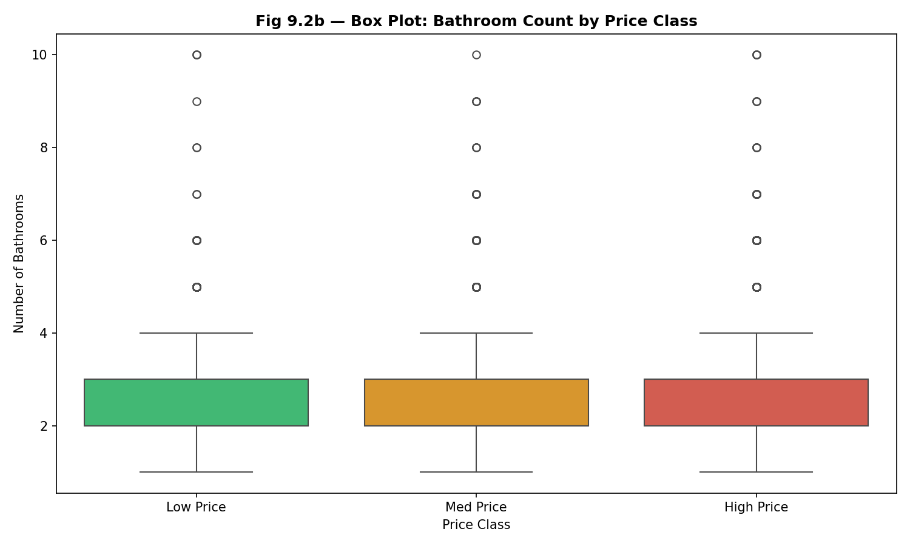
Fig. 9.2b — Box Plot: Bathroom Count by Price Class

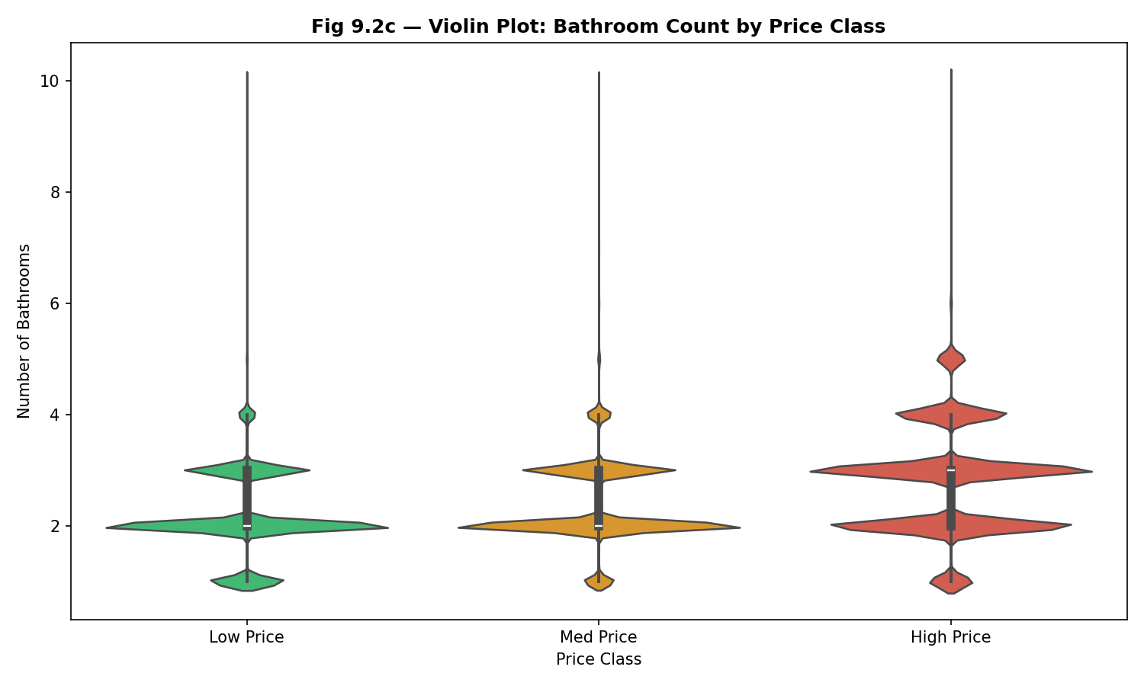
Fig. 9.2c — Violin Plot: Bathroom Count by Price Class

3.3 Interpretation
Pattern Observed: Low Price properties are heavily concentrated at 1–2 bathrooms (budget flats), while High Price properties show a distribution centered at 3–4 bathrooms with a meaningful tail toward 5+. The box plot confirms this with medians of 2 (Low), 2 (Medium), and 3 (High). The violin plot for High Price properties is notably wider and flatter, indicating greater variance — luxury properties range from 3-bedroom flats to large bungalows with 6+ bathrooms. Mean bathroom counts rise from 2.17 (Low) to 2.36 (Medium) to 2.78 (High).

Real-World Meaning: Bathroom count serves as a proxy for property size, configuration, and luxury level. Buyers in the premium market expect en-suite bathrooms for each bedroom, guest bathrooms, and servant quarters. The consistent increase across price tiers confirms that bathroom count is a valuable numerical feature for price prediction, especially for distinguishing medium from high-value properties.

4. Graph Set 3 — Price per Sqft Distribution by Class
Research Question 9.3 | How is the price per sqft spread within each price class — is the distribution skewed or uniform?
Variables | Independent: price_per_sqft (INR) | Dependent: price_class (Low/Med/High)
Hypothesis | High-price class properties will show a right-skewed and wide distribution, reflecting premium luxury properties commanding disproportionately high prices.

4.1 Code
# --- Graph 9.3: Combined Box + Violin (Boxenplot) ---
plt.figure(figsize=(12, 6))
sns.boxenplot(data=df_clean, x='price_class', y='price_per_sqft',
order=['Low Price', 'Med Price', 'High Price'],
palette={'Low Price':'#2ecc71', 'Med Price':'#f39c12', 'High Price':'#e74c3c'})
plt.title('Fig 9.3 — Price per Sqft Distribution by Price Class', fontweight='bold')
plt.xlabel('Price Class') ; plt.ylabel('Price per Sqft (INR)')
plt.tight_layout() ; plt.savefig('fig9_3_ppsf.png', dpi=150) ; plt.show()

# Compute mean by price class
print(df_clean.groupby('price_class')['price_per_sqft'].mean().round(2))

4.2 Graph (Fig 9.3)
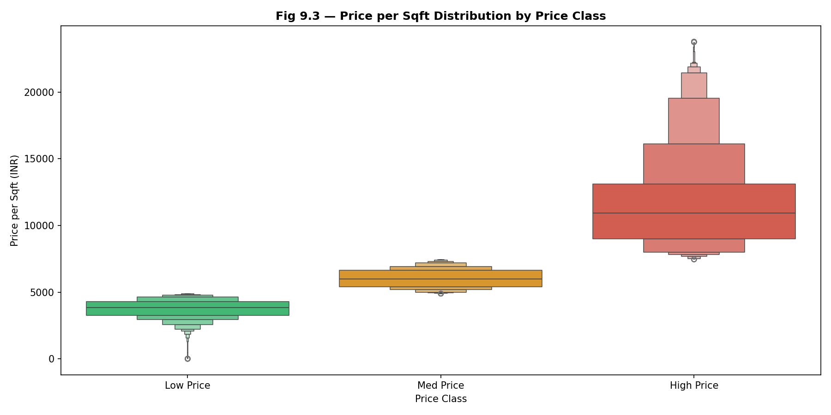
Fig. 9.3 — Price per Sqft Distribution by Price Class

4.3 Interpretation
Pattern Observed: Mean price per sqft rises dramatically across classes: Low Price (INR 3,768) → Med Price (INR 6,038) → High Price (INR 11,620). The High Price class shows a heavily right-skewed distribution, with a long upper tail extending toward ultra-premium properties (INR 50,000+ per sqft). Low and Medium classes have much tighter, symmetrical distributions. The boxen plot clearly shows increasing spread (IQR) as the price class rises, confirming that premium property pricing is more variable and driven by location, brand, and luxury amenities beyond just area.

Real-World Meaning: Compulsive (purposeless) premium spending is a hallmark of the luxury property market — buyers pay for location, reputation, and exclusivity rather than just size. The right-skewed distribution in the High Price class reflects the urban Indian premium property market (Mumbai, Pune, Bangalore) where a small number of ultra-luxury developments inflate the top tier. This skewness should be addressed via log-transformation before building ML models.

5. Summary Table — Numerical Features vs Price Class
Feature | Low Price Avg | Med Price Avg | High Price Avg | Key Pattern
Carpet Area (sqft) | 969 | 1,058 | 1,520 | Strong upward trend — 57% increase
Bathrooms (count) | 2.17 | 2.36 | 2.78 | Consistent rise — more baths in premium
Price/sqft (INR) | 3,768 | 6,038 | 11,620 | Tripling from Low to High price class
Balcony presence | Rare | Moderate | Common | Premium homes have more balconies
Furnishing level | Mostly unfurnished | Semi-furnished | Furnished | Clear premium-tier luxury upgrade

6. Conclusion
All three numerical features analyzed — Carpet Area (sqft), Bathroom Count, and Price per Sqft — show strong, consistent patterns of increase across the Low → Medium → High price class spectrum. Histograms confirm distributional shifts toward higher values in premium tiers, box plots confirm median and IQR changes, and violin plots confirm that High Price properties show wider, more variable distributions reflecting diverse luxury configurations.

Carpet area shows a 57% increase from Low to High price class (969 → 1,520 sqft), bathroom count rises from 2.17 to 2.78, and the mean price per sqft nearly triples (INR 3,768 → 11,620). These three features are among the most powerful predictors of property pricing tier and should be prioritized in the ML model feature selection step. Additionally, the right skewness in the price per sqft distribution for High Price properties suggests that log-normalization will be essential for model accuracy.

