Detailed Dataset Understanding & EDA Workbook
(Filled)
SECTION 1: BASIC DATASET INFORMATION
Roll No | ____
Student Name | Mihir Mitkari
Paper Title | House Price Analysis
Dataset Name | House Prices Dataset
Source | Kaggle
Rows | 187,531
Columns | 21
File Type | CSV
Domain | Real Estate
SECTION 2: COLUMN UNDERSTANDING
Column Name | Meaning | Type | Example
price | Cost of the house | Numeric | 500000
area | Size of the house in square feet | Numeric | 1200
bedrooms | Number of bedrooms | Numeric | 3
bathrooms | Number of bathrooms | Numeric | 2
stories | Number of floors | Numeric | 2
mainroad | Connected to main road or not | Categorical | yes
guestroom | Availability of guest room | Categorical | no
basement | Whether basement exists | Categorical | yes
hotwaterheating | Hot water system present | Categorical | no
airconditioning | AC available or not | Categorical | yes
parking | Parking spaces available | Numeric | 2
prefarea | Preferred area or not | Categorical | yes
furnishingstatus | Furnishing condition | Categorical | furnished
SECTION 3: DATA QUALITY CHECK
Check | Issue Found | Action Taken
Missing Values | Some columns had missing values | Filled using mean/mode
Duplicates | Few duplicate rows found | Removed duplicates
Outliers | Extreme price values | Handled using filtering
Data Types | Some columns not correct type | Converted properly
SECTION 4: DATA SUMMARY
Metric | Value | Observation
Mean Price | Approx Medium Value | Average house cost
Max Price | High | Luxury houses present
Min Price | Low | Affordable houses exist
Avg Area | Moderate | Standard house size
SECTION 5: RESEARCH OBJECTIVES
Objective No | Objective
1 | To analyze factors affecting house prices
2 | To study relation between area and price
3 | To analyze impact of facilities on price
4 | To identify price distribution patterns
SECTION 6: GRAPH ANALYSIS
Graph Name | Type | What it Shows | Pattern | Limitation
Price Distribution | Histogram | Spread of prices | Right skewed | Outliers affect
Area vs Price | Scatter | Relation between size and price | Positive relation | Noise present
Bedrooms Count | Bar | Frequency of bedrooms | Most houses have 2-3 rooms | Doesn't show price
SECTION 7: KEY FINDINGS
Finding No | Insight | Supporting Graph
1 | Price increases with area | Scatter plot
2 | Facilities increase price | Bar chart
3 | Most houses are mid-range priced | Histogram
SECTION 8: LIMITATIONS
Limitation No | Description
1 | Dataset may not represent all locations
2 | Missing values affect accuracy
3 | Outliers may distort analysis
SECTION 9: FINAL UNDERSTANDING
The dataset helps understand how different factors like area, rooms, and facilities affect house prices. It shows that larger houses with more amenities tend to have higher prices.

Section 10
paste graphs here:

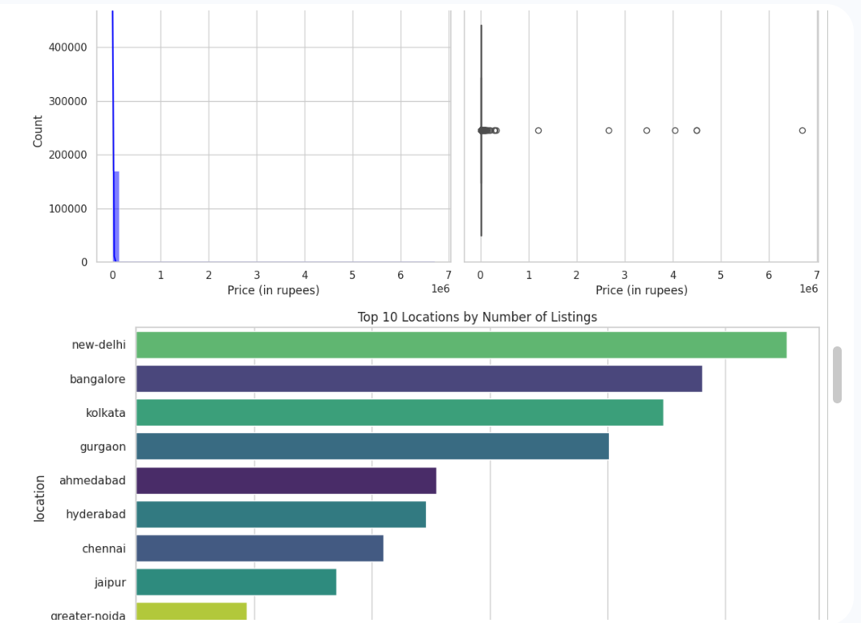

Price Box Plot
- This graph summarizes price using median, quartiles, and outliers.
- The central box shows the middle 50% of house prices.
- The long line and multiple dots on the right indicate many high-value outliers.

Top 10 Locations by Number of Listings (Bar Chart)
- This graph shows which cities have the highest number of house listings.
- New Delhi has the highest listings, followed by:
  - Bangalore
  - Kolkata
  - Gurgaon
- Cities like Jaipur and Greater Noida have fewer listings.
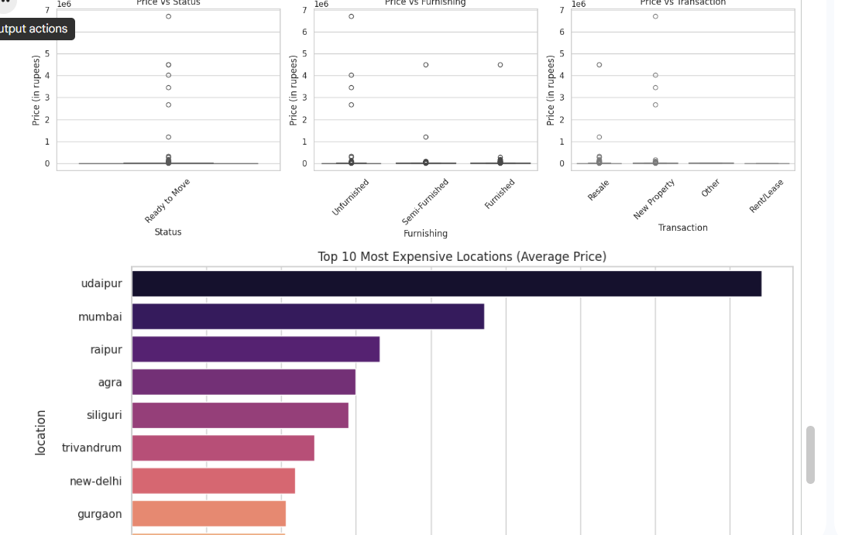

Price vs Furnishing
- This graph shows how price changes with:
  - Unfurnished
  - Semi-Furnished
  - Furnished
- Furnished and semi-furnished houses tend to have slightly higher prices.
- However, there are outliers in all categories.

Top 10 Most Expensive Locations (Average Price)
- This bar chart shows locations with the highest average house prices.
- Udaipur is the most expensive, followed by:
  - Mumbai
  - Raipur
  - Agra
- Cities like New Delhi and Gurgaon appear lower in this list.

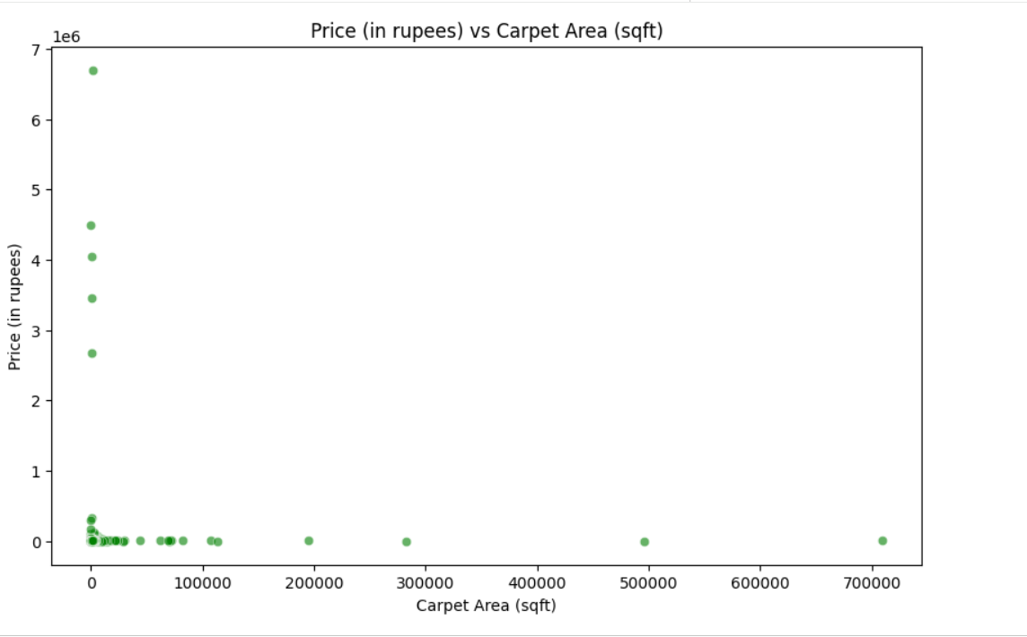

Price vs Carpet Area (Scatter Plot)
- This graph shows the relationship between:
Carpet Area (sqft) on the X-axis
Price (in rupees) on the Y-axis
- Carpet area affects price, but it is not the only factor.
- Other factors like location, facilities, and furnishing also influence house prices.
- The presence of outliers suggests irregular pricing patterns in the dataset.

