House Prices Graphs
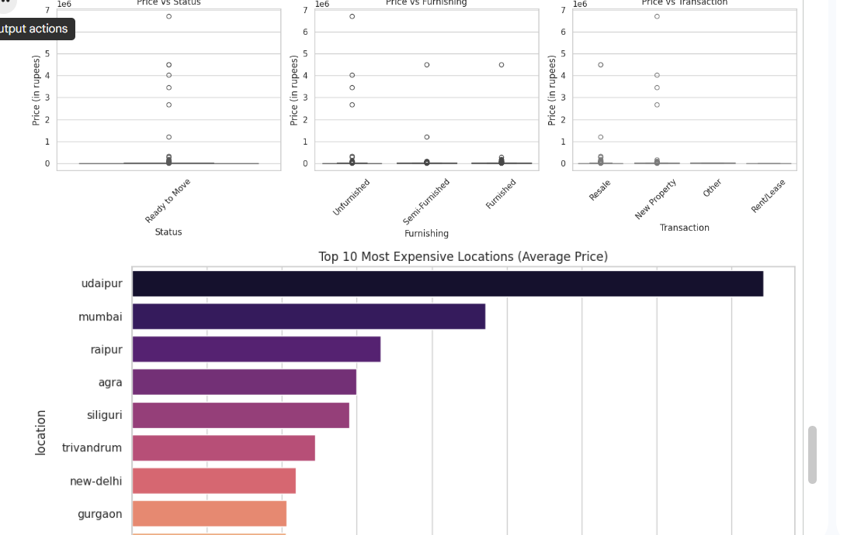

Price vs Furnishing
- This graph shows how price changes with:
  - Unfurnished
  - Semi-Furnished
  - Furnished
- Furnished and semi-furnished houses tend to have slightly higher prices.
- However, there are outliers in all categories.

Top 10 Most Expensive Locations (Average Price)
- This bar chart shows locations with the highest average house prices.
- Udaipur is the most expensive, followed by:
  - Mumbai
  - Raipur
  - Agra
- Cities like New Delhi and Gurgaon appear lower in this list.

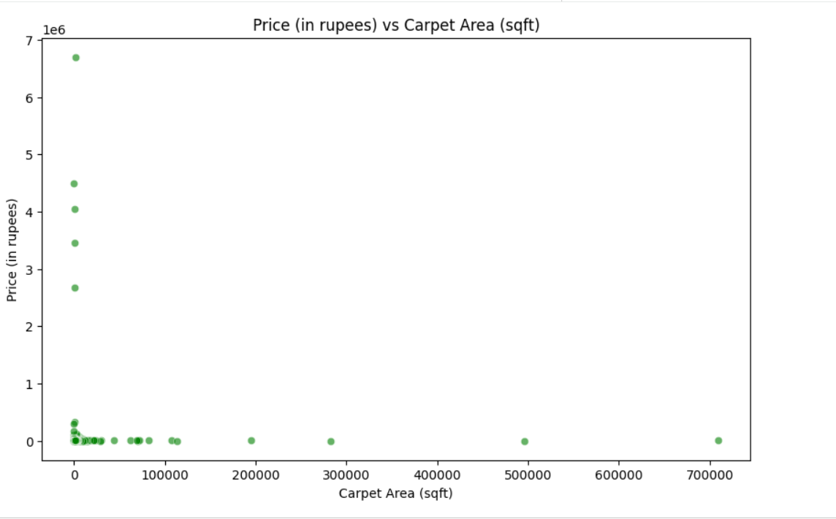

Price vs Carpet Area (Scatter Plot)
- This graph shows the relationship between:
Carpet Area (sqft) on the X-axis
Price (in rupees) on the Y-axis
- Carpet area affects price, but it is not the only factor.
- Other factors like location, facilities, and furnishing also influence house prices.
- The presence of outliers suggests irregular pricing patterns in the dataset.
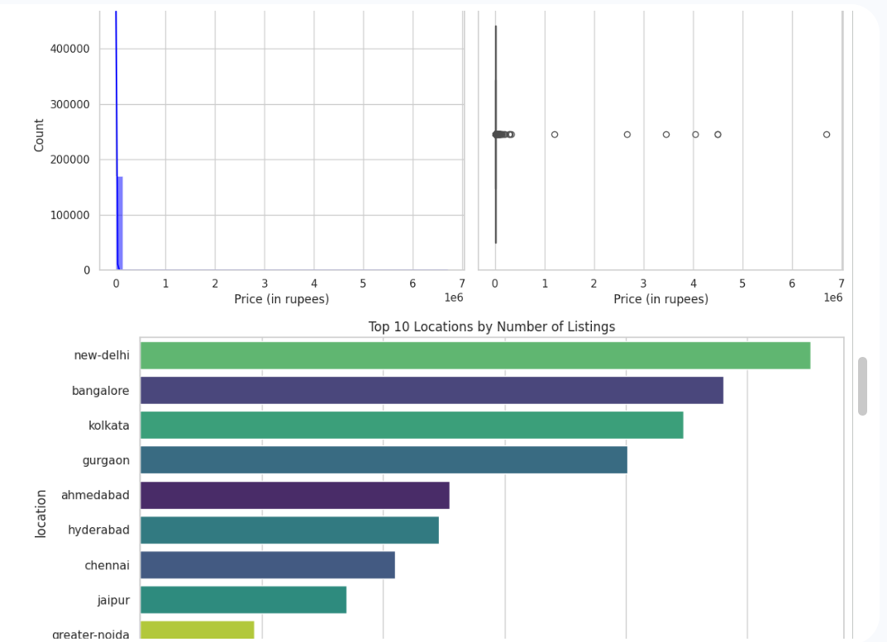

Price Box Plot
- This graph summarizes price using median, quartiles, and outliers.
- The central box shows the middle 50% of house prices.
- The long line and multiple dots on the right indicate many high-value outliers.

Top 10 Locations by Number of Listings (Bar Chart)
- This graph shows which cities have the highest number of house listings.
- New Delhi has the highest listings, followed by:
  - Bangalore
  - Kolkata
  - Gurgaon
- Cities like Jaipur and Greater Noida have fewer listings.

