**Modelling of evolving plant communities**

Dimitar Trendafilov and Tihomir Ivanov

*Faculty of Mathematics and Informatics, Sofia University “St. Kliment Ohridski”*

**Abstract**

*In this paper we describe popular methods for plant population simulation. We investigate previous works and come up with our own model by cherry picking techniques and ideas. Asymmetric competition for resources is the fundamental plant interaction which we build up on. We will also go into intricate implementation details missing in the source materials.*

**Keywords:** field-of-neighbourhood model; asymmetric plant competition; ecosystem simulation; modelling of natural phenomena

1. **Introduction**

Modelling and simulation of plant communities is an important and fast developing field of research, not only in ecology where it helps to predict the future and the condition of ecosystems, but also in applications such as computational biology, landscape planning and city architecture. Additionally, the methods can be used to achieve beautiful realistic scenes that are used in production films and computer games.

The proposed model is based on the so-called FON model (field-of-neighbourhood)[AD05]. The FON describes a circular zone of influence around a plant whose radius determines the distance up to which the plant interacts with neighbouring plants. This radius is not primarily dependent of the size of the plant, but also depends on the soil, i.e. by the amount of nutrition the plant needs and how much space is necessary to provide this nutrition. The extent of this zone is specified by a nonlinear function of the basal radius of the plant and coefficients *d, b*.

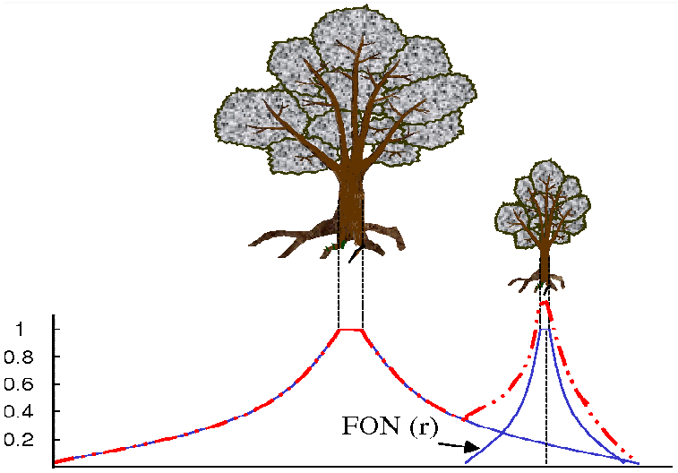

**Figure 1:** The zone of influence depends on the

diameter of the trunk base

1. **Growth**

The growth of the individual plant depends on their neighbouring plants and their actual size. It can be described by the Richards growth model [Ric59,Van89,GBFP01] and is written as follows:

Where *A* is the FON area, *k* is growth parameter and is the growth rate.

Here *i* and *j* are the plants and represents is the overlapping FON area, is a weighting factor expressing the exactly how asymmetric is the competition between the two entities.

1. **Reproduction**

Both reproduction and mortality investigated in the next section are heavily based on [BBHG02]. The mechanic used is seed spreading. Distribution of seeds is seasonal, meaning it happens periodically at a fixed time. Each mother plant disperses seeds locally and positions are calculated using two dimensional Gaussian probability function **Figure 2**.



**Figure 2:** 1000 Gaussian distributed random points

Seed count is based on the mother plant’s size, where production increase is a logistic curve **Figure 3**.

Where ϑ are the maximum number of seeds (5 in our implementation), *d* and *p* are parameters.



**Figure 3:** Seed count relative to

Seeds can never establish themselves in the basal area of established plants. On all other locations seed’s establishment depends on competitive situation. The local field influence value, is defined as the sum of all plants’ influence at point (x, y).

Whenever falls below a particular threshold, the seed is assumed to germinate and establish itself. Else the seed is assumed to die because the competitive pressure is too strong.

1. **Mortality**

The mortality if plants, which are influenced by high pressure of competition is higher than solitaire plants. We can define this mortality risk as the average plant size over the last few iteration steps. Consequently, plants that have reached their maximum age must also gradually die. All of this is expressed by the vigor average.

Where is the plant’s influence and *C* and *S* are the correction factors and for competition and size respectively. If the average vigour falls below a particular threshold, the individual is assumed to die. The memory approach allows plants to be able to tolerate competitive pressure for some time, but then die. Alternatively, plants may recover from competition (i.e. forget former competition) if competitive pressure is released owing to the death of neighbouring plants.

1. **Future work**

The current implementation supports a single type of plant species, however it can be easily extended. The variety will add visual complexity in the simulated ecosystems. On the other hand the results might not be satisfactory because the current state of the proposed mathematical model does not have enough per species parametrization. This will most probably lead to a noisy floral community with no evident structure, whereas as seen in **Figure 4** this is not the case.

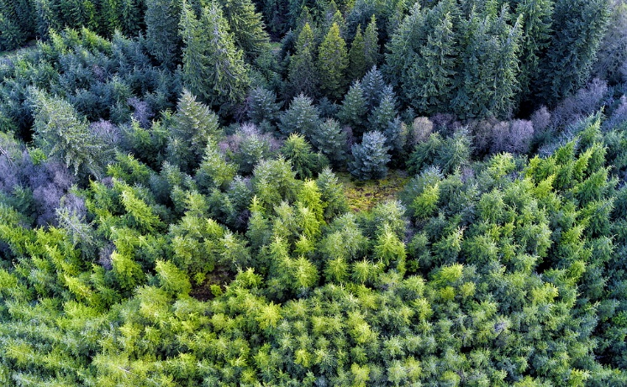

**Figure 4:** Species clustering based on various environmental factors such as resource availability and natural obstacles

Another missing feature is resource heterogeneity and diversity, meaning having constant/homogeneous resource density everywhere in map and having a single type of resource on which individuals depend and compete for. Moving to a heterogeneous resource grid will lead to plants of a single species creating clusters with nutrient related density and size difference. On the other hand adding resource parametrization is impractical in a single species system without heterogeneity, but will greatly improve results in a multi species one.

**Figure 5:** The varying density of the grey scale values represents

the differences in quantity of resources in the ground

and in the climate. Area I is hereby the best area, following

are areas III,II, IV, VI.

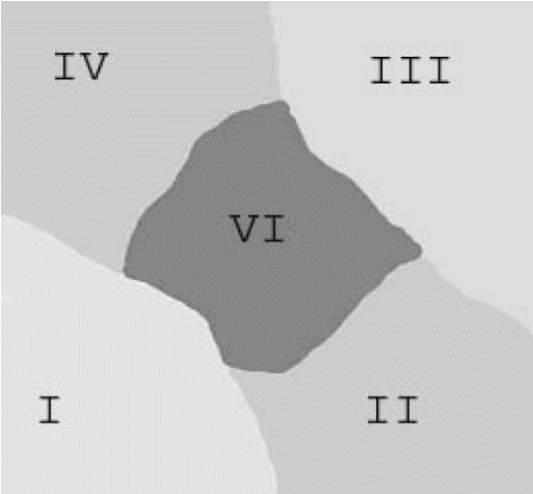

Finally, a better graphical visualization of the results should be devised for better intuition. POVRAY is software worth researching as every published paper on the topic seems to use it[DHP*].

1. **References**

[AD05] Alsweis M., Deussen O.: Modeling and Visualization of symmetric and asymmetric plant competition. In *Eurographics Workshop on Natural Phenomena,* 2005, pp. 83-88*.*

[BBHG02] Bauer S., Berger U., Hildenbrandt H.,

Grimm V.: Cyclic dynamics in simulated plant populations. *Proc R Soc Lond B Biol Sci. 269*, 1508 (2002), 2443–2450.

[DHP*] Deussen O., Hanrahan P., Pharr M., Lintermann B., Mech R., Prusinkiewicz P.: Realistic modelling and rendering of plant ecosystems. In *SIGGRAPH 98 Conf. Proc.,* ACM SIGGRAPH, pp. 275–286.

[Ric59] Richards F.: A flexible growth function for empirical use. *J. Exp. Botany 10* (1959), 290–300.

[Van89] Vandermeer J.: The ecology of intercropping.

*Cambridge University Press, Cambridge.* (1989).

[GBFP01] Garcia-Barrios L. D. M.-F. M. F. G. U.-V., Franco-Perez. J.: Development and validation of a spatial explicit individual-based mixed crop growth model. *Bulletin of Mathematical Biology 63* (2001), 507–526.