

Global Electronic Collaborative Agreement

(GECA)

Model Template

August 24 2010

Developed By:

Electronic Enterprise Integration Committee
Aerospace Industries Association, Inc.

Important Disclaimer: The Aerospace Industries Association of America, Inc. (“AIA”) has no intellectual property or other interest in the Global Electronic Collaborative Agreement (GECA) model template. By developing a model template GECA, and making it freely available to anyone, neither the AIA nor the AIA member companies who have assisted in the development of the GECA, assume responsibility for the GECA’s content or use, and disclaim any potential liability associated therewith.

Firstly, establish whether it is necessary for collaborative parties to agree a Global Electronic Collaborative Agreement (GECA).

- The following decision logic matrix may be useful in reaching a decision.

Is there a need
to share
electronic
information
?
Start
Yes
No
With others outside
of your legal entity
(not within your own
company)
Will
conventional media
e.g. CDROM
suffice
?
No
Will email and
file attachments
suffice
?
No
Yes
Yes
Conventional arrangements are all
that are required e.g.:
•
Confidentiality agreement
•
Agreement with the recipient on the
intended use of the information.
If there is no information to share, or if it is
to be retained and used within the legal
entity, then no agreements are required
Will the
originator(s) host and
provide access to
the information
?
Shared working environments offer concurrent access to information, often in a very well protected and secure environment, but typically at higher cost than conventional methods.
An electronic shared
working environment is
required
Yes
Yes
Is shared
information sensitive
or valuable
?
No
Is there
any requirement
for confidentiality
?
No agreements are essential;
any convenient form of
transmission may be used,
including a shared working
environment
Yes
No
No
N
= See note numbers in the text
1
2
3
6
4
5
7
8
9
10
11
These are value judgments taking into account ease of use and business effectiveness including timeliness, concurrency, configuration control and security requirements
If originators (information Owners) make the information available allowing other parties access, under specified controls, then conventional arrangements are all that are required, e.g.
Confidentiality Agreement
Property Rights Agreement
Agreement with the recipient on the
intended use of the information.
A Global Electronic Collaboration Agreement may be more suitable for this arrangement and should be considered.

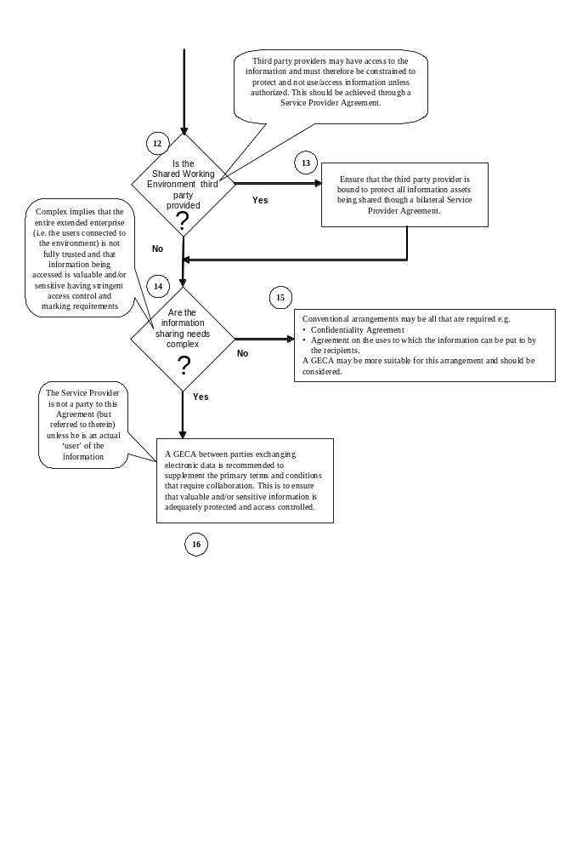

Notes to Figure

1. When considering information sharing it is not a given that it should be done by electronic means. Although we live in an ‘e’ society there are occasions when paper or physical media are appropriate, for example the information may be highly classified, resulting in very expensive electronic systems which may not provide added value. Furthermore information sharing is only a contractual/legal issue if it is being shared with others outside of your own company organization (the legal entity). This is simply because you cannot have a legal agreement or contract within parts of a single legal entity, as a minimum there must be two parties involved.
2. If the information you wish to share has no sensitivity or value, or restrictive property rights, then no form of agreement to ‘protect’ it is required.
3. Before finally deciding on whether or not an agreement is required ask the simple question, “If this information were published in the press, would it matter?” if the answer is yes, then you do need some form of agreement.
4. If there is no sensitivity to the information being available in the public domain, then no agreements are necessary, and any form of transmission may be used; as security will not be an issue.
5. This question relates to the choice of electronic media. Contractual/legal managers will prefer to ship physical media, as control is easier, it is always known what is on the disc. If physical electronic media are appropriate to the business being conducted, there would normally be no requirement for a separate electronic information sharing agreement distinct from the contract that required the supply of the information.
6. If greater concurrency and immediacy of access to the information are required than can be achieved with distribution of physical electronic media, then consider the use of email and file attachments. If email is appropriate to the business being conducted there would normally be no requirement for a separate electronic information sharing agreement distinct from the contract that required the supply of the information.
7. There are business, technical and security issues associated with conventional media, that the use of shared working environments have to address. Physical electronic media such as CDROM are potentially easier to control from an access control perspective, but do not offer the immediacy and access to a single source of information opening the door to configuration control problems if changes to the records are required to be made. Similarly email has limitations; these include limited maximum file size and poor configuration control, as not all parties will access the same information object, again opening the door to configuration control issues. Email is, though, a low cost technology (which can be secured via encryption software).
8. Conventional arrangements would include standard confidentiality and rights of use clauses either in the principal contract or in standalone agreements where there is no contract.
9. If the owner/originator of the information grants access by external parties to his own systems, then this can be ideal solution from a commercial standpoint, as it puts the onus for control etc. firmly onto the originator. Examples include publishing information on Intranet sites, and granting access to back office database systems. Since there are significant security issues to be addressed, very few organizations permit third party organizations to access their ‘in-house’ information systems directly.
10. Conventional arrangements would include standard confidentiality, rights of use, and rights of ownership clauses (e.g. Intellectual Property Rights) either in the principal contract or in standalone agreements where there is no contract. A Global Electronic Collaboration Agreement (GECA) may be more appropriate in these circumstances and should be considered.
11. You have reached the decision that a GECA is required to support the information sharing needs of your project. Shared working environments can potentially offer significant business improvements through concurrent working, access to common sources of information, and very high levels of security, access control and logging.
12. An electronic shared working environment can either be hosted directly by one of the principal parties to a contract, e.g. the Customer or Prime, or may be hosted by a third party service provider.
13. If hosted by a third party provider it is essential that the provider is considered in the context of access to information, as in most technical solutions the Shared Data Environment (SDE) administrators will have access to the information. However the Service Provider is not normally a ‘user’ of the information, so the only requirement is that he hold the information securely, and not permit access by unauthorised users. A straightforward SDE Service Agreement should, as a minimum, be put in place between the Service Provider and each SDE User to provide the requisite confidentiality provisions, as well as conditions relating to the SDE Service itself (e.g. availability). The SDE Provider need not to be a party to a GECA, unless the SDE Provider is a User of the information in his own right, provided an adequate bilateral Service Agreement is in place with each party. The commissioner of the Service Provider will need to establish the rules for access and control of the SDE in his agreement with the Service Provider, while the Users will need a different type of agreement with the Service Provider for access and use of the information.
14. Whether or not information sharing needs are complex is somewhat subjective depending on the trust levels in the extended enterprise (i.e. SDE users) and whether complex access controls and marking schemes are required to define the discretionary access controls that support the needed business processes. If complex, then multiparty GECA’s may be required.
15. If the information to be shared is straightforward for example not requiring specific protective marking or complex access controls, or if users are all inherently trusted (the only requirement is to protect the information from outsiders) then as long as there are good Service Agreements in place (to implement the required protection) all that is required are conventional arrangements. These would include standard confidentiality and rights of use clauses, either in the principal contract, or in standalone agreements where there is no contract. However, use of a GECA should also be considered in these circumstances to supplement the primary terms and conditions.
16. Finally, please note that the export of data by any media is subject to national regulations as detailed in clause 20 of the draft agreement.

17. You have reached the point where only a multiparty GECA will satisfy the commercial requirements.

If you have decided that a GECA is necessary the following pages provide an introduction into the GECA together with a draft agreement.

Introduction to the Model Global Electronic Collaborative Agreement (GECA)

Description: The GECA provides global parties with a common set of rules by which they agree to exchange electronic data. The template is used to support electronic collaboration between companies engaging in domestic and international eBusiness practices. The GECA will supplement the primary terms and conditions and will govern the exchange of collaborative eData. The latest version of the GECA may be found on the AIA (HTTP://www.aia-aerospace.org) website, but may also be found on websites and other locations such as trading exchanges, portals and enterprise web pages.
Purpose: The intention of the GECA is to compliment the primary contractual terms and conditions of contracts requiring collaboration among multiple Collaborative Parties. It eliminates the practice of imbedding Collaborative clauses in the business contract where clauses of this type can become difficult to implement and manage. The model GECA provides the rules and contractual coverage for electronic collaboration elements such as: electronic signature, non-repudiation, and protection of personal Data, and treatment of proprietary information, etc
What is a collaborative environment: One definition of "collaborate" is to work together in a joint effort. The term "collaborative" is applied to real-time interactions, groupware, Shared information spaces, file sharing, advanced monitoring and management, supply chain integration, etc. In the context of business, we call a process "collaborative" if it allows real-time, electronically-enabled business interactions. Collaboration allows parties to make joint decisions by sharing information and/or interacting on-line using a solution that allows interactive information / knowledge exchange.
.
Intended Use: The GECA is the master document establishing the set of common rules for sharing Data among Collaborative Parties over one or more existing or anticipated contracts. Fig 1.

Figure 1 The Collaborative Environment
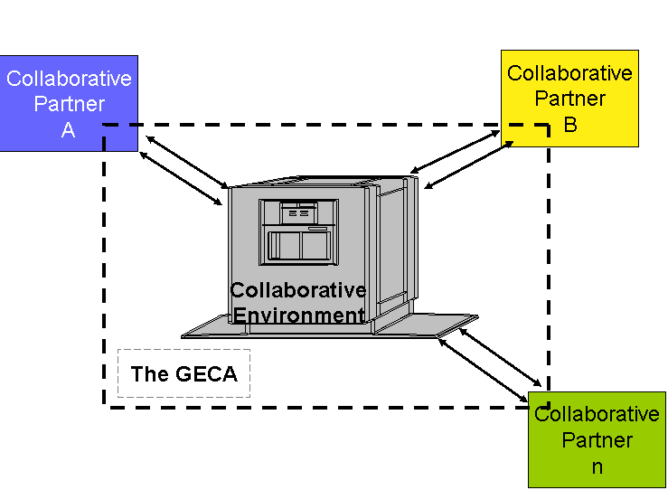

Documenting the technical requirements: The “Collaborative Protocol Profile” (CPP) describes one entity's electronic trading capabilities - what business processes they support, what communications protocols, what business documents, which versions of all of the above, security requirements, etc. The CPP for each party provides the baseline from which a negotiated Collaborative Protocol Agreement is created.

“Collaboration Protocol Agreement” (CPA) is the result of the blending of two or more parties CPPs and defines the technical implementation details that have been agreed to between the Parties that establishes the collaborative environment. This technical agreement includes, but is not limited to communication protocols, versioning, and security requirements. The CPA should be included as an attachment to the GECA. See Fig. 2.

Figure 2 The Collaborative Protocol Agreement:
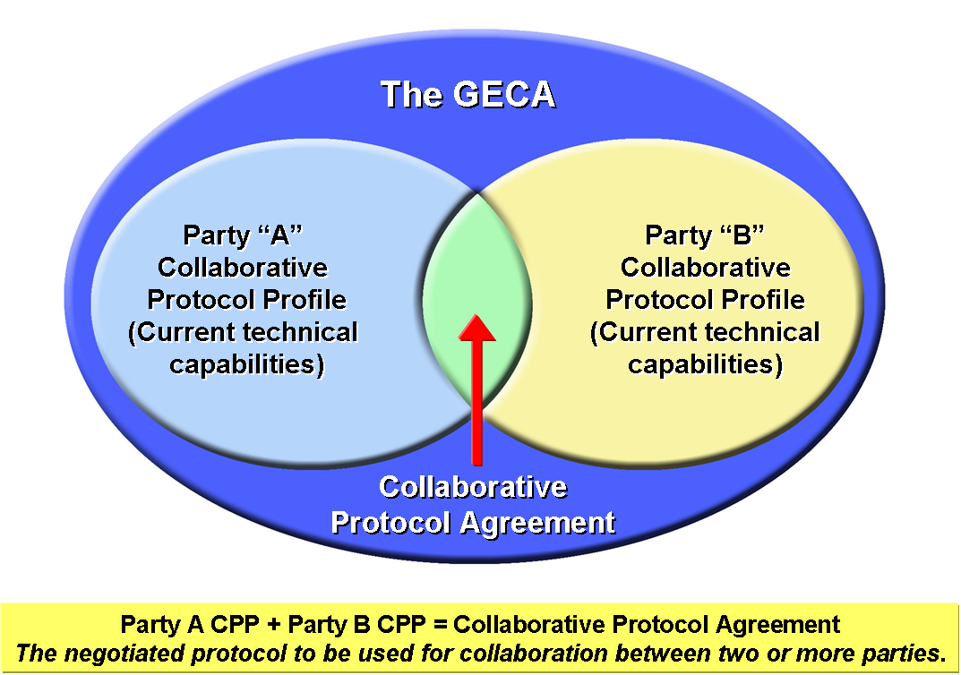

Benefits of the GECA: The GECA is intended to reduce the complexity and cycle time involved in creating a Collaborative Protocol Agreement. This provides companies, large and small, with practical contractual language to facilitate the electronic sharing of Data amongst global collaborative partners. The intent is to reduce the number of different of versions of Collaborative Agreements used across industry.
Users: Domestic and international collaborative parties.
Stakeholders: Contracts, Information Technology, Engineering, Logistics, Program personnel, and others where the sharing of Data is warranted.
History and GECA Endorsements: The GECA represents the collective eBusiness best practices of the Aerospace & Defense and other industries. Additionally, the model concept has the support and endorsement of the United Nations Center for Trade Facilitation and Electronic Business (UN/CEFACT) and other international standards bodies. It is recommended the document be used as published. Additionally, the document allows for modifications to accommodate electronic collaborative requirements unique to particular projects or parties.
Disclaimer: The published GECA is a template. All responsibility for the GECA’s content, however modified, is placed on each using party. The Aerospace Industries Association of America, Inc. (“AIA”) (originating organization), has no intellectual property or other interest in the use of the model GECA. The AIA and any of its member companies who have assisted in the development of the model GECA does not assume responsibility for the GECA’s content or use and disclaims any warranty or potential liability associated therewith.

BASIC GECA

- SCOPE
This Global Electronic Collaboration Agreement (hereinafter “GECA” or “Agreement”), as of ___________________,___________________,___________________,___________________ (“Effective Date”), governs the access or exchange of Data electronically is entered into by and between _______________________________ with offices in ______________________________________, (“Company”) and _____________________________________, with offices in ____________________, (Company and Collaborative Party are also referred to herein individually as a “Party” and collectively as “Parties”). This agreement governs the sharing of data electronically. Each Party agrees that the following provisions govern transmission, access, receipt and exchange of Data electronically and such provisions are complementary to the underlying business agreement (“Underlying Agreement”) governing the substantive business transaction.

2. PURPOSE
- The purpose of this agreement is to facilitate electronic sharing of data for the purposes of carrying out the Underlying Agreement(s).

- Nothing in the Agreement precludes Partners from sharing Data by any other means.

3. DEFINITIONS
(A) “Acknowledgement” means an electronic indicator verifying receipt or access of the Data.

(B) “Authentication Mechanism” means a mechanism that allows the receiver of an electronic transmission to verify the identity of the sender and the integrity of the content of the transmission through the use of an electronic key or algorithm which is Shared by the Parties. This may include the authentication of electronic signatures.

(C) “Collaboration” mean one or more Parties working together in a Common Electronic Environment.

(D) “Collaborative Environment” is an electronic domain where Data are Shared between two or more Parties

(E) “Collaborative Protocol Profile” or “CPP” means a Party’s current electronic trading capabilities, including without limitation business processes supported, communications protocols used, business documents used, security requirements, etc. The CPP for two or more individual Parties provides the baseline from which a negotiated Collaborative Protocol Agreement between those Parties is created.

(F) “Collaboration Protocol Agreement” or “CPA” means the technical implementation details set forth in Exhibit A for implementing a Collaborative Environment between the Parties, including without limitation communication protocols, administration of various versions of protocols, documents, etc., and security requirements.

(G) “Data” means any information transmitted / Shared electronically amongst the Parties.

(H) “Data Recovery Plan” means a plan for recovering data in the event of an interruption in normal operations, including without limitation plans for bringing processes back online at another location, hardware and software requirements, and step-by-step instructions for ensuring business continuity.

(I) “Data Provider” means, with respect to any Data, the Party that contributed such Data to the Collaborative Environment.

(J) “Digital Signature” means a unique, verifiable, secure, protected and non-refutable electronic digital identification consisting of symbols or codes as defined by the supplemental CPA hereto.

(K) "Electronic" means or relates to information created, recorded, transmitted, received or stored in digital or other intangible form by electronic, magnetic, optical or other similar means.

(L) “Electronic Information Exchange” means but is not limited to the sharing of data, using information exchange technologies, portal-type technologies, internet technologies, electronic mail, Electronic Data Interchange (EDI), and other means of sharing data electronically

(M) “Exhibit” means a supplemental attachment to this agreement

(N) “Offices In” means location of electronic collaboration operations of the Parties or the Collaborative Party’s legal entity.

(O) “Original” means, with respect to specific Data, the first instance of the Data.

(P) “Personal Data” means any information relating to an identified or identifiable natural person; an identifiable person is one who can be identified, directly or indirectly, in particular by reference to an identification number or to one or more factors specific to his physical, psychological, mental, economic, cultural or social identity.

(Q) “Properly” means in accordance with the prescribed protocol.

(R) “Service Provider” or “Provider” means any Third Party that provides equipment, software, and/or services for the purpose of supporting the Collaborative Environment.

(S) “Recoverable” shall mean capable of being electronically recreated in a readable format.

(T) “Share” means to access, view, and exchange, transmit, send, and/or receive Data.

(U) “Underlying Business Agreement” means the Terms and Conditions of the business relationship amongst the Parties. The Underlying Agreement(s) will reference this GECA as the governing document for the sharing of Data amongst the Parties

4. SYSTEM OPERATIONS
(A) Each Party, at its own expense, will provide and maintain the equipment, software and services necessary to Share Data. Each Party shall periodically test and monitor such equipment, software and services to ensure that they are satisfying the requirements for the control of the Data.

(B) Third Party Service Providers may be contracted to manage the Shared Data environment. Proposed changes in Service Providers, having material impact to the Underlying Agreement, shall be subject to mutual agreement and subsequent amendment of applicable Exhibits, hereto.

- Identification of the Third Party Service Provider may be attached by reference within an Exhibit to this agreement.

- The Party(s) contracting with a Third Party Service Provider shall contractually obligate the Service Provider not to change any Data and not to use such Data except in performing services in connection with the Agreement, and not to disclose such Data to any other Party without prior written approval.

- CONFIGURATION MANAGEMENT
The process of and responsibility for configuration management of the documents / collections of Data governed by this Agreement shall be in accordance with the Underlying Agreement(s).

- DATA SHARING
(A) Each Party shall be responsible for the Data it contributes to the Collaborative Environment being in a form usable in accordance with the CPA and the Underlying Agreement.

(B) Garbled/Lost Transmissions/Service Outages: In the event any of the Parties detects a failure or anomaly in the Shared Data, it is the obligation of that Party to notify the other Parties. The Data Provider is responsible for taking immediate actions to remedy said failure.

7. ARCHIVE AND RETRIEVAL OF DATA
Each Party shall maintain, within such Party’s computer domain separate from the Collaborative Environment, a backup copy in an electronic format of all source Data contributed by it to the Collaborative Environment.

8. DATA RECOVERY PLAN
Each of the Parties shall maintain a Data Recovery Plan as it relates to all Data it contributes to the Collaborative Environment. In the event any Party becomes aware of any loss of or anomaly in Data, such Party shall promptly notify the other Parties of such loss or anomaly and, to the extent known, of the effects on the ability of those Parties to perform under this Agreement and the Underlying Agreement.

9. FORCE MAJEURE
Parties shall not be liable for any failure to perform their obligations required for any sharing of Data, where such failure results from any act of God, or other cause beyond the Partner’s reasonable control including, without limitation, any mechanical, electronic or communications failure or other events as specified in the Underlying Agreement preventing such Parties from sharing any Data.

  - MEANS OF COLLABORATION
The Parties will use a Collaborative Environment in accordance with the Collaborative Protocol Agreement (CPA) in Exhibit A to this GECA.

  - NOTICES
All notices required to be given under this Agreement, except for Collaborative Data sharing, shall be in writing, shall be sent by written or electronic means, return receipt requested, to the Parties) as follows: [at the offices detailed in clause 1 of this Agreement.]
(A) If delivered by hand, notice will be deemed delivered on the day of delivery if it is the recipient's business day and otherwise on the recipient’s first business day immediately following delivery;
(B) If delivered by hand by a Commercial Express Delivery Service, notice will be deemed delivered to the receiving Partner on the third business day (or on the tenth business day, in the case of airmail) after collection by the Commercial Express Delivery Service;
(C) If sent by facsimile, telex or other electronic means:
I) If transmitted between 09:00 and 17:00 hours on a business day (recipient’s time) on completion of receipt by the sender of verification of the transmission from the receiving instrument; or
II) If transmitted at any other time, at 09:00 on the first business day (recipient’s time) following the completion of receipt by the sender of verification of the transmission from the receiving instrument.

12. CONFLICT RESOLUTION
Alternative dispute resolution is encouraged, however, any of the Parties may litigate any dispute arising under or relating to this Agreement:

  - Pending resolution of any such dispute by settlement or final judgment, the Parties shall proceed diligently with the terms of this agreement.
  - Disputes, controversies or claims arising out of this Agreement that involve Parties based within the same national boundary shall be brought and jurisdiction and venue shall be proper only in (specify court and country, here.)
(C) Disputes, controversies or claims arising out of this Agreement that involve Parties residing in different countries shall be finally settled under the rules of arbitration of the International Chamber of Commerce (ICC) by three (3) arbitrators, unless otherwise decided, appointed in accordance with the said rules. The language of the arbitration shall be English (unless otherwise agreed to) and the place of arbitration shall be (specify court and country here). Another jurisdiction may apply to give effect to the findings of the arbitration.

13. PUBLICITY
The right to publicize the existence of this Agreement shall be in accordance with the Underlying Agreement.

- RECORDS MANAGEMENT AND RECORDS RETENTION
For a period of three (3) years after the termination or expiration of the Underlying Agreement, each Data Provider shall provide accessibility to all Data it contributed to the Collaborative Environment as a result of this Agreement. Any Shared Data requiring a receipt and acceptance acknowledgement will be delivered in accordance with the Terms and Conditions of the Underlying Agreement.

15. SECURITY
The Parties will abide by the security requirements specified in the CPA in Exhibit A hereto.

16. CONFIDENTIALITY OF COLLABORATIVE CONTENT
- Each Party will comply with the requirements for the confidentiality of Data as specified in the Underlying Agreement. Each Party will use the same care to maintain the confidentiality of Data for which it is not the Data Provider but to which it has access via the Collaborative Environment in the same secured manner as it would maintain for its own paper documents containing confidential information of like kind and importance. Data in this instance includes Proprietary, Classified, Export, Personal or other Data as defined by the Partners.

- Data containing confidential information must be conspicuously identified to be confidential by the Partner sending the Data, and must not be disclosed to any Third Party (other than a provider of a Collaborative Environment hosting such Data) without the prior consent of the Data owner or used by the Partners other than for the purposes of the collaboration to which it relates, provided that no such obligations of confidentiality shall apply in respect of information which:

  - is in the public domain (other than by breach of the Partners of its confidentiality obligations hereunder); or
  - is in the Partners possession without restriction; or
  - has been lawfully received by the Partners without notice of confidentiality obligations from a Third Party entitled to disclose it; or
  - has been developed independently by the Partners. All rights of use shall be granted within the Underlying Agreement, which should specify the period of confidentiality.

‘(C) Unless otherwise agreed in the Underlying Agreement, the recommended period of confidentiality shall be five (5) years from the date the confidential Data was provided to the Partners(s) to this Agreement. The periods of confidentiality contained in the Agreement are subject to the exclusions and other provisions under the heading “Confidentiality” in the underlying Agreement. Where permitted by law, the Partner(s) may mutually agree to apply special protection to Shared Data by encryption or by other agreed means as defined by the Underlying Agreement or the CPA found as Exhibit A, hereto.

17. ASSIGNMENT
Parties(s) shall not assign, subcontract, charge or otherwise deal with or dispose in any way of the rights or obligations hereunder without the prior consent of the other Party(s), save that no such consent is required in the event of the internal reconstruction or reorganization of a Party.

18. DISCLAIMER OF WARRANTIES
(A) WARRANTY AGAINST THIRD PARTY INFRINGEMENT

Each Party represents and warrants that the use of any Data for which it is the Data Provider by the Parties in the Collaborative Environment in accordance with the terms of this Agreement will not infringe any patent, trademark, copyright, and right in a trade secret or other intellectual property right of any third party.

(B) DISCLAIMER OF WARRANTIES

EXCEPT AS EXPRESSLY SET FORTH IN SECTION 18(A) NEITHER PARTY MAKES AND EACH PARTY HEREBY SPECIFICALLY DISCLAIMS ANY AND ALL REPRESENTATIONS OR WARRANTIES, EXPRESS OR IMPLIED, ARISING BY LAW OR OTHERWISE, ARISING UNDER OR RELATING TO THIS AGREEMENT OR THE SUBJECT MATTER HEREOF, INCLUDING WITHOUT LIMITATION ANY IMPLIED WARRANTIES OF MERCHANTABILITY, FITNESS FOR A PARTICULAR PURPOSE, TITLE, NON-INFRINGEMENT, COURSE OF PERFORMANCE, COURSE OF DEALING, OR USAGE OF TRADE. THIS SECTION SHALL SURVIVE ANY TERMINATION OR EXPIRATION OF THIS AGREEMENT FOR ANY REASON.

19. ENFORCEABILITY AND ADMISSIBILITY

The conduct of the Parties pursuant to the Underlying Agreement, including the use of Data properly Shared hereunder, shall, for all legal purposes, evidence a course of dealing and a course of performance accepted by the Parties in furtherance of the purpose of these Agreement terms.

The Party(s) agree that any Data properly Shared pursuant to this Agreement will be deemed for all purposes:
(1) To be a “writing” or “in writing;” and
(2) To constitute an “original” in the ordinary course of the Parties’ business.

The Party(s) agree that to the extent permitted by law, the Shared Data Records maintained by the Party(s) shall be admissible in adversarial proceedings and may be used as evidence of the information contained in them. Any Data digitally signed pursuant to Clause 26 (Digital Signature) hereto, and electronically Shared pursuant to this Agreement will be as legally sufficient as written, signed, paper documents exchanged between the Party(s), notwithstanding any legal requirement that the Data be in writing or signed. Unsigned transmitted Data will be deemed legally sufficient as unsigned transmitted paper documents.

The conduct of the Parties pursuant to the Underlying Agreement, including the use of the Data Shared hereunder, shall for legal purposes, evidence a course of dealing and a course of performance accepted by the Party(s) in furtherance of these Agreement terms.

20. EXPORT

(A) Where Shared Data is accessible by Partner(s) across international boundaries, the Data Provider warrants that it has obtained all necessary approvals that comply with the export control and economic sanction laws applicable to the export of such Data. When the Data is being Shared across international boundaries and requires encryption, the Data Provider warrants that it complies with all encryption-related regulatory requirements. The accessing Partner warrants that it has obtained all necessary authorizations for the use of encryption technology. There is an obligation on the accessing Partner not to Share Data to another country, except by prior approval of the Data Provider and any applicable laws and regulations of the country of origin.

(B) Each Party agrees to indemnify and hold harmless the other Party from and against any liability (including fines or legal fees) incurred by that Party with respect to any activities by the other Party in violation of its obligations of international trade laws and regulations.

21. GOVERNING LAW
ALL QUESTIONS CONCERNING THE CONSTRUCTION, VALIDITY, AND INTERPRETATION OF THIS AGREEMENT AND/OR THE RIGHTS AND OBLIGATIONS OF THE PARTIES ARISING UNDER OR RELATING TO THIS AGREEMENT OR THE SUBJECT MATTER HEREOF, WILL BE GOVERNED BY THE LAWS OF [insert chosen Country ] WITHOUT REGARD TO ITS CONFLICT OF LAW PRINCIPLES AND THE PARTIES AGREE AND CONSENT TO EXCLUSIVE VENUE AND JURISDICTION COURTS OF [insert chosen Country] FOR ANY ACTION RELATING TO ANY OF THE FOREGOING AND WAIVE ANY DEFENSE OF INCONVENIENT FORUM IN CONNECTION WITH THE MAINTENANCE OF ANY SUCH ACTION OR PROCEEDING SO BROUGHT. EACH PARTY FURTHER AGREES NOT TO BRING ANY SUCH ACTION OR PROCEEDING IN ANY OTHER COURT.

Nothing in this Section, however, will affect the right of any party to serve legal process in any other manner permitted by law.

22. INCIDENTAL AND CONSEQUENTIAL DAMAGES

EXCEPT FOR A BREACH IN CLAUSE 20 (Export),
  - UNDER NO CIRCUMSTANCES SHALL EITHER PARTY BE LIABLE TO THE OTHER (i) FOR ANY PUNITIVE, EXEMPLARY OR OTHER SPECIAL DAMAGES ARISING UNDER OR RELATING TO THIS AGREEMENT OR THE SUBJECT MATTER HEREOF (ii) FOR ANY INDIRECT, INCIDENTAL OR CONSEQUENTIAL DAMAGES (INCLUDING WITHOUT LIMITATION LOSS OF USE, INCOME, PROFITS OR ANTICIPATED PROFITS, BUSINESS OR BUSINESS OPPORTUNITY, SAVINGS, DATA, OR BUSINESS REPUTATION) ARISING UNDER OR RELATING TO THIS AGREEMENT OR THE SUBJECT MATTER HEREOF, REGARDLESS OF WHETHER SUCH DAMAGES ARE BASED IN CONTRACT, BREACH OF WARRANTY, TORT, NEGLIGENCE OR ANY OTHER THEORY, AND REGARDLESS OF WHETHER SUCH PARTY HAS BEEN ADVISED OF, KNEW OF, OR SHOULD HAVE KNOWN OF THE POSSIBILITY OF SUCH DAMAGES.

  - EACH PARTY, AS A MATERIAL INDUCEMENT TO THE OTHER PARTY TO ENTER INTO AND PERFORM ITS OBLIGATIONS UNDER THIS AGREEMENT, EXPRESSLY WAIVES ITS RIGHT TO ASSERT ANY CLAIM RELATING TO SUCH DAMAGES AND AGREES NOT TO SEEK TO RECOVER ANY SUCH DAMAGES IN CONNECTION WITH ANY CLAIM, ACTION, SUIT OR PROCEEDING ARISING UNDER OR IN RELATION TO THIS AGREEMENT. IN NO EVENT SHALL THIS SECTION BE DEEMED OR DETERMINED TO HAVE FAILED OF ITS ESSENTIAL PURPOSE, AND THIS SECTION SHALL APPLY EVEN IF ANY OTHER WARRANTY, REMEDY OR OTHER PROVISION OF THIS AGREEMENT HAS BEEN DETERMINED TO HAVE FAILED OF ITS ESSENTIAL PURPOSE.

  - THE EXCLUSIONS CONTAINED IN PARAGRAPHS (A) AND (B) OF THIS SECTION SHALL NOT APPLY TO EITHER PARTY’S INDEMNIFICATION OBLIGATIONS SET FORTH IN SECTION 23B OF THIS AGREEMENT AND THE EXCLUSION IN PARAGRAPH A(ii) SHALL NOT APPLY TO ANY BREACH OF [THE NONDISCLOSURE AGREEMENT BETWEEN THE PARTIES OR THE CONFIDENTIALITY PROVISIONS OF THIS AGREEMENT].

(D) THIS SECTION SHALL SURVIVE ANY TERMINATION OR EXPIRATION OF THIS AGREEMENT FOR ANY REASON.

23. LIMITATION OF LIABILITY

(A) UNDERLYING AGREEMENT
The Limitation of Liability specified by the Underlying Agreement shall apply to this Agreement.

(B) MUTUAL INDEMNITY
Each party shall indemnify, defend and hold harmless the other Party and its affiliates, and its and their respective directors, officers, employees, partners, contractors or agents, from and against all claims, demands, suits, actions or other proceedings brought by third parties (“Claims”), and from and against all damages, payments made in settlement, and other liability payable to such third parties, and all costs and expenses incurred (including without limitation reasonable attorneys’, accountants’ and experts’ fees and expenses), as a result of such Claims (collectively, “Losses”), to the extent such Claims arise out of or are or were caused by the indemnifying Party's breach of its obligations under this Agreement, including without limitation any third party claim to the extent based on an allegation that the use of Data contributed to the Collaborative Environment by the indemnifying Party infringes any patent, copyright, trademark, trade secret right or other intellectual property right of the third party.

24. NATURE OF AGREEMENT
This Agreement does not express or imply any commitment to purchase or sell goods or services or conduct any business transaction.

- ORDER OF PRECEDENCE
In the event of a conflict between the Underlying Agreement and this Agreement, the Underlying Agreement shall take precedence.

- DIGITAL SIGNATURE
An authorized representative of each Party will, as appropriate, adopt a unique, verifiable electronic digital identification consisting of symbols or codes. Exhibit B hereto lists those transmissions subject to a digital signature. Use of any third party digital signature security service shall be in accordance with the CPA, Exhibit A hereto. Use of the electronic digital identification will be deemed for all purposes to constitute a “signature” and will have the same effect as a signature on a document in-writing. Each authorized representative of a Party will maintain sole control of the use of his or her digital identification, and neither Party will disclose the digital identification of the other Party to any unauthorized person. Each Party will have policies and procedures in place to ensure validity of the Digital Signature. [THIS LAST SENTENCE COULD BE INCORPORATED INTO THE CPA.]

- TERMS AND TERMINATION
(A) This Agreement shall take effect from the last date of signature of this Agreement.
(B) Any Party(s) may initiate actions to terminate this Agreement. Mutual consent must be in place to effect the termination. Should the Party(s) be unable to reach a mutual agreement, the Disputes Clause of this agreement will dictate next actions. The Party(s) will provide written notice to the other Party(s) specifying the effective date of termination. Any termination will not alter the rights or duties of the Party(s) with respect to Shared Data before the effective date of the termination.
(C) In the event that any Party(s) shall at any time during the term of this Agreement:
i). be in breach of its obligations hereunder where such breach is irremediable or (if capable of remedy) is not remedied within thirty (30) days of notice from the other Party(s) requiring its remedy; or

ii). be or become bankrupt or insolvent or make any composition with its creditors or have a receiver or manager appointed for the whole or any part of its undertaking or assets or (otherwise than as a solvent Party(s) for the purpose of and followed by an amalgamation or reconstruction where under its successor shall be bound by its obligations hereunder) commence to be wound up. ]

(D) The other Party(s) may forthwith by notice in writing, terminate this Agreement. Survival, all identities, warranties and representations made under the agreement and all accrued obligations under the agreement will survive cancellation or termination of the agreement.

(E) For the avoidance of doubt, termination of this Agreement shall not terminate the obligations of the Underlying Agreement(s).

- WAIVER AND SEVERABILITY

(A) If any provision hereof is held to be invalid, void, or unenforceable, the remainder of the provisions shall nevertheless remain unimpaired and in effect.

(B) Unless otherwise agreed by the Parties, the provisions of this Agreement shall not govern the contractual obligations arising from the Underlying Agreement(s) except as provided in Section 6 (Data Sharing) and Section 26 (Digital Signature), herein.

(C) Waiver. The failure of either Party to insist upon the performance of any provision herein or to exercise any right or privilege granted to it hereunder shall not be construed as a waiver of such provision or any provisions herein, and the same shall continue in full force. The various rights and remedies given to or reserved by either Party herein or allowed by law, shall be cumulative, and no delay or omission to exercise any of its rights shall be construed as a waiver of any default or acquiescence, nor shall any waiver of any breach of any provision be deemed to condone any continuing or subsequent breach of the same provision.

- USE OF MATERIALS, PROTECTION AGAINST DISCLOSURE
The ownership of any materials and/or Data shall not be affected by their having been provided under this Agreement; no rights, title or interest in or to the materials and/or Data provided under this Agreement are granted except as may be expressly provided in the Underlying Agreement(s).

- ENTIRE AGREEMENT
This Agreement, together with the exhibits and any attachments hereto and the Underlying Agreement(s), sets forth the entire understanding between the Parties and supersedes any previous or contemporaneous understandings, commitments, representations, warranties or agreements, written or oral, regarding the subject matter hereof. Unless expressly stated herein, the Parties do not intend by this Agreement to modify the terms of the Underlying Agreement(s) or any separate agreement, the subject matter of which is not involved herein. Any amendment, supplement, modification or change to this Agreement shall be in writing and signed by each party. No other act, document, usage or custom shall be deemed to amend or modify this Agreement.

Company: Collaborative Party:

By: By:
(Authorized Representative) (Authorized Representative)

Exhibit A - “Collaborative Protocol Agreement”

Defines the protocols for electronic transmission/access. The exhibit sets forth the categories of Data to be transmitted/accessed, formats and other information relevant to the transmission/access. As business requirements dictate, the Exhibit will be implemented by the parties, and provide substance to these Electronic Trading Terms and Conditions.

[Implementation Instruction: Users are to complete Exhibit A (based upon the specific circumstances agreed to between the Parties)].

“Exhibit B - “Transmissions Subject to Digital Signature”
Lists the documents requiring digital signature or signatures as appropriate.

[Implementation Instruction: Users are to complete Exhibit B (as applicable)].

