A genetic handicap approach: how to estimate the genome-wide burden of slightly-deleterious variants

Кристина, Настя, Алина, Аля, Штефан, Степа, Кнорре, Егор, Костя, Joshua, Deepa, Alex, Я

PLAN: (i) hypothesis (like in GR, but more precise, more pop gen) + (ii) math (analytics +
simulations + artificial life[may be better follow-up after]) + (iii) how to test it using model organisms.

All organisms harbor numerous slightly-deleterious (SD) variants in their genomes. However, the composition of this burden, as well as its total effect on fitness, are poorly known due to extreme complexity of the system: thousands of SD variants with very small individual phenotypic effects can interact with each other in non-additive ways, making reconstruction of fitness from genome data almost impossible. Taking into account widespread negative epistatic interactions between SD variants (doi: 10.1126/science.aah5238) we formulated a genetic handicap approach, claiming that the healthy (fit) carrier of severely-deleterious variant (hereafter “genetic handicap”) is expected to have decreased burden of SD variants genome-wide as compared to controls (organisms without severely-deleterious variants). If so, the genetic handicap can be used in evolutionary and population studies as a marker of potentially fitter genomes. Recently, considering trisomy 21 as a genetic handicap in humans (doi: 10.1101/gr.228411.117) we got the first empirical evidence, supporting our approach: live-born Down Syndrome patients have decreased burden of SD variants compared to controlindividuals. Here we investigate the genetic handicap approach addressing both theoretical, empirical and experimental levels: (i) Under which types of selection (e.g. hard / soft; different strength and direction of epistasis) does genetic handicap approach works? (ii) Which metrics if any (e.g. polygenic risk scores, Transcriptional risk scores) help to uncover the genetic handicap effects on genomic and transcriptomic population data? (iii) How can we design experiments with populations of model organisms to estimate their mutation burden?

=> Start from the problem to demonstrate empirically correlation between fitness and mutation load

All organisms harbor many slightly-deleterious (SD) variants in their genomes. For example, every human genome has approximately one thousand point SD coding variants, several thousand point SD regulatory variants, and dozens of SD copy number variants. Even though most of these mutations individually have small effects, their cumulative effect (mutation load) could substantially reduce the fitness of an individual. Despite its fundamental importance, the composition of this mutation load, as well as the total effect of the load on fitness, are poorly known due to extreme complexity of the system: thousands of SD mutations with very small individual phenotypic effects can interact with each other in non-additive ways. This makes the standard “bottom-up” approach (investigation of fitness consequences of each SD mutation in order to reconstruct the total mutation load) highly inefficient and laborious and even impossible if the fitness effects of SD mutations are too small to be measurable.
To overcome these limitations, I introduce a new “top down” approach, based on the interactions between a severely-deleterious mutation and the load of SD mutations (burden of deleterious alleles) in each individual genome. I propose the genetic handicap principle: an organism bearing a severely deleterious variant (genetic handicap) is viable (fit) only if its genome-wide load of SD mutations is sufficiently low. The genetic handicap approach predicts that live-born organisms with handicap (handicap-carriers) have decreased load of SD variants as compared to live-born organisms without handicap (control population) and this prediction will be used to validate the approach. Once validated, the approach has two basic far-reaching advantages. First, the handicap, causing a negative epistasis with a load of SD variants, induces very strong selection magnifying the fitness differences between the organisms with a high and a low load of SD variants – a potentially fundamental law, which has until now been only poorly empirically demonstrated for any organism. Second, handicap severity is expected to be correlated with the difference in loads of SD variants between handicap-carriers and controls, making it possible to assign a 'handicap fitness effect' to the amount of SD variants observed in the controls but not in the handicap-carriers.
To validate this approach and to investigate the interaction between a severely-deleterious mutation and load of SD variants, I address three aims – theoretical, empirical and experimental:
First, I plan to perform mathematical and computational experiments to estimate the efficiency of handicaps (as the difference in loads of SD variants between the handicap-carriers and the control population) under various modes of selection and population-genetics parameters. Our preliminary data show that the efficiency of handicap is maximal in case of truncation selection and minimal in case of soft selection which acts independently on handicap-carriers and controls.
Second, considering several human conditions (aneuploidies, rare large deleterious copy number variants, consanguineous parents) as genetic handicaps, I plan to compare the genomes of handicap-carriers with controls, expecting to reveal a decreased load of SD variants in the former. Our preliminary data show that a live-born cohort of Down Syndrome individuals has a decreased load of SD variants as compared to a control euploid population.
Third, I will introduce a genetic handicap in yeast populations and perform a large-scale proof-of-principle evolutionary genetic experiment, testing that (i) handicap-carriers have both a lower load of SD variants and higher fitness (in the absence of handicap) than controls; (ii) the handicap, causing a negative epistasis, uncovers a better correlation between the load of SD variants and fitness, and (iii) handicaps severity correlate with the observed difference in the load of SD mutations between controls and handicap-carriers. Based on the results of these experiments, it will be possible to use the genetic handicap as an approach to uncover the composition of the mutation load in model organisms.

ABSTRACT
The majority of aneuploid fetuses are spontaneously miscarried. However, little is known as to why some survive despite the strong genetic insult. Here, we hypothesize that the survival probability of these fetuses is affected by a genome-wide burden of slightly deleterious variants. Analyzing two cohorts of live-born Down Syndrome individuals (16 fibroblast transcriptomes and 388 genotyped individuals), we observed a deficit of slightly deleterious variants on chromosome 21 and decreased variation in the expression level of highly constrained genes transcriptome wide. Interpreting these results as signatures of embryonic selection we developed a genetic handicap model claiming that an individual bearing an extremely severe deleterious variant (i.e. “genetic handicap”) might escape embryonic lethality if the genome-wide load of weak deleterious mutations is sufficiently low. This approach can be used to determine the composition of the human mutational load.

INTRODUCTION
The majority of miscarriages are selective, i.e. contain chromosomal abnormalities or other severe mutations (Larsen et al. 2013; Forbes 1997)⁠. However little is known as to why fetuses with the same severe de novo variant can be either viable (at term) or not (miscarried). We hypothesize that the outcome is not purely stochastic but influenced by a background genetic component affecting the probability of fetal viability.
Recently, the genetic component of ongoing purifying selection in humans has been demonstrated on several human cohorts. For example, the deficit of transmitted homozygous Loss of Function variants (23.5% instead of 25%) was discovered through the analysis of a very large cohort (> 100 000) of random presumably healthy individuals in Iceland (Sulem et al. 2015)⁠. Interestingly, when selection is intensified by additional factors, such as consanguinity, the targets of selection become more evident even with moderate sample size. The analysis of 3222 exomes of healthy adults with high parental relatedness showed that selection eliminates around 13.7% of homozygous Loss of Function genotypes (Narasimhan et al. 2016)⁠. Following this logic, we expect that among carriers of extremely severe mutations, the genetic signature of embryonic selection to be even more pronounced.
In our study, we focus on live-born individuals with trisomy 21 (T21). T21 fetuses have extremely high (up to 80%) miscarriage rates (Nussbaum et al. 2004)⁠ and we aim to understand the properties of the live-born T21 individuals which successfully passed through the bottleneck of embryonic selection. To do this, we compared live-born T21 individuals with live-born, euploid control individuals. This approach is advantageous with respect to the comparison of miscarried T21 fetuses versus live-born T21 individuals because (i) the majority of miscarriages occur very early (prior to implantation) and are clinically unobserved (Larsen et al. 2013), adding significant complexity to the establishment of an unbiased set of miscarried T21 fetuses; (ii) when severe mutation is associated with high miscarriage rate, the strongest selection signal is expected to come from the analyses of rare live-born carriers rather than from the analysis of many miscarried carriers. This was recently shown in the first large-scale study to identify individuals who are protected from the effects of rare deleterious mutations (Chen et al. 2016)⁠.
Every human genome carries at least 1000 Slightly-Deleterious Variants (SDVs). This mutational load consists of several loss of function variants (Kaiser et al. 2015)⁠, dozens of exon-intersecting copy number variants (Sudmant et al. 2015)⁠ , hundreds (Xue et al. 2012)⁠ or thousands (Henn et al. 2016)⁠ of potentially deleterious single-nucleotide missense coding substitutions, and several thousand potentially deleterious single-nucleotide regulatory variants (Gulko et al. 2015). We hypothesized that this load of SDVs is of crucial importance for the survival of T21 fetuses. In addition, we assumed that the embryonic selection of T21 fetuses might be shaped either by specific SDVs directly interacting with trisomy (hereafter conditionally-deleterious variants, epistatically interacting with trisomy 21) or by general-purpose variants, affecting fitness of all fetuses irrespective of trisomy 21 status (hereafter unconditionally-deleterious variants, additively interacting with trisomy 21). Although precise allocation of all SDVs into two categories is challenging, we assign them according to their genomic location: chromosome 21 (conditional variants) versus all other autosomes (unconditional variants). This division assumes that the cis effect of each SDV is stronger than their trans effects.
The effect of trisomy 21 is primarily associated with the increased expression level of hundreds of genes located on chromosome 21. Thus, to search for signatures of embryonic selection, we focused on transcriptome data. We assumed that each gene has only one expression optimum and thus all deviations from this optimum are deleterious, such that individuals with excessively low or high gene expression are less fit. This assumption is consistent with numerous lines of evidence: both over- and under-expression of genes has been associated with pathological conditions (McCoy et al. 2015; Jacquemont et al. 2011; Carmona-Mora and Walz 2010; Adamo et al. 2015)⁠; variation in gene expression affects the severity of different mutations (Vu et al. 2015)⁠; increased variation in gene expression is associated with aging (Bahar et al. 2006; Végh et al. 2014) and low fitness (Wang and Zhang 2011)⁠; single-nucleotide regulatory variants have a genome-wide distribution and population genetic properties similar to slightly-deleterious mutations (Popadin et al. 2013, 2014)⁠.
In this study, we make two main assumptions regarding the relationship of gene expression data with fitness. First, for chromosome 21 genes, we hypothesized that a decrease in expression level may partially compensate the effect of trisomy 21, shifting expression pattern towards the population average (Fig 1A). Since this selective force works only in the case of trisomy 21, we consider these changes in the frequency of genetic variants and expression levels as conditional ones (based on the condition of trisomy). Second, for the remaining autosomes (excluding chromosome 21), we hypothesized that deviations from median gene expression are deleterious, so that individuals whose expression level of essential genes is too high or too low are less fit. If T21 fetuses with non-optimal (too low or too high) gene expression patterns are preferentially eliminated through miscarriages, we expect decreased variation in gene expression among live-born T21 individuals as compared to euploid controls (Fig 3A). The transcriptome variation is expected to be deleterious for all fetuses irrespective of trisomy status, and thus we consider the corresponding variation as unconditional (not dependent on trisomy 21). The analysis of fibroblast transcriptomes and genotypes of live-born T21 individuals, provided evidence of selection acting on both conditionally- and unconditionally- deleterious variants. Based on our findings, we formulated the “genetic handicap” principle, stating that an individual bearing an extremely severe deleterious variant (i.e. genetic handicap) might escape embryonic lethality if the genome-wide burden of SDVs is sufficiently low.

RESULTS
3. Genetic handicap hypothesis
If the biological fitness of an organism is determined as a function of its mutational load, and this mutational load consists mainly of unconditionally deleterious mutations, then we expect to observe a trade-off between the presence of a severely deleterious mutation and the total number of SDVs. Using the term handicap, introduced by Amotz Zahavi as a marker of high genome quality of a carrier (Zahavi 1975)⁠⁠, and defined in Oxford dictionary as "a circumstance that makes progress or success difficult", we introduce a genetic handicap principle, in which an organism bearing a severely-deleterious mutation (hereafter a 'genetic handicap' in Zahavi's sense) is only fit (viable at birth) if its genome wide load of SDVs is sufficiently low (Fig 4). The rationale for this hypothesis is that only highly fit organisms, with a sufficiently low SDV load, are able to tolerate the effects of severely-deleterious mutations and survive. It is interesting to note, that our approach resembles the 'liability' introduced by Falconer as a single continuous normally distributed factor representing a mixture of environmental and genetic traits and determining a probability to get a complex disease (FALCONER 1965)⁠.
Here, we define a genetic handicap as a severely-deleterious mutation with very broad effect on cellular metabolism. The broad effect assumes that the genetic handicap is unlikely to be compensated / modified by a few conditional variants and therefore, might only be compensated by a genome wide decreased load of unconditionally deleterious variants. In this case, we can approximate the total mutational load using the load of unconditionally deleterious mutations.
We assume here that embryonic viability is an important component of fitness, so that the genetic handicap splits the affected population into two groups: survivors at birth (hereafter called “handicap-carriers”) and non-survivors, thus providing a simple grouping of affected organisms based on their SDV loads (Fig 4). The main prediction of this hypothesis is that handicap-carriers have a lower number of SDVs as compared to controls (live-born organisms without handicap). Moreover, the stronger the genetic handicap severity, the higher the difference in loads of SDVs between handicap-carriers and controls is expected.
To quantitatively describe the effect of the genetic handicap on the number of SDVs per individual, we use a classic model of selection against deleterious mutations (Charlesworth 1990)⁠. Assuming that all mutations have the same selective disadvantage, the difference in the mean number of SDVs before and after selection is given by:
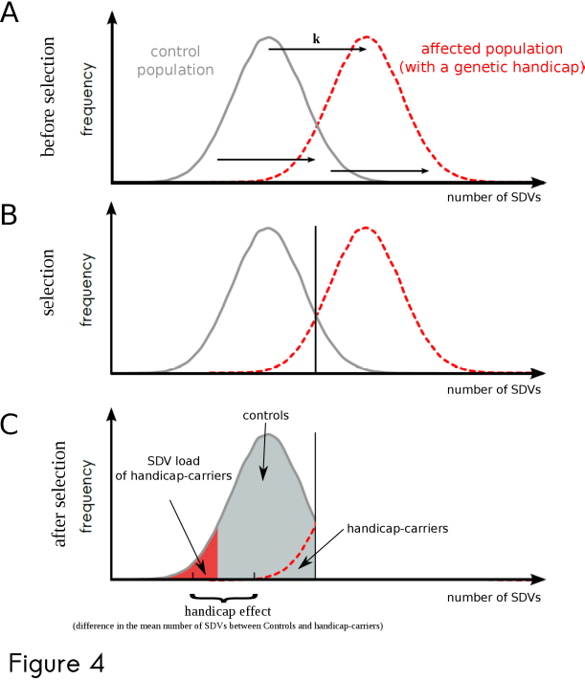figure 4. The genetic handicap principle.
4A. Occurrence of a genetic handicap. The distribution of the number of SDVs in control (gray) and affected (red) populations. The genetic handicap mutation (black arrows) is an equivalent of k SDVs.
4B. Truncation selection. Truncation selection eliminates all organisms with the number of SDVs higher than a given threshold (vertical black line) from both control and affected populations.
4C. Distribution of SDVs after selection. Handicap-carriers have decreased number of SDVs (SDVs do not include the genetic handicap per se) than controls (the difference is a handicap effect).
∆n = -(α + β∙n)∙V / (1+β∙V) (equation i)
where α is the selection coefficient of deleterious mutations; β measures the strength of epistasis between deleterious mutations, n and V are the mean and variance of the number of SDVs before selection, respectively (Charlesworth 1990; Appendix 1)⁠.
Assuming that the genetic handicap has an effect equivalent to that of k SDVs (handicap severity = k), the mean number of SDVs in a population is increased, but variance is unaffected. Thus, the change in the number of SDVs per individuals carrying a handicap follows as:
∆n_{k} = -(α + β∙(n+k))∙V / (1+β∙V) (equation ii)
Hereafter, to approximate the handicap effect (H) as a difference in the efficiency of purifying selection with and without handicap, we subtract ∆n_{k} from ∆n:
H = ∆n - ∆n_{k} = V∙β∙k / (1+β∙V) (equation iii)
We see from equation (iii) that if there is no variance in the number of SDVs before selection (V=0), or if there is no epistasis between SDVs (β = 0), the genetic handicap is absent (H = 0). However, when both the variance and the epistatic coefficient are higher than zero, the handicap effect increases linearly with handicap severity, k. Interestingly, when β approaches 1, indicating very strong positive epistasis, and variance increases infinitely, the handicap effect approaches the handicap severity:
lim [V∙β∙k / (1+β∙V)] = k; if V→ +∞ and β → 1 (equation iv)
The interpretation of this result is that, under truncating selection and very high intra-population variation, individuals with handicap can survive only if they initially had n-k mutations, i.e. located in the left tail of the distribution (see Fig 4).
To derive a biologically meaningful range of handicap effects applicable to the human genome conditions, we produced two heatmaps. First (see Fig 5A), assuming that the average human genome harbors 1000 SDVs and the distribution is close to Poisson distribution, we fixed the variance as 1000, fluctuated β from 0 to 0.1 (Charlesworth 1990)⁠, and applied a handicap severity value between 0 to 200, where 200 is the strongest difference in the SDVs between maximally and minimally loaded individuals from the population. This maximal handicap severity equals 200 assures us that there is a non-zero chance that an organism with a given handicap will be able to survive. We observed an increase in the handicap effect with both the handicap severity and the strength if epistasis. Second (see Fig 5B), we fixed β as 0.0008 (Charlesworth 1990)⁠ and fluctuated the variance from 0 to 10000 keeping the same range of handicap severity (0 to 200). In this scenario, the handicap effect increases with both the handicap severity and the variance of SDVs in a population.
Thus, the genetic handicap effect, under biologically meaningful parameters, might be as strong as 20% of the total mutation load (Fig 5A – the strongest handicap effect is close to 200 out of 1000). Considering that negative epistasis is a predominant mode of interaction between SDVs (Sarkisyan et al. 2016), we conclude that the genetic handicap principle is an universal concept applicable to humans and other species.
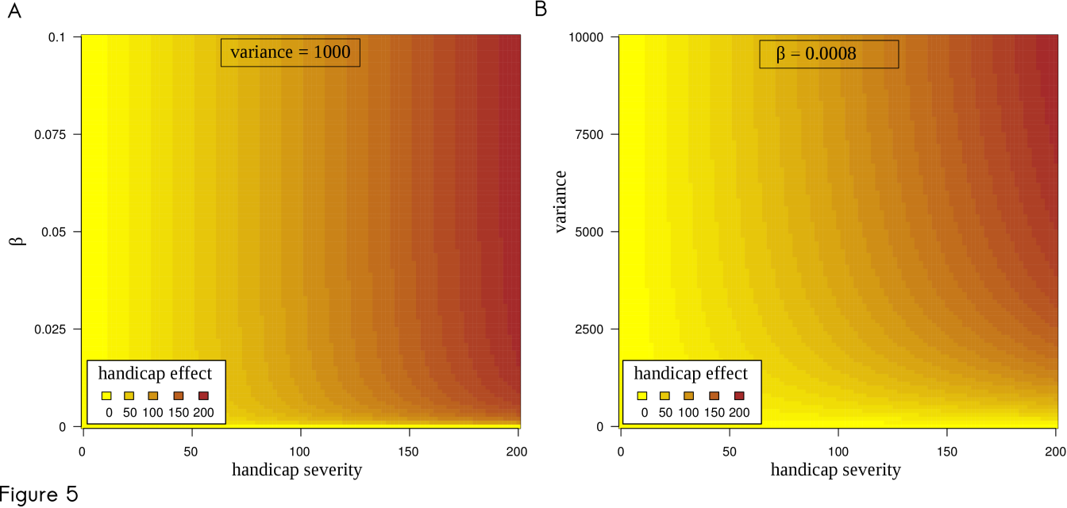Figure 5. Genetic handicap effect is a function of coefficient of epistasis (β), handicap severity (k) and variance of SDVs (V).
The genetic handicap effect represents an absolute difference in the expected numbers of SDVs in controls and handicap-carriers. This effect is color-coded from light-yellow (handicap effect = 0) to brown (handicap effect = 200). The handicap effect increases with the increase of three parameters: coefficient of epistasis (β), variance (V) and handicap severity (k).
5A. Handicap effect as a function of handicap severity (k is changing from 0 to 200) and coefficient of epistasis (β is changing from 0 to 0.1). Intra-population variance if the number of SDV is fixed as 1000 (V = 1000).
5B. Handicap effect as a function of handicap severity (k is changing from 0 to 200) and intra-population variance in the number of SDVs (V is changing from 0 to 10000). Coefficient of epistasis is fixed as 0.0008 (β = 0.0008).

DISCUSSION

Вникаю в твой pdf.
В случае "soft selection, no direct competition between cases and controls", насколько я понимаю, mean = 4/3 в обоих случаях, а не 1.5. Но это ничего не меняет.
Математически твой четвертый случай (soft selection, direct competition) эквивалентен эпистазу. Действительно, формально говоря, в этом случае
w1 = 1
w2 = 0.75
w21 = 0.5
w22 = 0.25
где w(x) - приспособленность генотипа с x мутациями. Из w1 и w2 имеем s=0.25. Тогда w(21)>>(1-s)^21, и w(22)>>(1-s)^22. Так что формально это вроде как то же самое, что эпистаз. Правда, в этом случае - не синергический, а антагонистический/diminishing returns (точнее - вообще какой-то s-образный).
Должен быть способ сделать мягкий отбор без эпистаза. Надо додумать.
Е.
Я сейчас говорил с Профессором, он про мягкий отбор говорит следующее. Мягкий отбор - это тот, который зависит от состояния популяции. Он легко может быть неэпистатическим (мультипликативным). Например, представим себе, что приспособленность падает от числа вредных мутаций экспоненциально (то есть эпистаза нет), но показатель при экспоненте зависит от плотности популяции: если высокая плотность - высокий, если низкая - низкий. Такой отбор мягкий, но не эпистатический.
Он говорит, что в это не врубаются Чарльзворт и Брюс Уолш - так что мы с тобой в хорошей компании.

In this paper, we propose that the negative fitness consequences of a severe mutation, which we call genetic handicap in Zahavi's sense, might be partially compensated by a reduced genome-wide load of either conditionally- and / or unconditionally-deleterious variants. If so, the presence of a severe mutation in a viable (fit) organism can be interpreted as a marker of an otherwise high genome quality, implying a reduced load of slightly-deleterious variants.
From a medical point of view, future investigations of the background load of SDVs in human genomes carrying a severe mutation might shed light on (i) the difference between miscarried and live-born individuals carrying the same genetic handicap as proposed in this study; (ii) the extensive clinical heterogeneity often observed among live-born individuals carrying identical severe mutations; (iii) the ratio of conditional (specific targets of embryonic selection) to unconditional (common targets of embryonic selection) variants.
From the evolutionary genetics point of view, one of the important applications of the genetic handicap approach is the possibility of establishing qualitative and quantitative links between the mutational load and fitness. Within a given population, individuals differ in their fitness, defined as their relative reproductive success (Haldane 1937)⁠. It has been proposed that the genetic component of this variation is predominantly due to slightly-deleterious mutations (Muller 1950)⁠, which, contrary to strongly deleterious and beneficial mutations, can segregate within a population for a long time and reach both relatively high frequencies in a population and high numbers in individual genomes (Crow 1958)⁠. The functional relationship between the SDV genetic load and fitness is of considerable importance for basic evolutionary and medical genetics aspects, such as the maintenance of intra-population variation in fitness (Haldane 1937)⁠, evolution of recombination and sexual selection (Agrawal 2001; Kondrashov 1988)⁠, fitness landscapes, speciation and species extinction (Meer et al. 2010; Ohta 1992; Popadin et al. 2007; Polishchuk et al. 2015)⁠, inbreeding depression (Charlesworth and Willis 2009)⁠, and the etiology of complex diseases (Cortopassi 2002)⁠.
Despite the fundamental relationship between SDVs and fitness, there is no solid empirical evidence regarding whether intra-population fitness variation is driven by variation in the SDV load. This is because both the SDV load is difficult to quantify and fitness is one of the most complex phenotypes to measure. Every apparently healthy human carries thousand(s) of deleterious variants in their genome; the unknown selection coefficients associated with SDVs and their epistatic interactions make it almost impossible to reconstruct fitness from genetic data. For example, it is unknown whether there is a difference in mutation load between human populations (see the controversy in the estimation of mutation load in African and non-African populations (Lohmueller et al. 2008; Fu et al. 2014; Simons et al. 2014; Do et al. 2015; Henn et al. 2016)⁠).
An important source of associations between SDVs and fitness in humans are genetic studies of complex diseases, where an increased burden of certain types of mutations in affected versus unaffected individuals has been demonstrated (Krumm et al. 2015; Cooper et al. 2011; Girirajan et al. 2011)⁠. Recently, the genome wide loads of Copy Number Variants (CNVs) (Männik et al. 2015)⁠ and Runs Of Homozygosity (ROHs) (Joshi et al. 2016)⁠ have been linked to fitness-related phenotypes (educational attainment) among healthy individuals. More direct effects of ongoing purifying selection in the healthy human population have been shown recently as a deficit of Loss of Function (LoF) variants transmitted from heterozygous parents to homozygous offspring (Sulem et al. 2015)⁠. Although these studies provide a first empirical correlation between the SDV load and fitness-related traits in human populations, they are still restricted to a few types of mutations/genes and would require large sample sizes to uncover the effects of moderately-deleterious variants.
In this paper we extensively use transcriptome data to approximate the fitness of individuals. We would like to emphasize the reliability of this approach considering transcriptome as an intermediate molecular phenotype between DNA and organism-level phenotype. From the DNA point of view, expression level is much more informative for us: expression level reflects an integral result of an interaction between numerous DNA coding, DNA regulatory and chromatin variants with different frequency, sign and magnitude of epistasis. As soon as we can’t yet reconstruct gene expression patterns accurately from genome information the transcriptome data (transcriptome deviations) provide us with much more precise approximation of the fitness as compared to the burden of slightly-deleterious variants. From the whole organism point of view, expression level is more sensitive because it can uncover minor differences invisible on the organism level: for example expression profiles allow to distinguish non-carriers, heterozygous carriers and patients, homozygous for autosomal recessive disorders (Smirnov and Cheung 2008; Cheung and Ewens 2006)⁠ while the first two groups are phenotypically indistinguishable on organism level.
The genetic handicap approach, described in this paper, can provide an a priori expectation of the difference in SDV loads between handicap-carriers and controls, which might be tested in empirical / experimental studies, and ultimately improve our understanding and functional annotation of the mutational load in humans and model organisms.
=> To mention mathematical paper of Kondrashov and empirical work of Sunyaev. What is the difference with my concept? One big mutation and the rest is SDMs.
=> The paper, which Sunyaev recommended to read (Interference among deleterious mutations favours sex and recombination in finite populations).
Additive / epistatic / multiplicative???
=> Возможно, мои симуляции не очень верны и при аддитивном отборе все таки ничего не работает. Я думаю что в моих симуляциях я ввожу эпистаз (порог), сравнивая приспособленность одного индивидуума со случайным числом (меньше или больше). Возвращаяюсь к моему предыдущему вопросу – чем отличается два генома если одни чистый и другой с вредной мутацией? Вредная мутация может просто ухудшать приспособленность или может быть скомпенсирована и говорить о качестве генома. Как отличить эти варианта? Мне кажется что при аддитивном взаимодействии вредная мутация всегда ухудшает присособленность и не служит ни фига маркером высокого качества если нет никакого порога выживаемости. Как только появляется порог выживаемости – гандикап начинает работать. Таким образом, возможно, правильно что гандикап работает только при эпистазе. Однако, прочитай внимательно Interference among….
Воможны все таки стохастические эффекты. По определению soft selection – когда приспособленность определяется по отношению к другим организмам в популяции. Поэтому если организм с гандикапом выжил – он будет более чистый чем другие. Ввожу ли я при этом эпистаз?
=> как отличать multiplicative and additive?
We acknowledge reviewer for raising this question. Despite the fact that we still consider that our model correctly describes human embryogenesis, we agree that mathematical model might be even more universal. Thus we decided to prepare extended mathematical paper where we plan to consider different types of selection (additive/epistatic), variation in selection coefficients, distribution of SDVs in a population, interaction between handicap and SDVs, fraction of conditionally/unconditionally deleterious variants etc. Correspondingly, in the current version of the manuscript we removed mathematical part completely and present only the scheme and verbal arguments.
First we explain why negative epistasis is essential for human embryogenesis (no direct competition between cases and controls) and later we extend this model and note that in other cases (if there is direct competition between controls and cases) genetic handicap might work even if SDVs interact additively.

=> Why negative epistasis is essential in human embryogenesis (no direct competition between cases and controls):

Here we would like to emphasize that under conditions of absence of direct competition between embryos (which most likely is a case in human embryogenesis) negative epistasis is essential.

Below we paste our modified text (which is currently removed from the main manuscript), related to the model and afterwards we answer reviewers’ questions.

“To quantitatively describe the effect of the genetic handicap on the number of SDVs per individual, we use a classic model of selection against deleterious mutations (Charlesworth 1990)⁠. Assuming that all mutations have the same selective disadvantage, the difference in the mean number of SDVs before and after selection is given by:
∆n = -(α + β∙n)∙V / (1+β∙V) (equation i)
where α is the selection coefficient of deleterious mutations; β measures the strength of epistasis between deleterious mutations, n and V are the mean and variance of the number of SDVs before selection, respectively (Charlesworth 1990; Appendix 1)⁠.
Assuming that the genetic handicap has an effect equivalent to that of k SDVs (handicap severity = k), the mean number of SDVs in a population is increased, but variance is unaffected. Thus, the change in the number of SDVs per individuals carrying a handicap follows as:
∆n_{k} = -(α + β∙(n+k))∙V / (1+β∙V) (equation ii)
Hereafter, to approximate the handicap effect (H) as a difference in the efficiency of purifying selection with and without handicap, we subtract ∆n_{k} from ∆n:
H = ∆n - ∆n_{k} = V∙β∙k / (1+β∙V) (equation iii)
We see from equation (iii) that if there is no variance in the number of SDVs before selection (V=0), or if there is no epistasis between SDVs (β = 0), the genetic handicap is absent (H = 0). However, when both the variance and the epistatic coefficient are higher than zero, the handicap effect increases linearly with handicap severity, k. Interestingly, when β approaches 1, indicating very strong positive epistasis, and variance increases infinitely, the handicap effect approaches the handicap severity:
lim [V∙β∙k / (1+β∙V)] = k; if V→ +∞ and β → 1 (equation iv)
The interpretation of this result is that, under truncating selection and very high intra-population variation, individuals with handicap can survive only if they initially had n-k mutations, i.e. located in the left tail of the distribution (see Fig 4).
To derive a biologically meaningful range of handicap effects applicable to the human genome conditions, we produced two heatmaps. First (see Fig 5A), assuming that the average human genome harbors 1000 SDVs and the distribution is close to Poisson distribution (Mashaal et al. 2016; Kondrashov 1995)⁠, we fixed the variance as 1000, fluctuated β from 0 to 0.1 (Charlesworth 1990)⁠, and applied a handicap severity value between 0 to 200, where 200 is the strongest difference in the SDVs between maximally and minimally loaded individuals from the population. This maximal handicap severity equals 200 assures us that there is a non-zero chance that an organism with a given handicap will be able to survive. We observed an increase in the handicap effect with both the handicap severity and the strength of epistasis. While it is intuitively expected that handicap severity is associated with the handicap effect, the strength of the negative epistasis is less obvious. To illustrate the importance of the negative epistasis we compared additive and negatively epistatic selection using simple example and revealed that only in epistatic scenario selection more effectively eliminates highly loaded genomes, thus significantly decreasing the mean number of SDVs among survivors (see figure S1).
Second (see Fig 5B), we fixed β as 0.0008 (Charlesworth 1990)⁠ and fluctuated the variance from 0 to 10000 keeping the same range of handicap severity (0 to 200). In this scenario, the handicap effect increases with both the handicap severity and the variance of SDVs in a population.
Thus, the genetic handicap effect, under biologically meaningful parameters, might be as strong as 20% of the total mutation load (Fig 5A – the strongest handicap effect is close to 200 out of 1000). Considering that negative epistasis is a predominant mode of interaction between SDVs (Sarkisyan et al. 2016; Mashaal et al. 2016), especially in case of organisms with complex genome (Sanjuán and Elena 2006)⁠ we conclude that the genetic handicap principle is an universal concept applicable to humans and model species with complex genomes.

Figure 5. Genetic handicap effect is a function of coefficient of epistasis (β), handicap severity (k) and variance of SDVs (V).
The genetic handicap effect represents an absolute difference in the expected numbers of SDVs in controls and handicap-carriers. This effect is color-coded from light-yellow (handicap effect = 0) to brown (handicap effect = 200). The handicap effect increases with the increase of three parameters: coefficient of epistasis (β), variance (V) and handicap severity (k).
5A. Handicap effect as a function of handicap severity (k is changing from 0 to 200) and coefficient of epistasis (β is changing from 0 to 0.1). Intra-population variance if the number of SDV is fixed as 1000 (V = 1000).
5B. Handicap effect as a function of handicap severity (k is changing from 0 to 200) and intra-population variance in the number of SDVs (V is changing from 0 to 10000). Coefficient of epistasis is fixed as 0.0008 (β = 0.0008).

Supplementary Figure 1. Negatively epistatic but not additive selection truncates the right part of the distribution of handicap-carriers.
Let's consider a population of 10000 individuals, with half of them having one deleterious variant and half of them having two deleterious variants. Each deleterious variant has a selection coefficient (s) equals 0.05, meaning that viability decreases by 5%. Let's assume that the genetic handicap (GH) is equivalent to 20 deleterious variants. We compare two types of selection: additive (independent interaction of deleterious variants) and negatively epistatic (joined effect of two variants is more severe as compared to the sum of individual effects). We can see, that despite the fact that there are less survived handicap carriers than controls (see scales of the Y axis), additive selection leads to identical shapes of the distribution of both controls and handicap carries while negatively epistatic selection eliminates higher fraction of more loaded individuals (right bin), leading to the decreased mean number of SDVs in handicap carriers versus controls. The difference between means is a handicap effect which is 0.0824 (1.4868 – 1.4044) in case of negative epistasis and 0 (1.4872 - 1.4872) in an additive scenario.
We note additionally, that negative epistasis might be induced by the presence of a severe mutation, and thus epistasis is not necessary to exist between slightly-deleterious mutations in the absence of the genetic handicap.
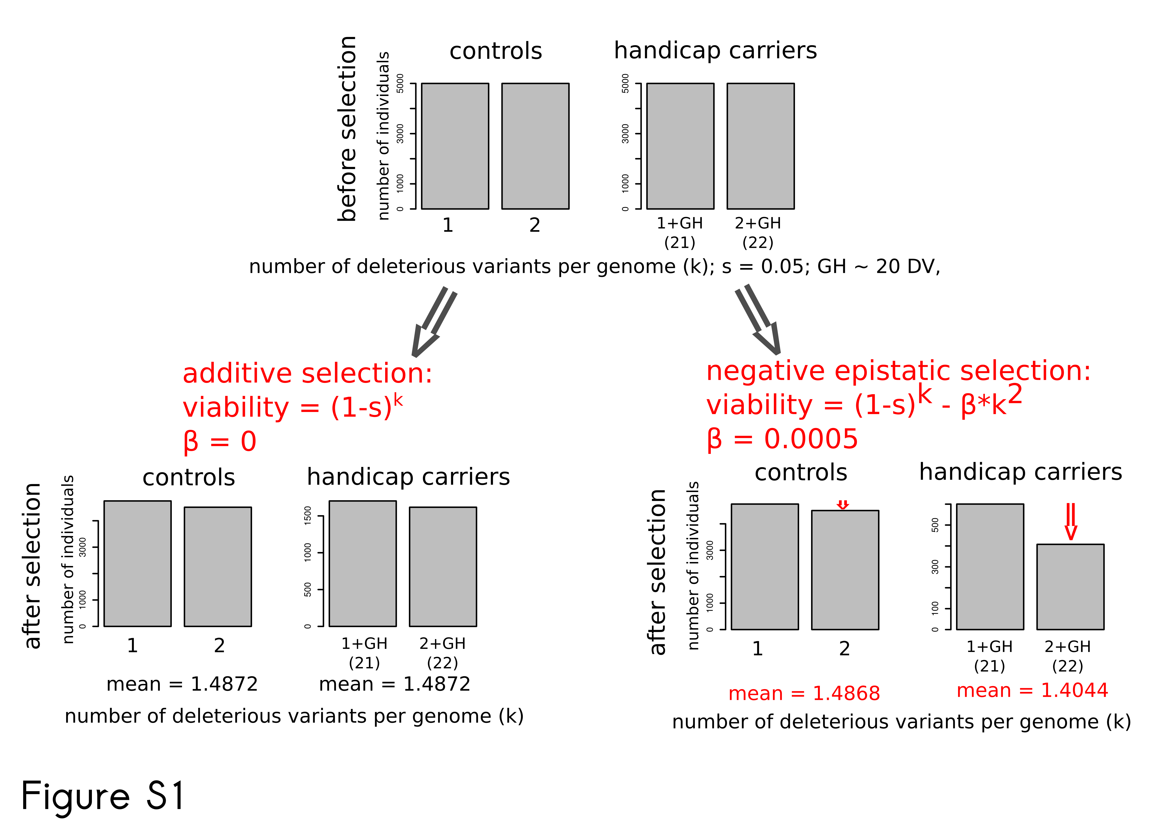
“

First, we used an equation from Appendix 1 which describes effect of selection on mutation load. This equation is universal and doesn't depend on recombination rate, which was indeed the main topic of the paper.
Second, using an example, described in Figure S1 (see above; there is no this supplement as well as math model in the current manuscript) we would like to convince the reviewer that the negative epistasis between deleterious variants is necessary for our model.

=> Negative epistasis is non essential if we consider direct competition between cases and controls:

If we assume that cases and controls can compete together (while no direct competition between cases and controls was assumed in our original model above) even additive model works out (according to our recent computer simulations). Thus under direct competition handicap effect is higher than zero even in pure additive model. Interestingly if we introduce negative epistasis into this “competitive” model, handicap effect is increasing significantly, meaning that negative epistasis, although mathematically not necessary anymore, might be still biologically important.

Hard selection: fitness is a function of SDVs only. Might be epistatic or additive.
Soft selection: fitness is relative and depends on a location of a given individual within a population (its percentile). How to discriminate epistatic and additive cases? First calculate fitness, second rank individuals according to fitness?

Examples:
1) Trisomy
2) Hsp90: drosophila, human
3) experiments with model organisms
In order to empirically investigate the interaction between severely-deleterious mutations and mutation load, I have planned a large-scale evolutionary genetic experiment with yeast. As a model organism, yeast provides a number of advantages for our study, specifically the ease of genetic manipulations, small genome size, short generation time and the possibility of estimating fitness easily even for each independent genome under different conditions^{144–148}⁠.
I plan to (i) establish genetically heterogeneous population of haploid yeasts, (ii) introduce handicap, (iii) estimate the fitness (viability) of each line with and without handicap and (iv) sequence the genome of each line. On the scheme (fig. 7) I present all five potential scenarios of the expected results among which three left possibilities (columns A, B & C) are in line with the genetic handicap hypothesis (although with different effect) and two right columns (columns D, E) reject it.
(i) To establish genetically heterogeneous population we are going to use several rounds of treatment by ethyl methanesulfate (EMS)¹⁴⁹⁠. It will give us an a-priory expectation of fitness and mutation load of each line: ancestral lines are expected to be more fit and have lower mutational load than derived lines. (ii) We plan to use one main genetic handicap (elimination of the mitochondrial genome by introduction to ancestral population of a tetracycline-sensitive promoter of the POLG gene, coding for mitochondrial DNA polymerase), and two additional chemical handicaps (geldanamycin - an inhibitor of HSP90, known to effectively uncover hidden SD genetic variation in several model species^{150–152}⁠, and cycloheximide - an inhibitor of protein biosynthesis). Our primary interest is focused on the elimination of mtDNA since it greatly affects the energy metabolism of the cell¹⁵³⁠ and thus can be compensated predominantly by the genome-wide decreased load of SD mutations. Combining handicaps with each other and with different laboratory conditions (temperature, salinity and ethanol) we can modify their severity. (iii) Fitness of each line (with and without handicap in different conditions) will be estimated in pair-wise competitive assays with standard ancestral line in liquid medium and lineage tracking every 4 hours during 24 hours. (iv) Small genome size of haploid yeast (12Mb) allows us to sequence whole genomes of up to 1100 yeast lines with average coverage 20x using 11 Illumina lines (paired-end). Using new protocol for multiplexed library preparation¹⁵⁴⁠ we will be able to perform fast and inexpensive sequencing. From these sequences we will derive mutation load. Since the majority of mutations are expected to be neutral or deleterious as the first approximation of mutation load we can just count the number of new mutations versus ancestral line. To reconstruct mutation load of each line more accurately we will use information on location and properties of each mutation as well as the affected gene, categorize mutations into classes with different deleterious effects and sum up mutations from each class (for the review of the available methods see section 2.1.1).
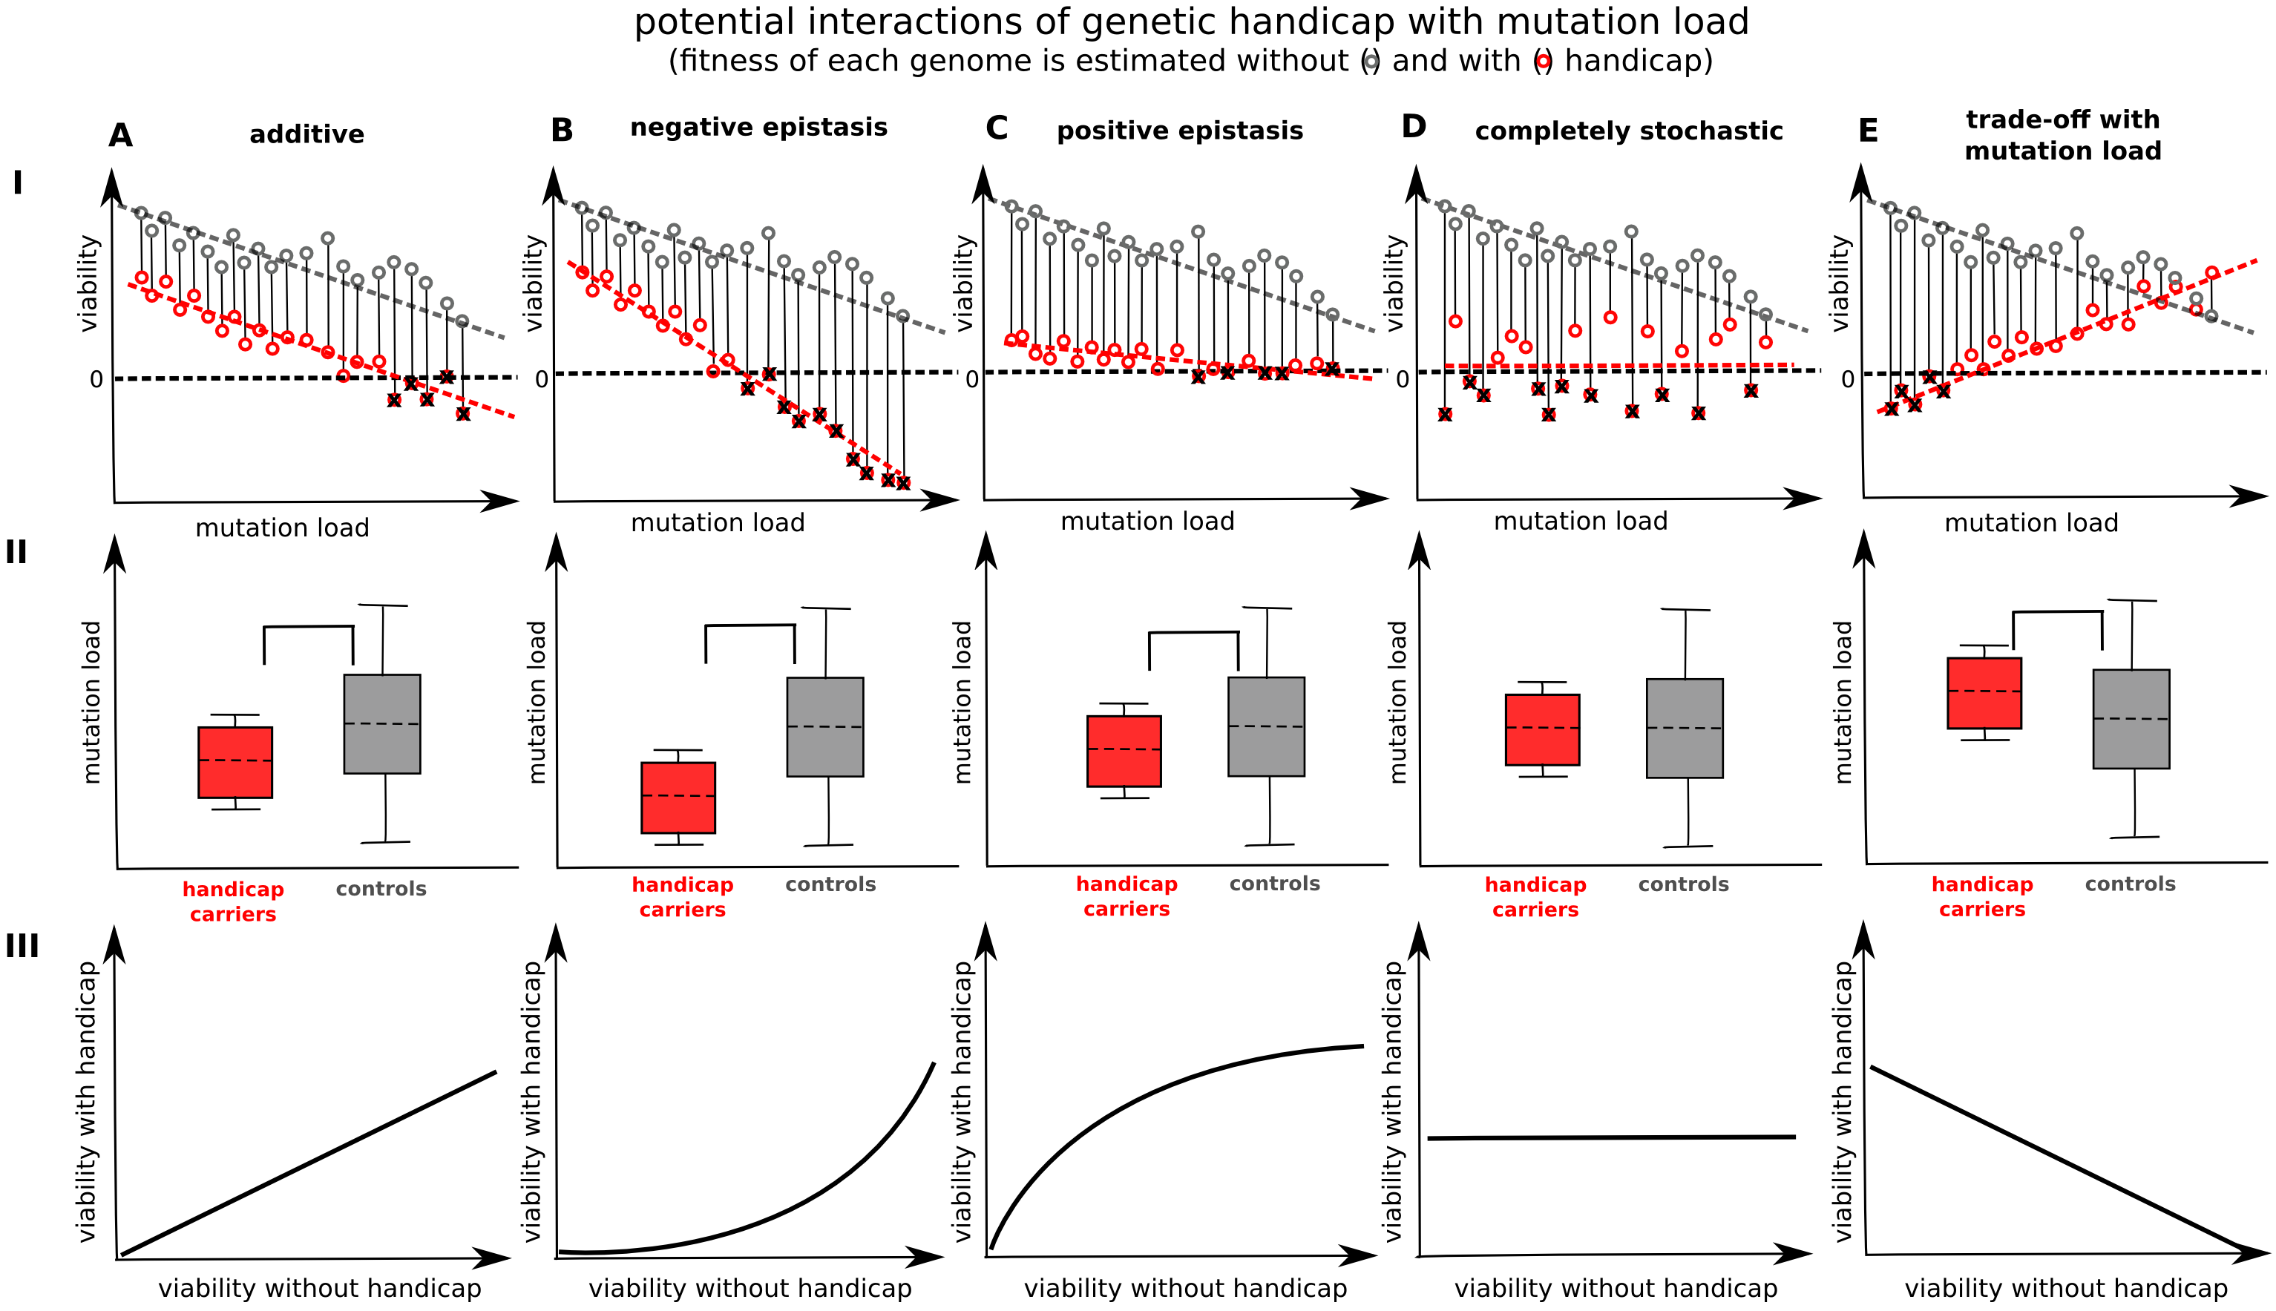Figure 7. Potential outcomes of the experiment.
Row I. Fitness (viability) of each line will be estimated without and with handicap that is marked by connected gray and red circles. Mutation load of each line can be either approximated a priori as the duration of EMS treatments or a posteriori as the number of SD mutations accumulated in the genome of this line determined after sequencing.
Row II. Handicap-carriers are survivors with handicap (red dots located above the zero dotted line). In all scenarios, compatible with the genetic handicap principle (columns A, B C) mutation load of handicap carriers is lower than in the controls. The difference is getting more pronounced from the scenario with positive epistasis (column C), through the scenario with no epistasis (column A) till the scenario with negative epistasis (column B). In case of random effect of handicap on viability (column D) there is no difference in mutation loads of handicap-carriers and controls. In case of scenario E handicap carriers possess higher mutation load than controls. This scenario, although counterintuitive, presents a trade-off between growth rate and cellular robustness to short-term stresses (for example 10 minutes of heat, oxidative or acid stresses) where slow dividing cells survive better¹⁵⁵⁠. Slower growth is also a common signature of genetic perturbations such as deletions¹⁴⁷⁠. Although the growth rate is an important parameter to take into account in our experiment, I don't expect an existence of the negative correlation between the genome-wide load of SD mutations and tolerability to handicap
Row III. Fitness of lines with handicap as a function of the fitness of the same lines without handicap.
Duration of EMS treatment should affect relative fitness as well as mutation load of lines and thus will be used as a quality control in the experiment: (i) fitness of derived lines is expected to be lower than fitness of ancestral (or less treated by EMS) lines; (ii) mutation load (total number of accumulated mutations, number of accumulated deleterious mutations etc) of derived lines is expected to be higher than it is in ancestral lines.
In order to learn the relevant techniques, fine-tune the details of the experiment (concentration of chemical handicaps, fitness assays under different conditions, number of analyzed lines in the experiment... etc) and run a pilot test we plan to visit collaborative yeasts laboratory of Prof. Sergey Kryazhimskiy, University of California, San Diego. Afterwards, the main experiment will be performed in Switzerland in the laboratory of Prof. Claudio De Virgilio, University of Fribourg, in tight collaboration with Dr. Dmitry Knorre from the team of Prof. Vladimir Skulachev, Lomonosov Moscow State University (all three letters of collaboration are attached).

REFERENCES
Adamo A, Atashpaz S, Germain P-L, Zanella M, D’Agostino G, Albertin V, Chenoweth J, Micale L, Fusco C, Unger C, et al. 2015. 7q11.23 dosage-dependent dysregulation in human pluripotent stem cells affects transcriptional programs in disease-relevant lineages. Nat Genet 47: 132–41. http://www.ncbi.nlm.nih.gov/pubmed/25501393 (Accessed December 4, 2015).
Agrawal AF. 2001. Sexual selection and the maintenance of sexual reproduction. Nature 411: 692–5. http://dx.doi.org/10.1038/35079590 (Accessed September 2, 2013).
Bahar R, Hartmann CH, Rodriguez KA, Denny AD, Busuttil RA, Dollé MET, Calder RB, Chisholm GB, Pollock BH, Klein CA, et al. 2006. Increased cell-to-cell variation in gene expression in ageing mouse heart. Nature 441: 1011–4. http://dx.doi.org/10.1038/nature04844 (Accessed April 11, 2015).
Carmona-Mora P, Walz K. 2010. Retinoic Acid Induced 1, RAI1: A Dosage Sensitive Gene Related to Neurobehavioral Alterations Including Autistic Behavior. Curr Genomics 11: 607–17. http://www.pubmedcentral.nih.gov/articlerender.fcgi?artid=3078685&tool=pmcentrez&rendertype=abstract (Accessed December 4, 2015).
Charlesworth B. 1990. Mutation-selection balance and the evolutionary advantage of sex and recombination. Genet Res 55: 199–221. http://www.ncbi.nlm.nih.gov/pubmed/2394378 (Accessed May 12, 2015).
Charlesworth D, Willis JH. 2009. The genetics of inbreeding depression. Nat Rev Genet 10: 783–96. http://dx.doi.org/10.1038/nrg2664 (Accessed July 15, 2014).
Chen R, Shi L, Hakenberg J, Naughton B, Sklar P, Zhang J, Zhou H, Tian L, Prakash O, Lemire M, et al. 2016. Analysis of 589,306 genomes identifies individuals resilient to severe Mendelian childhood diseases. Nat Biotechnol advance on. http://dx.doi.org/10.1038/nbt.3514 (Accessed April 11, 2016).
Cheung VG, Ewens WJ. 2006. Heterozygous carriers of Nijmegen Breakage Syndrome have a distinct gene expression phenotype. Genome Res 16: 973–9. http://www.ncbi.nlm.nih.gov/pubmed/16809669 (Accessed October 18, 2016).
Cooper GM, Coe BP, Girirajan S, Rosenfeld JA, Vu TH, Baker C, Williams C, Stalker H, Hamid R, Hannig V, et al. 2011. A copy number variation morbidity map of developmental delay. Nat Genet 43: 838–46. http://www.pubmedcentral.nih.gov/articlerender.fcgi?artid=3171215&tool=pmcentrez&rendertype=abstract (Accessed May 4, 2015).
Cortopassi GA. 2002. A neutral theory predicts multigenic aging and increased concentrations of deleterious mutations on the mitochondrial and Y chromosomes. Free Radic Biol Med 33: 605–10. http://www.ncbi.nlm.nih.gov/pubmed/12208346 (Accessed February 15, 2013).
Crow JF. 1958. Some possibilities for measuring selection intensities in man. Hum Biol 30: 1–13.
Do R, Balick D, Li H, Adzhubei I, Sunyaev S, Reich D. 2015. No evidence that selection has been less effective at removing deleterious mutations in Europeans than in Africans. Nat Genet 47: 126–131. http://dx.doi.org/10.1038/ng.3186 (Accessed January 14, 2015).
FALCONER DS. 1965. The inheritance of liability to certain diseases, estimated from the incidence among relatives. Ann Hum Genet 29: 51–76. http://doi.wiley.com/10.1111/j.1469-1809.1965.tb00500.x (Accessed November 1, 2016).
Forbes LS. 1997. The evolutionary biology of spontaneous abortion in humans. Trends Ecol Evol 12: 446–450. http://www.sciencedirect.com/science/article/pii/S0169534797011798 (Accessed April 14, 2015).
Fu W, Gittelman RM, Bamshad MJ, Akey JM. 2014. Characteristics of neutral and deleterious protein-coding variation among individuals and populations. Am J Hum Genet 95: 421–36. http://www.ncbi.nlm.nih.gov/pubmed/25279984 (Accessed February 9, 2016).
Girirajan S, Brkanac Z, Coe BP, Baker C, Vives L, Vu TH, Shafer N, Bernier R, Ferrero GB, Silengo M, et al. 2011. Relative burden of large CNVs on a range of neurodevelopmental phenotypes. PLoS Genet 7: e1002334. http://www.pubmedcentral.nih.gov/articlerender.fcgi?artid=3213131&tool=pmcentrez&rendertype=abstract (Accessed August 29, 2015).
Gulko B, Hubisz MJ, Gronau I, Siepel A. 2015. A method for calculating probabilities of fitness consequences for point mutations across the human genome. Nat Genet 47: 276–283. http://dx.doi.org/10.1038/ng.3196 (Accessed January 20, 2015).
Haldane JBS. 1937. The effect of variation on fitness. Am Nat 71: 337–386.
Henn BM, Botigué LR, Peischl S, Dupanloup I, Lipatov M, Maples BK, Martin AR, Musharoff S, Cann H, Snyder MP, et al. 2016. Distance from sub-Saharan Africa predicts mutational load in diverse human genomes. Proc Natl Acad Sci 113: 201510805. http://www.pnas.org/content/113/4/E440.abstract (Accessed December 30, 2015).
Jacquemont S, Reymond A, Zufferey F, Harewood L, Walters RG, Kutalik Z, Martinet D, Shen Y, Valsesia A, Beckmann ND, et al. 2011. Mirror extreme BMI phenotypes associated with gene dosage at the chromosome 16p11.2 locus. Nature 478: 97–102. http://dx.doi.org/10.1038/nature10406 (Accessed August 27, 2015).
Joshi PK, Esko T, Mattsson H, Eklund N, Gandin I, Nutile T, Jackson AU, Schurmann C, Smith A V., Zhang W, et al. 2016. Directional dominance on stature and cognition in diverse human populations. Nature 523: 459–62. http://www.ncbi.nlm.nih.gov/pubmed/26131930 (Accessed July 1, 2015).
Kaiser VB, Svinti V, Prendergast JG, Chau Y-Y, Campbell A, Patarcic I, Barroso I, Joshi PK, Hastie ND, Miljkovic A, et al. 2015. Homozygous loss-of-function variants in European cosmopolitan and isolate populations. Hum Mol Genet 24: 5464–74. http://www.pubmedcentral.nih.gov/articlerender.fcgi?artid=4572071&tool=pmcentrez&rendertype=abstract (Accessed July 21, 2015).
Kondrashov AS. 1988. Deleterious mutations and the evolution of sexual reproduction. Nature 336: 435–40. http://dx.doi.org/10.1038/336435a0 (Accessed July 14, 2011).
Krumm N, Turner TN, Baker C, Vives L, Mohajeri K, Witherspoon K, Raja A, Coe BP, Stessman HA, He Z-X, et al. 2015. Excess of rare, inherited truncating mutations in autism. Nat Genet 47: 582–8. http://www.ncbi.nlm.nih.gov/pubmed/25961944 (Accessed May 12, 2015).
Larsen EC, Christiansen OB, Kolte AM, Macklon N. 2013. New insights into mechanisms behind miscarriage. BMC Med 11: 154. http://www.biomedcentral.com/1741-7015/11/154 (Accessed March 21, 2015).
Lohmueller KE, Indap AR, Schmidt S, Boyko AR, Hernandez RD, Hubisz MJ, Sninsky JJ, White TJ, Sunyaev SR, Nielsen R, et al. 2008. Proportionally more deleterious genetic variation in European than in African populations. Nature 451: 994–7. http://dx.doi.org/10.1038/nature06611 (Accessed January 31, 2013).
Männik K, Mägi R, Macé A, Cole B, Guyatt AL, Shihab HA, Maillard AM, Alavere H, Kolk A, Reigo A, et al. 2015. Copy number variations and cognitive phenotypes in unselected populations. JAMA 313: 2044–54. http://jama.jamanetwork.com/article.aspx?articleid=2297168 (Accessed September 22, 2015).
McCoy RC, Demko Z, Ryan A, Banjevic M, Hill M, Sigurjonsson S, Rabinowitz M, Fraser HB, Petrov DA. 2015. Common variants spanning PLK4 are associated with mitotic-origin aneuploidy in human embryos. Science (80- ) 348: 235–238. http://www.sciencemag.org/content/348/6231/235.abstract (Accessed September 7, 2015).
Meer M V, Kondrashov AS, Artzy-Randrup Y, Kondrashov FA. 2010. Compensatory evolution in mitochondrial tRNAs navigates valleys of low fitness. Nature 464: 279–82. http://dx.doi.org/10.1038/nature08691 (Accessed July 13, 2015).
Muller HJ. 1950. Our load of mutations. Am J Hum Genet 2: 111–76. http://www.pubmedcentral.nih.gov/articlerender.fcgi?artid=1716299&tool=pmcentrez&rendertype=abstract (Accessed February 21, 2012).
Narasimhan VM, Hunt KA, Mason D, Baker CL, Karczewski KJ, Barnes MR, Barnett AH, Bates C, Bellary S, Bockett NA, et al. 2016. Health and population effects of rare gene knockouts in adult humans with related parents. Science (80- ). http://www.ncbi.nlm.nih.gov/pubmed/26940866 (Accessed March 4, 2016).
Nussbaum RL, McInnes RR, Willard HF. 2004. Thompson & Thompson Genetics in Medicine, Revised Reprint, 6th Edition. Saunders http://www.amazon.com/Thompson-Genetics-Medicine-Revised-Reprint/dp/0721602444 (Accessed February 15, 2013).
Ohta T. 1992. The Nearly Neutral Theory of Molecular Evolution. Annu Rev Ecol Syst 23: 263–286. http://www.annualreviews.org/doi/abs/10.1146/annurev.es.23.110192.001403 (Accessed February 17, 2014).
Polishchuk L V., Popadin KY, Baranova MA, Kondrashov AS. 2015. A genetic component of extinction risk in mammals. Oikos n/a–n/a. http://doi.wiley.com/10.1111/oik.01734 (Accessed April 23, 2015).
Popadin, Gutierrez-Arcelus M, Lappalainen T, Buil A, Steinberg J, Nikolaev SI, Lukowski SW, Bazykin GA, Seplyarskiy VB, Ioannidis P, et al. 2014. Gene age predicts the strength of purifying selection acting on gene expression variation in humans. Am J Hum Genet 95: 660–74. http://www.ncbi.nlm.nih.gov/pubmed/25480033 (Accessed April 22, 2015).
Popadin K, Gutierrez-Arcelus M, Dermitzakis ET, Antonarakis SE. 2013. Genetic and Epigenetic Regulation of Human lincRNA Gene Expression. Am J Hum Genet 93: 1015–26. http://www.ncbi.nlm.nih.gov/pubmed/24268656 (Accessed January 23, 2014).
Popadin K, Polishchuk L V, Mamirova L, Knorre D, Gunbin K. 2007. Accumulation of slightly deleterious mutations in mitochondrial protein-coding genes of large versus small mammals. Proc Natl Acad Sci U S A 104: 13390–5. http://www.pnas.org/content/104/33/13390.full (Accessed March 4, 2014).
Sarkisyan KS, Bolotin DA, Meer M V., Usmanova DR, Mishin AS, Sharonov G V., Ivankov DN, Bozhanova NG, Baranov MS, Soylemez O, et al. 2016. Local fitness landscape of the green fluorescent protein. Nature 533: 397–401. http://www.nature.com/nature/journal/v533/n7603/pdf/nature17995.pdf (Accessed May 11, 2016).
Simons YB, Turchin MC, Pritchard JK, Sella G. 2014. The deleterious mutation load is insensitive to recent population history. Nat Genet 46: 220–4. http://dx.doi.org/10.1038/ng.2896 (Accessed December 10, 2015).
Smirnov DA, Cheung VG. 2008. ATM gene mutations result in both recessive and dominant expression phenotypes of genes and microRNAs. Am J Hum Genet 83: 243–53. http://www.ncbi.nlm.nih.gov/pubmed/18674748 (Accessed October 18, 2016).
Sudmant PH, Mallick S, Nelson BJ, Hormozdiari F, Krumm N, Huddleston J, Coe BP, Baker C, Nordenfelt S, Bamshad M, et al. 2015. Global diversity, population stratification, and selection of human copy number variation. Science (80- ). http://www.ncbi.nlm.nih.gov/pubmed/26249230 (Accessed August 7, 2015).
Sulem P, Helgason H, Oddson A, Stefansson H, Gudjonsson SA, Zink F, Hjartarson E, Sigurdsson GT, Jonasdottir A, Jonasdottir A, et al. 2015. Identification of a large set of rare complete human knockouts. Nat Genet 47: 448–452. http://dx.doi.org/10.1038/ng.3243 (Accessed March 25, 2015).
Végh MJ, Rausell A, Loos M, Heldring CM, Jurkowski W, van Nierop P, Paliukhovich I, Li KW, del Sol A, Smit AB, et al. 2014. Hippocampal extracellular matrix levels and stochasticity in synaptic protein expression increase with age and are associated with age-dependent cognitive decline. Mol Cell Proteomics 13: 2975–85. http://www.ncbi.nlm.nih.gov/pubmed/25044018 (Accessed May 27, 2015).
Vu V, Verster AJ, Schertzberg M, Chuluunbaatar T, Spensley M, Pajkic D, Hart GT, Moffat J, Fraser AG. 2015. Natural Variation in Gene Expression Modulates the Severity of Mutant Phenotypes. Cell 162: 391–402. http://www.cell.com/article/S009286741500762X/fulltext (Accessed July 16, 2015).
Wang Z, Zhang J. 2011. Impact of gene expression noise on organismal fitness and the efficacy of natural selection. Proc Natl Acad Sci U S A 108: E67–76. http://www.pnas.org/content/early/2011/03/29/1100059108 (Accessed February 15, 2013).
Xue Y, Chen Y, Ayub Q, Huang N, Ball E V, Mort M, Phillips AD, Shaw K, Stenson PD, Cooper DN, et al. 2012. Deleterious- and disease-allele prevalence in healthy individuals: insights from current predictions, mutation databases, and population-scale resequencing. Am J Hum Genet 91: 1022–32. http://www.cell.com/AJHG/fulltext/S0002-9297(12)00538-1 (Accessed January 29, 2013).
Zahavi A. 1975. Mate selection—A selection for a handicap. J Theor Biol 53: 205–214. http://dx.doi.org/10.1016/0022-5193(75)90111-3 (Accessed February 1, 2013).

