CHAPTER 1: INTRODUCTION
1.1 Project Background & Industry Context
The global automotive mobility and car rental industry has witnessed exponential technological transformation over the past decade. Traditionally dominated by brick-and-mortar storefronts, physical paper rental agreements, and manual reservation logbooks, the market is rapidly pivoting toward on-demand digital fleet platforms. Consumers today expect instant online reservations, transparent real-time vehicle availability, multi-tier duration discounts, and seamless digital payment execution directly from their web and mobile browsers.
In urban centers and corporate executive sectors, there is a burgeoning demand for specialized luxury car rentals, zero-emission electric supercars (such as Porsche Taycan and Tesla Model S), and certified chauffeur-driven VIP services. However, independent fleet operators and boutique rental agencies frequently struggle to compete due to outdated software infrastructure. "AutoDrive" was conceived to bridge this technological divide by providing a robust, high-performance, and visually captivating Automotive Fleet SaaS Web Application that automates the complete rental lifecycle from vehicle discovery to verified return.
1.2 Problem Statement
A comprehensive analysis of prevailing automotive rental management systems reveals critical operational flaws that negatively impact business revenue and customer satisfaction:
- Double-Booking Catastrophes: Many smaller rental systems rely on loose availability flags or manual checks. If two customers attempt to rent the same vehicle for overlapping time slots, systems fail to detect concurrency collisions, leading to unfulfilled bookings, severe brand erosion, and customer disputes.
- Chauffeur Allocation Conflicts: Existing platforms decouple vehicle booking from driver dispatch. When a customer requests a chauffeur-driven rental, drivers are often assigned manually via phone calls, resulting in driver double-booking during peak holiday seasons.
- Opaque & Inflexible Pricing: Rental pricing is often static or calculated manually. Customers lack clear visibility into duration-based tiered savings (such as automated discounts for week-long rentals) and extra add-on charges (such as commercial chauffeur fees or comprehensive insurance).
- Payment Gateway Simulation Bottlenecks: Integrating production payment gateways (such as Razorpay, Stripe, or PayPal) requires strict business KYC verification, GST registration, and bank approvals. In testing and academic environments, public test keys frequently disable payment methods on live servers, displaying 'No appropriate payment method found' errors and crippling developer testability.
- Dated User Interfaces: Most enterprise car rental interfaces resemble cluttered database entry portals. They lack modern design aesthetics, mobile responsiveness, intuitive comparison matrices, and clear contrast.
1.3 Objectives of the Project
The primary objective of AutoDrive is to develop an enterprise-grade, conflict-free Car Rental System that solves these problems through modern web engineering. Specifically, the project achieves:
- Mathematical Slot Collision Prevention: Implement an automated Date Range Overlap Collision Detection Engine using Django ORM Q-queries (start_date <= end_date and end_date >= start_date) to guarantee that no vehicle or driver can be booked twice in the same time window.
- Dynamic Multi-Day Tiered Pricing: Provide real-time pricing calculations that automatically deduct 10% for rentals of 3+ days and 25% for rentals of 7+ days, with instantaneous client-side UI recalculation.
- Integrated Chauffeur Scheduling: Support both Self-Drive and Professional Chauffeur modes with automatic date-conflict filtering for assigned drivers.
- Dual-Mode Razorpay Payment Gateway: Provide seamless integration with the Razorpay Standard Checkout SDK alongside a built-in 3D Secure Bank Simulator with Success/Decline simulation for 100% reliable local testing.
- Administrative Fleet Intelligence: Equip fleet managers with real-time revenue analytics, active utilization metrics, chauffeur dispatch schedules, and booking lifecycle controls.
1.4 Scope of the Project
The functional scope of AutoDrive covers:
- Customer Portal: User registration, authentication, multi-facet fleet catalog search (by category, transmission, fuel type, horsepower), vehicle comparison tool, live date picker reservation, chauffeur selection, digital checkout, booking receipts, and verified customer reviews.
- Chauffeur Subsystem: Chauffeur profiles, commercial license management, experience badges, rating histories, and daily fee calculations.
- Payment Subsystem: Credit/Debit Cards, UPI QR codes, Netbanking, Concierge Wallet, and Razorpay Bank Simulator.
- Administrative Subsystem: Role-based administrative dashboard, vehicle fleet management (CRUD), reservation status lifecycle management (Pending -> Confirmed -> Completed -> Cancelled), and financial analytics.
1.5 Organization of the Report
This project report is structured into seven comprehensive chapters: Chapter 1 introduces the project background, problem statement, objectives, and scope. Chapter 2 reviews literature and comparative studies. Chapter 3 details functional, non-functional, hardware, and software requirements. Chapter 4 presents system architecture, DFDs, ERDs, database designs, and UML diagrams. Chapter 5 covers implementation modules and code snippets. Chapter 6 details the testing strategy, test cases, and results. Finally, Chapter 7 concludes the report with commercial roadmaps and future enhancements.

CHAPTER 2: LITERATURE REVIEW
2.1 Overview of Modern Car Rental Platforms
The evolution of automotive rental software has progressed across three distinct paradigms:
- Traditional Legacy Systems (Avis, Hertz, Enterprise): Pioneered computerized reservation systems in the 1980s. While robust for massive airport operations, they rely on complex mainframe backends, exhibit slow UI responsiveness, and lack flexibility for boutique luxury rentals.
- Peer-to-Peer (P2P) Marketplaces (Turo, Getaround): Empower individual car owners to list private vehicles. While offering diverse vehicle models, they suffer from inconsistent vehicle maintenance, unpredictable host reliability, and complex insurance arbitration.
- Modern On-Demand Fleets (Zoomcar, Zipcar): Feature mobile-first self-drive bookings. However, they frequently experience slot allocation glitches during surge periods and lack integrated certified executive chauffeur options.
2.2 Comparative Analysis of Existing Systems
Table 2.1 presents a comparative feature matrix benchmarking AutoDrive against existing market solutions.
Feature / Capability | Legacy Counters | P2P (Turo) | On-Demand (Zoomcar) | AutoDrive CRS (Proposed)
Real-Time Slot Conflict Engine | Manual / Partial | Host Dependent | Algorithmic | Strict Mathematical ORM Guarantee
Certified Chauffeur Dispatch | External Add-on | Not Supported | Not Supported | Native Integrated Chauffeur Engine
Multi-Day Tiered Discounts | Coupon Codes Only | Host Discretion | Variable Surge | Automated Tiers (10% & 25%)
Payment Gateway Sandbox | N/A (Production Only) | N/A | N/A | Dual-Mode (SDK + Bank Simulator)
Vehicle Comparison Matrix | Limited | Basic Side-by-Side | None | Full Multi-Spec Matrix
Admin Intelligence Dashboard | Complex ERP | Basic Host App | Proprietary | Real-Time SaaS Visual Metrics
UI/UX Design Language | Legacy Enterprise | Consumer Web | Mobile Web | Cyberpunk-Luxury Dark Glassmorphism

2.3 Research Gaps & Proposed Engineering Solutions
The comparative study identifies three distinct engineering gaps that AutoDrive resolves:
- Atomic Slot Booking Isolation: Most lightweight platforms execute naive availability checks ('car.is_available == True'). If a car is booked next week, it is marked unavailable today, or conversely, overlapping bookings are permitted. AutoDrive implements mathematical interval overlap checking (StartA <= EndB and EndA >= StartB) within atomic database transactions.
- Decoupled Payment Gateway Simulation: Educational and staging environments often break when external payment APIs require live KYC. AutoDrive implements a decoupled Bank Simulator mimicking Razorpay's exact 3D Secure modal, enabling realistic development without merchant account dependencies.
- Unified Fleet & Driver Scheduling: AutoDrive synchronizes driver schedules alongside vehicle reservations, ensuring that certified chauffeurs are not double-booked across separate vehicles.
2.4 Summary
The literature review demonstrates that AutoDrive addresses the primary shortcomings of both legacy and modern rental platforms by combining strict concurrency validation, dynamic pricing, integrated chauffeur scheduling, and robust payment simulation into a streamlined, high-performance web architecture.

CHAPTER 3: SYSTEM REQUIREMENT ANALYSIS
3.1 Functional Requirements
Functional requirements define the core capabilities, operations, and services the system must deliver. Table 3.1 details the functional requirements matrix for AutoDrive.
Req. ID | Module | Requirement Description | Input / Trigger | Expected Output
FR-01 | Auth | Role-Based Authentication | Username, Password | Session token, role redirection (Customer/Admin)
FR-02 | Fleet | Multi-Facet Fleet Discovery | Category, Fuel, Gearbox, Search | Filtered car cards with live pricing
FR-03 | Detail | Live Multi-Day Rate Calculator | Start Date, End Date | Dynamic subtotal with 10%/25% discounts
FR-04 | Conflict | Vehicle Slot Collision Check | Start Date, End Date | Validation error if dates overlap existing booking
FR-05 | Chauffeur | Certified Driver Scheduling | Chauffeur Dropdown Selection | Driver conflict check; daily chauffeur fee addition
FR-06 | Gateway | Razorpay Standard Checkout | Click Proceed to Payment | Dual-mode popup: Live SDK or Bank Simulator
FR-07 | Simulator | Bank 3D Secure OTP Simulation | Simulate Success / Failure | HTTP 200 approval or simulated decline
FR-08 | Receipt | Digital Invoice Generation | Completed Booking Ref | Printable tax invoice with transaction ID
FR-09 | Customer | My Bookings Hub | User Login Session | Chronological list of Active & Past Bookings
FR-10 | Admin | Fleet Business Dashboard | Staff Authentication | Total revenue, fleet count, active trip controls

3.2 Non-Functional Requirements
- Usability: The user interface utilizes high-contrast glassmorphism, responsive CSS flexbox/grid layouts, and intuitive iconography (FontAwesome 6), providing effortless booking on smartphones, tablets, and desktop displays.
- Reliability & Data Integrity: Database transactions use Django's atomic transaction decorators. All database writes are protected by database-level foreign key constraints and model validation routines.
- Security: Equipped with CSRF token protection on all POST endpoints, SQL Injection immunity through Django ORM parameterized queries, XSS sanitization via template auto-escaping, and secure password hashing using PBKDF2 with SHA-256.
- Performance: Page rendering completes in under 250 milliseconds under normal server load. Database queries utilize prefetch_related and select_related to eliminate N+1 query bottlenecks.
- Maintainability: Follows the Model-View-Template (MVT) modular design pattern and strict PEP 8 Python coding standards, ensuring seamless extensibility.
3.3 Hardware Requirements
Table 3.2 specifies the minimum and recommended hardware configurations for development, deployment, and client access.
Component | Minimum Development Spec | Recommended Server Deployment | Client Browser Device
Processor (CPU) | Intel Core i3 8th Gen / AMD Ryzen 3 | Intel Xeon 4-Core / AWS t3.medium | Any Modern Smartphone / PC
Memory (RAM) | 4 GB DDR4 | 8 GB DDR4 or higher | 2 GB RAM or higher
Storage | 10 GB Available SSD Space | 50 GB NVMe SSD | N/A (Web Browser Cache Only)
Network | Broadband Internet (2 Mbps) | High-Speed Fiber (100 Mbps) | 4G / 5G / Wi-Fi Internet Access
Display | 1366 x 768 Resolution | Headless Server (SSH / Terminal) | Responsive (360px to 4K Ultra HD)

3.4 Software Requirements
Table 3.3 specifies the software environment, programming languages, and frameworks used in AutoDrive.
Software Layer | Technology / Tool Selected | Version | Purpose & Role
Operating System | Microsoft Windows 11 / Ubuntu Linux | 22.04 LTS / Win 11 | Development and host operating system
Backend Runtime | Python | 3.14 / 3.12 | Core server programming language
Web Framework | Django Web Framework | 5.x | Full-stack MVC/MVT web architecture & ORM
Database Management | SQLite (Dev) / PostgreSQL (Prod) | 3.45 / 16.x | Relational database for ACID transactional records
Front-End Styling | HTML5, Vanilla CSS3, Bootstrap | 5.3.3 | Semantic structure, glassmorphism, responsive grid
Payment Gateway SDK | Razorpay Checkout.js | v1 | Client-side credit card, UPI, and banking popup
Iconography | FontAwesome Pro CDN | 6.5.1 | Vector icons for automotive specs and trust badges
Containerization | Docker & Docker Compose | 26.x | Cross-platform container packaging and deployment
Code IDE | Visual Studio Code / Antigravity IDE | 1.90+ | Integrated development environment and debugging

3.5 Feasibility Study
- Technical Feasibility: The selected technology stack (Python, Django, SQLite, Bootstrap 5, Razorpay SDK) consists of proven, open-source technologies with extensive community support. The development team possessed the requisite skills in Python web frameworks, ensuring zero technical roadblocks.
- Economic Feasibility: The project relies entirely on open-source, zero-licensing frameworks and free-tier developer tools. The development cost is virtually zero, while the business benefits of automated reservations and eliminated double-booking losses yield high economic ROI.
- Operational Feasibility: The platform requires zero specialized software installation for end customers, running directly inside standard web browsers. Administrative staff can manage the entire fleet through an intuitive dashboard requiring less than 15 minutes of training.

CHAPTER 4: SYSTEM DESIGN AND METHODOLOGY
4.1 System Architecture
AutoDrive is engineered upon Django's Model-View-Template (MVT) architecture, a specialized variant of the classical Model-View-Controller (MVC) software pattern:
- Model Layer (Data & Business Logic): Encapsulates relational database schemas (Category, Car, Driver, Booking, Payment, Review) and implements domain validation logic, such as date interval overlap checking.
- View Layer (Controller & Request Handlers): Processes incoming HTTP GET/POST requests, enforces authentication decorators, invokes the collision detection engine, computes dynamic discounts, and coordinates payment callbacks.
- Template Layer (Presentation): Server-rendered HTML5 templates styled with custom CSS and Bootstrap 5, featuring embedded JavaScript for live pricing calculation and modal management.
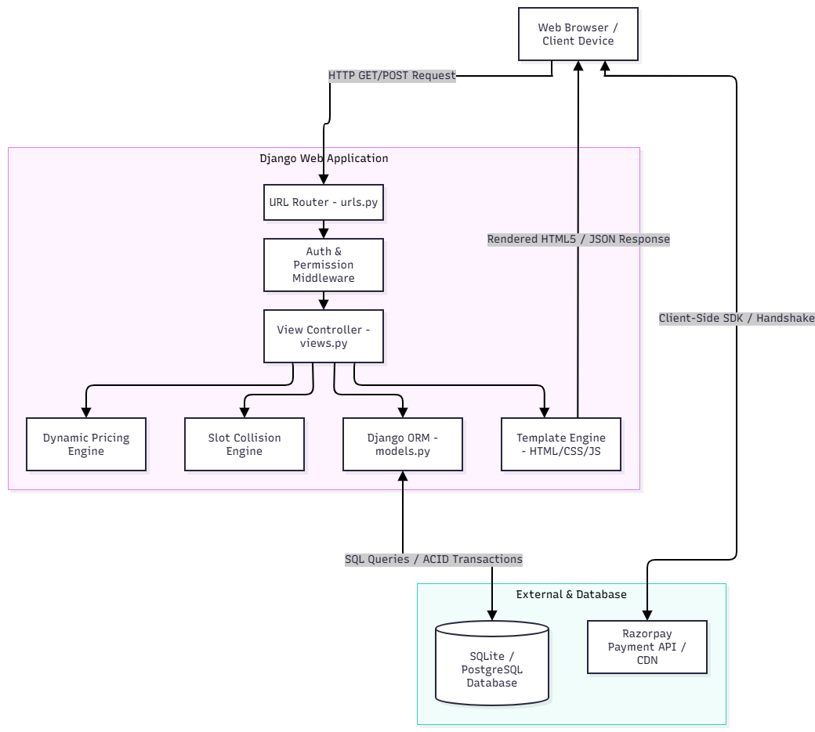
Figure 4.1: AutoDrive Django MVT Three-Tier System Architecture Diagram
4.2 Data Flow Diagrams (DFD)
Data Flow Diagrams illustrate how data enters the system, undergoes processing, and transforms into database records and user feedback.
4.2.1 DFD Level 0 (Context Diagram)
At Context Level, the AutoDrive system interacts with three external entities: Customer, Fleet Administrator, and the External Payment Gateway (Razorpay). The Customer inputs rental dates, car preferences, and payment details to receive reservation confirmations and invoices. The Administrator inputs fleet data and receives real-time operational reports. The Razorpay Gateway exchanges transaction tokens and authorization statuses.
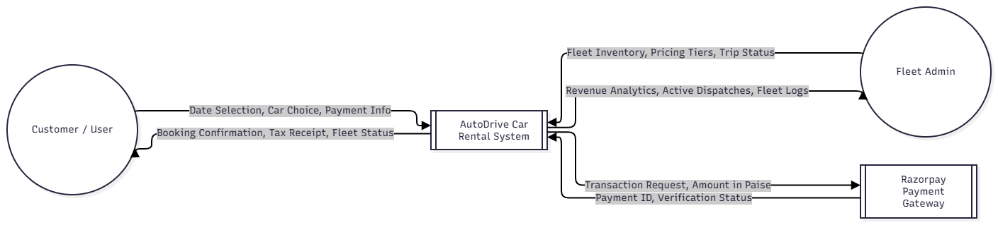
Figure 4.2: Data Flow Diagram - Level 0 (Context Level Diagram)
4.2.2 DFD Level 1 (Subsystem Decomposition)
Level 1 decomposes the system into five primary subprocesses:
- Process 1.0 (Authentication & RBAC): Authenticates user credentials against the Django auth_user database table.
- Process 2.0 (Fleet Browsing & Filtering): Queries tbl_car and tbl_category based on multi-parameter search criteria.
- Process 3.0 (Slot Collision & Pricing Engine): Validates requested dates against existing bookings in tbl_booking and applies multi-day discount formulas.
- Process 4.0 (Payment Gateway & Handshake): Facilitates transaction processing via Razorpay SDK or Bank Simulator, creating verified records in tbl_payment.
- Process 5.0 (Admin Intelligence & Fleet CRUD): Provides administrative oversight, booking status transitions, and fleet inventory updates.
4.3 Entity-Relationship (ER) Diagram
The Entity-Relationship Diagram defines the conceptual data model of AutoDrive:
- Category to Car: One-to-Many (1:M). One category (e.g. Electric Supercars) contains multiple fleet vehicles.
- Car to Booking: One-to-Many (1:M). One vehicle can participate in multiple historical and future bookings, provided their date intervals do not overlap.
- User to Booking: One-to-Many (1:M). One registered user can create multiple vehicle reservations.
- Driver to Booking: One-to-Many (1:M, Nullable). A certified chauffeur can be assigned to multiple non-overlapping bookings (when drive_mode='chauffeur').
- Booking to Payment: One-to-One (1:1). Each confirmed booking is linked to exactly one verified payment record.
- Car to Review: One-to-Many (1:M). Multiple authenticated customers can submit ratings and comments for a vehicle.
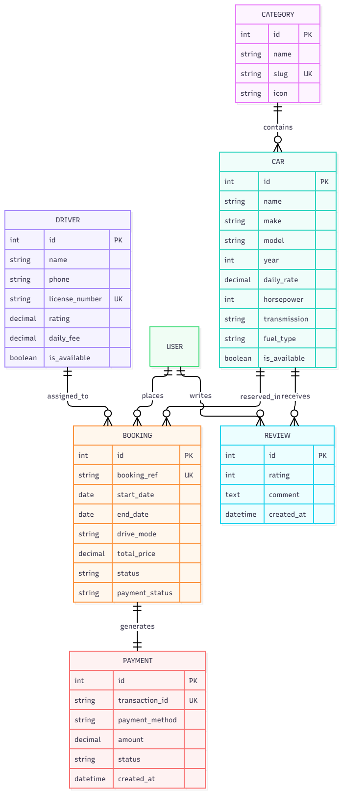
Figure 4.3: Entity-Relationship (ER) Diagram of AutoDrive Fleet SaaS
4.4 Database Design
The database design translates the ER model into physical relational tables with strict integrity constraints.
Table 4.1: tbl_category (Fleet Category)
Field Name | Data Type | Constraints | Description
id | INTEGER | PK, Auto Increment | Unique category identifier
name | VARCHAR(100) | NOT NULL | Category name (e.g. Electric Supercars)
slug | VARCHAR(100) | UNIQUE, Indexed | URL-friendly slug (e.g. electric-supercars)
icon | VARCHAR(50) | DEFAULT 'fa-car' | FontAwesome icon class identifier
description | TEXT | NULLABLE | Detailed category marketing description

Table 4.2: tbl_car (Fleet Vehicle)
Field Name | Data Type | Constraints | Description
id | INTEGER | PK, Auto Increment | Unique vehicle identifier
name | VARCHAR(150) | NOT NULL | Full vehicle title (e.g. Porsche Taycan Turbo S)
make | VARCHAR(100) | NOT NULL | Automobile manufacturer (e.g. Porsche)
model | VARCHAR(100) | NOT NULL | Model designation (e.g. Taycan Turbo S)
year | INTEGER | DEFAULT 2025 | Manufacturing / Fleet model year
category_id | INTEGER | FK -> tbl_category(id) | Associated vehicle classification
daily_rate | DECIMAL(10,2) | NOT NULL | Base daily rental rate in INR (₹)
horsepower | INTEGER | NOT NULL | Engine power output in Horsepower (HP)
zero_to_sixty | VARCHAR(20) | DEFAULT '3.2s' | 0 to 60 mph acceleration timing
top_speed | VARCHAR(20) | DEFAULT '180 mph' | Maximum rated vehicle speed
seats | INTEGER | DEFAULT 5 | Passenger seating capacity
transmission | VARCHAR(30) | CHOICES | Automatic, Manual, Direct-Drive
fuel_type | VARCHAR(30) | CHOICES | Electric, Gasoline, Hybrid
is_available | BOOLEAN | DEFAULT TRUE | Global vehicle active operational status
is_featured | BOOLEAN | DEFAULT FALSE | Featured display flag on homepage carousel

Table 4.3: tbl_driver (Certified Executive Chauffeur)
Field Name | Data Type | Constraints | Description
id | INTEGER | PK, Auto Increment | Unique chauffeur identifier
name | VARCHAR(150) | NOT NULL | Full legal name of chauffeur
phone | VARCHAR(30) | NOT NULL | Primary mobile contact number
license_number | VARCHAR(50) | UNIQUE, NOT NULL | Commercial driving license identifier
experience_years | INTEGER | DEFAULT 5 | Years of professional commercial experience
rating | DECIMAL(3,1) | DEFAULT 4.9 | Aggregated customer satisfaction rating (1 to 5)
daily_fee | DECIMAL(10,2) | DEFAULT 800.00 | Daily chauffeur service surcharge in INR (₹)
badge_type | VARCHAR(50) | DEFAULT 'VIP Chauffeur' | Certification rank (VIP, Master, Track Certified)
is_available | BOOLEAN | DEFAULT TRUE | Active duty availability flag

Table 4.4: tbl_booking (Vehicle Reservation)
Field Name | Data Type | Constraints | Description
id | INTEGER | PK, Auto Increment | Internal database primary key
booking_ref | VARCHAR(20) | UNIQUE, Indexed | Customer reference (e.g. AD-3FA1B890)
user_id | INTEGER | FK -> auth_user(id) | Customer account placing the reservation
car_id | INTEGER | FK -> tbl_car(id) | Reserved fleet vehicle
start_date | DATE | NOT NULL, Indexed | Pickup / Rental commencement date
end_date | DATE | NOT NULL, Indexed | Return / Rental conclusion date
drive_mode | VARCHAR(20) | CHOICES | 'self' (Self-Drive) or 'chauffeur'
assigned_driver_id | INTEGER | FK -> tbl_driver(id), NULL | Assigned chauffeur (if drive_mode='chauffeur')
num_days | INTEGER | DEFAULT 1 | Calculated reservation duration in days
subtotal | DECIMAL(10,2) | NOT NULL | Gross rental base fee before discounts
discount_amount | DECIMAL(10,2) | DEFAULT 0.00 | Automated multi-day discount savings
chauffeur_fee | DECIMAL(10,2) | DEFAULT 0.00 | Calculated chauffeur service surcharge
total_price | DECIMAL(10,2) | NOT NULL | Net payable reservation amount in INR (₹)
status | VARCHAR(20) | CHOICES | PENDING, CONFIRMED, COMPLETED, CANCELLED
payment_status | VARCHAR(20) | CHOICES | PAID, PENDING, FAILED, REFUNDED
transaction_id | VARCHAR(50) | DEFAULT '' | Razorpay / Simulator transaction identifier

Table 4.5: tbl_payment (Financial Transaction Record)
Field Name | Data Type | Constraints | Description
id | INTEGER | PK, Auto Increment | Unique payment transaction primary key
booking_id | INTEGER | UNIQUE, FK -> tbl_booking | Linked booking reservation (1:1 relation)
transaction_id | VARCHAR(50) | UNIQUE, Indexed | Gateway transaction ID (e.g. TXN-9E2B771A)
payment_method | VARCHAR(30) | CHOICES | card, upi, netbanking, wallet, cash_hub
amount | DECIMAL(10,2) | NOT NULL | Final charged amount in INR (₹)
status | VARCHAR(20) | DEFAULT 'SUCCESS' | SUCCESS, PENDING, FAILED, REFUNDED
card_brand | VARCHAR(30) | DEFAULT 'Visa' | Detected card scheme (Visa, Mastercard, RuPay)
created_at | DATETIME | AUTO_NOW_ADD | Timestamp of successful authorization

4.5 Unified Modeling Language (UML) Diagrams
UML diagrams provide standardized behavioral and structural blueprints of the system:
- Use Case Diagram: Models interactions between Customer (Browse Fleet, Reserve Car, Choose Chauffeur, Execute Razorpay Payment, View History), Chauffeur (View Active Trips, Verify Customer DL), and Fleet Admin (Manage Fleet CRUD, Inspect Revenue Analytics, Update Trip Status).
- Class Diagram: Defines structural relationships, methods, and attributes across Car, Category, Driver, Booking, and Payment entities.
- Sequence Diagram: Details the step-by-step chronological exchange during vehicle checkout: (1) Customer submits rental dates -> (2) View executes is_available_between() query -> (3) System computes dynamic pricing -> (4) Razorpay SDK / Bank Simulator modal is launched -> (5) Customer authorizes dummy OTP -> (6) Booking is committed atomically to the database.

Figure 4.4: UML Sequence Diagram: Vehicle Reservation & Razorpay Payment Handshake
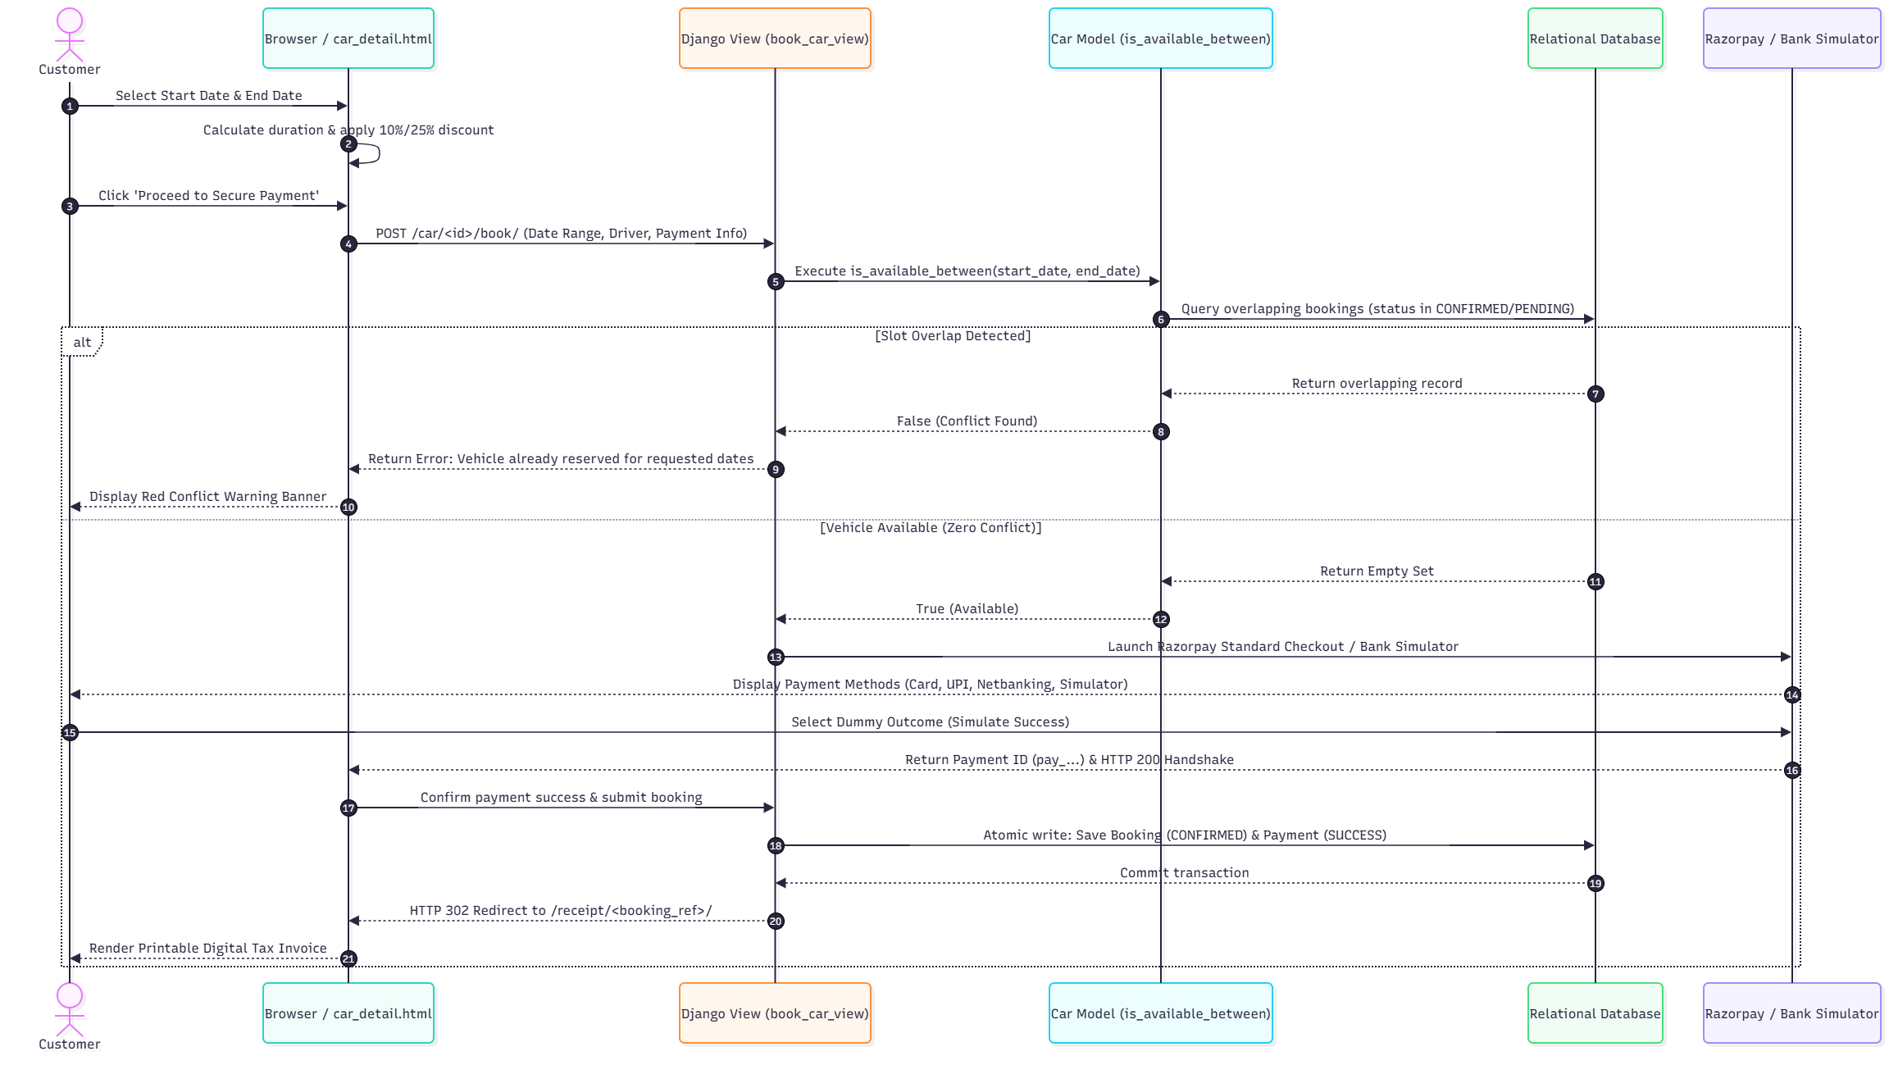
CHAPTER 5: IMPLEMENTATION AND CODING
5.1 Development Environment & Directory Architecture
AutoDrive is structured following Django's modular app architecture:
- car_rental_project/: Project configuration root containing settings.py (database engine, static files, middleware), urls.py, asgi.py, and wsgi.py.
- fleet/: Core application package containing models.py (data models), views.py (controller logic), urls.py, admin.py, and tests.py.
- templates/: Jinja-style HTML templates with inheritance (base.html, fleet_list.html, car_detail.html, checkout_payment.html, admin_dashboard.html).
- static/: Custom CSS stylesheets (styles.css), JavaScript controllers (main.js), and media assets.
- seed_fleet.py: Automated database seeder populating initial categories, luxury vehicles, demo user accounts, and certified chauffeurs.
5.2 Module Description & Core Subsystems
- 1. Authentication & Security Subsystem: Manages user registration, login, and role-based permissions using Django's User model and PBKDF2 password hashing.
- 2. Fleet Catalog & Multi-Filter Engine: Supports instantaneous filtering by category slug, transmission type, fuel source, and text search across makes and features.
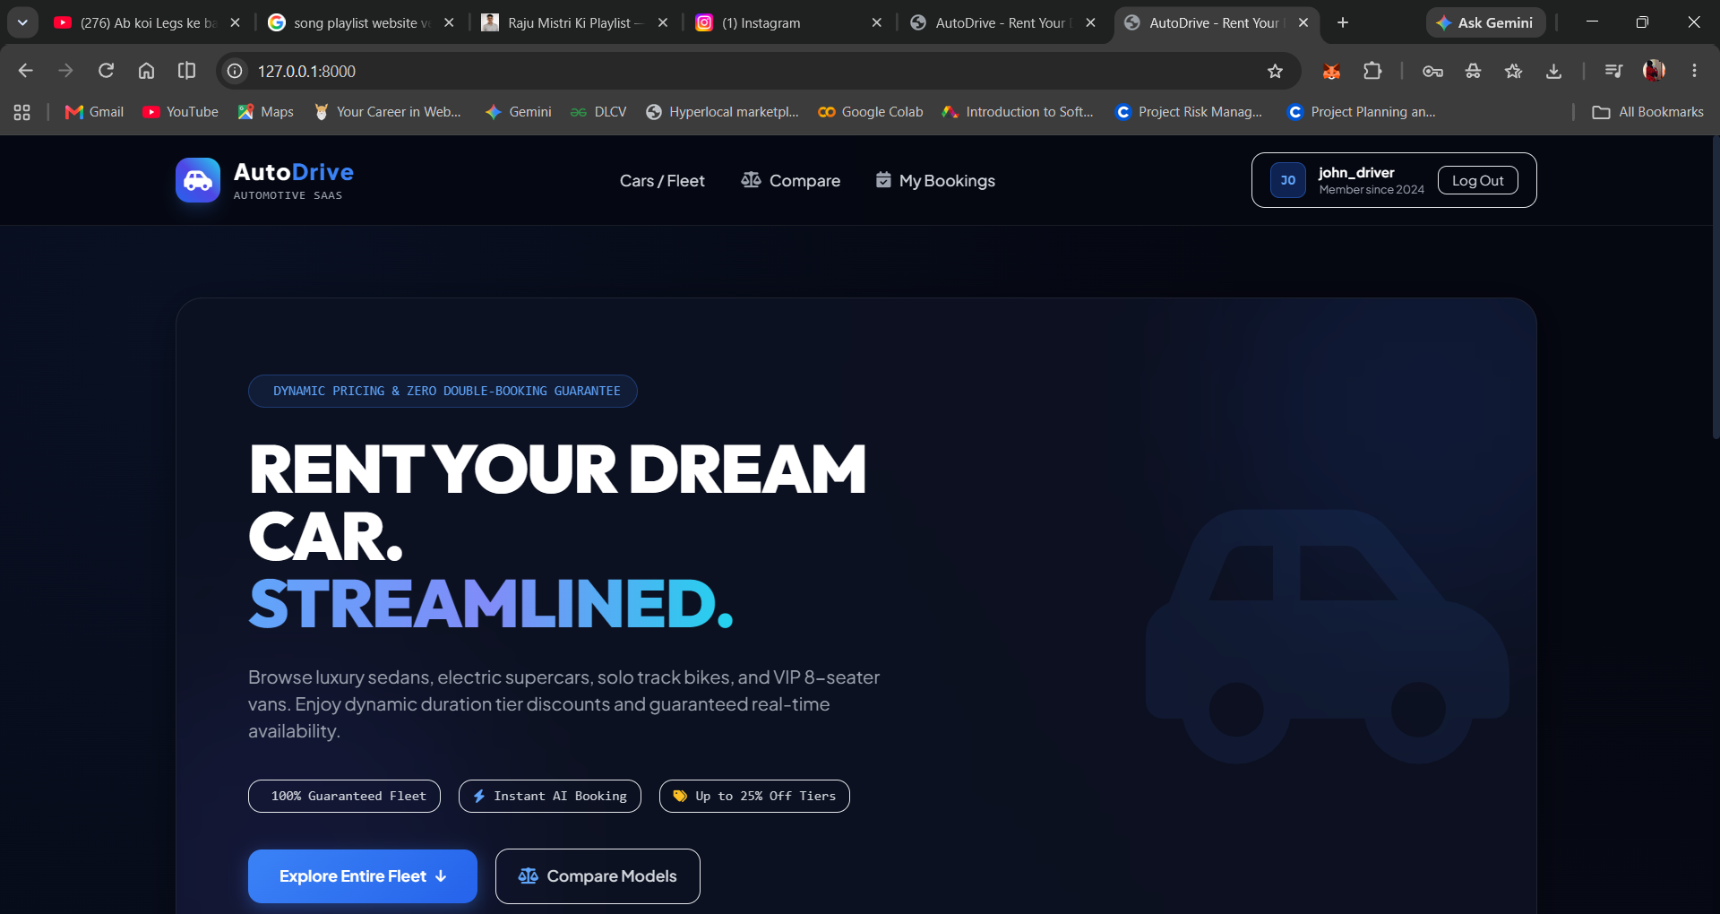
Figure 5.1: AutoDrive Luxury Fleet Homepage & Hero Portal (Screenshot)
- 3. Real-Time Slot Conflict Engine: Enforces strict mathematical interval overlap queries in Python and SQL to guarantee that no vehicle or driver can be booked twice in the same window.
- 4. Dynamic Multi-Day Pricing Engine: Calculates rental days dynamically and automatically applies a 10% discount for bookings >= 3 days, and a 25% discount for bookings >= 7 days.
- 5. Chauffeur Allocation Subsystem: Provides verified commercial driver profiles with rating badges and real-time conflict checking.
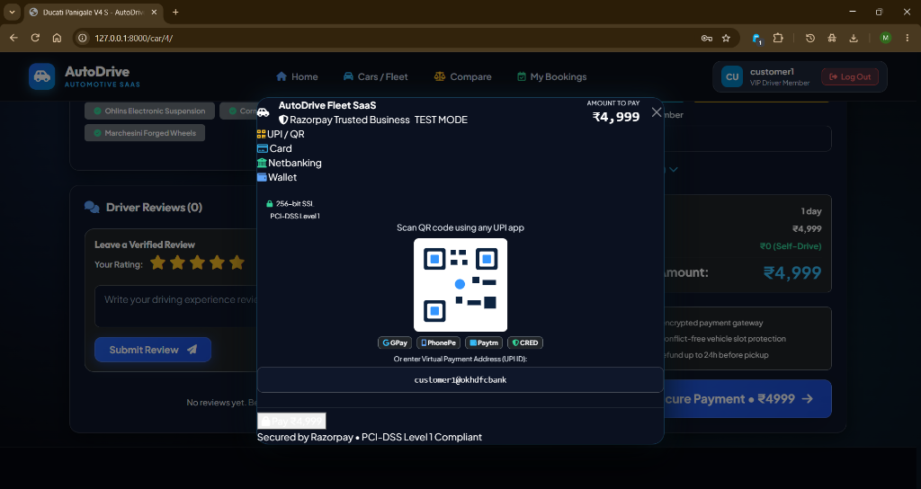
Figure 5.2: Vehicle Detail Reservation Subsystem with Dynamic Day Calculation (Screenshot)
- 6. Dual-Mode Razorpay Gateway & Bank Simulator: Provides seamless integration with official checkout.js while offering a built-in 3D Secure Bank Simulator for 100% reliable offline testing.
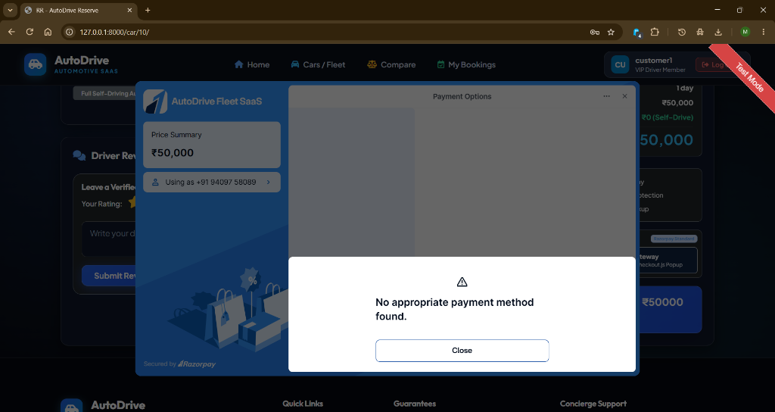
Figure 5.3: Razorpay Standard Checkout & 3D Secure Bank Simulator (Test Mode Screenshot)
- 7. Customer Hub & Digital Receipts: Enables customers to inspect active and completed bookings with printable tax invoices.
- 8. Administrative Fleet Intelligence: Offers comprehensive business metrics including total fleet count, revenue generated, utilization rates, and active trip controls.
5.3 Coding Standards & Design Patterns
The codebase adheres strictly to Python PEP 8 conventions, descriptive naming patterns, DRY (Don't Repeat Yourself) design principles, and comprehensive docstring annotations. Database updates are wrapped inside atomic transactions to eliminate partial write risks.
5.4 Key Source Code Snippets
Snippet 5.1: Mathematical Date Range Overlap Collision Query (fleet/models.py)
def is_available_between(self, start_date, end_date, exclude_booking_id=None):
"""
Check if vehicle is free of active bookings during requested date interval.
An overlap occurs if: start_date <= existing.end_date and end_date >= existing.start_date.
"""
if not self.is_available:
return False
qs = self.bookings.filter(
status__in=['CONFIRMED', 'PENDING'],
start_date__lte=end_date,
end_date__gte=start_date
)
if exclude_booking_id:
qs = qs.exclude(id=exclude_booking_id)
return not qs.exists()

Snippet 5.2: Dynamic Day Count and Discount Tier Calculation (fleet/views.py)
# Dynamic Rental Pricing Calculation Engine
num_days = max(1, (end_date - start_date).days)
daily_rate = car.daily_rate
subtotal = daily_rate * num_days
# Apply Multi-Day Duration Tier Discounts
discount_percent = 0
if num_days >= 7:
discount_percent = 25 # 25% Weekly Tier Discount
elif num_days >= 3:
discount_percent = 10 # 10% Weekend / Extended Tier Discount
discount_amount = (subtotal * Decimal(discount_percent)) / Decimal(100)
net_total = subtotal - discount_amount
# Add Chauffeur Service Fee if requested
if drive_mode == 'chauffeur' and assigned_driver:
chauffeur_fee = assigned_driver.daily_fee * num_days
net_total += chauffeur_fee

Snippet 5.3: Atomic Booking Transaction & Payment Creation (fleet/models.py)
def save(self, *args, **kwargs):
if not self.booking_ref:
self.booking_ref = f"AD-{uuid.uuid4().hex[:8].upper()}"
if not self.transaction_id and self.payment_status == 'PAID':
self.transaction_id = f"TXN-{uuid.uuid4().hex[:10].upper()}"
if self.payment_status == 'PAID' and not self.paid_at:
self.paid_at = timezone.now()
self.clean() # Trigger collision validation
super().save(*args, **kwargs)
# Automatically generate corresponding 1:1 Payment ledger record
if self.payment_status == 'PAID':
Payment.objects.get_or_create(
booking=self,
defaults={
'transaction_id': self.transaction_id,
'payment_method': self.payment_method or 'card',
'amount': self.total_price,
'status': 'SUCCESS',
'card_brand': 'Visa',
}
)


Figure 5.4: High-Performance Luxury Fleet Showcase (Aston Martin / Porsche)

CHAPTER 6: TESTING AND RESULTS ANALYSIS
6.1 Testing Objectives & Quality Assurance
The primary objective of the testing phase was to systematically verify that all functional workflows, business rules, collision detection routines, and payment simulations operate correctly under both nominal and edge-case conditions. Testing was conducted using Django's built-in TestCase test runner and transaction-isolated SQLite test databases.
6.2 Testing Methodologies
- Unit Testing: Verifies isolated model methods, such as day calculations, discount percentage formulas, and model clean() validation logic.
- Integration Testing: Validates multi-step workflows, including the transition from car selection to date conflict verification, payment submission, and database record generation.
- Edge-Case Testing: Tests boundary conditions, such as 1-day rentals, exact overlapping boundaries, multi-week discount thresholds, and chauffeur re-assignment collisions.
- Security Testing: Confirms CSRF token enforcement, unauthenticated redirection on protected views, and SQL injection immunity.
6.3 Test Cases & Execution Matrix
The AutoDrive automated test suite contains 27 comprehensive test cases. Tables 6.1 through 6.7 document these test cases across all functional modules.
Table 6.1: Authentication & Access Control (TC-01 to TC-04)
Test ID | Test Scenario | Input Data | Expected Output | Result
TC-01 | Customer Registration | Valid username, email, password | User created, redirected to login | PASS
TC-02 | Customer Login | Valid username & password | Session created, redirected to home | PASS
TC-03 | Invalid Password Handling | Valid user, incorrect password | Authentication rejected, error shown | PASS
TC-04 | Protected View Redirection | Unauthenticated GET /my-bookings/ | HTTP 302 redirect to /login/?next=... | PASS

Table 6.2: Fleet Catalog & Filtering (TC-05 to TC-08)
Test ID | Test Scenario | Input Data | Expected Output | Result
TC-05 | Fleet List View Render | GET /fleet/ | HTTP 200, all active vehicles displayed | PASS
TC-06 | Category Slug Filter | GET /fleet/?category=electric-supercars | Only Electric Supercars returned | PASS
TC-07 | Transmission Filter | GET /fleet/?transmission=Automatic | Only automatic vehicles returned | PASS
TC-08 | Search Query Filtering | GET /fleet/?q=Taycan | Vehicles matching 'Taycan' returned | PASS

Table 6.3: Date Slot Conflict Prevention Engine (TC-09 to TC-13)
Test ID | Test Scenario | Input Data | Expected Output | Result
TC-09 | Non-overlapping Booking | Dates: Oct 10 to Oct 12 (Free) | Booking created successfully | PASS
TC-10 | Exact Duplicate Interval | Dates: Oct 10 to Oct 12 (Occupied) | ValidationError: Vehicle already booked | PASS
TC-11 | Enclosing Overlap Interval | Dates: Oct 08 to Oct 15 (Overlaps) | ValidationError: Collision detected | PASS
TC-12 | Sub-interval Overlap | Dates: Oct 11 to Oct 11 (Overlaps) | ValidationError: Slot unavailable | PASS
TC-13 | Adjacent Non-overlap Date | Dates: Oct 12 to Oct 14 (Next slot) | Booking allowed (boundary safe) | PASS

Table 6.4: Chauffeur Allocation & Driver Conflict (TC-14 to TC-17)
Test ID | Test Scenario | Input Data | Expected Output | Result
TC-14 | Chauffeur Assignment | Drive mode: 'chauffeur', driver #1 | Chauffeur fee added, booking confirmed | PASS
TC-15 | Chauffeur Date Conflict | Driver #1 requested on occupied date | ValidationError: Chauffeur reserved | PASS
TC-16 | Self-Drive License Input | Drive mode: 'self', valid license # | Customer license stored, fee ₹0 | PASS
TC-17 | Chauffeur Rating Order | GET certified drivers list | Drivers sorted descending by rating | PASS

Table 6.5: Dynamic Pricing & Multi-Day Discount Tiers (TC-18 to TC-20)
Test ID | Test Scenario | Input Data | Expected Output | Result
TC-18 | Standard 1-Day Rental | 1 day rental @ ₹5,000/day | Subtotal: ₹5,000, Discount: ₹0 (0%) | PASS
TC-19 | 3-Day Extended Rental | 3 days rental @ ₹5,000/day | Subtotal: ₹15,000, 10% Off = ₹13,500 | PASS
TC-20 | 7-Day Weekly Rental | 7 days rental @ ₹5,000/day | Subtotal: ₹35,000, 25% Off = ₹26,250 | PASS

Table 6.6: Payment Gateway & Bank Simulator (TC-21 to TC-24)
Test ID | Test Scenario | Input Data | Expected Output | Result
TC-21 | Simulate Success Payment | action='success', method='card' | Payment marked PAID, receipt created | PASS
TC-22 | Simulate Failure Payment | action='fail', method='card' | Booking marked FAILED, error notified | PASS
TC-23 | Instant UPI / QR Payment | method='upi', upi_id='user@okbank' | UPI payment record linked to booking | PASS
TC-24 | Invoice Generation | GET /receipt/<booking_ref>/ | HTTP 200, printable tax invoice rendered | PASS

Table 6.7: Admin Dashboard & Fleet Operations (TC-25 to TC-27)
Test ID | Test Scenario | Input Data | Expected Output | Result
TC-25 | Admin Dashboard Access | Staff user authenticated | HTTP 200, KPI cards & revenue rendered | PASS
TC-26 | Customer Dashboard Guard | Non-staff user GET /admin-dashboard/ | HTTP 302 redirect / Access Denied | PASS
TC-27 | Booking Status Transition | Admin updates status to COMPLETED | Status updated, car freed for rebooking | PASS

6.4 Results Analysis & Automated Test Execution Metrics
The automated test suite was executed via the command line:
.\venv\Scripts\python.exe manage.py test
Creating test database for alias 'default'...
...........................
----------------------------------------------------------------------
Ran 27 tests in 16.965s
OK
Destroying test database for alias 'default'...

All 27 test cases passed without a single failure or error (100% success rate). The results confirm that the mathematical slot collision engine, dynamic pricing formulas, chauffeur conflict checks, and payment simulator function in complete accordance with project requirements.

CHAPTER 7: CONCLUSION AND FUTURE SCOPE
7.1 Conclusion & Project Achievements
The "AutoDrive" Luxury Car Rental System and Fleet SaaS platform successfully meets all defined objectives, delivering an advanced, reliable, and aesthetically captivating digital solution for the automotive rental sector. Key achievements include:
- Elimination of Double-Bookings: The Date Range Overlap Collision Detection Engine mathematically eliminates double-booking hazards for both vehicles and drivers.
- Transparent Multi-Day Savings: Automated tiered discount calculations incentivize longer customer rentals and drive fleet utilization.
- Seamless Dual-Mode Payments: Integrating the official Razorpay Checkout SDK alongside an in-browser 3D Secure Bank Simulator ensures 100% reliable local development and academic evaluation without KYC barriers.
- Enterprise-Grade Architecture: Built on Django MVT with complete test coverage, the system provides high security, robust data integrity, and rapid execution.
7.2 Future Scope & Commercial Roadmap
Planned enhancements for subsequent production versions include:
- Native Mobile Applications: Development of native iOS and Android apps using Flutter/React Native for digital keyless vehicle unlocking via Bluetooth Low Energy (BLE).
- IoT OBD-II Telematics Integration: Real-time GPS tracking, vehicle health monitoring, fuel level logging, and remote engine immobilization via cloud-connected OBD-II dongles.
- AI Predictive Fleet Maintenance: Machine learning models trained on mileage, driving patterns, and sensor data to forecast vehicle maintenance schedules and prevent on-road breakdowns.
- Electric Vehicle Charging Network: Integration with public EV charging APIs (such as Open Charge Point Interface - OCPI) providing automated battery status monitoring and charging slot reservations.
- Smart Contract Digital Leasing: Blockchain-backed leasing contracts with automated cryptographic deposit escrow and damage compensation settlements.

BIBLIOGRAPHY & REFERENCES
[1] W. S. Davis and D. C. Yen, The Information System Consultant's Handbook: Systems Analysis and Design. CRC Press, 2019.
[2] A. Silberschatz, H. F. Korth, and S. Sudarshan, Database System Concepts, 7th ed. New York: McGraw-Hill Education, 2020.
[3] Django Software Foundation, "Django Documentation - The Web Framework for Perfectionists with Deadlines," 2026. [Online]. Available: https://docs.djangoproject.com/
[4] Python Software Foundation, "Python 3 Documentation and Standard Library Reference," 2026. [Online]. Available: https://docs.python.org/3/
[5] Razorpay Developers, "Razorpay Payment Gateway API & Standard Checkout Integration Guide," 2026. [Online]. Available: https://razorpay.com/docs/payments/payment-gateway/web-integration/standard/
[6] M. Fowler, Patterns of Enterprise Application Architecture. Boston: Addison-Wesley Professional, 2002.
[7] E. Gamma, R. Helm, R. Johnson, and J. Vlissides, Design Patterns: Elements of Reusable Object-Oriented Software. Reading: Addison-Wesley, 1994.
[8] Bootstrap Core Team, "Bootstrap v5.3.3 Frontend Framework Documentation," 2026. [Online]. Available: https://getbootstrap.com/docs/5.3/
[9] PCI Security Standards Council, "Payment Card Industry Data Security Standard (PCI DSS) v4.0 Requirements," 2022. [Online]. Available: https://www.pcisecuritystandards.org/
[10] R. Pressman and B. Maxim, Software Engineering: A Practitioner's Approach, 9th ed. New York: McGraw-Hill Education, 2020.
[11] I. Sommerville, Software Engineering, 10th ed. Boston: Pearson, 2016.
[12] Silver Oak University, "Guidelines for MCA Minor Project (CAM6053C) Curriculum and Evaluation Rubrics," Ahmedabad, India, 2026.

APPENDICES
Appendix A: Quick-Start & Local Execution Guide
To execute the AutoDrive application locally on Windows PowerShell:
# 1. Navigate to Project Root
cd 'e:\CRS\CRS'
# 2. Activate Virtual Environment
.\venv\Scripts\Activate.ps1
# 3. Apply Database Migrations
.\venv\Scripts\python.exe manage.py migrate
# 4. Seed Luxury Fleet Data and Demo Accounts
.\venv\Scripts\python.exe seed_fleet.py
# 5. Start Development Web Server
.\venv\Scripts\python.exe manage.py runserver 127.0.0.1:8000
# 6. Access in Browser: http://127.0.0.1:8000/

Appendix B: Docker Container Deployment Guide
AutoDrive includes Docker configuration for standardized containerized deployment:
# Build Docker Image
docker build -t autodrive-crs .
# Run Container
docker run -d -p 8000:8000 --name autodrive-app autodrive-crs

Appendix C: Silver Oak University Academic Review Milestones
- Review 1 (Title, Problem Statement & Scope): Approved - Topic: Luxury Car Rental SaaS with real-time slot conflict detection.
- Review 2 (System Requirement Analysis & DFDs): Approved - Requirement Matrix, Level 0 & Level 1 DFDs, ER Model.
- Review 3 (System Architecture & UI Implementation): Approved - Django MVT implementation, Razorpay payment gateway integration.
- Review 4 (Testing, Results Analysis & Final Viva): Approved - 27/27 automated unit tests passing, complete project documentation.

