
Tracksuit/T-Shirt Size : 38/38
Athletics(Men) - 4×100 mts. Relay SPRT251003655

SAVITRIBAI PHULE PUNE UNIVERSITY
INDIVIDUAL ELIGIBILITY PROFORMA - 2025-2026
Zone - Nashik
12022199227

College Details |  |  |  |  |  |  |  |  | 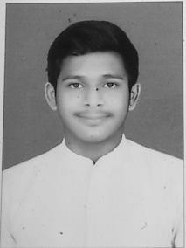
College Name |  |  | S.N.J.B. (Jain Gurukul) S.N.J.B. Late Sau. Kantabai Bhavarlalji Jain College of Engineering Addr: Neminagar Jain Gurukul Ta: Chandwad Dist: Nashik
College Type |  |  | Non-Granted | Principal Name | Rajendrakumar Giridharilal Tated
Principal Type |  |  | Permanent | Mobile Number | 8530639445
Director of Physical Education Name - Darekar Dipak Harinarayan
Director of Physical Education Mobile & Email - 9689360625, dipak.darekar13@gmail.com
Player Details
Name of the Player | JAIN PIYUSH RAMESH |  |  |  | Name in Devnagri | N`न ֌֟h¸֙ ֒e`֘
Mother Name | NISHA |  |  |  | DOB | 27/Jun/2004
Mobile Number | 9960506211 |  |  |  | EmailId | jainpiyush2223@gmail.com
Blood Group | B+ |  |  |  | Aadhar No. | 981233293712
Local Address | A/p. Khapar, Tal. Akkalkuwa, Dist. Nandurbar
Class Details
Permanent Registration Number (PRN) - 72240367E
Present Course Name |  | B.E. (Computer) |  |  | Present Course Level |  | Graduate
Present Year |  | Third Year |  |  | Present Roll No. |  | 75
Last Year Institution/ College/ Board/ School - S.N.J.B. Late Sau. Kantabai Bhavarlalji Jain College of Engineering
Last Course Name |  | B.E. (Computer) |  |  | Last Class Year |  | Second Year
Should you do a post graduate qualification earlier? - No
Admission Details
Class | Institution/ College/ Board/ School |  |  |  | Admission Month & Year |  |  | Passing Month & Year
SSC | Anand Gurukul English Medium School, Pune |  |  |  | Jun 2019 |  |  | Mar 2020
HSC | Sant Jagnade Mahraj Arts, Commerece, Science College, Khapar |  |  |  | Jun 2021 |  |  | Mar 2022
Under Graduate | S.N.J.B. (Jain Gurukul) S.N.J.B. Late Sau. Kantabai Bhavarlalji Jain College of  Engineering |  |  |  | Nov 2022 |  |  | Jun 2024
Declaration :
We, the undersigned, agreed that the above student is a regular fulltime bonafide student of this College/Institution, we do hereby solemnly declare that the student is not employed either on whole-time basis or part-time basis during this academic year. Further we clarify that the information filled in the sports eligibility form is fair and correct as per our record. If any negligence found in this case we are aware that the student or entire team’s participation in the said event/tournament may stand cancel.

.................................
Signature of the player
.....................................
Signature of the Director of Physical Education
.....................................
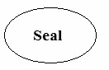


Signature of the Principal

10/7/2025 7:47:42 PM 1 of 1

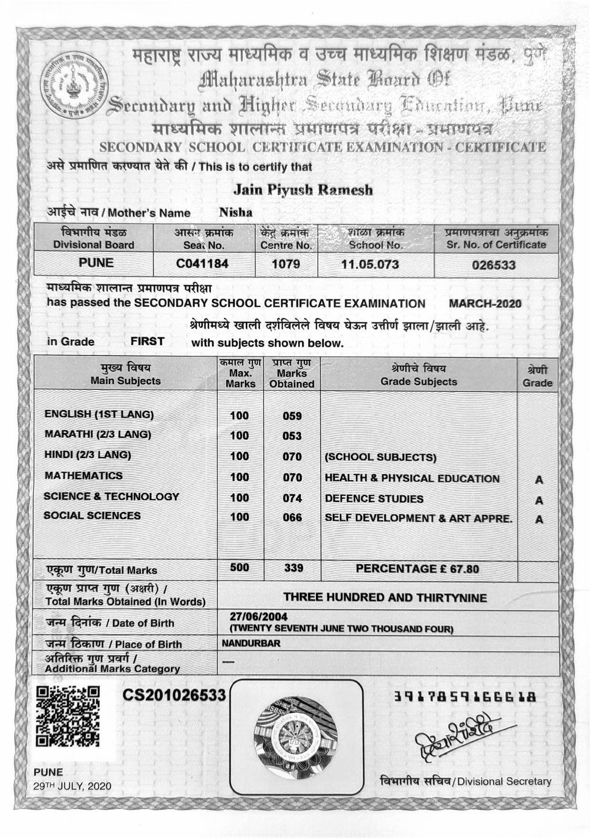

SPRT251003655
Name:-PIYUSH RAMESH JAIN Document Name:- SSC Passing Certificate

