9.Problem : Write a program to implement k-Nearest Neighbour algorithm to classify the iris data set. Print both correct and wrong predictions. Java/Python ML library classes can be used for this problem.

Algorithm :

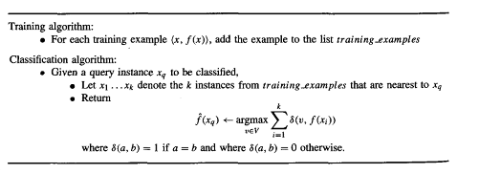



Program Code:

|  |
| --- |
| from sklearn.datasets import load_iris  from sklearn.neighbors import KNeighborsClassifier  import numpy as np  from sklearn.model_selection import train_test_split  iris_dataset=load_iris()  print("\n IRIS FEATURES \ TARGET NAMES: \n ", iris_dataset.target_names)  for i in range(len(iris_dataset.target_names)):  print("\n[{0}]:[{1}]".format(i,iris_dataset.target_names[i]))  print("\n IRIS DATA :\n",iris_dataset["data"])    X_train, X_test, y_train, y_test = train_test_split(iris_dataset["data"], iris_dataset["target"], random_state=0)    print("\n Target :\n",iris_dataset["target"])  print("\n X TRAIN \n", X_train)  print("\n X TEST \n", X_test)  print("\n Y TRAIN \n", y_train)  print("\n Y TEST \n", y_test)  kn = KNeighborsClassifier(n_neighbors=1)  kn.fit(X_train, y_train)    x_new = np.array([[5, 2.9, 1, 0.2]])  print("\n XNEW \n",x_new)    prediction = kn.predict(x_new)    print("\n Predicted target value: {}\n".format(prediction))  print("\n Predicted feature name: {}\n".format  (iris_dataset["target_names"][prediction]))  i=1  x= X_test[i]  x_new = np.array([x])  print("\n XNEW \n",x_new)  for i in range(len(X_test)):  x = X_test[i]  x_new = np.array([x])  prediction = kn.predict(x_new)  print("\n Actual : {0} {1}, Predicted :{2}{3}".format(y_test[i],iris_dataset["target_names"][y_test[i]],prediction,iris_dataset["target_names"][prediction]))  print("\n TEST SCORE[ACCURACY]: {:.2f}\n".format(kn.score(X_test, y_test))) |