RESULTS
Plot 01 — Churn Distribution
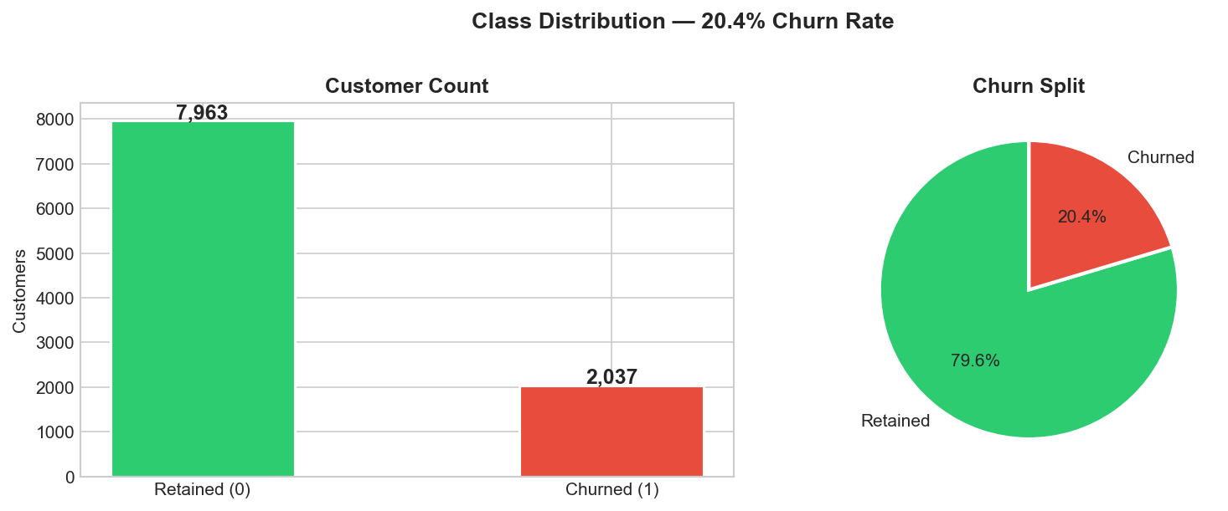
Plot 01 — Churn Distribution (Bar + Pie) 79.6% of customers stayed while only 20.4% churned, revealing a significant class imbalance. This means accuracy alone is misleading a model that always predicts "stays" would still score ~80%.

Plot 02 — Age: Churned vs Retained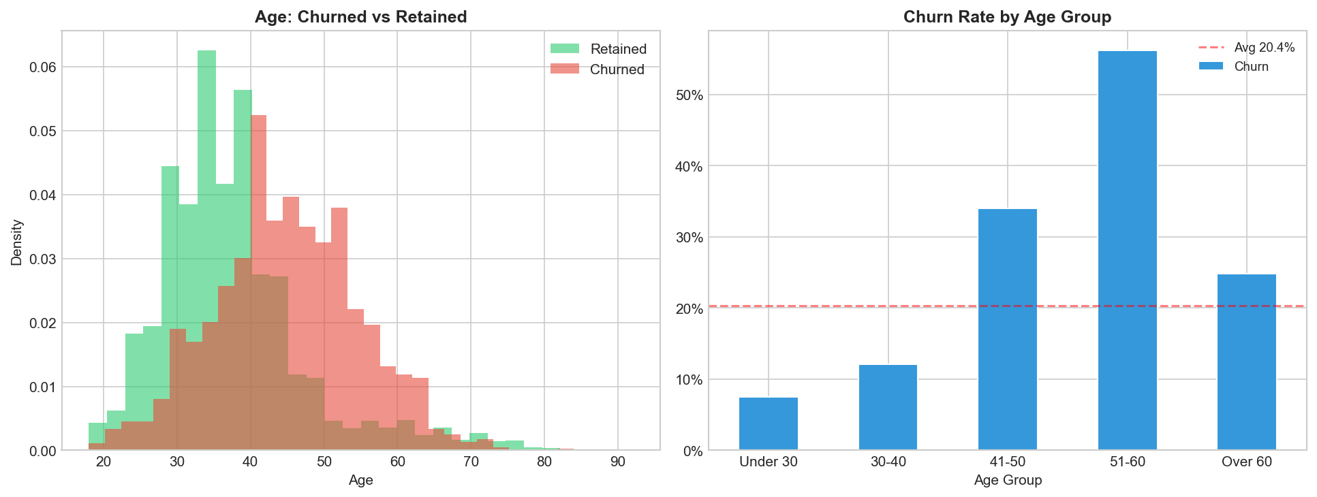
Plot 02 — Age: Churned vs Retained The 51–60 age group has the highest churn rate at 55.2%, while customers under 30 barely churn at 7.5%. Older customers are financially experienced and actively shop for better rates, making age the strongest single predictor.

Plot 03 — Purchases (NumOfProducts) vs Churn
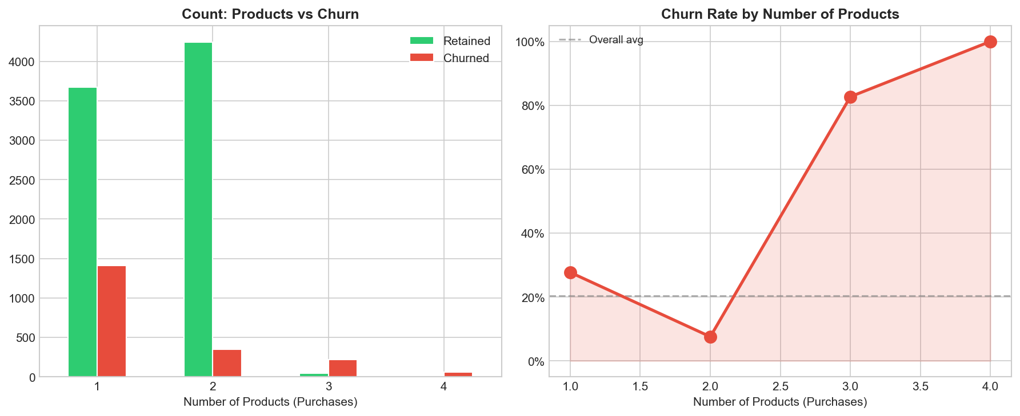
Plot 03 — Purchases (NumOfProducts) vs Churn Churn follows a non-linear U-curve: 2 products is the safest zone (7.6% churn),while 3–4 products spikes to 83–100%. Customers pushed into too many products feel over-sold, frustrated, and leave.

Plot 04 — Membership vs Churn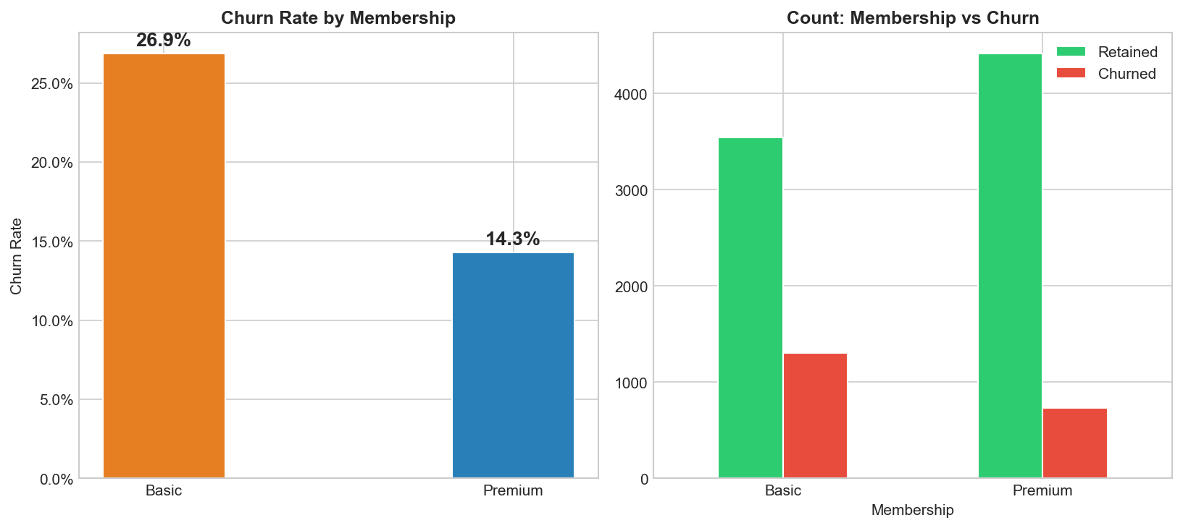
Plot 04 — Membership vs Churn Basic (inactive) members churn at nearly double the rate of Premium members 26.9% vs 14.3%. Inactivity is a leading indicator, meaning customers disengage mentally before they formally close their account.

Plot 05 — Income Distribution by Churn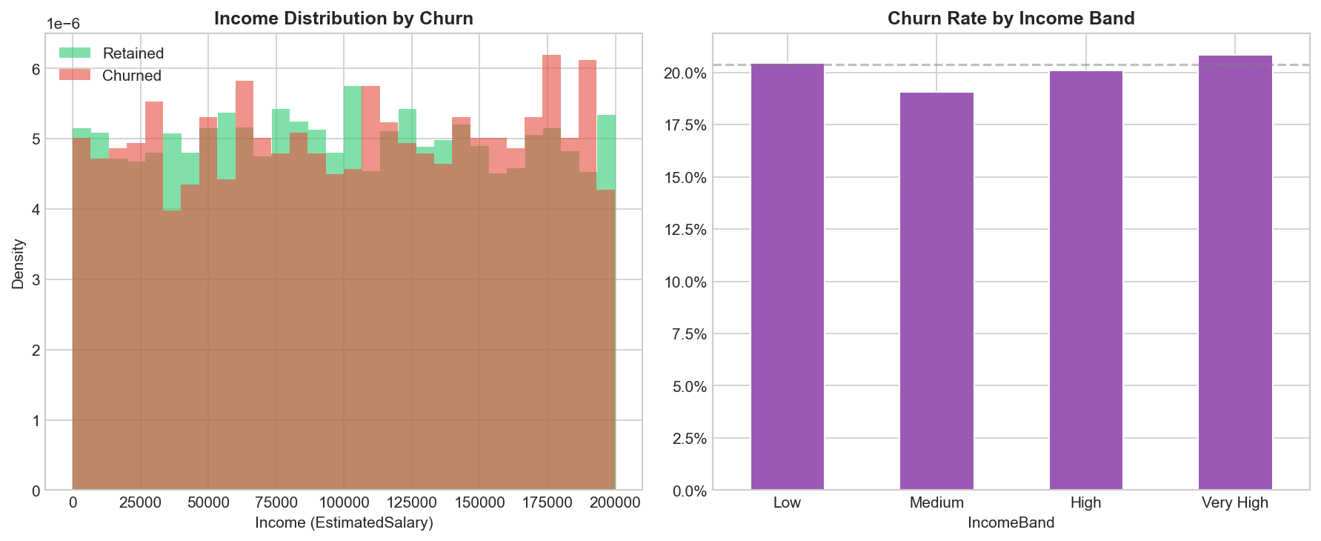
Plot 05 — Income Distribution by Churn Churn rates are nearly flat across all income bands (Low, Medium, High, Very High), all hovering around 20%. Income (EstimatedSalary) is a weak standalone predictor and not a reliable churn driver.

Plot 06 — Geography vs Churn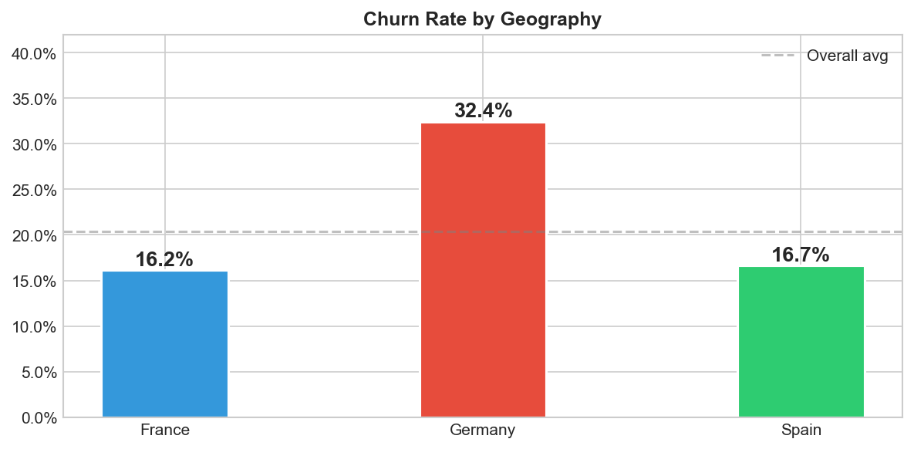
Plot 06 — Geography vs Churn Germany churns at 32.4% roughly double France (16.2%) and Spain (16.7%). This gap is too large to be explained by individual customer profiles, pointing to a structural business issue specific to Germany.

Plot 07 — Balance Distribution & Gender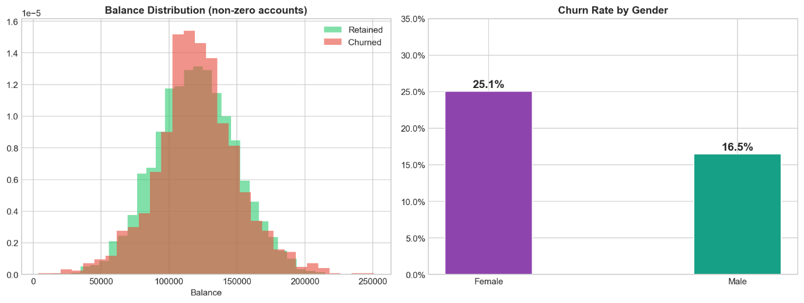
Plot 07 — Balance Distribution & Gender Churned customers tend to hold higher balances, likely accumulating funds while evaluating a switch rather than high balance causing churn. Female customers churn at 25.1% vs 16.5% for males a consistent but secondary gap.

Plot 08 — Model Comparison (All Metrics) 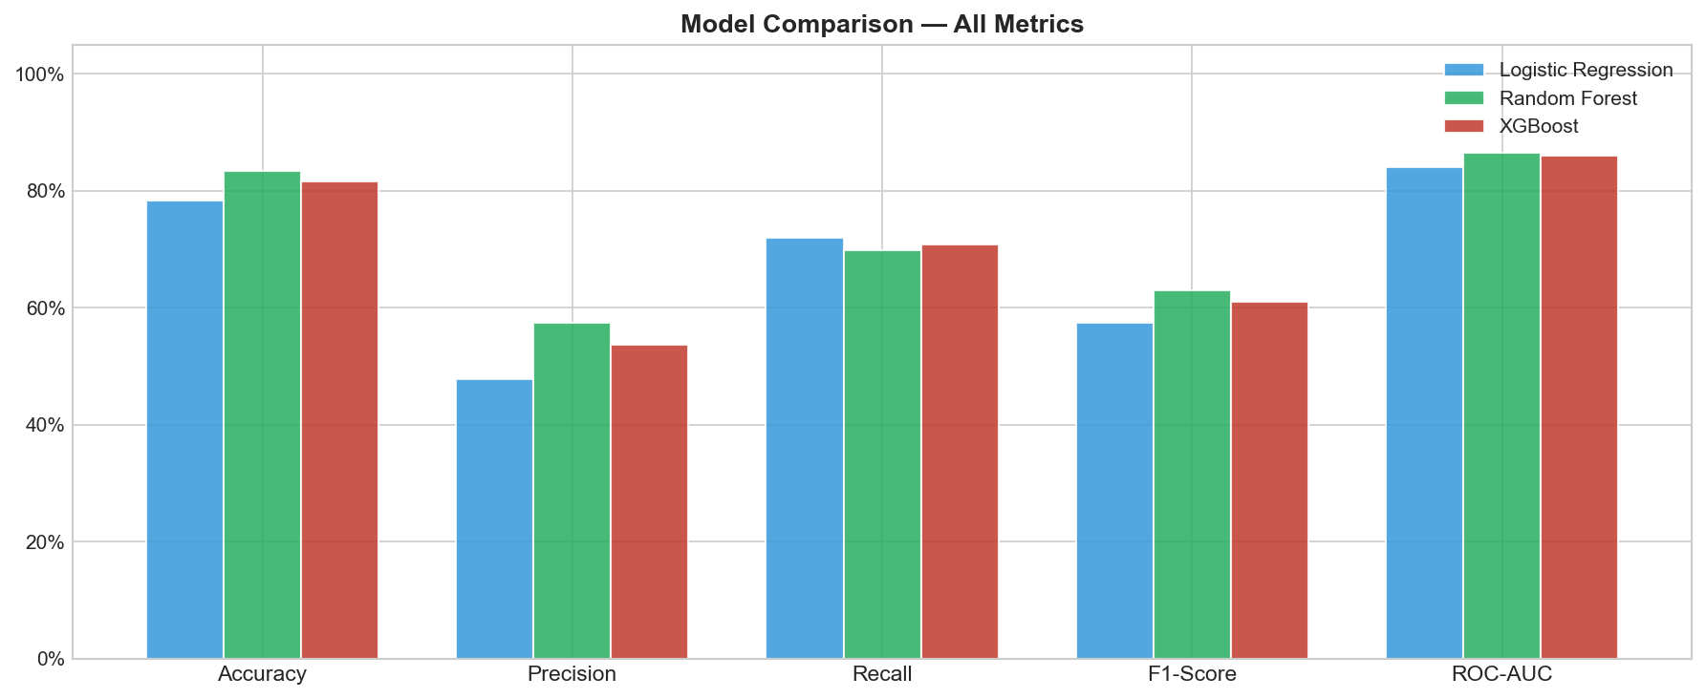
Plot 08 — Model Comparison (All Metrics) Random Forest achieves the highest accuracy (83.3%) and F1-Score (62.97%), while Logistic Regression leads on Recall (71.99%) due to its liberal churn predictions. XGBoost sits competitively across all metrics without dominating any single one on the test set.

Plot 09 — ROC Curves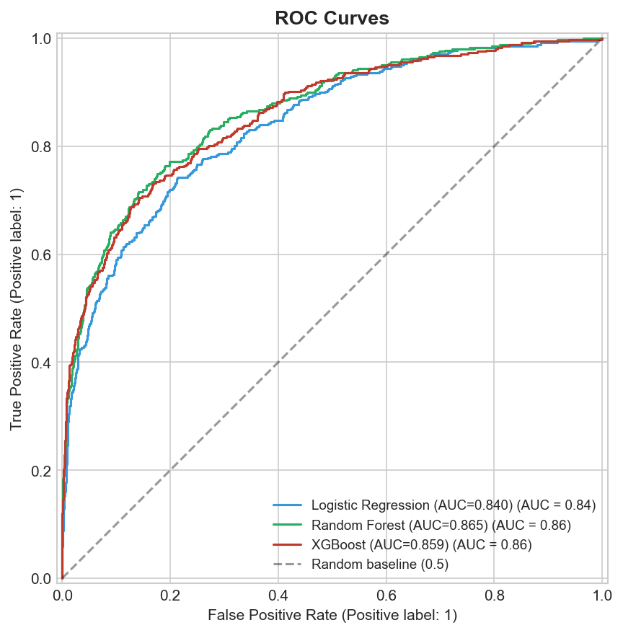
Plot 09 — ROC Curves Random Forest and XGBoost are nearly identical in ROC-AUC (0.865 vs 0.859), both well above Logistic Regression (0.840). All three models significantly outperform the random baseline, confirming genuine predictive power.

Plot 10 — Confusion Matrice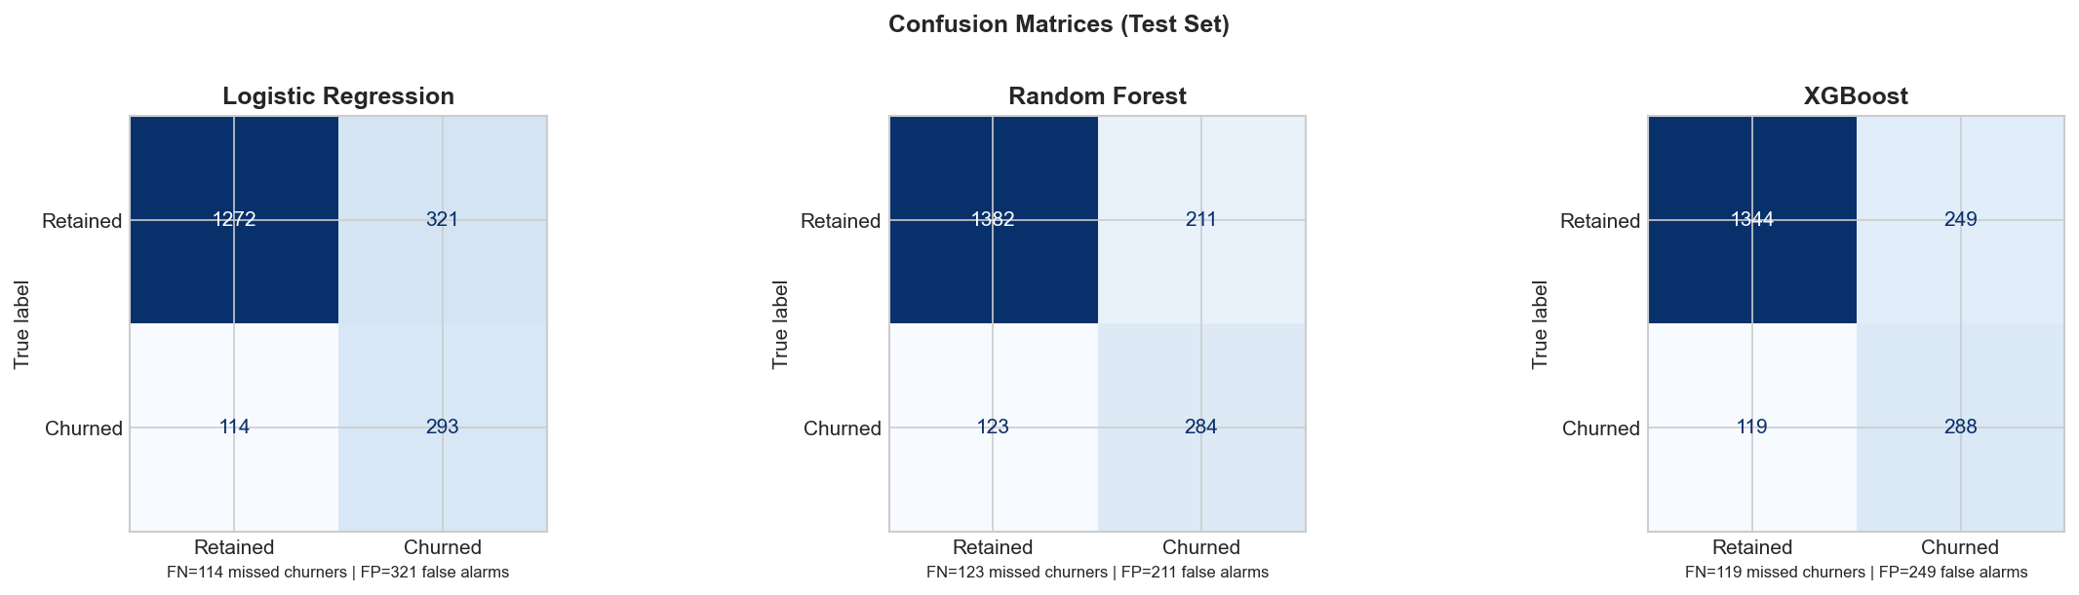
Plot 10 — Confusion Matrices Random Forest misses the fewest churners overall with the lowest false alarm count (211 false positives), while Logistic Regression catches the most churners (293) but at the cost of 321 false alarms. XGBoost balances between the two.

Plot 11 — Random Forest Feature Importance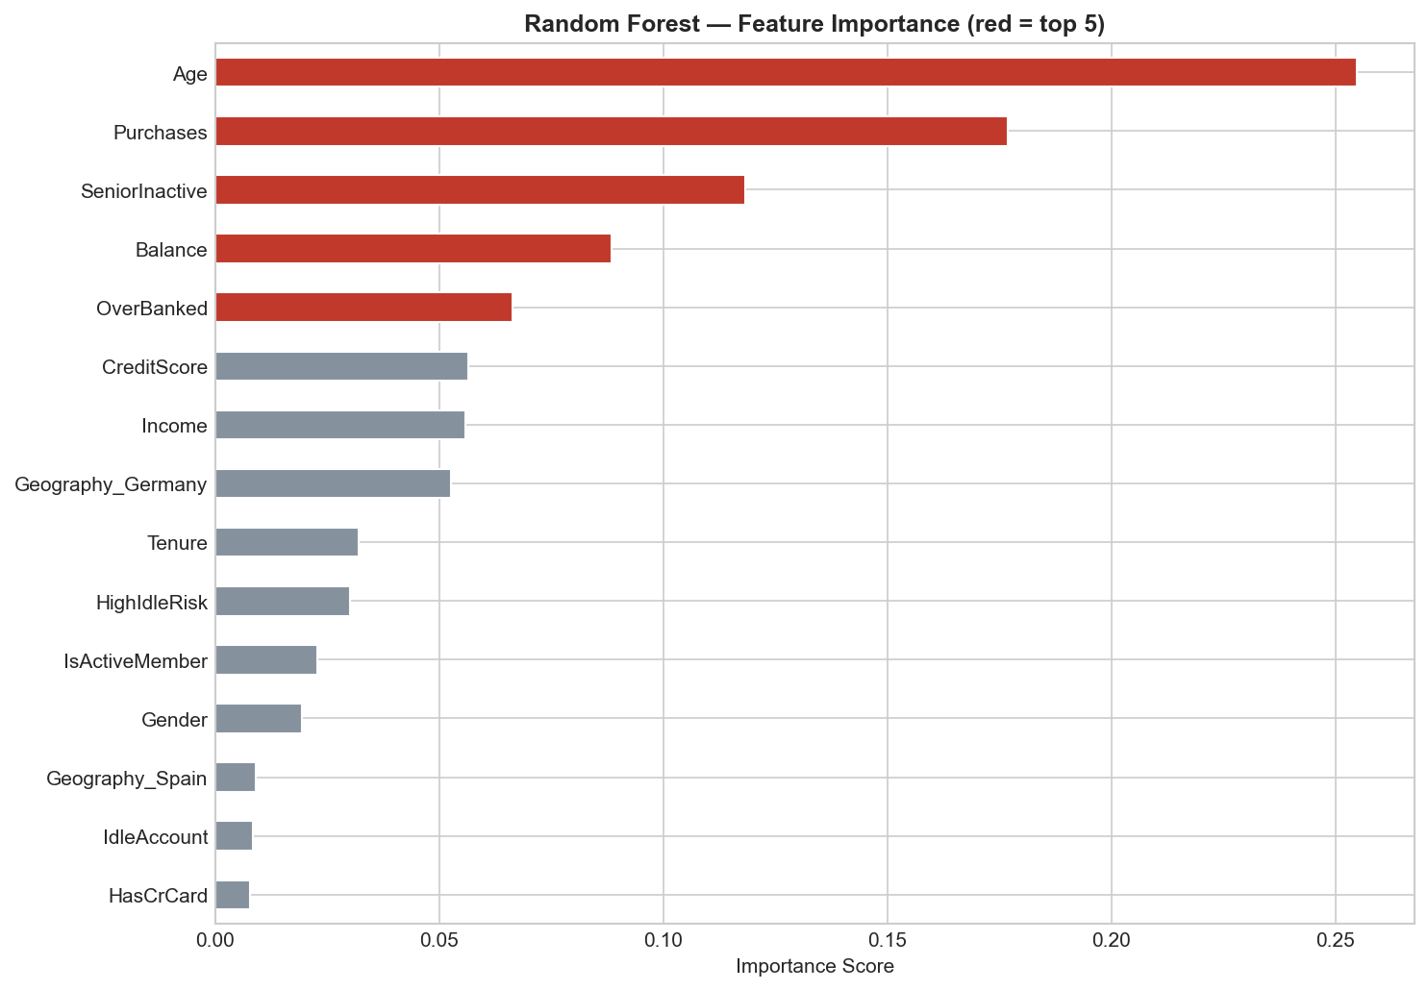
Plot 11 — Random Forest Feature Importance Age and Purchases dominate at 25.5% and 17.7%, followed by the engineered feature SeniorInactive at 11.8%. Three of the top five features are from the original dataset, with two engineered features also breaking into the top tier.
Plot 12 — XGBoost Feature Importance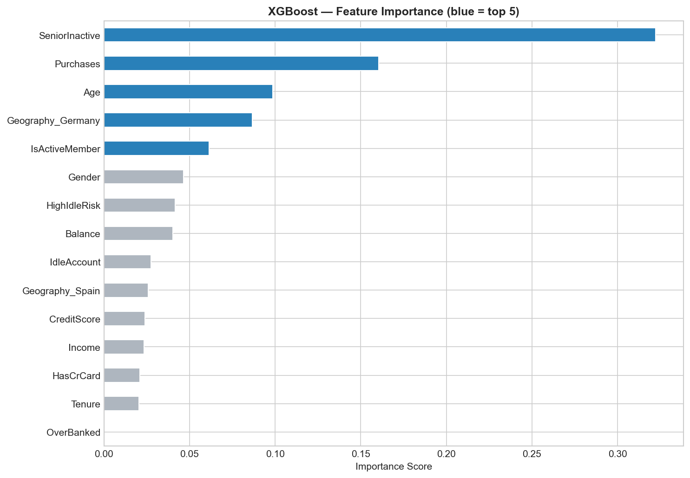
Plot 12 — XGBoost Feature Importance The engineered feature SeniorInactive ranks #1 at a dominant 32.2%, far ahead of Purchases (16%). This strongly validates the feature engineering step combining age and inactivity created a signal the model found more useful than either individual column.

Plot 13 — Random Forest: Before vs After Tuning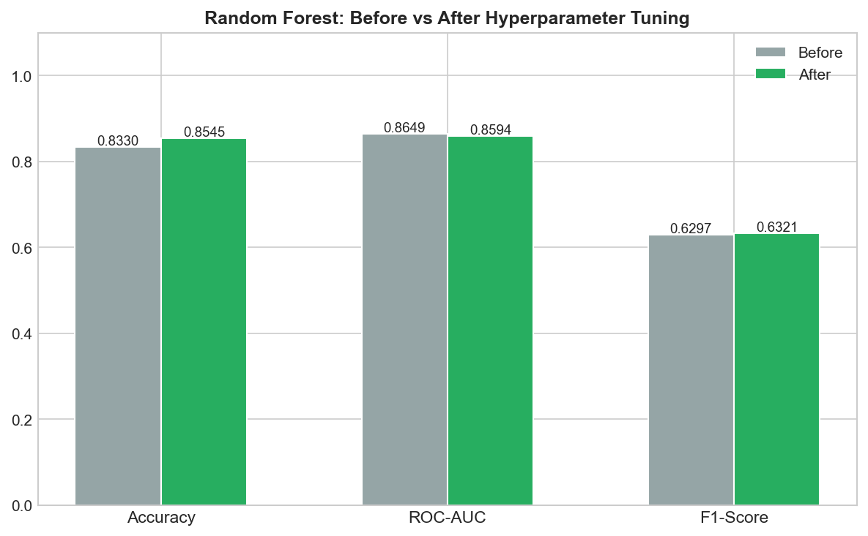
Plot 13 — Random Forest: Before vs After Tuning Hyperparameter tuning improved accuracy from 83.3% to 85.45% (+2.15 pp) while F1 barely moved (0.6297 -> 0.6321). The small gain confirms the default configuration was already reasonable and XGBoost's edge comes from its sequential architecture, not better tuning.

