Step 1 and 2)

Edited SSHD_config file and added a password to login

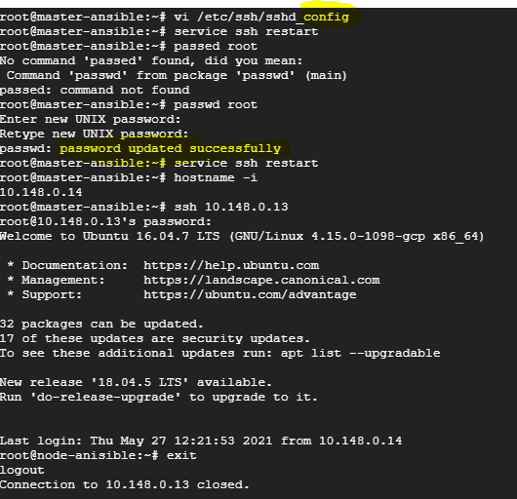

Adding a ssh public key to the node to connect by copying, now logging in without password

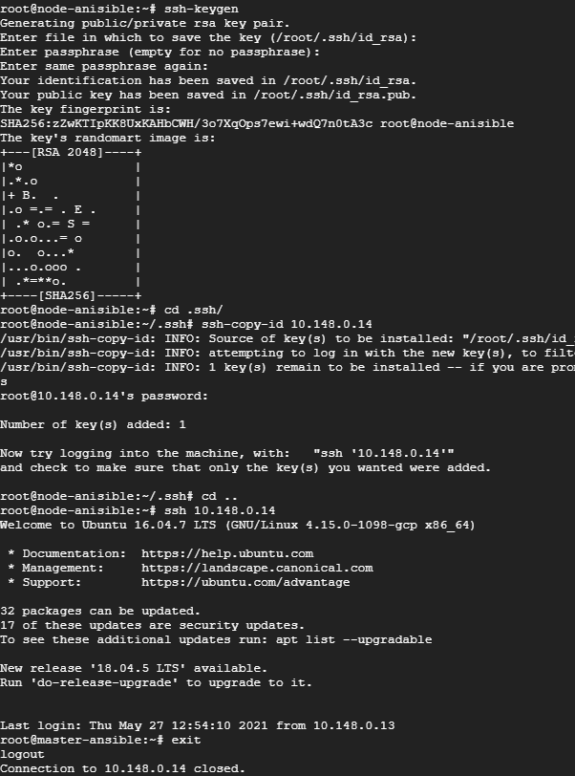

3) Login in to master and installing ansible

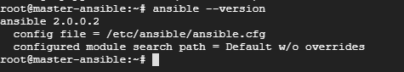

Adding the slave node IP in hosts and running ping

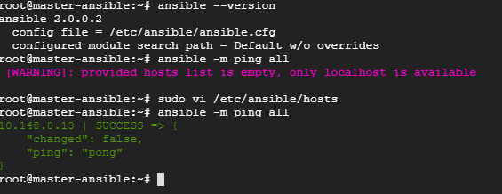

4) Creating yml file for playbook

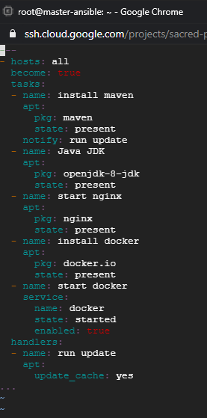

Running the playbook

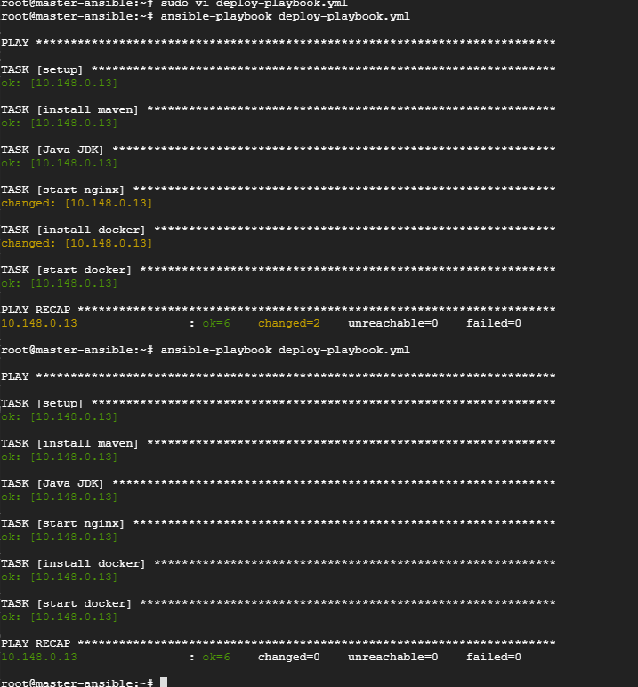

All version ID from slave

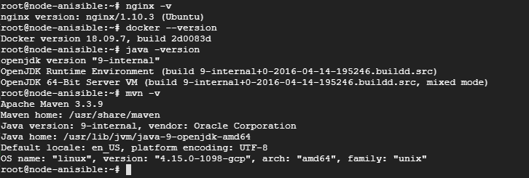

5) cloning repo in master

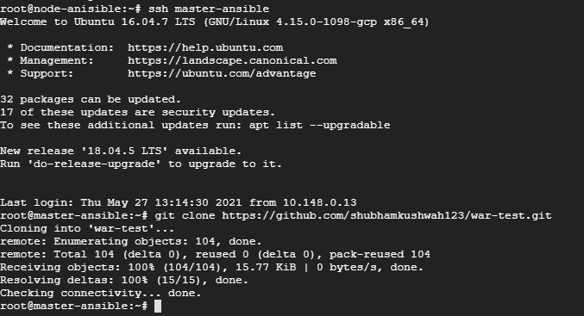

Creating war file with mvn command

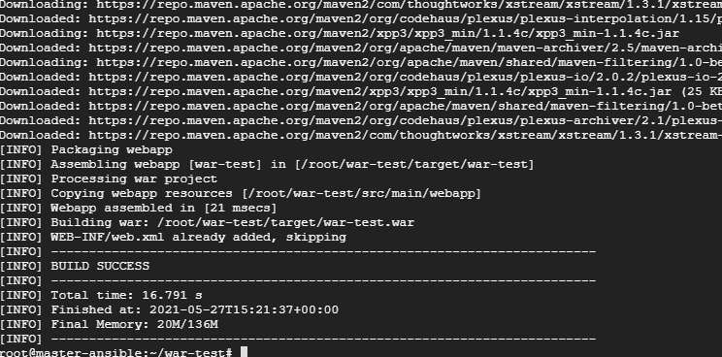

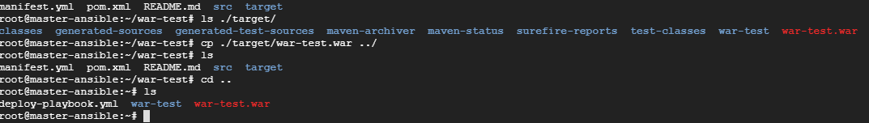

Creating dockerfile to build image with the war file

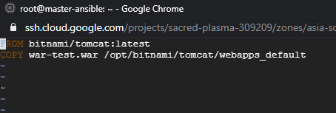

Creating image

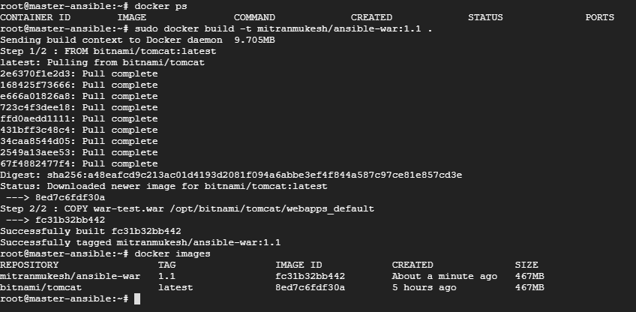

Pushing the image to dockerhub

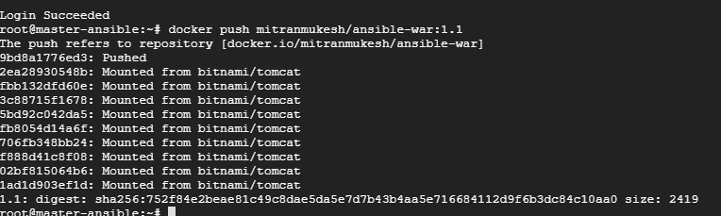

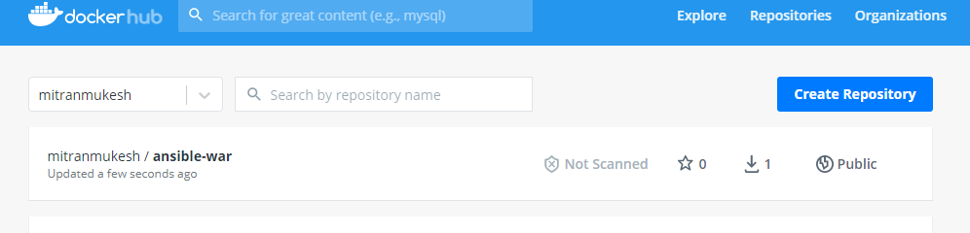

Editing the yml file to deploy the image in slave docker

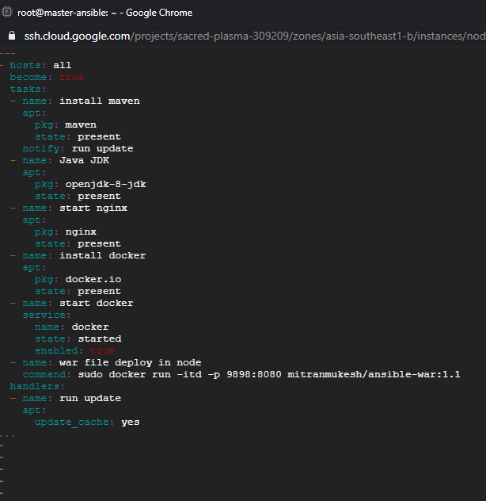

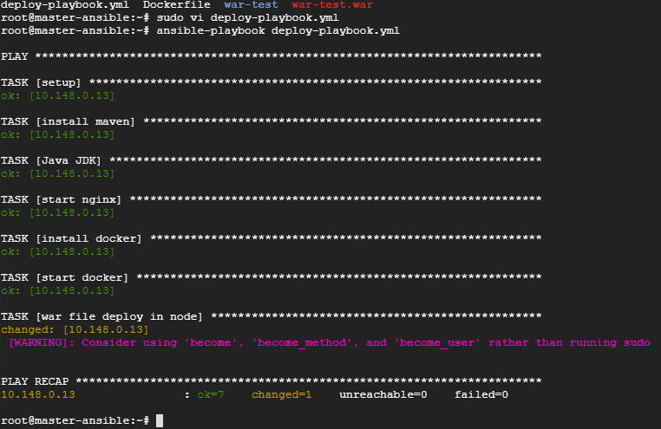

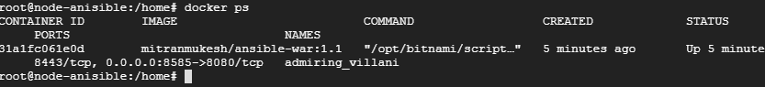

Deployed war file

