About
Peer2Peer is a simple application built using socket programming in C++ which is capable of transferring files over TCP. Since TCP is used file verification(hashing) is not considered.

Design
The P2P communication is achieved by two threads running under a main thread.
One thread acts as a server and other thread acts as a client running under a single process.
Thus if a new process is started it can communicate with each other. The hostname and port
is needed to make the connection.

Major Files:
P2Pmain.cpp : The main startup file, resposible to create two threads.
PeerReceiver.cpp: The peer receiver or the server thread, resposible to accept and provide files to other peers.
PeerSender.cpp: The peer sender or the client thread, resposible to connecte to other peers and give commands to download specific file.

OutPutLog:
The below section list the output of the running application. Since I have not two separate machines to test, I have ran two different process on the same machine with different server ports. Then the client of one is connected to the other. Below is a snapshot of the o/p.

1.Here Peer1 is started with command ./PeerToPeer
2. Hostname(localhost) and Port (8084)is entered by the user
3. The same step (1&2) is performed in another terminal (Peer2), with values(Hostname(localhost) and Port (8080))
4. Now Peer1 connects to Peer2 by providing hostname(localhost) and port(8080)
5. As the connection succeds, Peer2 server list all the files which can be downloaded by Peer1
6. The Peer1 now types the name of the file to be downloaded
7. Downloaded is sucessfull for 2 files.
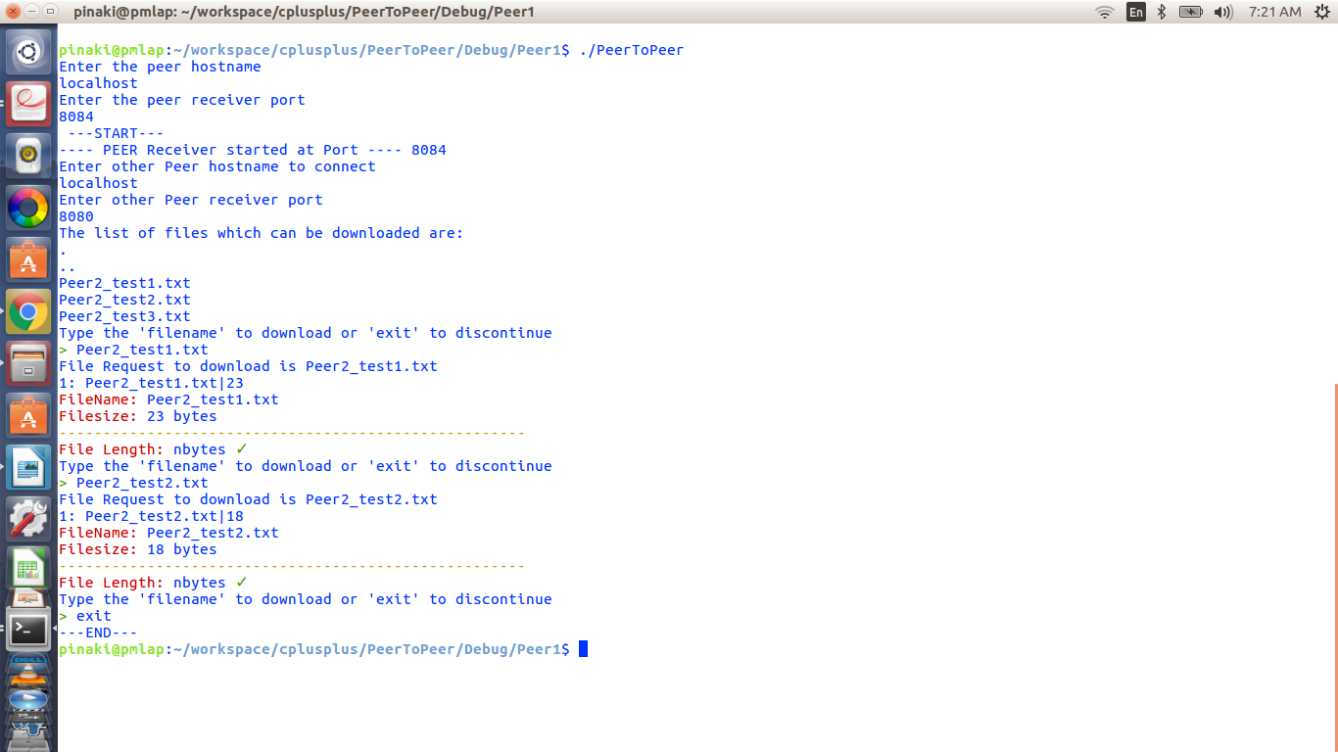
8. Peer1 close the connection by typing exit

How To Test:
A sample test is provided under the “Test” folder.
The `Test` directory contains a simple structure of a P2P setup with 2 peers, Peer1 and Peer2. Each of them have a shared directory named, `shared`. Each of them have a executable named `PeerToPeer` which can be used to create a connection between each other.

Environment/Tools:
A Linux ubuntu desltop:
`uname -a`
Linux pmlap 4.4.0-119-generic #143-Ubuntu SMP Mon Apr 2 16:08:24 UTC 2018 x86_64 x86_64 x86_64 GNU/Linux
Compiler : C++14
Editor: Eclipse

Limitation:
- The compiler warnings need to be fixed
- Error and Exception handling can be improved
- More test case and different file format need to be tested.
- Unit test case addition

Note:
The source and other required files will be attached in the mail.

