**Test Ingest Repository (TIR) General User Guide**

Table of Contents

1 References 6

2 Purpose 6

3 Getting Started 6

3.0 Request Account Access 6

3.1 Account Permissions 7

3.2 Login 7

4 Interfaces 8

4.1 Dashboard 8

4.2 Boundaries 9

4.3 Libraries 10

4.3.1 STIG Libraries 10

4.3.2 CCI Matrix 11

4.4 About Page 12

4.5 User Profile 12

4.6 Notifications 15

5 Creating your Work Environment 16

5.1 Creating Companies 16

5.2 Creating a Boundary 18

5.3 Adding Systems to your Boundary 21

5.3.1 Add Single System 21

5.3.2 Add System via Widget 22

5.3.3 Add Systems by Importing Scan Results via Folder(s) 23

5.3.4 Add Systems by Importing Scan Results via .Zip Folder 25

5.3.5 Add Systems by Importing Scan Results via CSV File 25

6 Changing Boundary and/or Company Permissions 26

6.1.1 Modify Company Permissions 26

6.1.2 Modify Boundary Permissions 27

7 Import Test Data for System 30

7.1 Manually Adding STIGs to a System 30

7.2 Adding Checklists and XCCDF Results Data to a System 32

7.2.1 Import Results via Folder 32

7.2.2 Import Results via Zip Folder 33

7.2.3 Import Results via Multiple File Selection 34

8 POA&M Management 34

8.1 Boundary View 35

8.1.1 System Statuses and Overrides 37

8.1.2 POAM Fields 38

8.2 System View 39

9 Exports 41

9.1 Plan of Action and Milestones (POA&M) 42

9.2 Findings 42

9.3 Checklists 43

Figure 1: Login Page 8

Figure 2: Dashboard 9

Figure 3: Companies in the Boundary Tab 10

Figure 4: Boundaries nested under Companies 10

[Figure 5: STIG Libraries 11](https://lmco.sharepoint.us/sites/US-ironforge_tir_subcommittee/Shared%20Documents/General/TIR%20User%20Guides/Test%20Ingest%20Repository%20(TIR)%20General%20User%20Guide_RevC.docx#_Toc164252360)

Figure 6: CCI Matrix 12

Figure 7: About Page 12

Figure 8: User Profile 13

Figure 9: Change Password 13

Figure 10: Time Zones 14

Figure 11: Create API Token 14

Figure 12: Light Mode vs Dark Mode 15

Figure 13: Notification Bell 15

Figure 14: Notification Alert Center 16

Figure 15: Example Boundary Structures 17

Figure 16: Creating a Company 17

Figure 17: Companies Example 18

Figure 18: Creating a Boundary/Enclave 19

Figure 19: Viewing the list of created Boundaries 19

Figure 20: Boundary Overview 20

Figure 21: Add System Options 21

Figure 22: Add Single System 22

Figure 23: Duplicate a System by using the Widget 23

Figure 24: Standardized Organizational Structure for Folder Imports 23

Figure 25: Adding Systems via Folder(s) 24

Figure 26: Confirm Upload 24

Figure 27: Verifying Successful Creation of Systems 25

Figure 28: Adding System via .Zip Folder 25

Figure 29: Modify Company Permissions 26

Figure 30: Adding Members – Search Users 26

Figure 31: Manage Members – Choose level of Access 27

Figure 32: Member Access – User Added with Editor Role 27

Figure 33: Modify Company Permissions 28

Figure 34: Adding Members – Search Users 28

Figure 35: Manage Members – Choose level of Access 29

Figure 36: Member Access – User Added with Editor Role 29

Figure 37: Upload Test Data to your System 30

Figure 38: Adding STIGs to your System 31

Figure 39: Successfully added STIGs to your System 31

Figure 40: Import Test Data via Folder 32

Figure 41: Successful Upload of Results via Folder 33

Figure 42: Import Results Data via Zip Folder 33

Figure 43: Upload Test Data via Multiple File Selection 34

Figure 44: Export Data 41

Figure 45: Export Options 42

Figure 46: POAM Output 42

Figure 47: Export Findings 43

Figure 48: Findings Worksheet Output 43

Figure 49: Checklist Export – Default 44

Figure 50: Checklist Export – Folders 44

Figure 51: Checklist Export – Multiple Checklists 44

Figure 52: Checklist Export – Single STIG per Checklist 45

Figure 53: Checklist Export – Folders - Single STIG per System 45

Figure 54: Checklist Export – Single STIG per System 45

# References

For documentation related to the deployment and installation of the Test Ingest Repository please see the **Test Ingest Repository (TIR) Deployment Guide**.

For documentation related to the administration of the Test Ingest Repository please see **Test Ingest Repository (TIR) Privileged User Guide**.

# Purpose

The purpose of this document is to provide a guide for General User functions for Test Ingest Repository (TIR). This guide is designed for authorized Information System Security Officers (ISSO), Information System Security Managers (ISSM), and System Administrators responsible for maintaining compliance and Continuous Monitoring (ConMon) for systems and/or networks, where TIR is deployed.

TIR is a MITRE Security Assessment Framework (SAF) tool, built in collaboration with Lockheed Martin, that is used to support boundary compliance, software compliance, and continuous monitoring.

TIR Users have access to certain features in the software. TIR Users have the ability to create new Companies and Boundaries. The user that creates a Company or Boundary will be assigned the owner permissions of that Company or Boundary by default. For Boundaries and Companies that were not created by the user, access will need to be granted by an Admin or Owner. This helps maintain required separation of roles and responsibilities within TIR.

# Getting Started

TIR is a repository that will store and manage your system or network’s STIG compliance and Plans of Actions and Milestones (POA&M). Your TIR instance should be deployed and configured by your System Administrator, and access through a web browser. For information about deploying TIR to a new environment please see the Test Ingest Repository (TIR) Deployment Guide.

## Request Account Access

Please follow instructions defined by your program to request an account. Administrators have access to create accounts and reset passwords.

## Account Permissions

TIR has two types of users, Administrators and Users. Administrators have access to the **Administration,** **Libraries**, and **Boundary** tabs. Users only have access to Libraries and Boundary tabs. TIR is setup as a hierarchical system with Companies and Boundaries. Users can be granted permissions to be Owners, Reviewers, and Editors for Companies and Boundaries. A summary of permissions is show in Table 1, below.

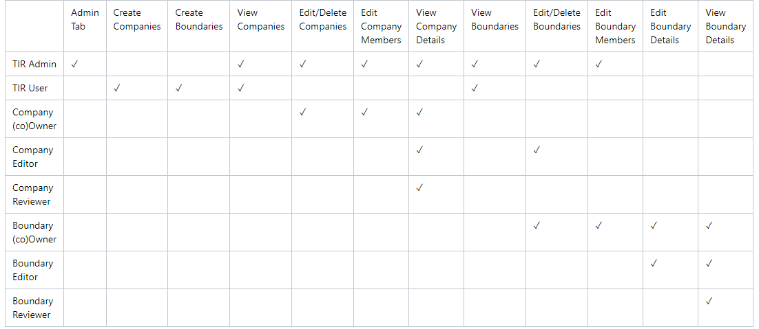

Table 1: Access Control – User Permissions

## Login

Once your account has been created, please navigate to the TIR home page. Enter your **Username** and P**assword**, then review the **IS User Agreement** and acknowledge that you have read it by clicking the check box. Then, click **Sign in**.

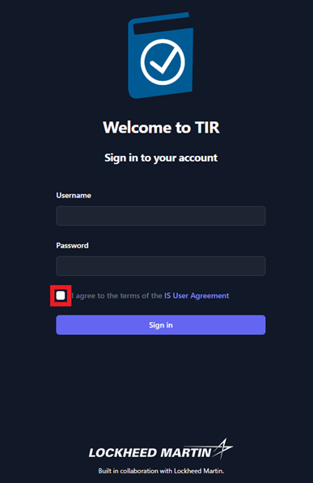

Figure 1: Login Page

# Interfaces

Upon a successful login, the user will be welcomed into TIR and the **Dashboard** will be displayed. At the top of the page, you will see three buttons: **Dashboard**, **Boundaries**, and **Libraries**. In later sections of this guide, you will find detailed instructions on how to properly configure and use each of these interfaces.

## Dashboard

The dashboard will show you the most recent changes to your TIR instance and will display any important upcoming dates that the user should be aware of. Some examples of displayable content include; recent changes to Boundaries and the newest Security Technical Implementation Guide (STIG) libraries imported.

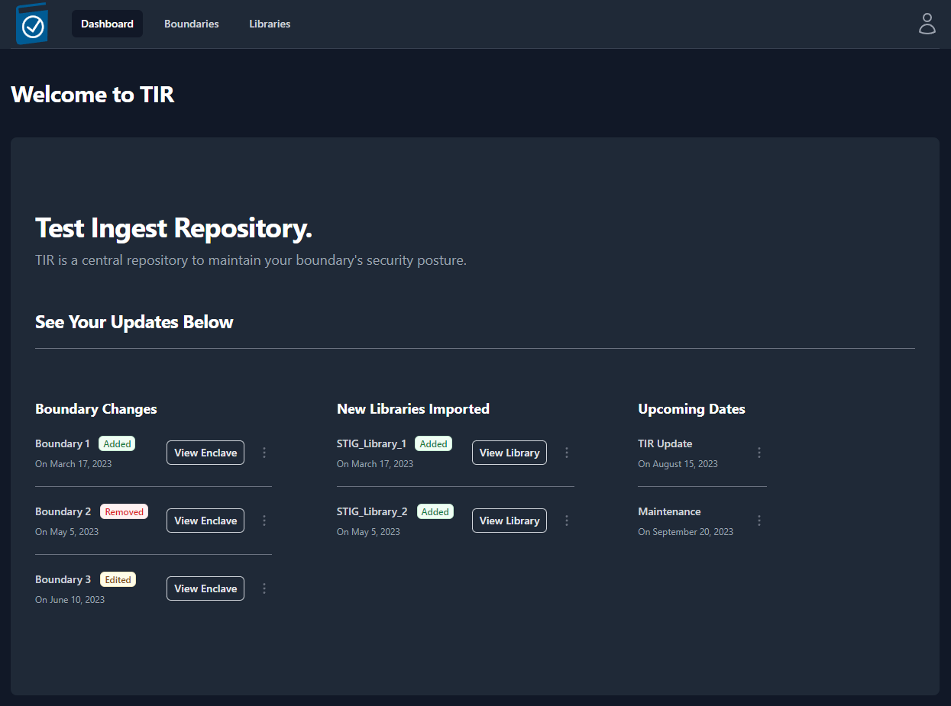

Figure 2: Dashboard

## Boundaries

The Boundary tab contains “Companies” and “Boundaries” in a hierarchical structure to best support multiple programs within a single TIR instance. Companies will be used to store and organize Boundaries. The Boundaries will store your Systems and all of the STIG data associated with those Systems. Permissions can be granted to Companies or Boundaries and your permissions will be granted based on the Role of your user account (see Table 1 for user permissions).

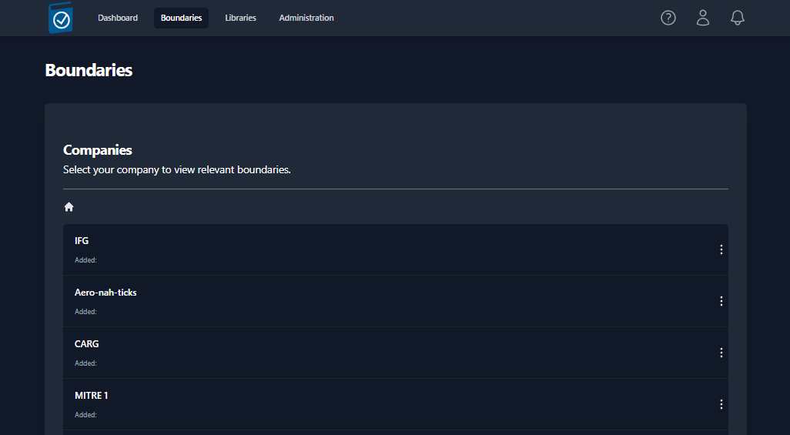

Figure 3: Companies in the Boundary Tab

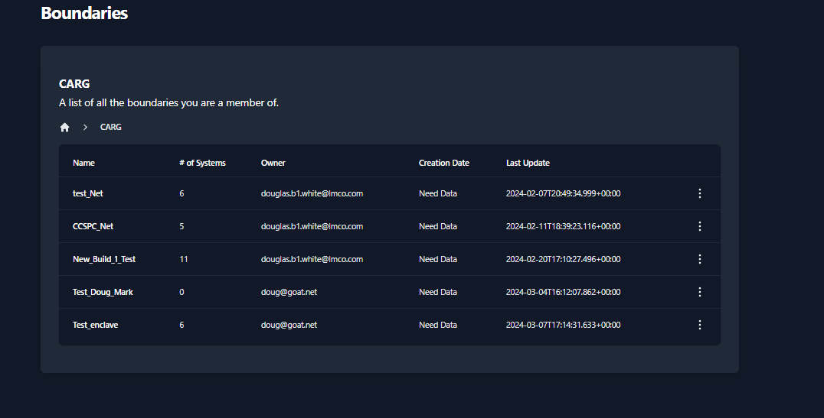

Figure 4: Boundaries nested under Companies

## Libraries

The Libraries tab provides the ability to import new STIG libraries and updated Control Correlation Identifiers (CCI) mappings for different NIST SP 800-53 revisions.

### STIG Libraries

The Department of Defense (DoD) releases quarterly updates to the STIG benchmarks. STIG Libraries can be downloaded at <public.cyber.mil>. These quarterly updates are released as .zip files. Once downloaded, the .zip files can be uploaded to TIR and made available to all users.

#### View STIG Libraries

Navigate to the **Libraries** page by clicking the **Libraries** button at the top on the page.

The **Libraries** page will display all of the STIG libraries that have been uploaded to your TIR instance.

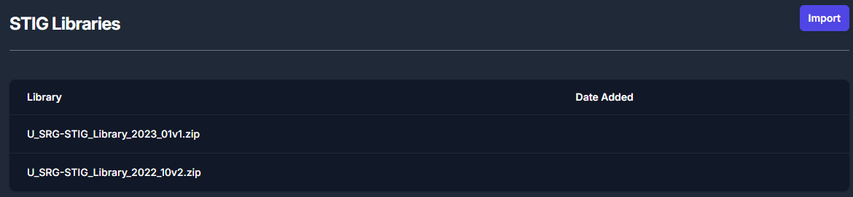

Figure 5: STIG Libraries

#### Import STIG Libraries

To import a new STIG library, navigate to the **Libraries** page and click the **Import** button inside the **STIG Libraries** section. For reference, this button can be found in the top right of *Figure 5: STIG Libraries*.

The **Import** button will open a file navigation window. Navigate to the .zip file containing the STIG Library and click **Open**.

Once imported, the STIG libraries will follow a standardized naming convention. The naming convention will follow this template: **U_SRG-STIG_Library_{year}_{month}{revision}.zip**.

Please refer to the table below for more examples.

|  |  |  |  |
| --- | --- | --- | --- |
| **Year** | **Release Quarter/ Month** | **Revision** | **Naming Convention** |
| 2022 | Q1 / January (01) | v1 | U_SRG-STIG_Library_2022_01v1.zip |
| 2022 | Q2 / April (04) | v2 | U_SRG-STIG_Library_2022_04v2.zip |
| 2023 | Q3 / July (07) | v1 | U_SRG-STIG_Library_2023_07v1.zip |
| 2023 | Q4 / October (10) | v2 | U_SRG-STIG_Library_2023_10v2.zip |

Table 2: STIG Library Naming Conventions

### CCI Matrix

CCI mappings are distributed by NIST and are updated as necessary. The latest CCI Matrix can be downloaded at the following <https://public.cyber.mil/stigs/cci/>. Please note that CCI mappings differ between SP 800-53 Rev 4 and Rev 5, and keeping this updated will ensure more granular mapping of STIGs to applicable CCIs.

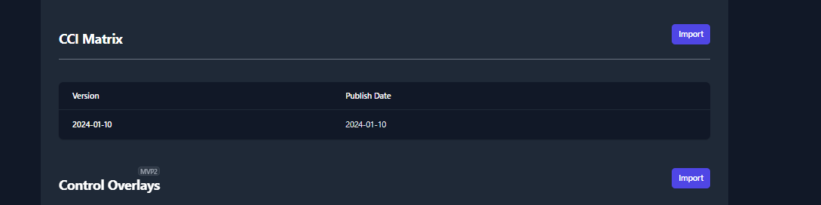

Figure 6: CCI Matrix

#### Import CCI Matrix Updates

To import a new CCI Matrix, navigate to the Libraries page and click the Import button inside the CCI Matrix section. For reference, this button can be found in the top right of Figure 6: CCI Matrix.

## About Page

The **About Page** will let the user know what version of TIR they are currently accessing as well as the date that the current version was pushed to their environment.

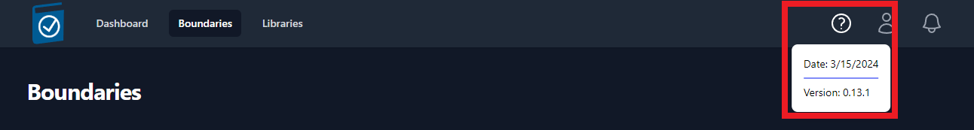

Figure 7: About Page

## User Profile

The User Profile icon looks like a person and is located in the top-right of the screen. To access your profile, click the **Icon** and then click **Your Profile** (as seen in Figure 8). If you wish to sign out, you can find the **Sign Out** button located under **Your Profile**.

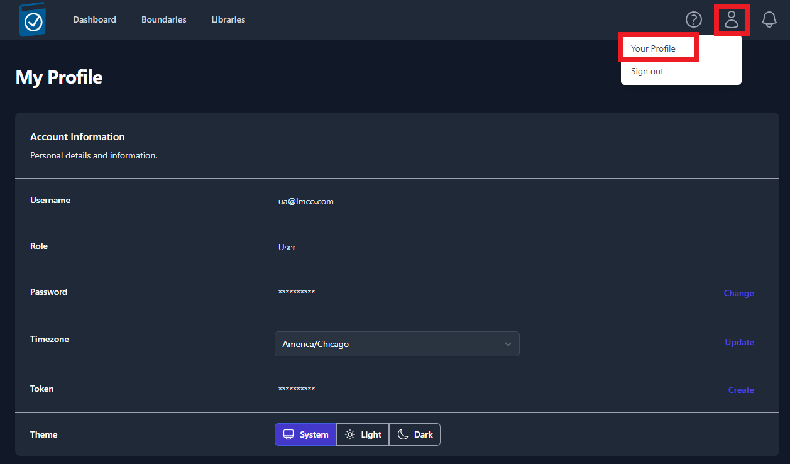

Figure 8: User Profile

Your **User Profile** will display your **Username**, **Role**, **Hidden Password**, **Time zone**, **API Token**, and **Color Theme**.

* To change your password, click the **Change** button located on the right-side of the **Password** row. Enter a **New Password**, **Confirm the Password**, and click **Save**.

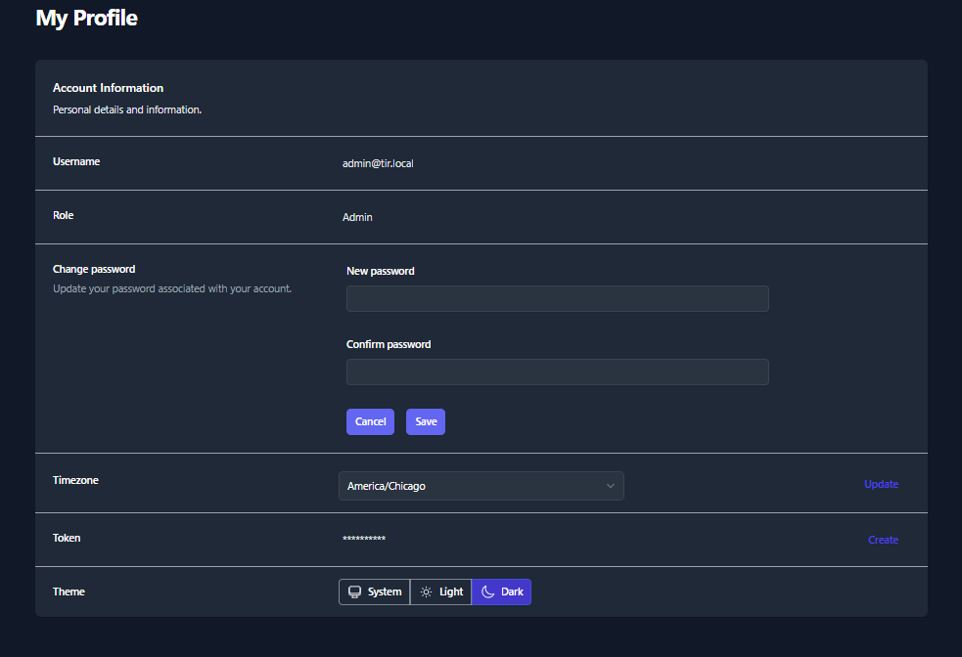

Figure 9: Change Password

* To update your Time zone, select a new time zone from the drop-down menu and click **Update** button located on the right-side of the **Timezone** row.

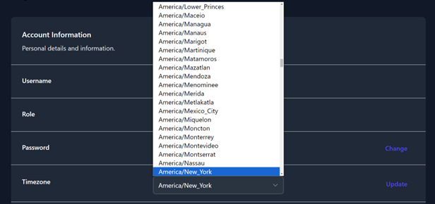

Figure 10: Time Zones

* To create an **API Token**, click the **Create** button on the right-side of the **Token** row. Enter a **Token Name** and an **Expiration Data,** then click **Generate**. A pop-up window will appear that contains your **Token Code**. Please save that code before closing the window. A list of your existing tokens can be found in the **Token Table**. Please see Figure 11 as an example.

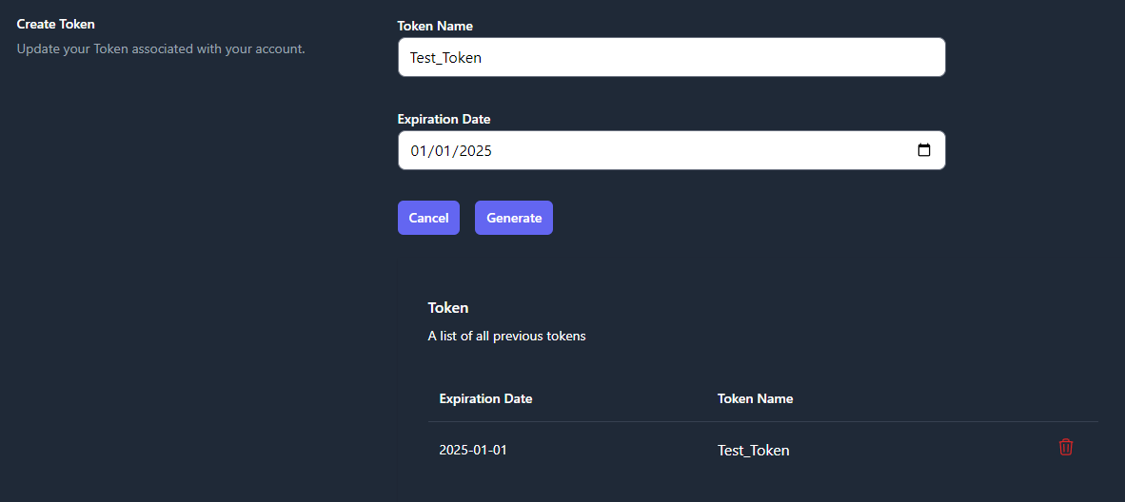

Figure 11: Create API Token

* To change the **Coloring Theme** of TIR, choose **System**, **Light**, or **Dark** from the **Theme** row. The **System** option will use the theme from your client system’s settings.

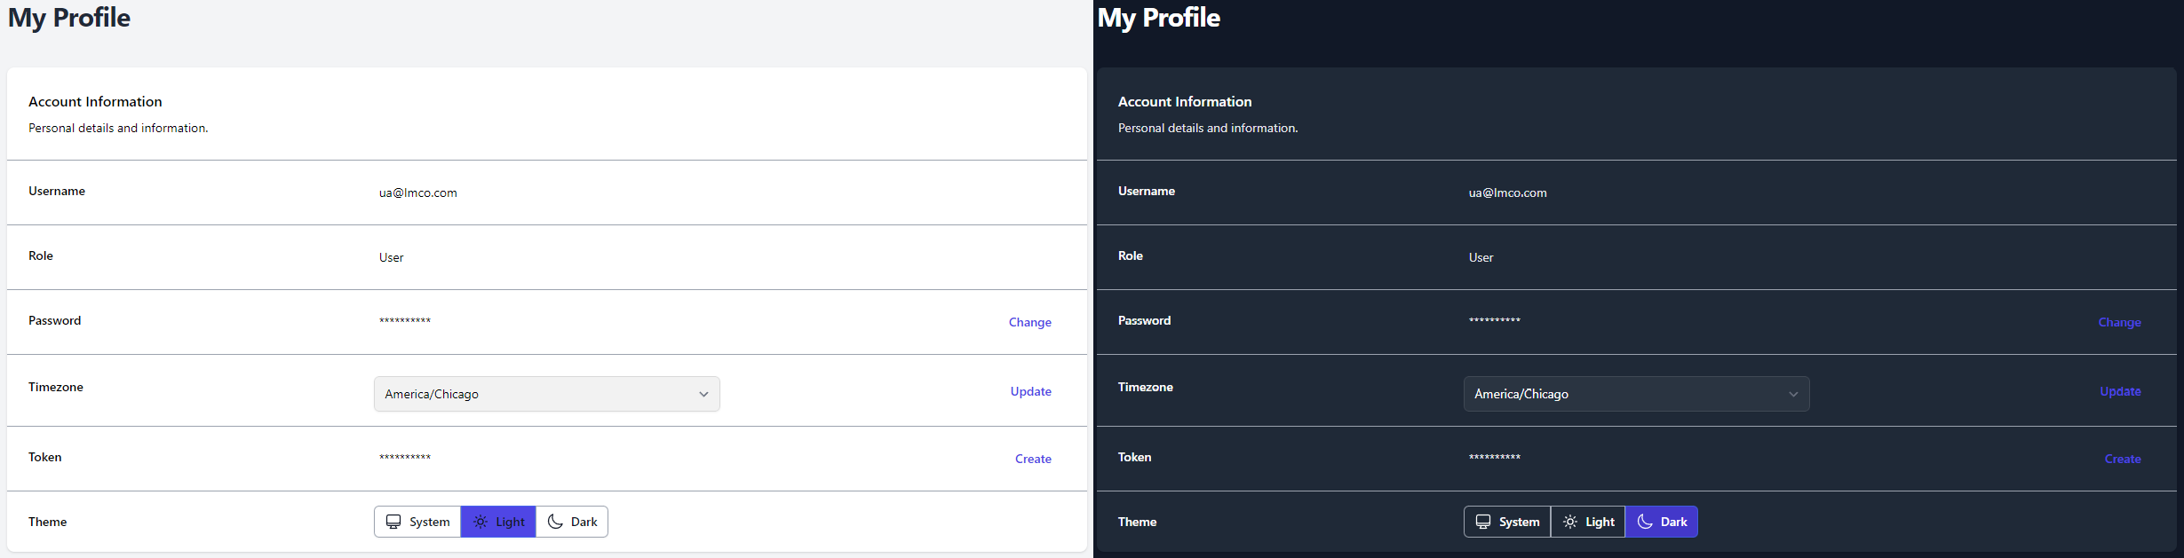

Figure 12: Light Mode vs Dark Mode

## Notifications

Users will receive notifications about important dates related to their Boundaries and when new STIG Libraries are available. The notification for a new STIG Library will be sent out to all Boundary Owners once a new STIG Library is imported into your TIR instance. These notifications will be displayed by the **Bell** icon in the top-right of the screen (as seen in Figure 13). A snippet of each unread notification will be displayed from this view.

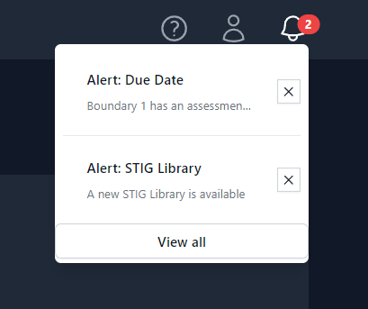

Figure 13: Notification Bell

To view all of your notifications, press the **View all** button at the bottom of the Notification Bell menu (Figure 13). An example of the full notification page can be seen below in Figure 14.

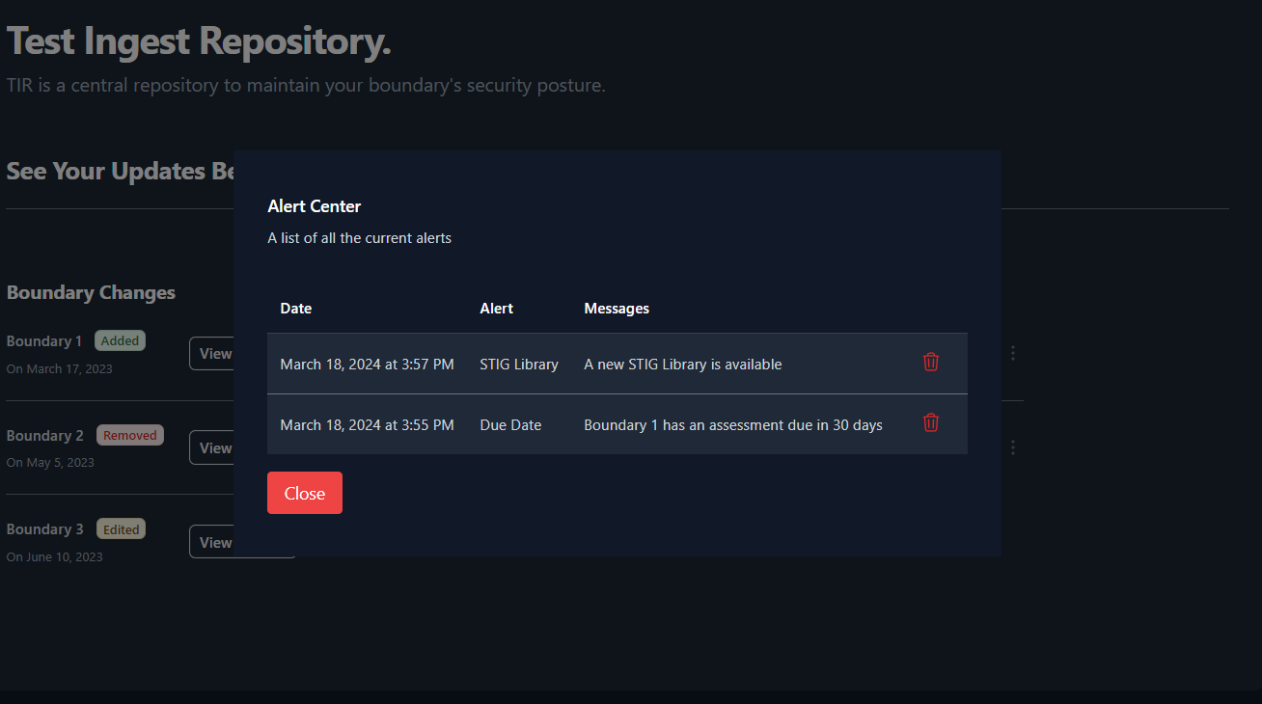

Figure 14: Notification Alert Center

# Creating your Work Environment

The Test Ingest Repository is designed to a store your boundary composition in a hierarchical format. Before you can begin your cyber assessment, you will need to create the path to store your boundary’s scan data.

All instructions within this section will be explicitly from the **Boundaries** interface.

## Creating Companies

The **Boundaries** landing page will show you the highest level of your organizational structure.

The structure of your boundaries will depend greatly on where TIR is being hosted. For environments being accessed by a wide range of users, compartmentalization will be important. For smaller environments, the compartmentalization structure will not need to be as extravagant.

The owner of each boundary will be responsible for creating their **Boundary** inside of TIR. Before creating a boundary, please strategize on the access control elements of your boundary. When creating a boundary, the user will have the option to add a **Company** or add a **Boundary**. The **Companies** are used as a nesting structure to organize where your boundary is stored. The **Boundaries** will be a container that stores all of the cyber assessment data and will provide a workspace to address any findings. To compare to a traditional directory structure, the **Companies** will act as the higher-level directories and the **Boundaries** will act as the lowest level directory. **Systems** will be added to each boundary, and those **Systems** will be the equivalent to actual files existing in your directories.

To better illustrate this comparison to the traditional directory structure, please refer to the Figure 15: Example Boundary Structures below.

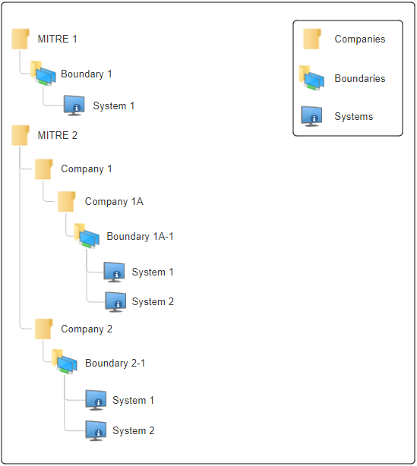

Figure 15: Example Boundary Structures

With that illustration in mind, let’s get started with creating boundaries inside of TIR. Navigate to the **Boundaries** page by clicking the **Boundaries** button at the top on the page. To create a new company, click the **[+] Company** button as shown in Figure 16.

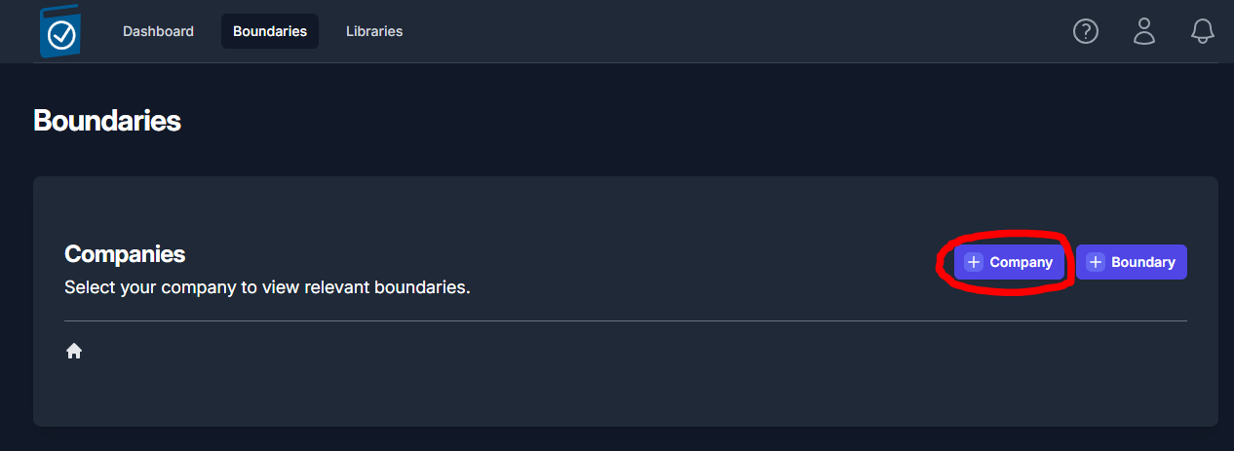

Figure 16: Creating a Company

A side panel will open from the right of the screen. Enter the name of the company into the **Company Name** text field and click **Save**.

You should now see an item titled with the name you entered into the **Company Name** field. For demonstration purposes, we’ll use the example from Figure 15. We’ll start by creating a company for MITRE 1 and MITRE 2, as seen in Figure 17.

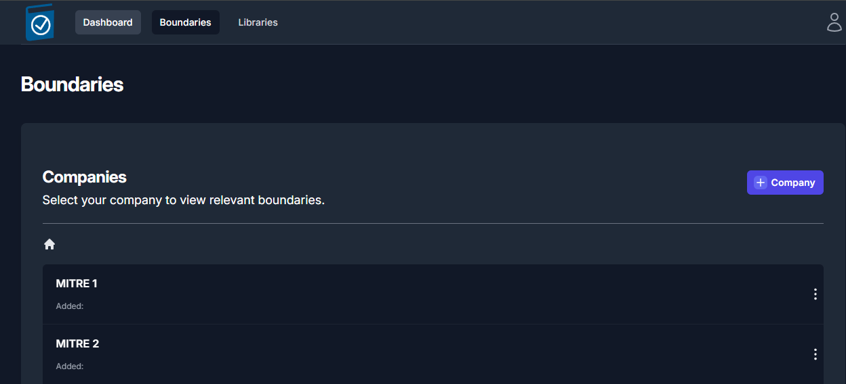

Figure 17: Companies Example

Navigate inside of your newly created Company by clicking on the item (ex: MITRE1). Once navigating inside a new Company, you will see the **[+] Company** and **[+] Boundary** buttons. You have the ability to create as many nested Companies as you see fit.

It is important to note that Boundaries can only exist at the lowest level of a company. A company cannot hold both Boundaries and Companies at the same level. This means; once you click the **[+] Boundary** button inside a Company, you will not be able to nest any more Companies. This works likewise for when you are nesting Companies. Once you click the **[+] Company** button, you will not be able to create a Boundaries at the level where a Company exists.

## Creating a Boundary

Once you are ready to create a **Boundary**, navigate to an empty Company and click the **[+] Boundary** button. A side panel will slide out from right side of the screen (Figure 18) that will require you to fill out a couple fields. Once you have completed all of the fields, click the **Save** in the bottom-right of the side panel. See Table 3 below for more information on the Boundary fields.

|  |  |  |  |
| --- | --- | --- | --- |
| **Field** | **Required** | **Description** | **Default Value** |
| Enclave Name | Yes | Name of your Boundary |  |
| Owner | Yes | Owner of the Boundary | The current user |
| STIG Baseline | Yes | Set the STIG baseline | The latest STIG Baseline |
| RMF Versions | Yes | Set the Cybersecurity Framework | NIST SP 800-53 |
| Classification | Yes | Classification Marking |  |
| Caveat | No | Additional Classification Markings |  |

Table 3: Boundary Settings

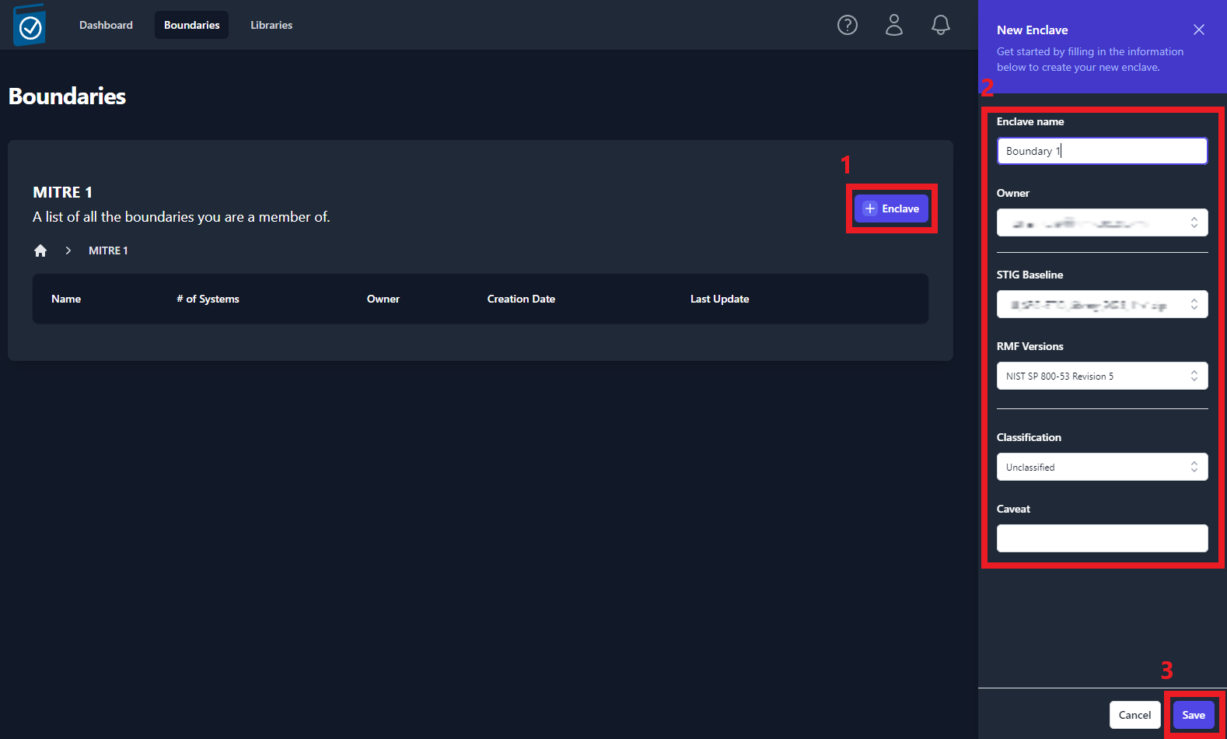

Figure 18: Creating a Boundary/Enclave

Your newly created boundary will appear in the table, as shown in *Figure 19: Viewing the list* of created Boundar*y*. To view your boundary, click on the item in the table.

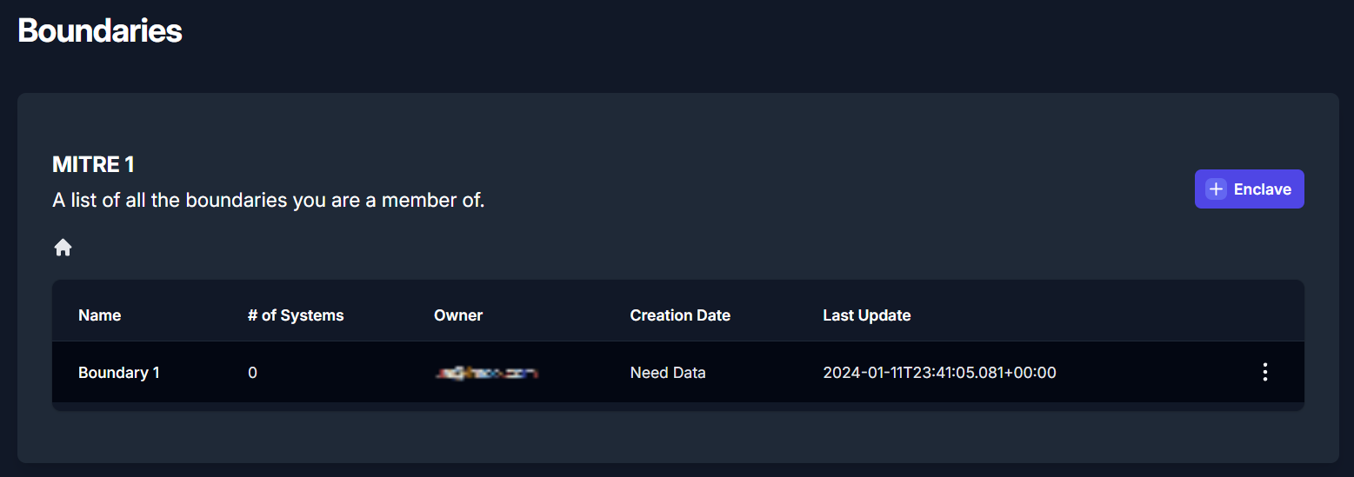

Figure 19: Viewing the list of created Boundaries

When a Boundary is selected, you will be taken to the Overview sub-tab of the Boundary dashboard. The boundary overview sub-tab will display a high-level overview of your systems and the findings associated with each system.

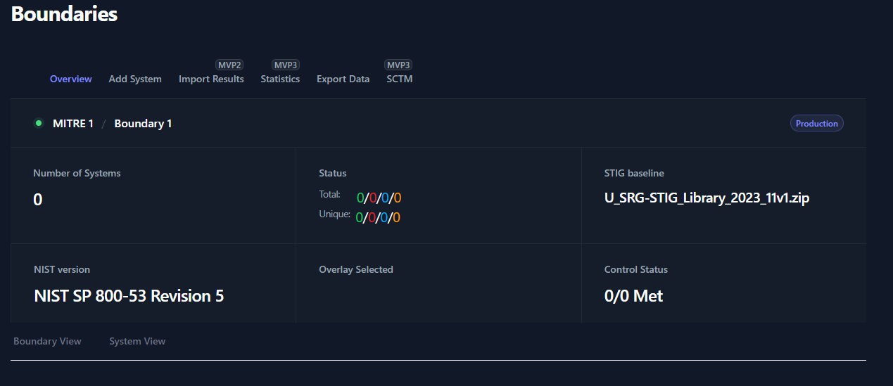

Figure 20: Boundary Overview

* At the top of the Boundary Overview table you will find the **Path to your Boundary** with breadcrumbs that a linked back to each parent for easy navigation.
* The **Number of Systems** field will display the amount of Systems that have been added to your boundary.
* The **Status** fields will display a total number of STIG checks and the unique number of STIG checks. The total number of checks come from the sum of the total checks for each system. The number of unique checks come from the statuses of the checks contained inside the Boundary applied STIGs. For example, if two systems have the same STIG check set to Open, this will count as **two** open findings for the **Total** count but only **one** open finding for the **Unique** count.
* The **STIG baseline** field will display the STIG Library set for this boundary. This STIG baseline can be updated as new STIG Libraries become available. To update this field for your boundary:
  1. Import STIG Libraries
  2. Navigate to your boundary’s **parent folder**, press the **three dots** to the right of your boundary, select **Edit**
  3. Use the drop-down menu for **STIG Baseline** to select the newest STIG Baseline
  4. Click **Save**
* The **NIST version** field will display RMF Framework that was assigned to your boundary.
* The **Overlay Selected** and **Control Status** fields are for future development.

## Adding Systems to your Boundary

Navigate to the Boundary that you wish to add a system to. Click the **Add System** sub-tab and view the available options.

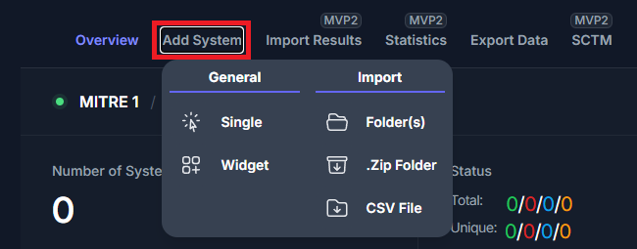

Figure 21: Add System Options

There are five options available when adding a system to your boundary:

|  |  |  |
| --- | --- | --- |
| **Field** | **Description** | **Required Inputs** |
| Single | * Manually create a single system | System Name |
| Widget | * Load blank STIG Checklists * Duplicate Existing Systems | System Name  STIG Checklists |
| Folder(s) | * Import Scan Results (CKL, XCCDF) | Directory |
| .Zip Folder | * Import Scan Results (.ZIP) | .Zip Folder |
| CSV File | * Import a List of Systems | .Csv File |

Table 4: System Creation Types

The **Single** and **Widget** options are manual options for creating a system. The **Folder(s)** and **.Zip Folder** options allow you to create your boundary using your results from your cyber scans. The final option for adding systems to your boundary is the **CSV File**. The CSV File will allow you to pre-build out your boundary by providing a list of names for each of your systems.

### Add Single System

The single system add feature will allow to create a new system inside of your boundary. When creating a new system, you will be asked to assign the system a name and click Save. This newly created system will be blank. For this system to be functional, you will need to add STIG checklist(s) and/or scan results.

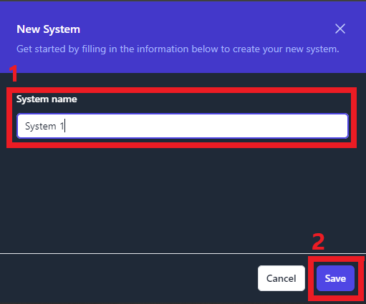

Figure 22: Add Single System

### Add System via Widget

The Widget feature is primarily used to duplicate existing Systems inside of your boundary. When adding Systems manually, this tool eliminates some of the manual steps of creating a new System. You’ll have the ability to duplicate as many systems as needed.

The Widget tool is useful when creating systems that mirror already existing systems in your boundary. For example, if you have multiple workstations that will contain the same STIGs, you can create the system and duplicate it for each mirrored workstation in your boundary.

To duplicate a system using the Widget, navigate inside of your boundary, click **Add System** and then click **Widget** (as seen inFigure 21**)**. A pop-up window will appear (as seen in figure 21). Locate the system that you wish to duplicate and click the **Duplicate** button on the right side of the row. This will create a new system and apply the exact same STIGs that previous system contained. To rename this new system, type the new name into the **System Name** field. To add additional STIGs, use the **STIGs** field. Finally, to remove any STIGs, navigate to the **Applied** STIGs field and click the **X** to the left of the STIG.

Once you are satisfied with the new system(s) click the **Create Systems** button. For an example of using the widget tool, see Figure 23.

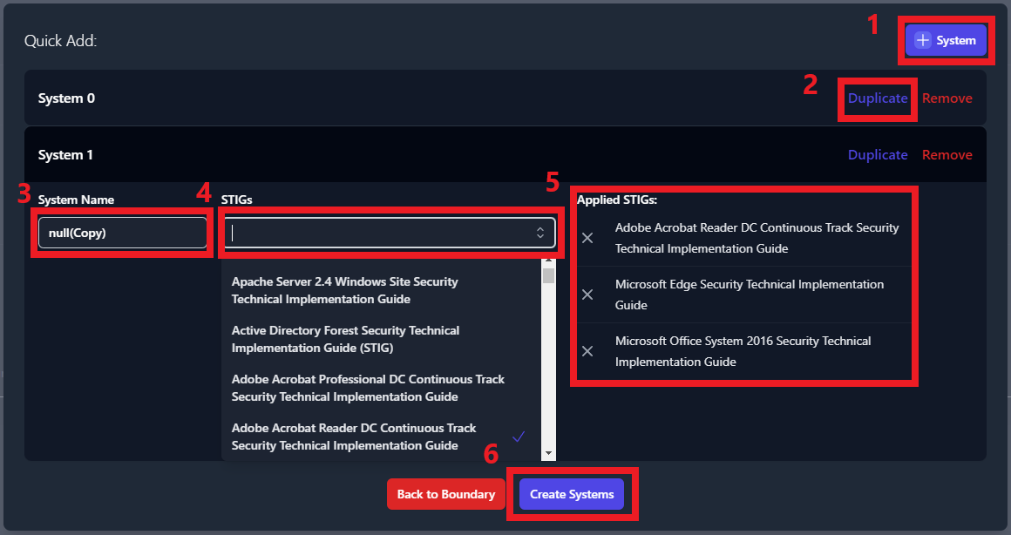

Figure 23: Duplicate a System by using the Widget

### Add Systems by Importing Scan Results via Folder(s)

This method of adding systems will require scan results from each of the systems in your boundary. This import function supports CKL and XCCDF file formats, and automates the creation of the systems inside of your boundary.

There is a standard format that your cyber scan data will need to be organized in for this tool to correctly build your boundary. First, a parent folder for your boundary needs to be created. Then, navigate inside of your boundary folder and create a folder for each system in your boundary. Inside of each of these system folders, place all of the cyber scan data (.ckl and .xccdf files) associated to that system.

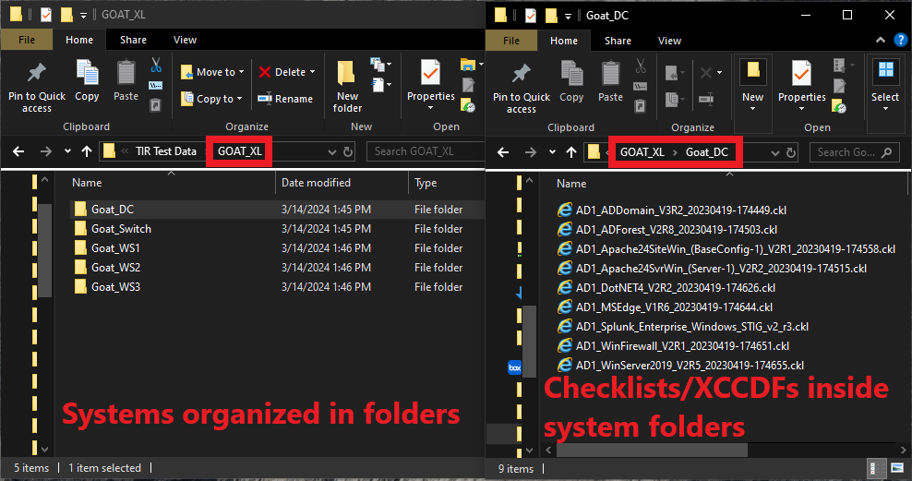

Figure 24: Standardized Organizational Structure for Folder Imports

To create systems by using cyber scan data, navigate inside of your boundary, click **Add System** and then click **Folder(s)** (as seen inFigure 25**)**. A file navigation window will open which will ask you to select a folder. It is very important that you select the parent folder that contains individual folders for each system on your boundary. When clicking the **Upload** button (inside the file navigation window), you should be looking at all of the folders with your system names and the parent folder should be displayed in the **Folder** field directly above the **Upload** button.

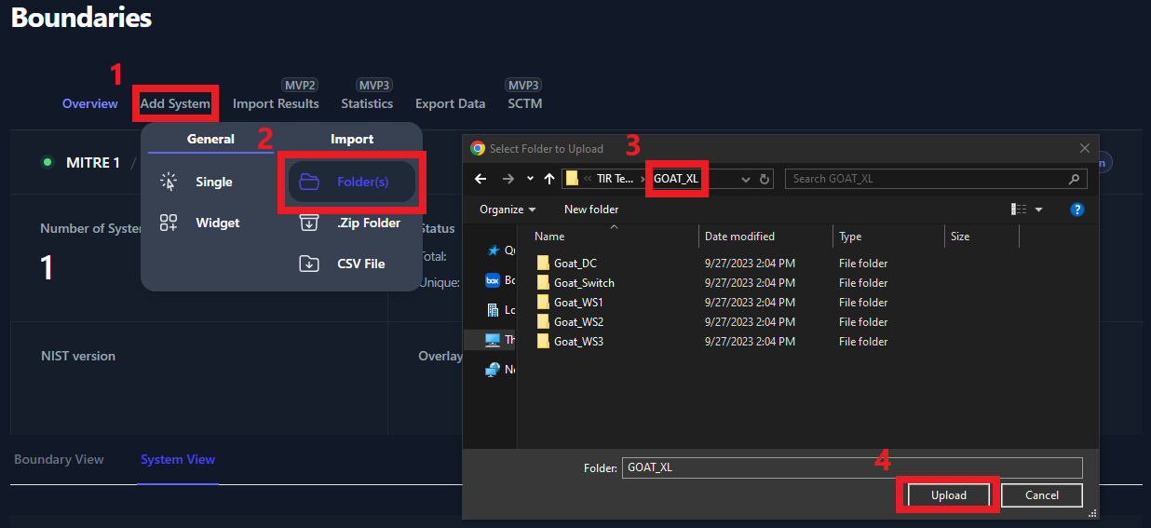

Figure 25: Adding Systems via Folder(s)

Once you click the **Upload** button, you will be prompted to confirm that you wish to upload all of your results. Click **Upload** on the prompt.

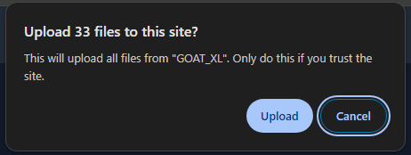

Figure 26: Confirm Upload

Once all of the files have been uploaded you will be able to view each system in the **System View** tab. For more information about the System View, please see Section 8.2: System View.

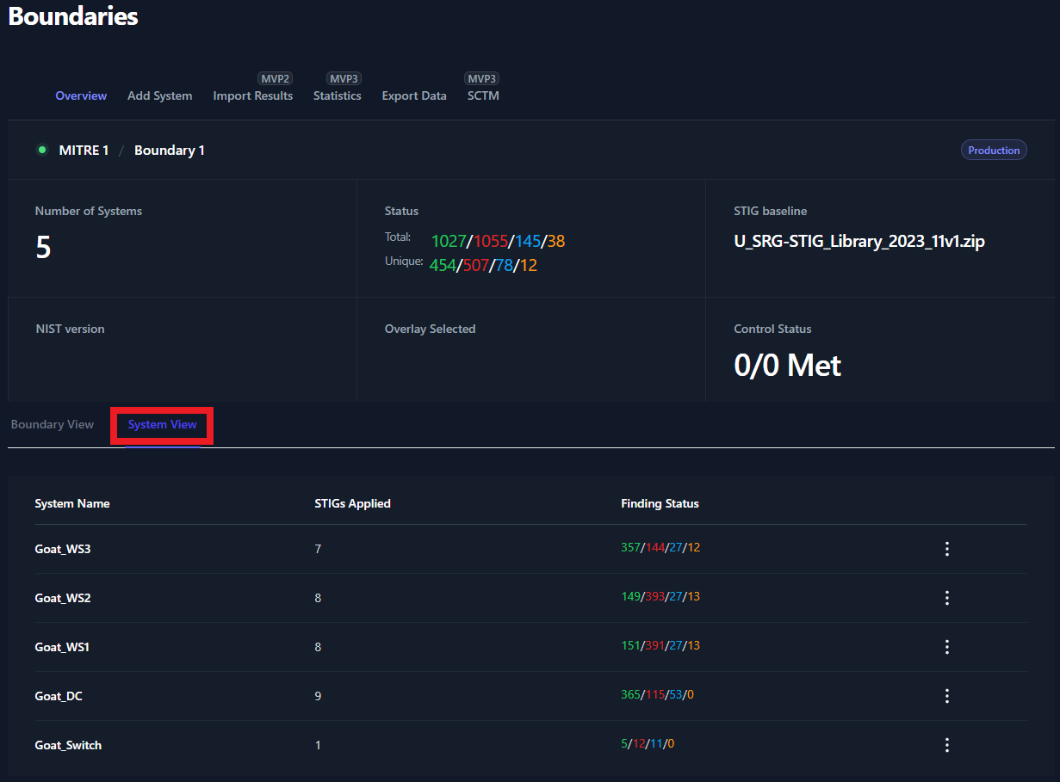

Figure 27: Verifying Successful Creation of Systems

### Add Systems by Importing Scan Results via .Zip Folder

Users have the option to zip up the results and import the .zip folder to create a new system. Each system will need their own .zip folder. Please rename the .zip folder to contain the System Name. In our example below, **Goat_DC** is the name of the system that we are creating. The **Goat_DC.zip** folder contains all of our checklist and XCCDF scan data. Please note; if you have multiple .zip folders to upload, they will need to be uploaded one at a time.

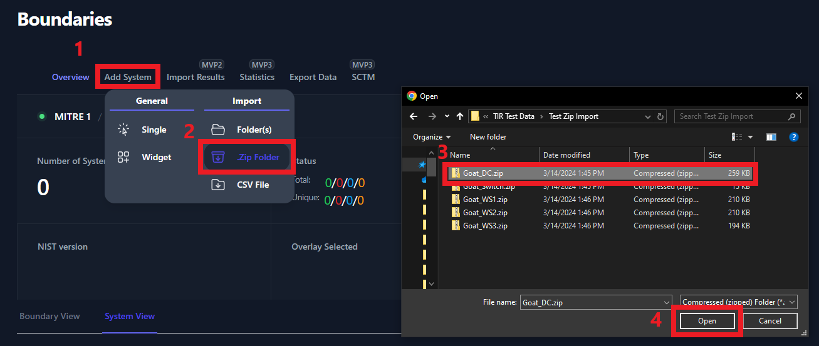

Figure 28: Adding System via .Zip Folder

### Add Systems by Importing Scan Results via CSV File

This feature is planned for a later release.

# Changing Boundary and/or Company Permissions

### Modify Company Permissions

To modify Company permissions select the 3 buttons to the far right of the Company and select Manage Users.

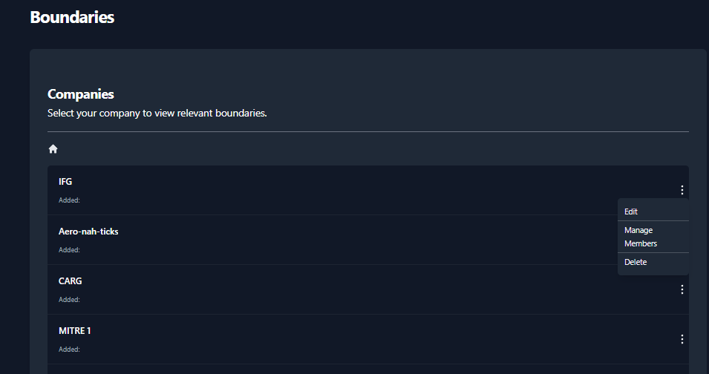

Figure 29: Modify Company Permissions

* Then the Members dialog box comes up, enter the username in the **Search Users** box.

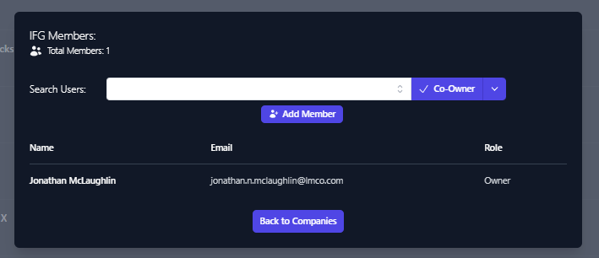

Figure 30: Adding Members – Search Users

* The Search Users box should provide a list of similar usernames. Select the user account you wish to add.
* Once selected click the down arrow next to Co-Owner and select the level of permission you wish to grant.

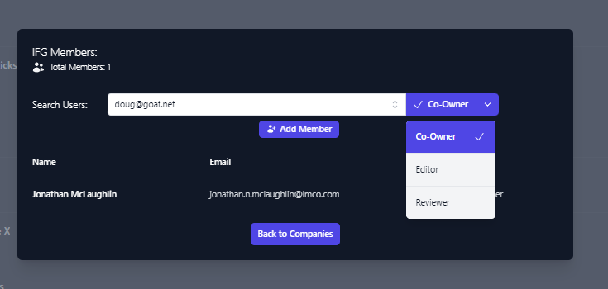

Figure 31: Manage Members – Choose level of Access

* Once the level of access you wish to grant is selected, Click **Add Member**
* You will see the account added to the user permissions list for the applicable company.

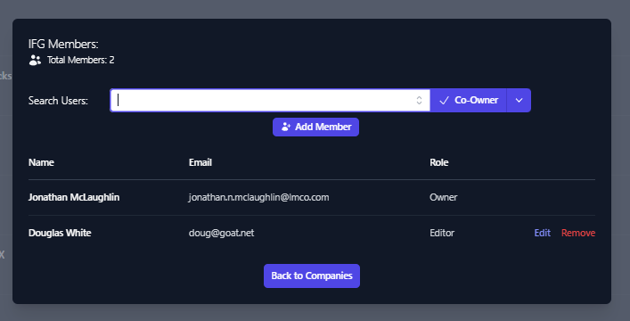

Figure 32: Member Access – User Added with Editor Role

Member access can be edited or removed from this view as well.

### Modify Boundary Permissions

To modify Boundary permissions select the 3 buttons to the far right of the Company and select Manage Users.

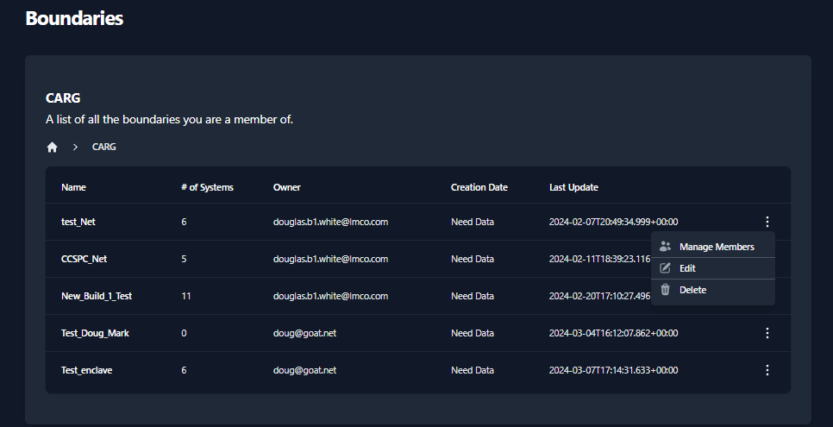

Figure 33: Modify Company Permissions

* Then the Members dialog box comes up, enter the username in the **Search Users** box.

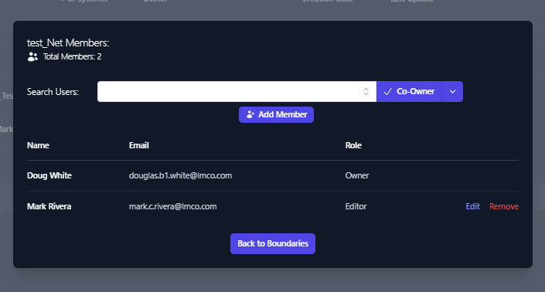

Figure 34: Adding Members – Search Users

The Search Users box should provide a list of similar usernames. Select the user account you wish to add.

Once selected click the down arrow next to Co-Owner and select the level of permission you wish to grant.

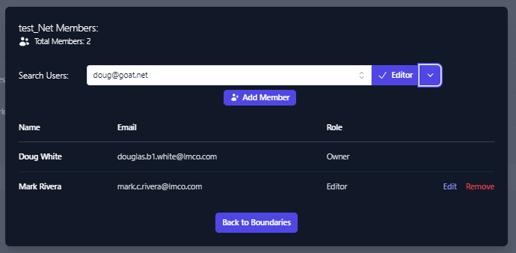

Figure 35: Manage Members – Choose level of Access

Once the level of access you wish to grant is selected, Click **Add Member**

You will see the account added to the user permissions list for the applicable company.

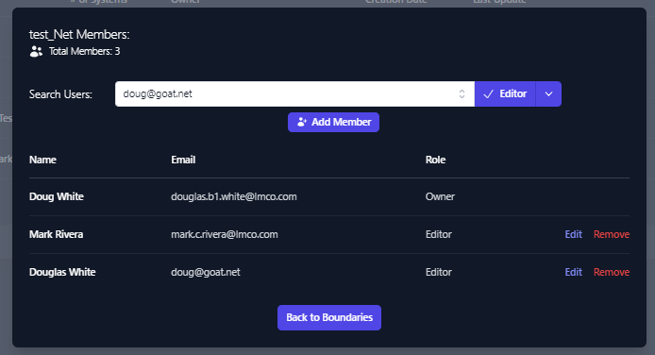

Figure 36: Member Access – User Added with Editor Role

Member access can be edited or removed from this view as well.

# Import Test Data for System

Once your Boundary has been created, you will need to import your test data into your Boundary. To do this, navigate to your Boundary, click on the System you wish to upload test data of.

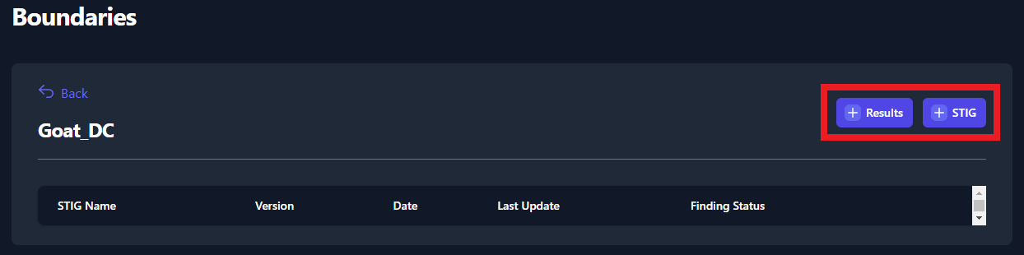

Figure 37: Upload Test Data to your System

The two buttons found in the screenshot above will be used to upload STIGs and Test Data Results to your systems. Follow the steps in the sections below for more detailed instructions on uploading test data.

## Manually Adding STIGs to a System

Before adding STIGs to your systems, be sure that you have the latest STIG Library uploaded. See Section 4.3.1.2 for instructions on how to upload the latest STIG Library.

Once you have the latest STIG Library uploaded, navigate to your System and click the button titled **[+] STIG** (as seen in Figure 37: Upload Test Data to your System). A side panel will appear on the right side of your screen. Use the search bar (highlighted in Figure 38: Adding STIGs to your System) to find each STIG that is applicable for you System. Click on the STIG to add it to the **Applied STIGs** section at the bottom of the panel. Once you’ve added all of your STIGs, click the **Save** button at the very bottom of the panel.

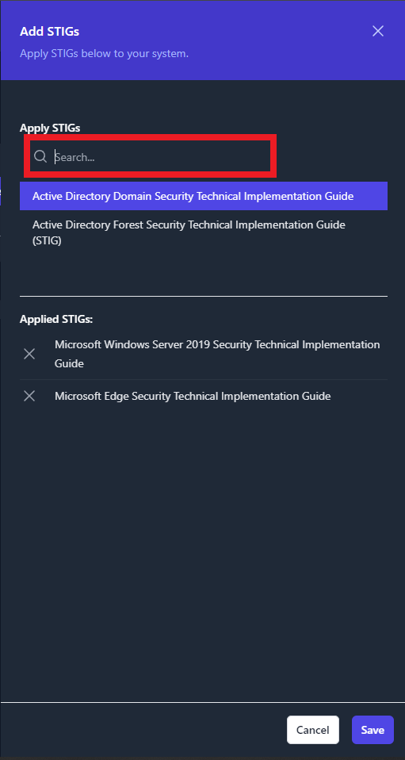

Figure 38: Adding STIGs to your System

Once the STIGs have been added, you will see them displayed in the Boundary page. See Figure 39 below for an example.

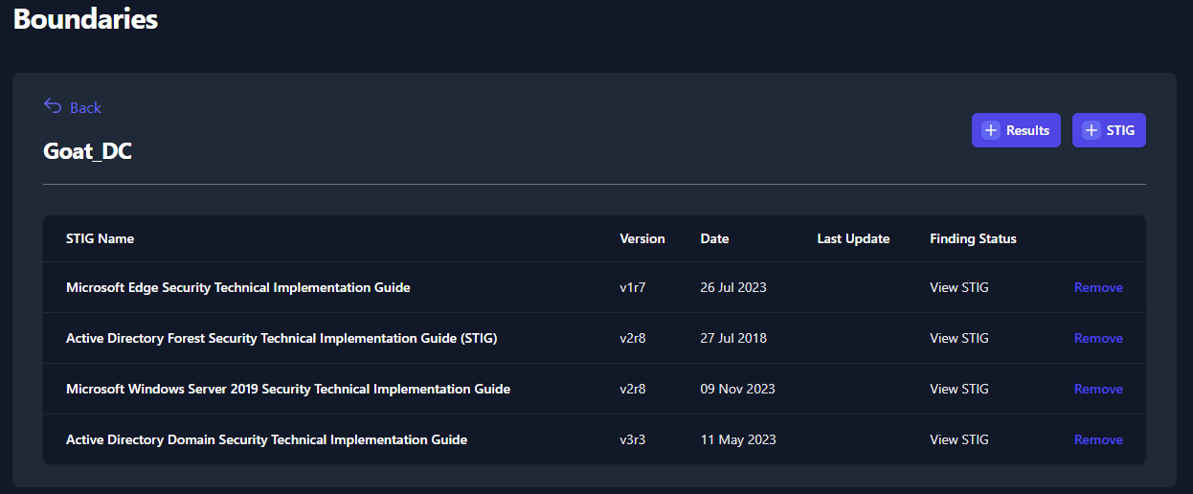

Figure 39: Successfully added STIGs to your System

## Adding Checklists and XCCDF Results Data to a System

To add results data, navigate to you System and click the **[+] Results** button (as seen in Figure 37). You will have three options when importing test data: **Import Folder**, **Import ZIP Folder**, and **Multiple File Selection**. See the below sections for more instructions on those import functions. All of these import functions can import checklist and XCCDF data. You do NOT need to upload the blank STIG benchmarks to your system prior to importing results.   
The import results functions will add the checklists to the existing System.

### Import Results via Folder

To use this import function, please place all of your test data for your System into a single folder. Next, navigate to your System, click the **[+] Results** button then click **Import Folder**. This will launch a file navigation window. Navigate to the folder that contains your test data and click **Upload**. The actual files will not be visible in the file navigation window so please verify that the result data is present in a separate window (as seen in Figure 40).

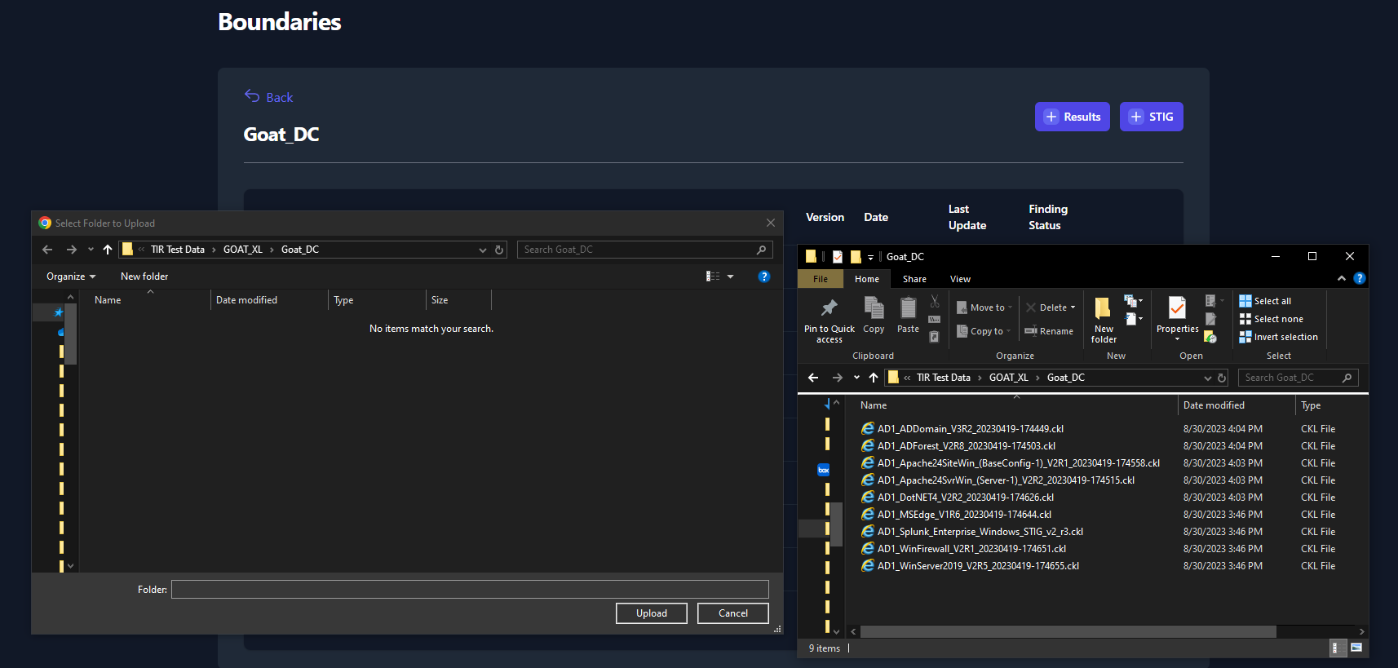

Figure 40: Import Test Data via Folder

Notice that we only uploaded four STIG benchmarks in Section 7.1 but we uploaded results of nine different STIG checklists. All nine checklists will be uploaded to your System, as seen below in Figure 41.

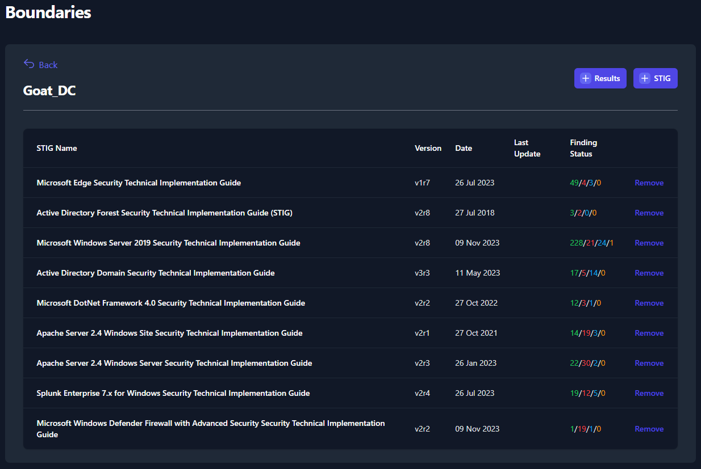

Figure 41: Successful Upload of Results via Folder

### Import Results via Zip Folder

To use this import function, please place all of your test data for your System into a single .zip folder. Next, navigate to your System, click the **[+] Results** button then click **Import ZIP Folder**. A file navigation window will be displayed. Navigate to the .zip folder that contains your test data for your system, then press **Open**.

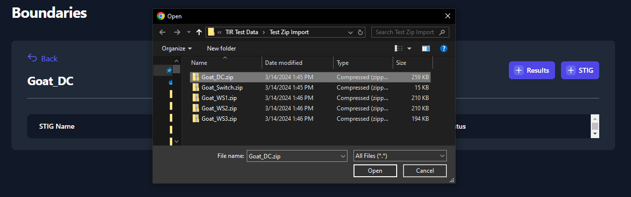

Figure 42: Import Results Data via Zip Folder

Upon a successful upload of test data, the test data will be displayed inside your System (identical to Figure 41).

### Import Results via Multiple File Selection

To use this import function, please place all of your test data for your System into a single .zip folder. Next, navigate to your System, click the **[+] Results** button then click **Multiple File Selection**. A file navigation window will be displayed. Navigate to your checklist and/or XCCDF data and select each file that you would like to upload and click **Open**.

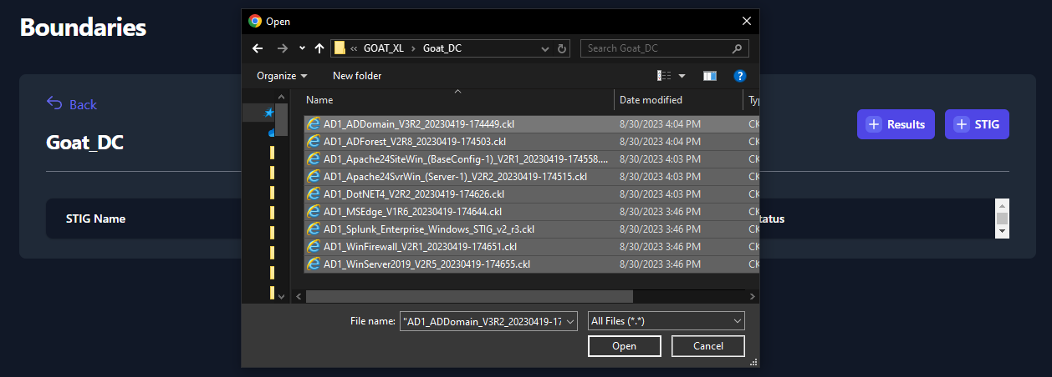

Figure 43: Upload Test Data via Multiple File Selection

Upon a successful upload of test data, the test data will be displayed inside your System (identical to Figure 41).

# POA&M Management

TIR is a repository to store and manage your test artifacts. TIR provides a **Boundary View** and a **System View** to manage your data. The **Boundary View** allows you to view each STIG as a superset of the boundary. Meaning; from a single STIG check view, you will be able to view and edit the status of each system that contains that check. The **System View** will show you the list of systems inside your boundary and will allow you to view all checks related to that individual system.

The access these views, navigate to your Boundary and click the **Boundary View** or **System View** (as seen in Figure 41).

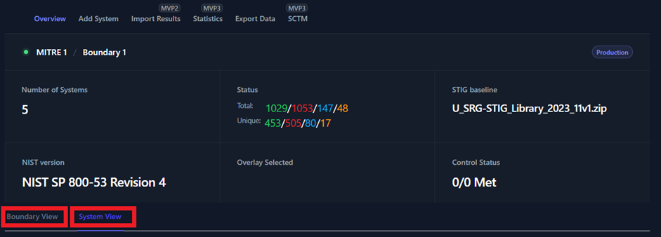

**Figure 41: Boundary and System Views**

## 8.1 Boundary View

As mentioned in the summary under Section 8, the **Boundary View** allows you to view each STIG as a superset of the boundary. You will be able to target specific STIG checks and check the status of all the systems that contain that check. From the **Boundary View** you will be able to change the status of STIG checks, however, you will not be able to edit the **Finding Details** and **Comments** for each individual system. To edit either one of those fields for a specific system, you will need to navigate to the **System View**.

Once you click the **Boundary View** tab, you will see a unique list of all the STIG checklists that have been added to systems in your boundary (as seen below in Figure 42).

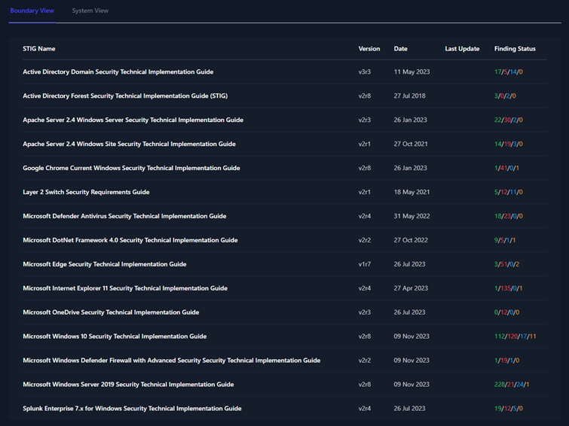

**Figure 42: Boundary View Tab**

To view the STIG checks inside each of these STIG checklists, simply click on the STIG. For this example, we will be looking at the **Microsoft Edge Security Technical Implementation Guide**.

Once you open the STIG View, you will see a variety of information related to the Boundary, STIG Library, and STIG Check. Each item is labeled below in Figure 43.

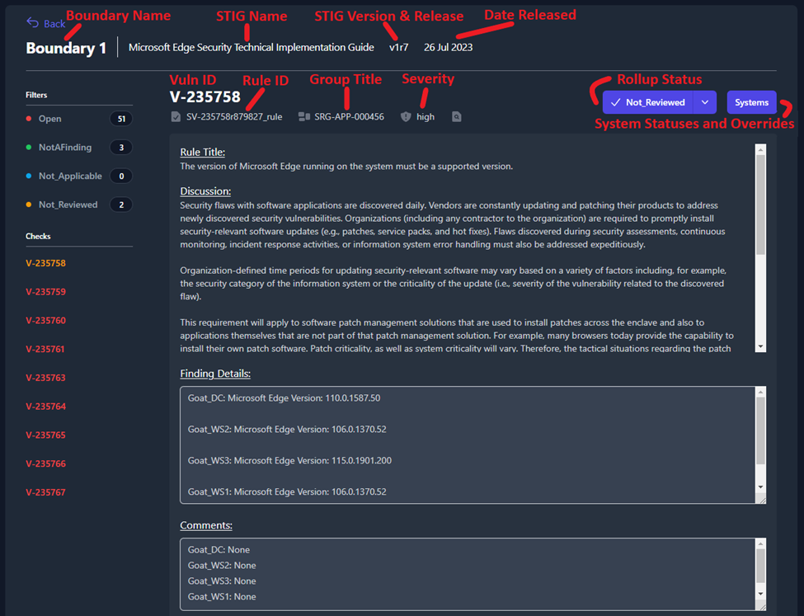

**Figure 43: STIG View Data Key**

On the left side of the screen, you will see a section titled **Filters** that contain four status types: **Open**, **NotAFinding**, **Not_Applicable**, and **Not_Reviewed**. Each one of the status types can be toggled on and off to display the STIG checks with that status. When filters are selected, they will be colorized. For example, Figure 44 is filtering so that only STIG checks with a status of **Open** (red) or **Not_Reviewed** (yellow) will be displayed.

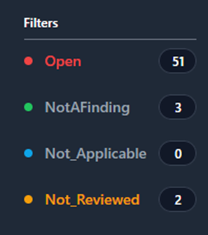

**Figure 44: Filtering by Status**

### System Statuses and Overrides

In Figure 45 you will see that the **Finding Details** and **Comment** fields pull the data for this check from each system in your boundary. We can see that this check is pulling data from four separate systems in our boundary: **Goat_DC**, **Goat_WS2**, **Goat_WS3**, and **Goat_WS1**.

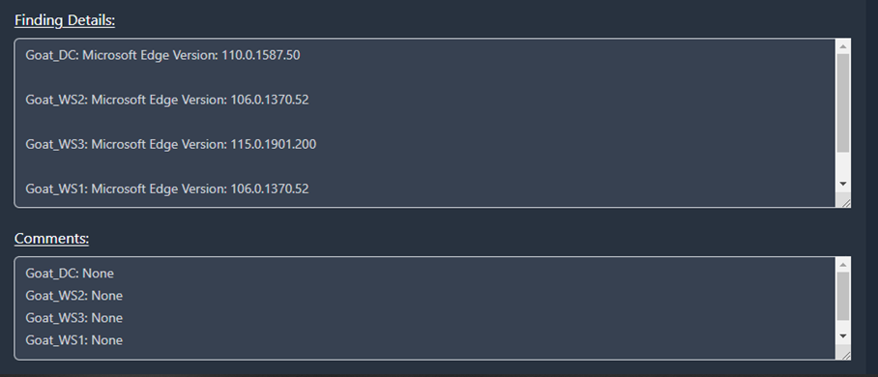

**Figure 45: Finding Details and Comments inside of the Boundary View**

To view the status of each one of those systems, you will need to click the **Systems** button (highlighted in Figure 46).

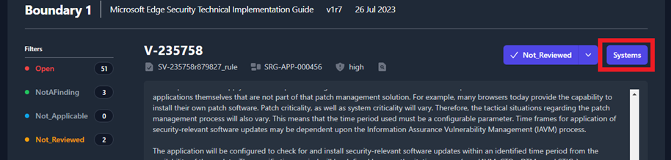

**Figure 46: Systems Button**

A pop-up window will appear that displays all of the systems where this STIG check applies and the current status for each system.

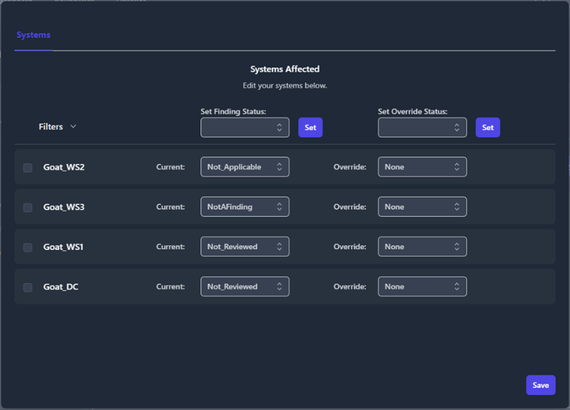

**Figure 47: System Status and Overrides**

To make an update to a system; select the **checkbox** next to that system, change the **Current** status field using the drop-down menu, then click **Save**.

If you want to change the status of multiple systems at once, select the **checkbox** next to each system that you are changing. The **Filters** drop-down in the upper left will allow you to select multiple systems with the single click of a button. Once the desired systems are checked, select the new status from the **Set Finding Status** drop-down (at the top of the middle column) and click the **Set** button directly next to that drop-down menu.

The third column is for **Overrides**. Override rules can be set on a STIG check so that the status you assign to this check persists on the selected systems when new test data is imported in the future. This override feature should be used almost exclusively to set statuses of **Not Applicable** for checks that are deemed **Not Applicable** to your boundary. Using this feature to set an override status of **NotAFinding** could cause you to miss a potential open finding in the future if security settings or Group Policy Objects (GPOs) are disabled or removed. To apply an override, select the **checkbox** next to each targeted system, select the override status from the **Set Override Status** drop-down menu, then click the **Set** button directly next to that drop-down menu.

Once all of your changes have been made, click the **Save** button in the bottom-right corner of the pop-up window.

[Add screenshot show the asterisk to overrides]

### POAM Fields

From the **Boundary View**, each STIG check will have collapsible and expandable section titled **POAM Fields**. The user will have the ability to provide additional comments, program information, milestones, adjust risk levels, and more. These fields need to be filled out for each **Open** finding in your boundary. All of this data will be pulled directly into the POAM export.

After you’ve completed filling out the **POAM Fields** for you STIG check, click the **Save** button at the bottom of the page.

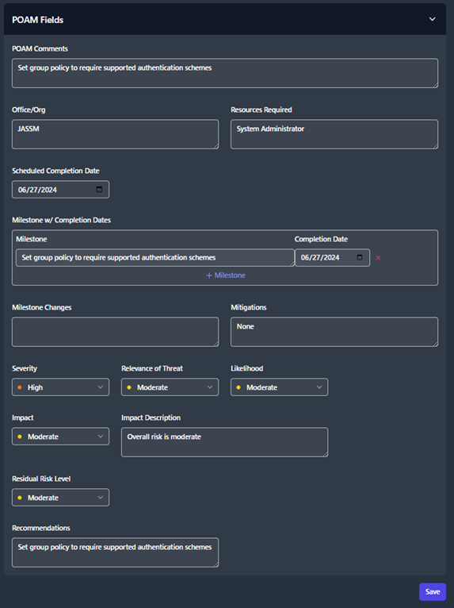

**Figure 48: POAM Fields**

## System View

The **System View** tab shows you a list of all the systems inside your boundary, the number of STIGs applied to each system, and the total status counts for all of the checks applied to that system.

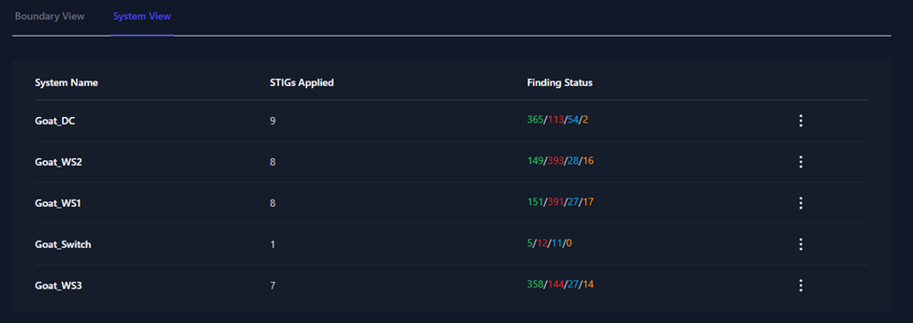

**Figure 49: System View Tab**

To view and edit the data pertaining to one of these systems, click on the system. The next page will show you the list of STIGs that apply to that system. This page will provide versions, dates, and statuses for each STIG. Click on one of the STIGs to open the **STIG View**.

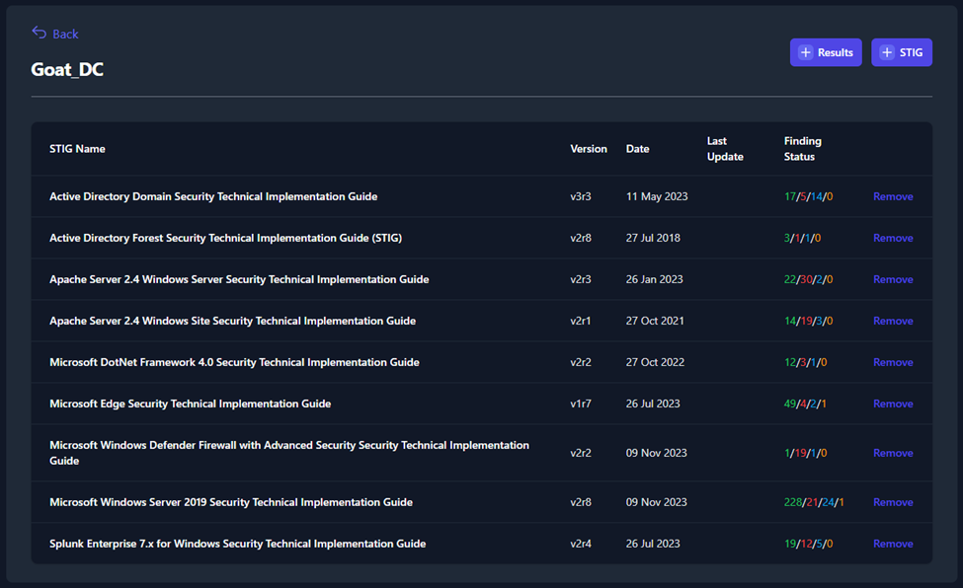

**Figure 50: System View STIG List**

This **STIG View** page will provide a variety of information related to the System, STIG Library, and STIG Check. These items are also available in the **Boundary View** and have been labeled in Figure 43. Additionally, like the **Boundary View**, you have the ability to filter STIG check based on their status (see Figure 44).

Unlike the **Boundary View**, the **System View** allows you to edit the **Finding Details** and **Comments** fields. To update the status of each STIG check, use the status drop-down menu in the upper-right (seen in Figure 51).

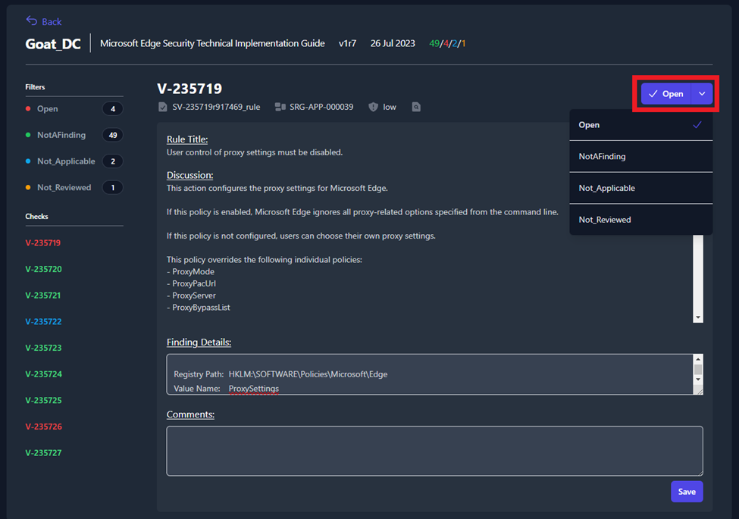

**Figure 51: Changing the Status from the System View**

# Exports

Once you have uploaded all of the test data on for your boundary, you have the ability to export your data into a **Plan of Action and Milestones (POA&M)**, a **Findings Worksheet**, or a **Checklist**. To export your data, navigate to your Boundary and click the **Export Data** button (as seen in Figure 44).

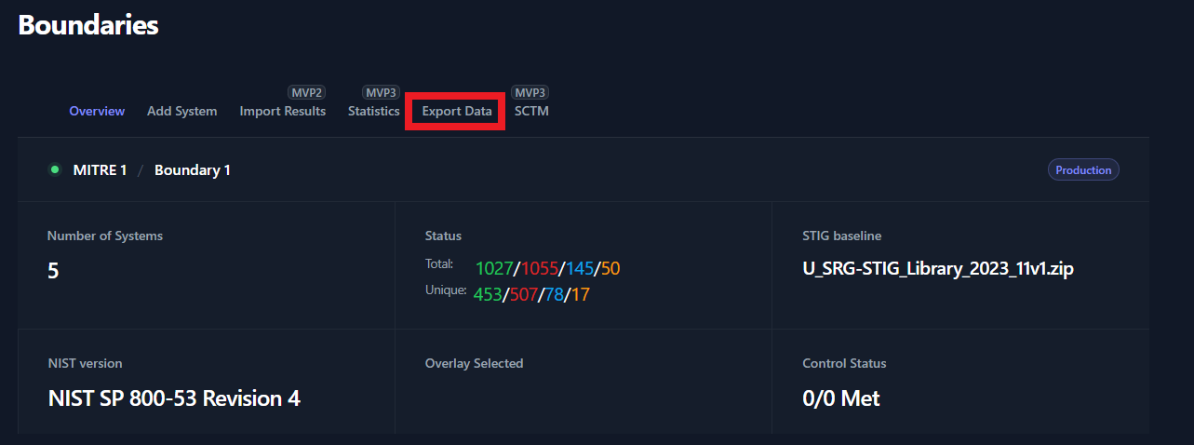

Figure 44: Export Data

A popup window will appear, please use the tabs at the top of the popup window to specify the output type (POAM, Findings, Checklist).

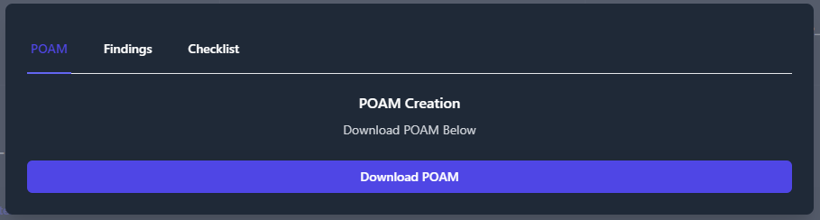

Figure 45: Export Options

## Plan of Action and Milestones (POA&M)

To export a POA&M; navigate to your Boundary, click the **Export Data** button, click the **POAM** tab, then click **Download POAM**.

The POA&M will organize all of the findings data for each security control that is not being met.

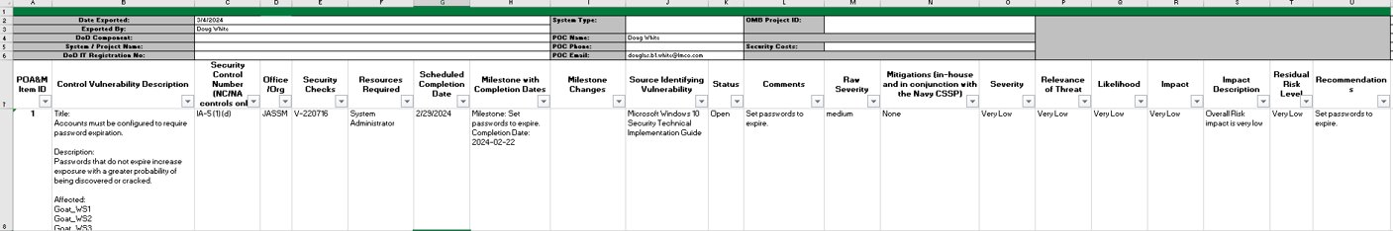

Figure 46: POAM Output

## Findings

To export your data into a **Findings Worksheet**; navigate to your Boundary, click the **Export Data** button, and click the **Findings** tab. The Findings Worksheet allows you to export data based on their finding status. Check the box next to each of finding status’ that you want to export. Then press the **Download** Findings button. For this example, we will export only the **Open** findings for our Boundary.

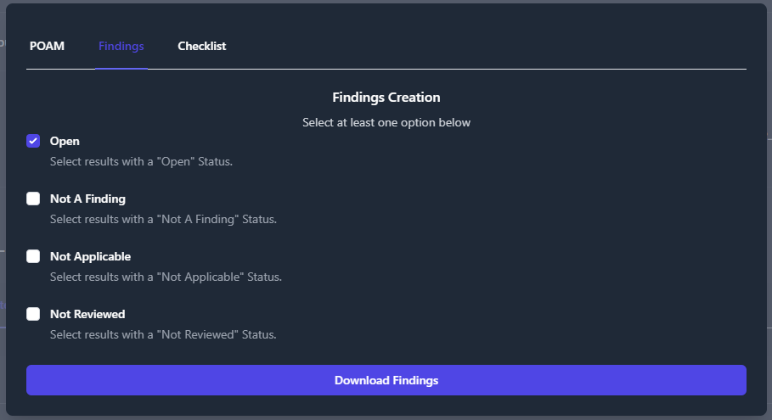

Figure 47: Export Findings

A file will be downloaded to your computer titled **Findings *.xlsx**. This findings worksheet will display every finding with the statuses that you specified in the previous step.

The findings worksheet will create an item for each Vulnerability/Finding inside of your Boundary and list all of the Systems Affected by that vulnerability.

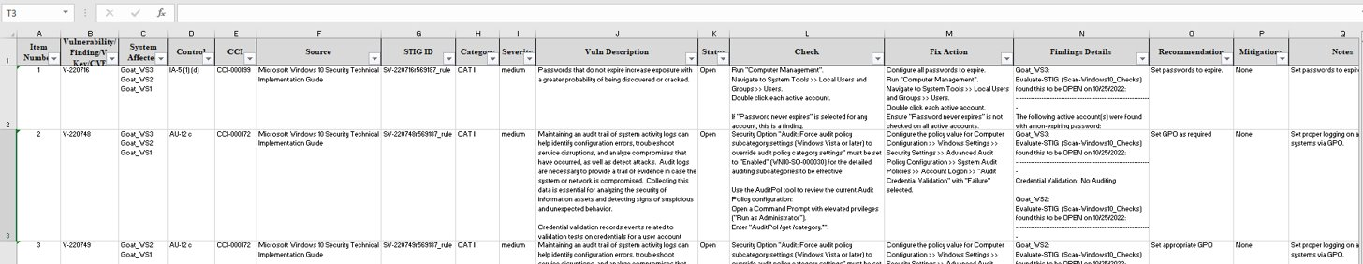

Figure 48: Findings Worksheet Output

## Checklists

TIR provides two options for exporting checklists. The default option exports separate checklists for each STIG in a folder with the name of the system. The second option creates a single checklist, containing all STIGs, in a folder with the name of the system.

For the default option, select **Export Data**, select the **Checklist tab**, and click **Download Checklist.**

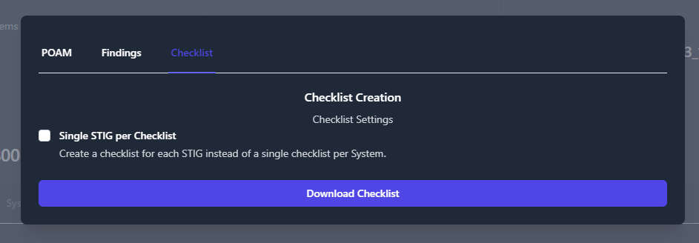

Figure 49: Checklist Export – Default

The output should look like the following:

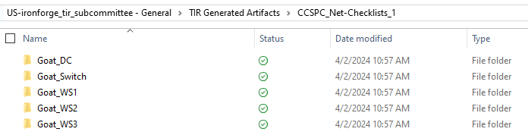

Figure 50: Checklist Export – Folders

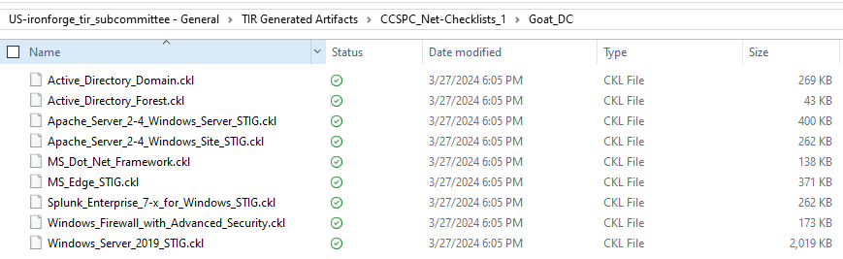

Figure 51: Checklist Export – Multiple Checklists

For a single checklist per system, select the **Single STIG per checklist** box.

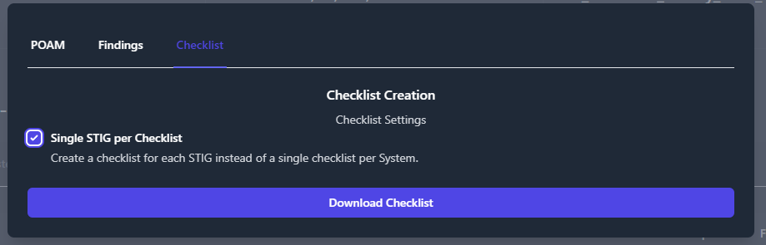

Figure 52: Checklist Export – Single STIG per Checklist

The output is as follows:

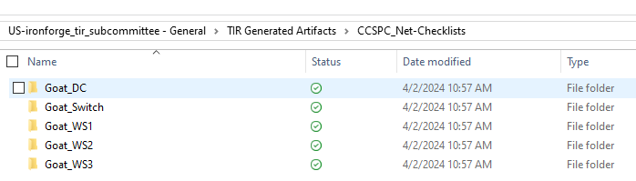

Figure 53: Checklist Export – Folders - Single STIG per System

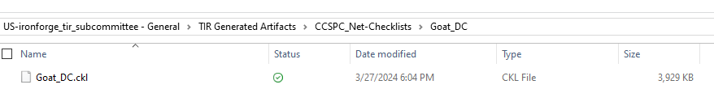

Figure 54: Checklist Export – Single STIG per System