Game design document of:

MAGDELIVERY
WE GET YOU WHAT YOU WANT

All rights go to ©2022 adventurous team
Written by: Daria Khylobok
Idea: Sergey Miachkov, Daria Khylobok
Game developed by: Sergey Miachkov, Daria Khylobok, Alvina Perly
Designed by: Daria Khylobok
Artists: Dorsa Amiri, Nyasha Audrey Dzere, Alvina Perly
Feature artist: Anna Maksimchuk
Theme song author: Sergey Miachkov
Version #10.1
January 1, 2022

TECHNICAL ASPECTS & GAME OVERVIEW

TECHNICAL FORM: game consists of 2D graphics, art style made in PixelArt technique.

VIEW: side view on flat surface.

PLATFORM: PC

LANGUAGE: C#

PLAYER: 1 player

GENRE: runner

SETTING: midnight magic forest

TARGET: 0-99+ y.o. players, witches and anyone who loves a good simple game.

BUDGET: $0

SCALE OF THE PROJECT:
Developer team:
Sergey Miachkov – programmer, tester, tech and team lead. Salary: $0
Daria Khylobok – programmer, designer, team lead. Salary: $0
Alvina Perly – programmer(07.10-20.11), artist. Salary: $0
Dorsa Amiri – artist. Salary: $0
Nyasha Dzere – artist. Salary: $0

CONCEPT:
You are a delivery guy in the countryside. Usually you deliver pizza, but sometimes customers get a little extraordinary…
In this game you get orders from mysterious forest inhabitants and your goal is to get them what they ask for. But be careful! Twilight forest is a dangerous place, you never know who you can stumble upon. Besides, you may find a lot of things you don’t need – try to avoid them since space in your backpack is limited.

FEATURES & FEATURE DETAILS
Character is automatically running. His ability that is controlled by player is jumping. You can jump in the air or jump on the platforms. There can be one, two or three of them at a time, they can be on different heights.
The character has three lives. They are shown in the top left corner of the screen. There are a maximum of 3 lives. The character loses a life when they run into an obstacle. When there’s no hearts left, the game ends.
Player gets orders from Magdelivery customers. Orders are presented as a list of items which have to be collected while running through the forest. List of items are visible throughout the game in the top center of the screen. When the player’s inventory is full or they collected the whole order correctly, character gets to the clients house and gives them their package.
Goal is to collect items which are called artifacts. When the character touches an item it appears in the inventory. However, there is only 5 cells in the inventory and the player should not collect the things they don’t need to complete the order.
On the go player can stumble upon different obstacles – rocks, bats, dead trees. Another landscape element is platforms. Player can jump on platforms to avoid unwanted artifacts or to get the ones that are on top.
Player can get help in this uneasy travel by collecting different kind of power-ups – there are heart, bin, mystery box and a shield ones. When the player finds and catches a heart, it gives them one additional life (only if the health bar wasn’t full – maximum of 3 lives). Mystery box adds one random artifact to the inventory, it can be useful or not. Shield power-up makes the character invincible for 5 seconds – even on touching the obstacle health bar stays the same. Bin booster helps to get rid of an unwanted item in the inventory. It won’t touch the good ones.

DEVELOPMENT HISTORY

07 Oct. – Team coming up with different ideas. Choosing between runner game and word game, making a concept of the game. Deciding on team positions, select the artists and the programmers, starting the GDD document.
13 Oct. – Start of development. Making Git repository with basic starting files(done by Sergey Miachkov), picking game’s base colors and overall player’s view, adding details to the starting idea (new items, models, inventory, character’s health bar, obstacles, the point of the game). Idea and concept belongs to Sergey Miachkov and Daria Khylobok.
First samples (sketched by Daria Khylobok):
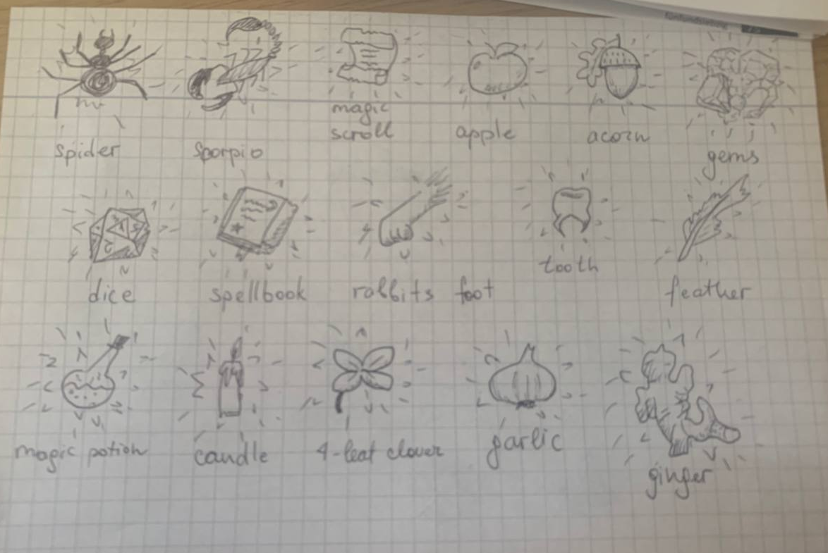
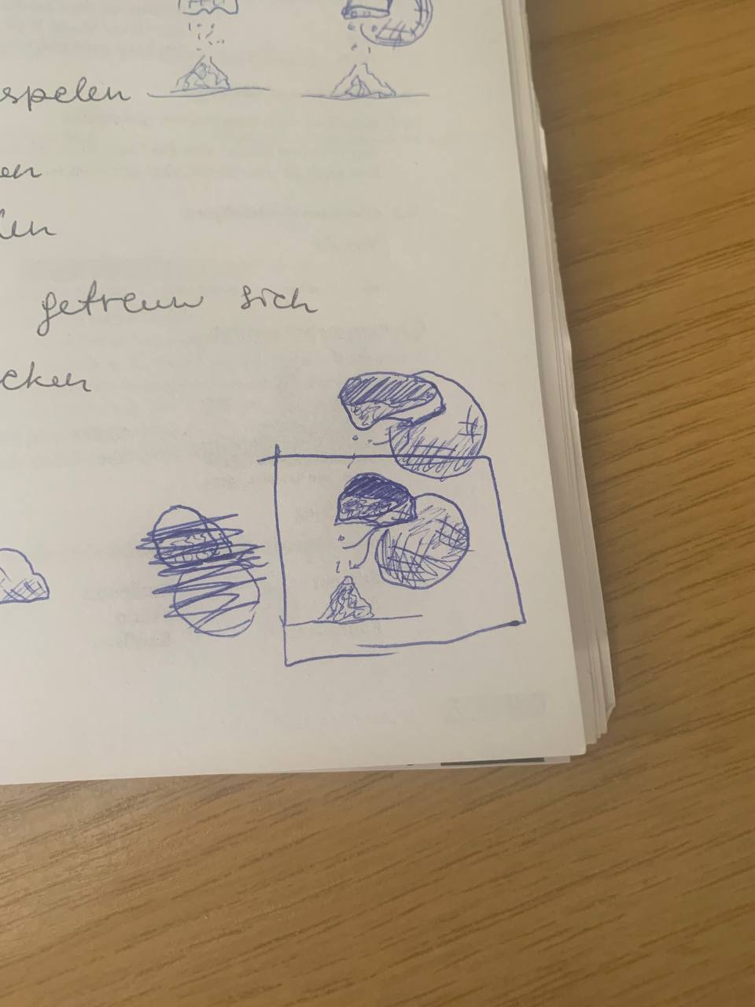

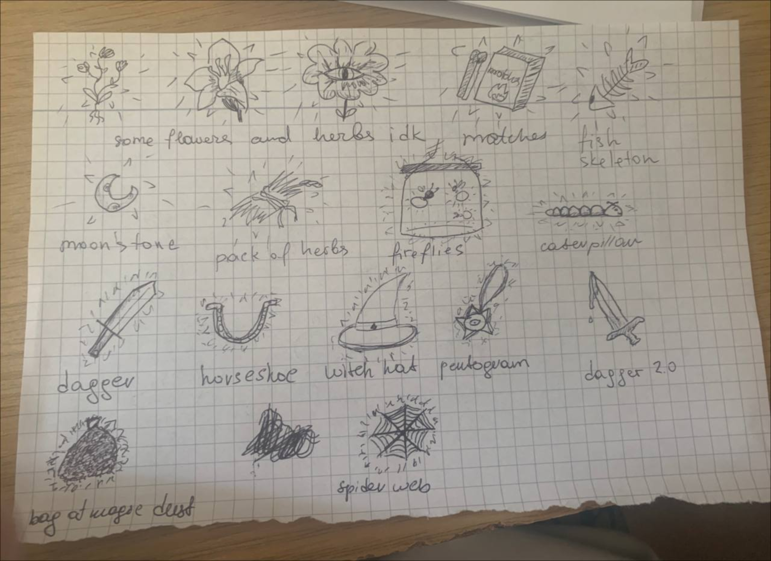

20-27 Oct. – Continuing with the idea, adding more features to the plan. Jump mechanics are done by Sergey Miachkov.
3 Nov. – first digital sketches done:
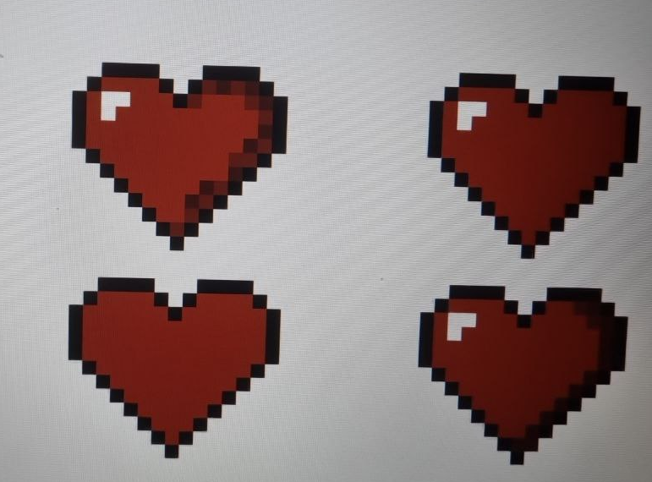
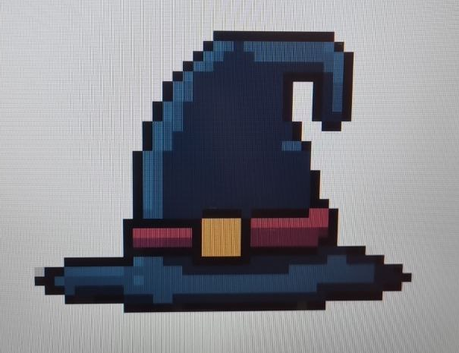

Artist: Dorsa Amiri
Artist: Dorsa Amiri

28 Oct. – 3 Nov. -- Platforms (by Sergey Miachkov) and obstacles (by Alvina Perly) are now added to the game. There is a sample of the background and a color palette for the art part of the development. Visual representation is added below.

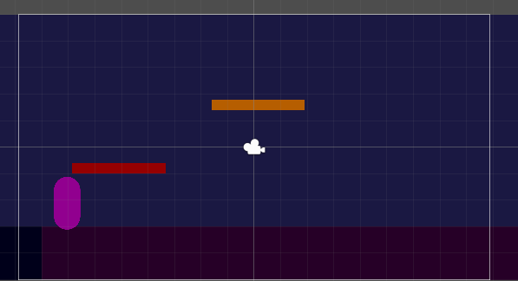

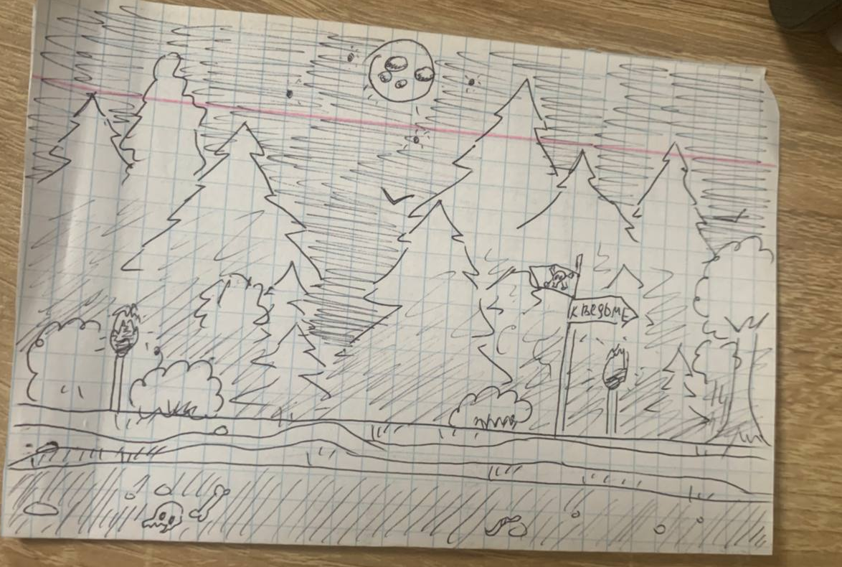

Platforms are done by Sergey Miachkov, background sample and color palette by Daria Khylobok.

by 15 Nov. the game looks like this:

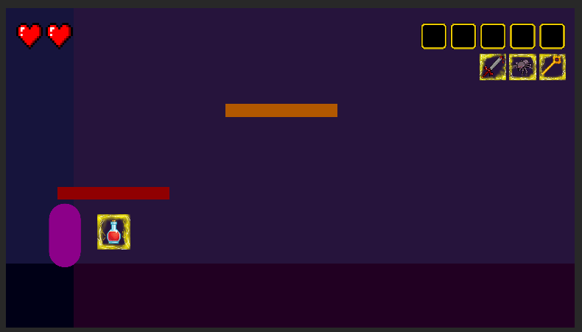
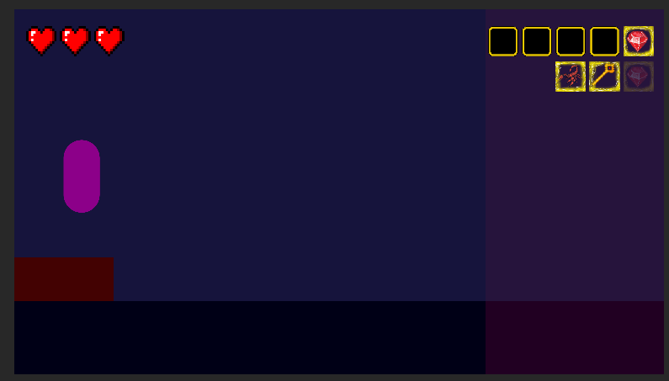

Items generation and collection scripts are done by Daria Khylobok. There are a lot of different variations of artifacts appearing. Two main spots are on the ground and on the platform, but different sets of platforms needed individual items’ placements. When player touches an artifact, it disappears.

Lives count added by Alvina Perly. When touching an obstacle, one heart disappears, and when none is left, game restarts.

Inventory and items collection done by Sergey Miachkov. Inventory has five cells. After touching an artifact, it appears in the most left empty cell. Under the inventory, list of items is made – it shows the player which items they have to collect to finish the order. After the item is collected, the image goes transparent, showing that it isn’t needed anymore. Also game restarts when inventory is full. Later different scenes will be added for it.

Some of items added so far:


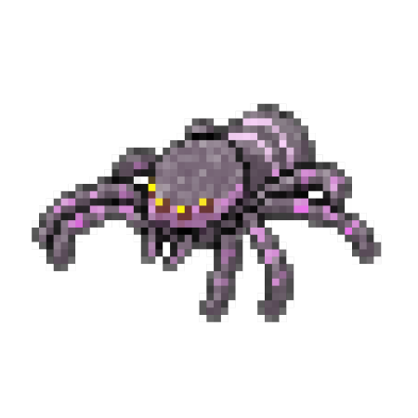
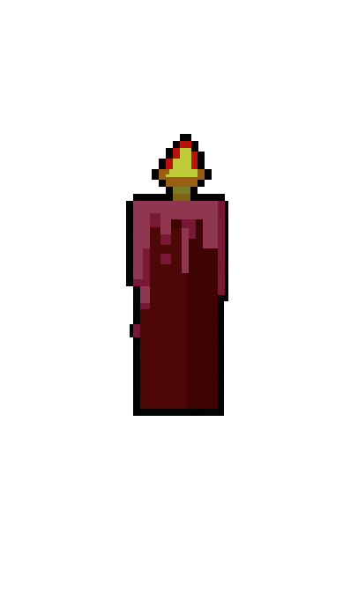


Magic potion, Sergey Miachkov
Spider,
Anna Maksimchuk

Flower,
Daria Khylobok
Candle,
Nyasha Dzere

All graphics and references from the game can be found by the link:
https://drive.google.com/drive/folders/1qXNH0fF7lpXdNzQv7VB48m3lmrkDyAsb
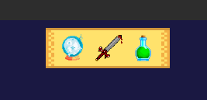
18 Nov – Sergey Miachkov improved visuals of the game by putting list of items on the top center of the screen. It is more efficient than the previous version and the colors are brighter, so artifacts are easily identifiable.
When artifact from the list is collected, it appears as transparent to not confuse the player.
Also artifacts on the ground and platforms appear in golden boxes, but in the inventory and order list they don’t have any establishments.

20 Nov-- Sergey Miachkov added a “game over” screen for all three scenarios: dying(losing all of the hearts, completing the order and filling your inventory to maximum of 5 artifacts. Also now the object generation is faster, so the game has become more intense and engaging. Flying obstacle can now appear right after the platform catching the player mid-air.

25 Nov – digital versions of obstacles by Alvina Perly:
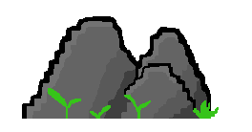


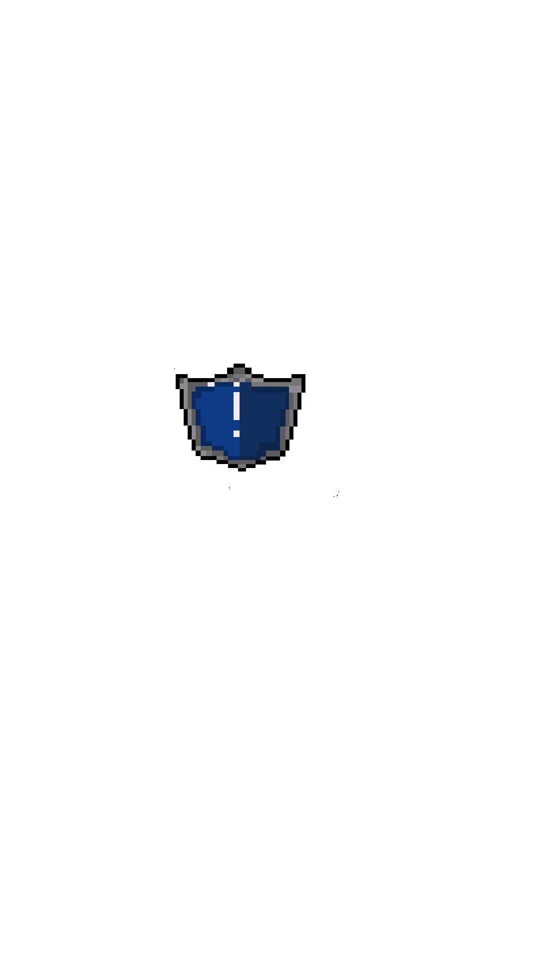
When all the basic mechanics are done, it’s time to get to the additional features. Daria Khylobok added a shield power-up. When player collects it, the character becomes immortal for five seconds – lives count won’t change and there’s no need to avoid any of the obstacles and be scared of losing the game.
For now, after picking up a shield, player’s sprite changes color, but later on another animation will be added for it.
Artist: Nyasha Dzere

27 Nov – Sergey Miachkov created a MagDelivery soundtrack with a few varieties of it’s bpm. The best version of it was chosen collectively by the team and will be added to the game closer to the finishing date.
Soundtrack is also added to the GoogleDrive folder and is available by the link:
https://drive.google.com/drive/folders/1Swd7-blAIAcXATBAOvsI4t47pYAU7h4u?usp=share_link

28 Nov – Alvina Perly created a visual for platforms:
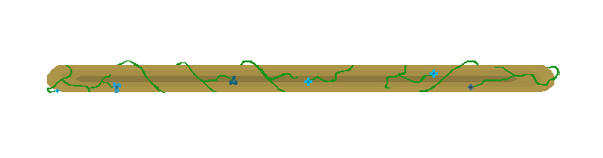
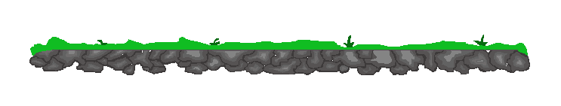


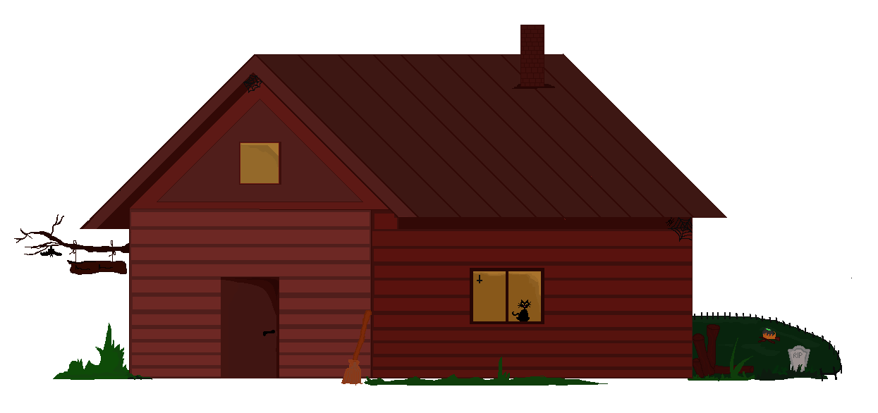
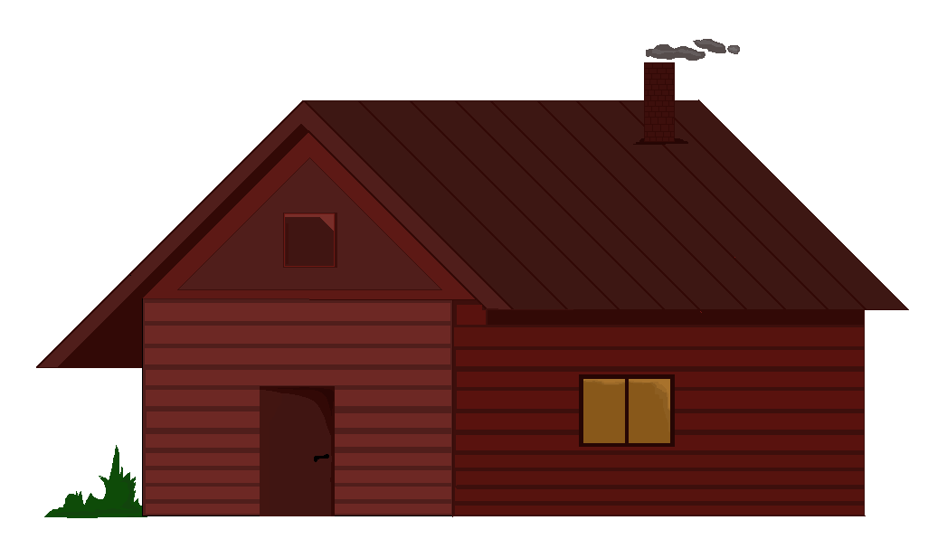
Two versions of witch’s house for the ending scene of the game:
Artist: Alvina Perly


29 Nov – Sky and the clouds by Dorsa Amiri

8 Dec – Ground by Dorsa Amiri and obstacles by Alvina Perly – dead tree and an improved log. These colors still seem too dark for the setting, so might be changed in the future.
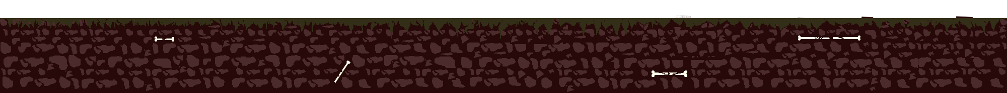
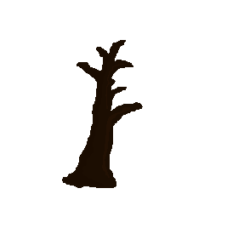



While waiting for the final version of the background, Sergey Miachkov added all the previous pictures to the game and made sure they look good in the final product.
Nyasha Dzere came up with the background part that didn’t fit the previous plans, and it was decided to change the discussed 2 layers with trees and the sky separately to just one picture with the forest in the background. There is an unfinished look of it:

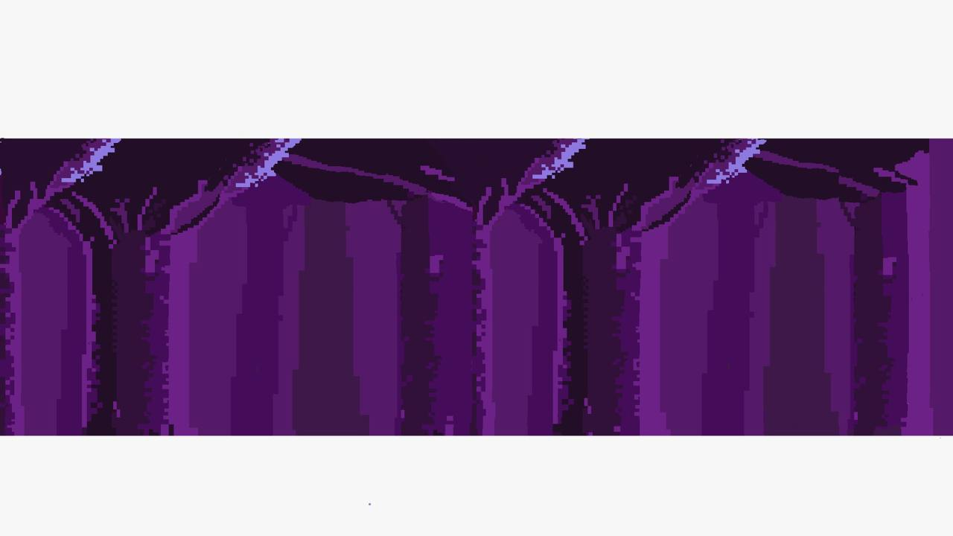

9 Dec – Alvina Perly got the main character design. The discussion behind it was huge and needed to make a lot of examples to choose from. The final version that was added to the game was chosen by the poll and every person on the team took part in deciding on the player’s model. So here you can take a look at MagDelivery guy’s development and how he became the person he is now.
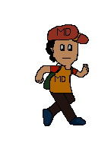














Bat animation frames by Alvina Perly. The bat is a flying obstacle and was added to the plan by Daria Khylobok at the designing stage.



11 Dec – Sergey Miachkov updated the sprites with recent pictures and added a new power-up – the bin. It checks if the player has a cast-off artifact in their inventory and gets rid of it. Power-up looks like this and is made by Dorsa Amiri.


13 Dec – Dorsa Amiri updated the icon for the health bar and submitted a new crystal one.



15 Dec – Daria Khylobok done all the animations in the game. Now the main character moves his legs while running and stops moving them in the moment of jumping. Bat is also animated.

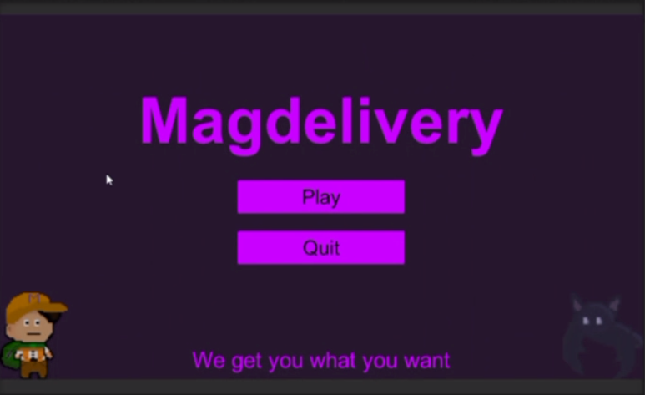
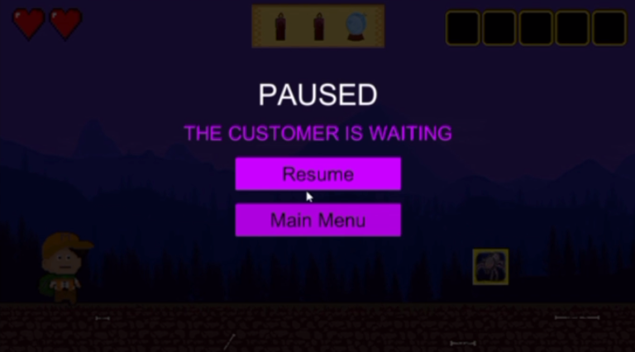
17 Dec – Sergey Miachkov added a start screen and a pause menu that is activated by the escape button. Player can resume or exit the game from there.

22 Dec – dark forest background is done by Nyasha Dzere and is ready to be put in the game.


23 Dec – Sergey Miachkov added a new Mystery Box power-up that adds one random artifact to the inventory. The image for it is done by Nyasha Dzere on 22 of December.
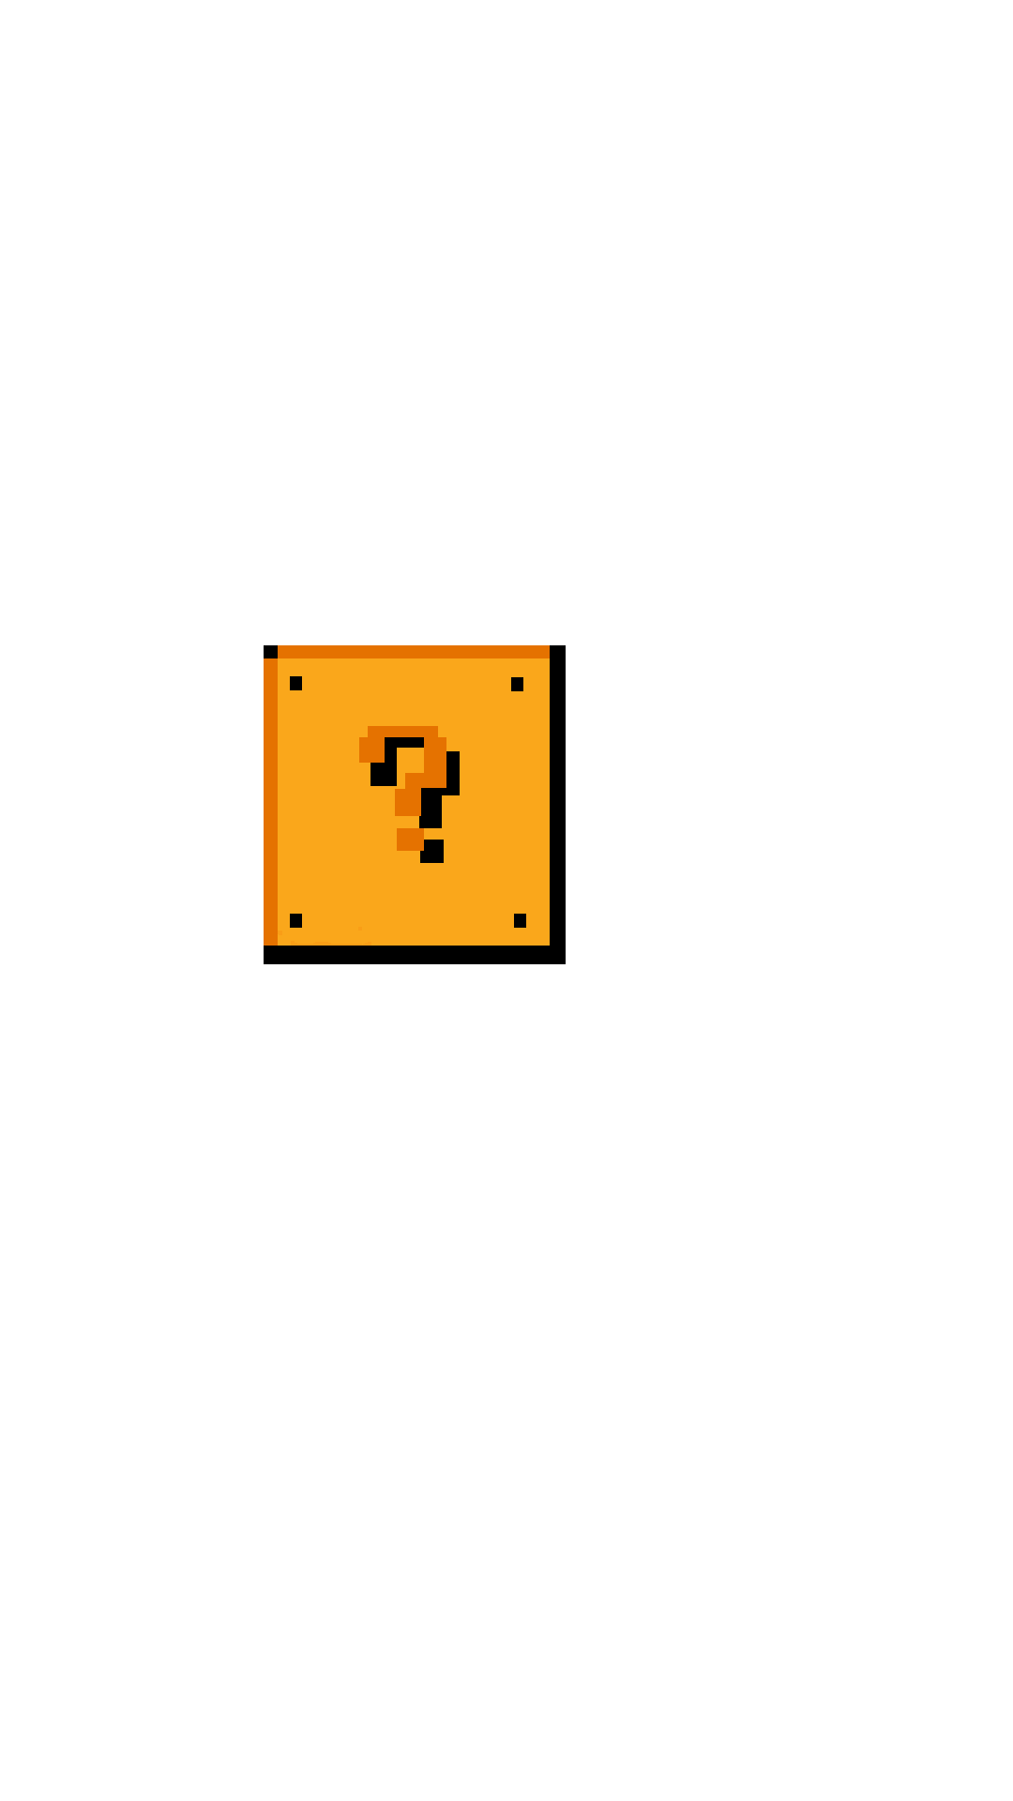

Background is now added and the game looks complete.
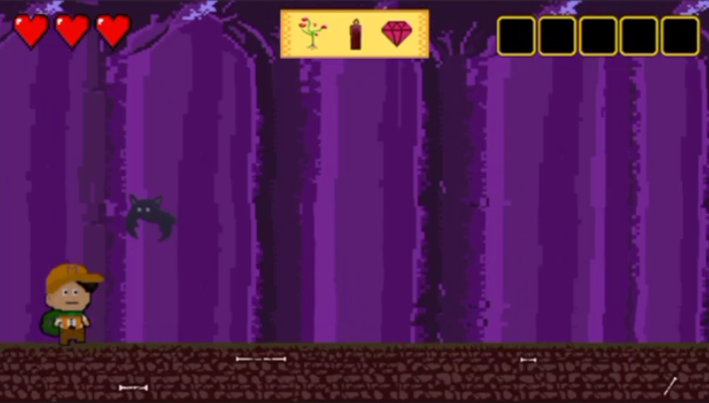

29 Dec – the game awaits for the final touches, so Alvina Perly created the wizards who are actually MagDelivery clients and the ones who make orders. They appear on the screen once the player finishes the delivery to collect their order and thank the player.
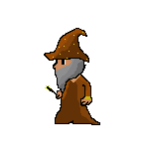

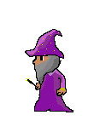

30 Dec – Daria Khylobok added a collision blinking animation on touching an obstacle by the player.

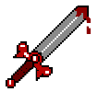
31 Dec – finishing artifact from Dorsa Amiri:

1 Jan – last visual touch ups, Sergey Miachkov added and checked all the new pictures and details to make sure everything is working and looking good, finishing testing was performed.

8 Jan – Sergey Miachkov did a double check of the game, made the power-ups appear more often to optimize the gaming process and doubled the theme song length. Now the game has a new installer, so everyone can enjoy it. MagDelivery Development is finished.
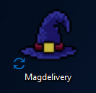

Everything the player can experience and see in MagDelivery game is created by the loving hands of Adventurous team – Sergey Miachkov, Daria Khylobok, Dorsa Amiri, Alvina Perly, Nyasha Dzere and feature artist Anna Maksimchuk. We express our gratitude to everyone who was involved in the process of creating the game and to everyone who ever plays it.

GAME TESTING
Jumping mechanics
Character can jump only once, so Sergey(our tester) was testing if the double jump was possible and apparently it wasn’t. That was a good start. It was also important to make sure that the player can correctly interact with platforms, meaning they are able to jump on, stay on and jump from them without going through the texture. Everything was working just fine.
Platforms positioning
For smooth gameplay we needed platforms to be nicely positioned in the way they wouldn’t touch each other, the player can easily jump from one another, go between low- and high-positioned platforms and fit under the lowest platforms. Sergey tried different layouts for groups of platforms and chose the best ones to go with.
Obstacles
Later on, when obstacles were added to the game, it also needed some testing. First of all, character should be able to go through them. Also, all of 4 types of obstacles should be of perfect sizes for player to be able to jump over the ground barriers and go under the flying one, while keeping it a challenge. For this different sizes and forms were tried and Sergey spent quite a lot of time playing the game to make sure it was working nicely. On touching an obstacle, player is supposed to lose 1 life. In the development process, we faced a bug which made all of the lives disappear just after one collision. This problem was found in the life-checking loop of the code and was fixed quickly.
Artifacts
Artifacts positioning required a lot of calculations. Daria was the one responsible for the artifacts mechanics and she joined Sergey for the testing part. They tried many different combination of generating items on the ground, on and under the platforms. A lot of variations were dismissed during this stage as they were found either not interesting or not suitable for the gameplay. Eventually, 22 combinations of items generating were added to the game. The way item is located should also be aesthetically pleasant, so each variation is set to its own x and y. As of animation, artifact disappears after player touches it.

Collecting mechanics
Identifying the artifact collected was a challenge. After many tries, the name comparison method was chosen. The logic behind that is comparing the name of collected artifact with all the sprites names and set its parameter to collected. Inventory cell for each collected item is chosen by a loop which checks which cell is free and if there is overall enough cells for adding new artifacts. All mechanics were tested and are working without any issues.

Power-ups
The first added power-up was the one that gives an extra life. Since it was a new mechanic, a lot of things needed to be tested and approved. Randomiser ratios and places of generation were checked, the implementation of adding health went smoothly.
For the shield power up a coroutine was used and it was a challenging new thing to tackle. There were problems with keeping the coroutine caller from deletion and link to the player – at first shield couldn't be properly applied, then it couldn't be properly taken back off, but eventually all mistakes were figured out. After playing a bit with the duration time, it was decided to settle on 5 seconds time period.
Implementing the most complex power up of them all – the recycle bin, was a challenging task. For this was needed an algorithm that determines which item to delete from the inventory and which ones to keep. Many attempts were made to come up with a pleasantly working algorithm and at first, a bunch of different bugs were occuring, i.e. deleting all of the artifacts, deleting a random artifact no matter was it ordered or not, not deleting any artifacts at all. The most challenging aspect was working with the ordered artifacts, because if player has more instances of the same artifact than it was ordered, then every extra one should still be considered as excess. Eventually, Sergey came up with an algorithm that was counting appearances of the artifact in the inventory and in the order list. Then judging by the difference of these two numbers the fate of the item was decided. This solution worked great and the power up was done.
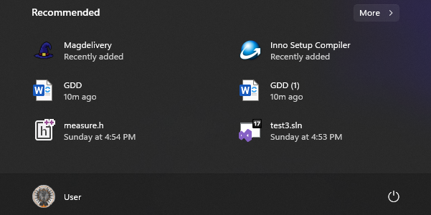
The last implemented power-up was the Mystery Box. Developing part of it was not as challenging as the previous ones, but yet, one accident happened. Handing the project between the team’s programmers was made through Git repository and the day this power-up was added, something happened. All the work done at this point wasn’t saved, the Mystery Box script was lost and it was discovered only a week later. For the purpose of the final product, Sergey took the responsibility of remaking this part, so it was added by all means, so that players can enjoy this useful power-up and see the game in the form it was originally thought of.

