# 

**Department of Computer Science and Engineering**

**Netaji Subhas University of Technology (NSUT)**

# **ML-based Personalized User Experience Using Usability Heuristics and Heatmap**

**Name of Student Roll No.**

Rohan Mittal 2021UCS1505

Sujal Nimbalkar 2021UCS1574

Navneet Kumar 2021UCS1576

**Under the Supervision**

of

Professor Ritu Sibal

## **Table of contents**

| **Sr. No** | **Content** | **Page No** |
| --- | --- | --- |
| 1 | Abstract | 3 |
| 2 | Introduction | 4 |
| 3 | Motivation | 5 |
| 4 | Literature Survey | 6-8 |
| 5 | Problem Statement | 9 |
| 6 | Objective | 10 |
| 7 | Methodology | 9-10 |
| 8 | Simulation Platform and Requirements | 11-12 |
| 9 | Result | 16 |
| 9 | Conclusion and Future Scope | 19 |
| 10 | References | 20 |

## **Abstract**

As digital experiences evolve, there is a growing need for user interfaces (UI) that cater to individual preferences and behavior patterns. Conventional UIs, which often rely on static designs, struggle to offer an engaging and personalized experience. To bridge this gap, this paper investigates the use of machine learning (ML) techniques in conjunction with real-time user interaction data, such as heatmaps, to develop adaptive UIs.

The system proposed in this study dynamically adjusts the UI in by analyzing user interaction data—such as mouse movements, clicks, and time spent on specific elements. These adjustments are designed to improve usability by aligning the interface with recognized usability heuristics, such as maintaining consistency and reducing cognitive load. This paper details the technical process involved, from data collection to the application of machine learning models, and assesses the system’s effectiveness in enhancing the user experience.

Beyond the technical aspects, this study emphasizes the broader implications of implementing adaptive UIs in various domains. Personalization in digital platforms is not merely a trend but a necessity in areas such as e-commerce, education, and healthcare, where user satisfaction and efficiency are paramount. The ability to adapt interfaces dynamically holds the potential to revolutionize user interaction, fostering environments that are both intuitive and user-centered. By addressing key challenges such as balancing adaptability with system stability and ensuring transparency in adaptive decisions, this research provides a framework for the future of intelligent interface design. Ultimately, the findings of this study highlight the transformative potential of ML-driven adaptive UIs in creating experiences that are engaging, efficient, and tailored to the unique needs of users.

## **Introduction**

The increasing demand for personalized digital experiences has transformed the way user interfaces (UIs) are conceptualized and developed. Traditional UIs, which rely on static and uniform designs, often fall short in meeting the diverse needs of users, as they are unable to adapt to individual preferences or behavioral patterns. This rigidity can lead to a less engaging and intuitive experience, where users struggle to find relevant information or interact efficiently with the interface. To address these limitations, leveraging machine learning (ML) techniques in combination with real-time interaction data, such as heatmaps and user activity logs, presents a promising approach. Adaptive UIs powered by ML have the potential to revolutionize the digital experience by tailoring interfaces dynamically to individual users, enhancing both usability and satisfaction.

This paper investigates the design and development of a dynamic UI system that evolves in real time based on user behavior and interaction patterns. The system captures detailed interaction data, including mouse movements, click frequencies, and dwell times on specific elements, to gain insights into user preferences and engagement. By analyzing this data using advanced ML algorithms, the system can intelligently adapt the interface to better align with the user’s needs. For instance, frequently accessed features can be prioritized or highlighted, while less relevant elements can be repositioned or minimized. These adjustments not only improve the interface’s usability but also adhere to critical usability principles, such as maintaining consistency, reducing cognitive load, and promoting intuitive navigation.

The research provides a comprehensive examination of the end-to-end implementation of this adaptive system, detailing the methods for data collection, preprocessing, and the training and deployment of machine learning models. It also evaluates the system's impact on user engagement and performance metrics, such as task completion rates and satisfaction levels. The findings highlight the effectiveness of real-time UI adaptation in enhancing user experiences across various digital platforms, including e-commerce, education, and healthcare.

Furthermore, this study delves into the broader implications of adaptive UI systems and the challenges associated with their implementation. It addresses concerns such as maintaining the balance between adaptability and stability, ensuring transparency in UI changes, and safeguarding user privacy in data collection processes. By presenting a scalable framework for building adaptive UIs, this research underscores the importance of personalization in modern digital interactions and paves the way for more intuitive and user-centric design paradigms.

## **Motivation**

In a world increasingly driven by digital experiences, user satisfaction is critical for the success of web and mobile applications. Many existing user interfaces (UI) fail to consider the diversity of user behaviors and preferences, leading to suboptimal engagement and usability. With the rapid evolution of technology, users now expect interfaces that not only function efficiently but also adapt to their individual needs and contexts.

The motivation behind this research is to address the gap between static UI designs and the growing demand for personalized, adaptive experiences. By leveraging real-time user interaction data, such as heatmaps, and combining it with machine learning algorithms, we can create interfaces that dynamically adjust based on user preferences and behaviors. This not only enhances the usability of the system but also increases user satisfaction and engagement by providing a more intuitive experience.

Furthermore, the challenge of ensuring that these dynamic adaptations do not compromise established usability principles, such as consistency, simplicity, and user control, adds an additional layer of importance to this research. This paper aims to demonstrate that adaptive UIs can improve overall user experience without sacrificing key usability standards, providing a framework for future innovations in user-centric design.

## **Literature survey**

User experience (UX) design has evolved significantly with the increasing complexity of web and mobile applications. However, many user interfaces (UIs) still rely on static layouts that do not cater to individual user needs or behaviors. Traditional approaches, which often follow predefined patterns, fail to provide the personalized experiences modern users expect. As digital interactions become more integral to everyday life, there is a growing need for systems that adapt dynamically to real-time user behavior while maintaining key usability standards.

### **4.1 Heuristic Evaluation and Usability Principles**

Usability heuristics remain central to effective UI design. Key principles such as consistency, visibility of system status, user control, and error prevention are essential for creating intuitive interfaces. While these principles were originally applied in static interfaces, they are equally relevant in dynamic and adaptive systems. The challenge lies in ensuring that as interfaces change dynamically, they continue to align with these heuristics. Early usability testing methods demonstrated the value of evaluating interfaces before their implementation to identify potential usability issues. This type of inspection method helps in detecting problems early in the design process, making it easier to iterate and improve.

* **System Status Visibility**: Ensure the system provides timely and clear feedback to users, keeping them informed about ongoing processes or changes.
* **Alignment with Real-World Concepts**: The system should use language, symbols, and concepts familiar to users, mirroring real-world logic and avoiding technical jargon.
* **User Control and Undo Options**: Allow users to easily undo actions or exit processes to recover from mistakes, without requiring them to follow a complex procedure.
* **Consistency and Adherence to Standards**: Maintain uniformity in language, design elements, and interactions, ensuring users do not have to guess the meaning of actions or terms.
* **Error Prevention**: Design interfaces to prevent mistakes before they happen. When errors are possible, offer confirmation options to avoid unintended actions.
* **Recognition Over Recall**: Reduce the user's cognitive load by making interface elements, options, and instructions visible or easily accessible when needed, so users don’t have to remember information.
* **Flexibility and User Efficiency**: Provide shortcuts or advanced features for experienced users while keeping the design simple and accessible for beginners. Enable customization of frequent actions.
* **Minimal and Aesthetic Design**: Keep the interface uncluttered by displaying only essential information, ensuring that important content is not overshadowed by irrelevant details.
* **Error Recognition and Recovery**: Use plain language for error messages, clearly identifying the issue and suggesting actionable solutions for users.
* **Help and Guidance**: While an intuitive system minimizes the need for help, provide clear and accessible documentation or support if users require guidance to complete their tasks.

Over time, as interfaces evolved, qualitative analyses became increasingly important. Examining user interactions with UI elements such as buttons, links, and layout designs provided insights into how to structure an interface to better align with user expectations. By continuously analyzing how users engage with these elements, designers can enhance the overall user experience, ensuring it is both efficient and intuitive.

### **4.2 Machine Learning and Adaptive UIs**

Machine learning (ML) has opened new possibilities for creating adaptive user interfaces that personalize the user experience. Instead of relying solely on fixed layouts and designs, ML allows systems to learn from user interactions and make informed adjustments to the UI. By analyzing behavior such as mouse movements, clicks, and the amount of time spent on specific elements, machine learning models can predict user preferences and modify the interface to suit those preferences.

This approach is rooted in the concept of continuous feedback. Systems can be designed to learn from each interaction and progressively refine their behavior, ensuring that they adapt to the needs of individual users over time. As systems collect more interaction data, they can adjust their responses, providing users with interfaces that feel increasingly tailored to their unique behavior patterns.

In this way, adaptive UIs can adjust the size, position, and prominence of various interface elements based on how users interact with them. For instance, if a user repeatedly clicks on a specific button, the system can make that button more accessible or more prominent in future interactions. These kinds of dynamic adjustments are made possible by combining machine learning models with interaction data, creating a more personalized experience without sacrificing usability.

### **4.3 Real-Time Interaction Data and Heatmaps**

Real-time interaction data, particularly through tools like heatmaps, has become a valuable asset for understanding how users engage with a UI. Heatmaps provide a visual representation of user activity, showing where users click, move their cursors, or spend the most time. By analyzing this data, designers can identify which areas of the UI are most effective and which need improvement.

Heatmaps, when integrated with machine learning models, allow for deeper insights into user behavior. Instead of relying solely on static user testing or post-launch feedback, real-time data collection enables systems to adjust dynamically based on ongoing interactions. This approach provides a more immediate response to user needs and improves usability and user satisfaction.

For example, if a critical button is not receiving enough interaction, a heatmap analysis might show that it is not positioned in an intuitive location. The system can then adjust the button’s size or location to make it more visible and accessible. Similarly, if users are spending too much time searching for key information, the UI can be adjusted to highlight or simplify the navigation process. This ability to adapt based on live data sets adaptive UIs apart from traditional, static designs.

### **4.4 Integration of Usability Heuristics in Adaptive Systems**

While personalization is important, it is equally critical that adaptive systems maintain adherence to usability heuristics. A UI that adapts to user behavior must do so in a way that does not introduce confusion or violate core design principles. Usability standards such as recognition over recall, simplicity, and user control need to be preserved, even as the system adapts in real time.

In adaptive UIs, maintaining a consistent and familiar experience is vital. While the system may change based on user interactions, those changes should align with the user's expectations and avoid overwhelming them with too many adjustments. For example, ensuring that changes are subtle, like repositioning or resizing elements, rather than drastic shifts in design, helps to maintain a consistent and familiar user experience.

The use of machine learning models in this context offers a balance between personalization and usability. By continuously analyzing interaction data, these models can suggest changes that enhance the user experience without violating established design principles. Additionally, dynamic systems can be built to monitor potential usability violations and adjust accordingly, ensuring that the system remains user-friendly.

### **4.5 Practical Applications and Considerations**

Real-world applications of adaptive UIs demonstrate the potential of these systems to enhance user experience. For instance, personalization platforms in e-commerce dynamically adjust content and recommendations based on user behavior, providing tailored suggestions that increase engagement. Responsive frameworks in web design adjust layouts based on the device being used, ensuring a consistent experience across different platforms.

## **Problem Statement**

In modern web and mobile applications, providing a personalized and intuitive user experience (UX) is crucial for improving user satisfaction and engagement. However, most existing UX designs rely on static layouts and generalized interactions that fail to account for individual user preferences, behaviors, and contextual factors. These conventional designs often lead to less effective interactions, reducing the overall user experience.

The challenge lies in dynamically adapting user interfaces in real-time while maintaining core usability principles such as consistency, simplicity, and user control. Although advancements in machine learning (ML) offer opportunities for personalization, the integration of these techniques with established usability heuristics is often overlooked. Real-time data, such as user interaction patterns captured through heatmaps, can be valuable in driving these adaptations, yet few systems utilize this data effectively to create personalized interfaces.

Therefore, this research seeks to address the gap by integrating machine learning with user interaction data and usability heuristics. The goal is to develop a system that can dynamically adapt the user interface based on interaction data, optimizing the layout, content, and design to meet individual user needs while adhering to recognized usability standards. This approach aims to enhance both user engagement and satisfaction, creating a more seamless and personalized UX.

## **Objective**

This research focuses on developing an innovative user interface (UI) system that intelligently adapts to user behavior by leveraging advanced machine learning techniques and interaction data analysis. The primary objective is to create an interface that evolves based on user preferences and engagement patterns, captured through detailed interaction data such as mouse movements, clicks, and other behavioral indicators. By analyzing this data, the system will gain valuable insights into how users interact with various UI elements, enabling it to deliver a more intuitive and responsive experience.

A critical aspect of this system is its adherence to established usability principles, ensuring that the adaptive nature of the interface does not compromise core usability standards. The design will emphasize consistency across the UI, provide users with a sense of control, and minimize cognitive load to enhance overall user satisfaction. Even as the system makes real-time adjustments to the interface, these usability guidelines will remain central to its functionality.

The system will utilize machine learning models to personalize the user experience by tailoring key aspects of the interface, such as layout, navigation, and other design elements, to meet the unique needs and preferences of individual users. This personalization aims to create a user-centered interface that evolves dynamically to align with changing user behaviors and requirements over time.

To ensure the system strikes a balance between adaptability and stability, it will be designed to prioritize performance and reliability. While the interface will adjust dynamically, these changes will be implemented in a way that maintains the system's ease of use and prevents unnecessary disruptions to the user experience. By focusing on stability, the system will foster a seamless and engaging interaction environment.

Finally, the impact of this adaptive UI will be rigorously evaluated through empirical assessments of user engagement, satisfaction, and task completion rates. These evaluations will determine whether the system's dynamic adjustments successfully enhance the user experience without introducing usability issues. The ultimate goal is to validate the system's ability to provide meaningful and effective personalization, ensuring it meets the needs of diverse users while adhering to high usability standards.

## **Methodology**

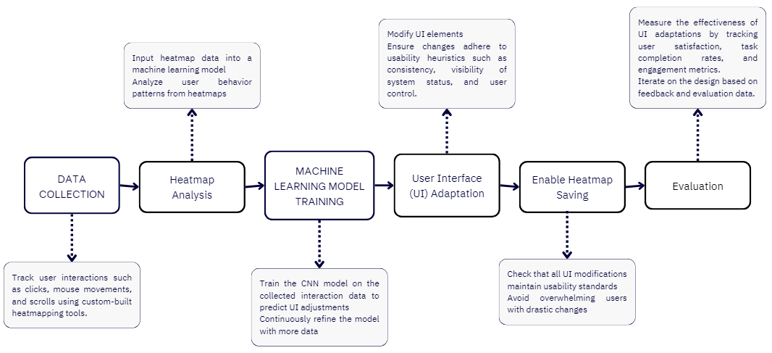

**1.** **Data Collection**: Collect interaction data from users interacting with the UI, including mouse movements, clicks, hover time, and scroll patterns. Capture heatmap data from user interactions and save it into labeled categories: 'YES' for correct design and 'NO' for incorrect design. A total of 23,000 images have been generated as the dataset.

**2.** **Data Preprocessing**: Load the heatmap images from the respective directories (`dataset/ Augmented/ YES/` and `dataset/Augmented/NO/`). Convert images to grayscale and resize them to a fixed size (64x64). Flatten the resized images to create feature vectors and associate them with appropriate labels ('1' for YES and '0' for NO).

YES Image

The "YES" image represents a correct or well-designed UI layout. In these images, the heatmap likely shows concentrated user activity around important elements like buttons, forms, or key information areas. The design facilitates a smooth user experience, with minimal unnecessary mouse movement or confusion, indicating intuitive navigation and well-placed UI elements.



NO Image

The "NO" image depicts an incorrect or poorly designed UI layout. In these images, the heatmap shows scattered or excessive mouse movement, possibly indicating user confusion or difficulty in locating key elements. Users may spend more time hovering over non-interactive or irrelevant areas, signaling that the design causes friction, leading to a less effective user experience.



**3. Train-Test Split**: Split the dataset into training and testing sets (80% training, 20% testing) to ensure an unbiased evaluation of the model.

**4. Model Selection and Cross-Validation**: Use a RandomForestClassifier for training, leveraging the ensemble technique for robust classification. Perform cross-validation (5-fold) on the training set to ensure that the model generalizes well across different subsets of the data.

**5. Hyperparameter Tuning**: Apply GridSearchCV to perform hyperparameter optimization by searching over a predefined parameter grid for the best model settings (e.g., `n_estimators`, `max_depth`, etc.). Use accuracy as the scoring metric to evaluate different model configurations during hyperparameter tuning.

**6. Model Training**: Train the best-performing model (determined through GridSearchCV) on the training data to capture the relationship between heatmap patterns and UI correctness.

**7. Model Evaluation**: Make predictions on the test set and assess the model’s accuracy, confusion matrix, and classification report to gauge performance.Evaluate performance metrics such as overall accuracy, precision, recall, and F1-score.

**8. Recommendation System**: Develop a recommendation function that processes new heatmap files.Based on the trained model’s prediction, provide suggestions regarding whether the UI element requires modification or if the design is already optimal.

**9. Deployment & Testing**: Test the recommendation system on new heatmap images to validate the prediction and decision-making logic. Provide UI change recommendations based on predictions from unseen heatmap data.

## **Simulation Platform and Requirements (improvise sub topics)**

The project uses a custom-built simulation platform designed specifically for analyzing and testing adaptive user interfaces (UI) based on user interaction data. The platform integrates our custom-made heat mapping tools and machine learning models to simulate and measure user behavior across different UI designs.

#### **8.1 Custom Heat Mapping Tools**

Rather than relying on third-party solutions, the team developed their own heat mapping tools. These tools track user interactions such as clicks, scrolls, and mouse movements across the interface. The collected data is used to generate heatmaps that visually represent user engagement. This data helps identify areas where users focus their attention or encounter issues in navigating the interface.

#### **8.2 Machine Learning Integration**

The platform is equipped with machine learning models, such as Convolutional Neural Networks (CNNs), to analyze the heatmap data. These models are trained to identify patterns in user behavior, allowing the system to predict where UI adjustments are needed. Over time, the system adapts based on ongoing data collection.

#### **8.3 Usability Heuristics Compliance**

The simulation platform incorporates Jakob Nielsen’s usability heuristics to ensure that adaptive changes in the UI adhere to recognized usability standards. This helps maintain a balance between dynamic interface changes and core usability principles.

#### **8.4 UI Adaptation**

The platform enables UI changes based on user interactions. Designers can experiment with dynamic adjustments and evaluate how these changes affect user behavior, engagement, and overall satisfaction.

### **8.5 Requirements for the Project**

The successful development of this adaptive user interface system requires meeting several technical and operational criteria. These include:

#### **8.5.1 Technological Requirements**

**Frontend Framework**: Dynamic UI updates rely on React.js to ensure seamless interaction with the machine learning models, allowing the interface to change based on user behavior.

**Custom Heat Mapping Tools**: The project includes developing a proprietary heat mapping tool that captures user interaction data. The system tracks user behaviors such as clicks, mouse movements, and scroll depth to analyze engagement patterns.

**Machine Learning Frameworks**: TensorFlow.js or scikit-learn will be used to train machine learning models that predict which parts of the interface need adjustment based on user behavior.

**Data Visualization Libraries**: To represent user interaction data visually, libraries like heatmap.js are used to generate heatmaps from the collected data.

#### **8.5.2 Data Requirements**

**User Interaction Data**: The system requires continuous collection of data related to mouse movements, clicks, and other user interaction patterns. This data is essential for training the machine learning models and informing UI adjustments.

**Heatmap Data**: Data generated by the custom-built heat mapping tool serves as the primary input for the machine learning models, helping identify areas of high or low user engagement.

#### **8.5.3 Computing Requirements**

**Server Infrastructure**: The system requires a high-performance server infrastructure capable of processing large datasets in real-time. Cloud services or dedicated servers must handle the continuous flow of interaction data.

**GPU-Enabled Machines**: Machine learning models, especially CNNs used for heatmap analysis, will require GPU-enabled machines to accelerate training and analysis.

#### **8.5.4 Team and Expertise Requirements**

**Machine Learning Engineers**: A team of engineers skilled in machine learning and data analysis will be required to develop and train models that analyze user behavior patterns and optimize the UI.

**Frontend and Backend Developers**: Full-stack developers experienced in React.js/Vue.js (frontend) and Node.js/Python (backend) are necessary to build, maintain, and integrate the adaptive UI system.

**UI/UX Designers**: Designers with expertise in creating adaptive interfaces and understanding usability heuristics are key to ensuring that the system remains user-friendly and intuitive.

## **Result**

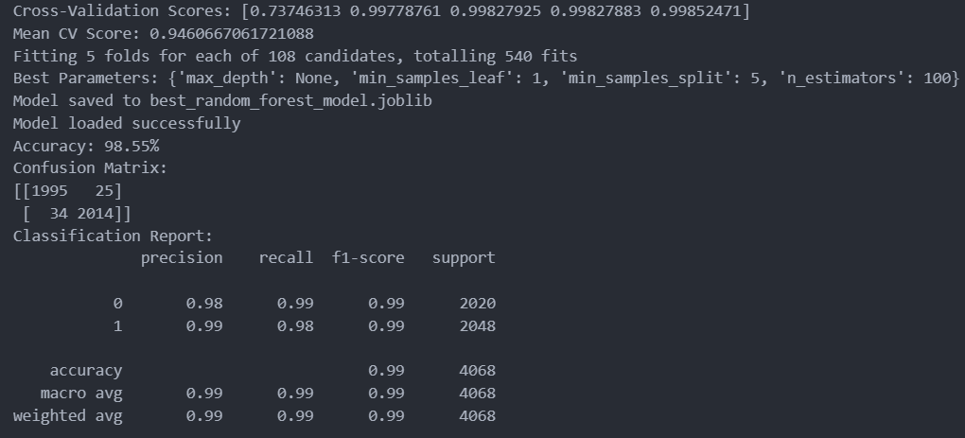

The mean CV score of **94.6%** suggests strong performance across different data splits.

The model achieved **98.55% accuracy** on the test set, signifying excellent predictions.

Out of 4068 samples, only 12 misclassifications occurred, showing minimal errors.

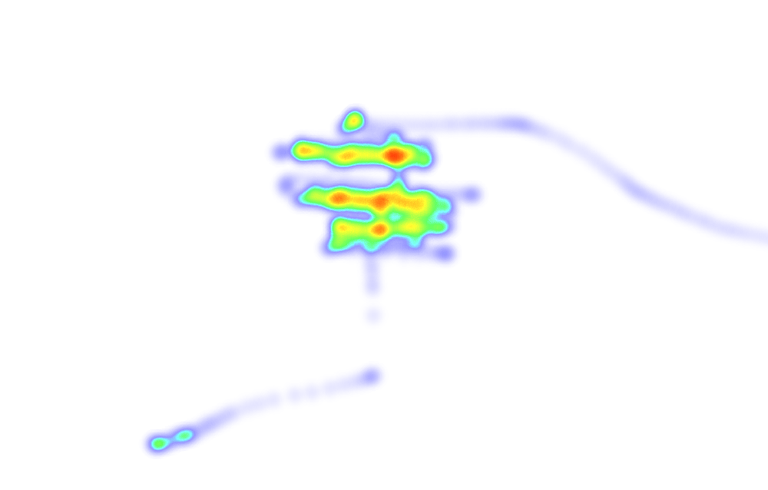



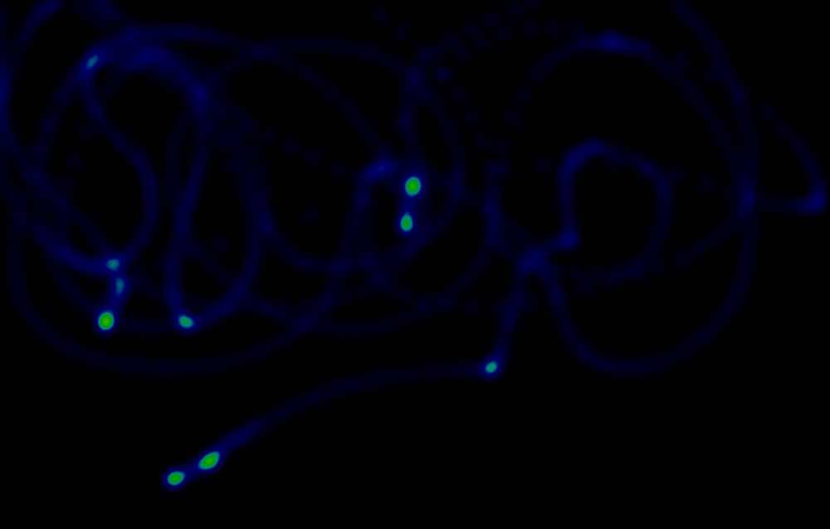

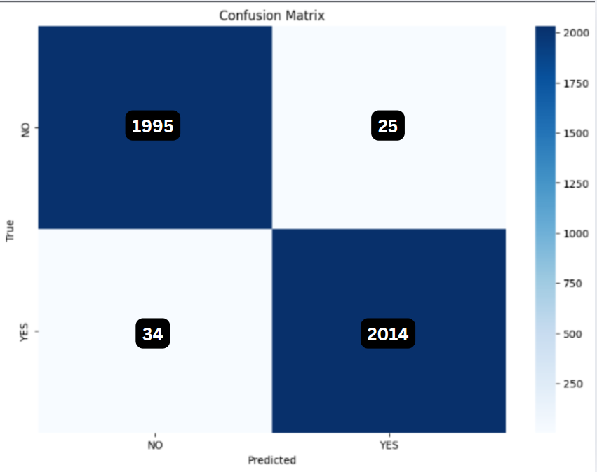

A confusion matrix is a tool used to evaluate the performance of a classification model. It displays the counts of correct and incorrect predictions, categorized for each class, offering a clear summary of the model's accuracy.

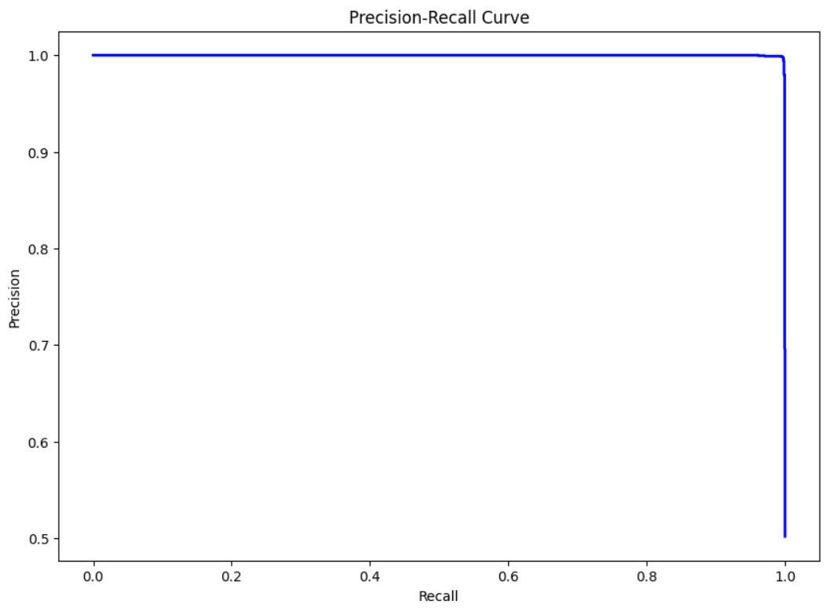

The ROC curve visually illustrates the performance of a binary classifier by plotting the true positive rate against the false positive rate at various threshold settings, highlighting the model's ability to distinguish between classes.

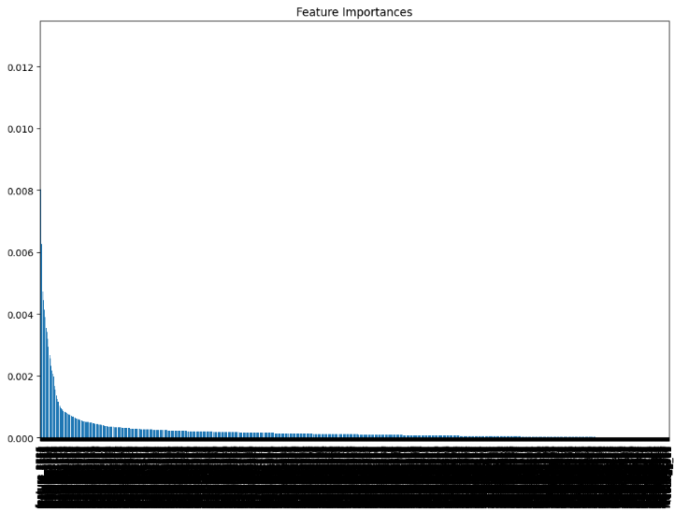

Feature importance provides a score that indicates how useful or valuable each feature was in the construction of the boosted decision trees within the model. This helps in understanding which features are contributing the most to the predictions.

## **Conclusion and Future Scope**

This research has demonstrated the development of an adaptive user interface (UI) system that uses machine learning and real-time interaction data to deliver personalized user experiences. Traditional static UIs often fail to address the diverse behaviors and preferences of users. By leveraging custom heat mapping tools and machine learning models, this system dynamically adjusts UI elements based on individual user interactions, enhancing engagement and satisfaction.

A key aspect of this project was ensuring that dynamic changes to the UI adhered to recognized usability heuristics, such as consistency, user control, and minimizing cognitive load. The integration of Convolutional Neural Networks (CNNs) allowed the system to analyze heatmap data in real time, predicting and implementing changes that improve the user experience without compromising usability.

Meeting technical requirements, such as custom heat mapping, server infrastructure, and team expertise, was crucial for the successful implementation of the system. The project has provided a framework for the future of personalized UIs, combining real-time data, usability principles, and machine learning to create intuitive and adaptive digital environments.

Moving forward, integrating the Rico dataset into this system can significantly enhance its adaptability and scope. The dataset's diverse UI designs and interaction patterns can refine model predictions, enabling more precise and effective personalization across varied applications. Additionally, the system can be expanded to include predictive analytics, where user behavior trends are forecasted to proactively adjust interfaces before potential usability issues arise. Integrating generative AI models to create and test UI prototypes dynamically based on Rico’s data could further streamline the design process. These advancements, coupled with Rico’s insights, pave the way for universally adaptable and predictive interfaces that prioritize user experience while aligning with cutting-edge design innovations.

## **References**

1. Nielsen, J., and Molich, R. Heuristic evaluation of user interfaces. Proc. ACM CHZ’90 (Seattle, WA, 1–5 April 1990), 249–256.
2. Nielsen, J. Paper versus computer implementations as mockup scenarios for heuristic evaluation, Proc. INTERACT’90 3rd IFIP Config Human–Computer Interaction (Cambridge, U.K., 27–3 1 August 1990),3 15–320.
3. Nielsen, J. (1994a). Enhancing the explanatory power of usability heuristics. Proc. ACM CHI'94 Conf. (Boston, MA, April 24-28), 152-158.
4. Nielsen, J. (1994b). Heuristic evaluation. In Nielsen, J., and Mack, R.L. (Eds.), Usability Inspection Methods, John Wiley & Sons, New York, NY.
5. Kellogg, W.A. Qualitative artifact analysis. Proc. INTERACT’ 90 3rd IFIP Config Human--Computer Interaction (Cambridge, U.K., 27-31 August 1990), 193-198.
6. Liu W, Dai B, Humayun A et al (2017) Iterative machine teaching. In: Precup D, Teh YW (eds) Proceedings of the 34th international conference on machine learning, proceedings of machine learning research, vol 70. PMLR, 2149–2158,
7. Suh J, Ghorashi S, Ramos G et al (2019) Anchorviz: facilitating semantic data exploration and concept discovery for interactive machine learning. ACM Trans Interact Intell Syst
8. Zhu X (2015) Machine teaching: An inverse problem to machine learning and an approach toward optimal education. In: Proceedings of the twenty-ninth AAAI conference on artificial intelligence. AAAI Press, AAAI’15, 4083–4087
9. Moussette, C. 2012. Simple haptics: Sketching perspectives for the design of haptic interactions. Ph.D. Dissertation, Umea Universitet.
10. Yang, Q.; Sciuto, A.; Steinfeld, A.; Forlizzi, J.; and Zimmerman, J. 2018. Investigating how experienced UX designers effectively work with machine learning. Manuscript submitted for publication.
11. Sekhavat, Y.A.; Parsons, J. The effect of tracking technique on the quality of user experience for augmented reality mobile navigation. Multimed. Tools Appl. 2018, 77, 11635–11668.
12. Nielsen, J., & Molich, R. (1990). Heuristic evaluation of user interfaces. Proceedings of the SIGCHI conference on Human factors in computing systems (pp. 249-256). ACM.
13. El-Halees, A. M. (2014). Software Usability Evaluation Using Opinion. Journal of software, 9(2).